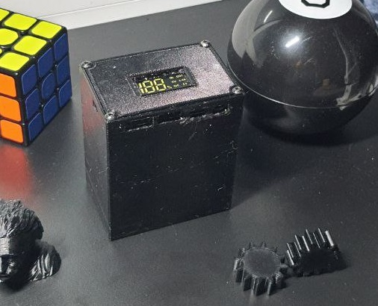 Instructions how to assemble - Power Bank 6 elements 21700

*Parts:*

1. Printed parts:

a) bottomPartPowerBank21700.

b) topLidPartPowerBank21700.

c) bracketInsidePartPowerBank21700.

d) buttonPowerBank21700.

2. 21700 (any of), it is desirable to find 5000mAh.

I personally recommend these - (shorturl.at/jL146).

3. LED Dual USB 5V 2.4A Micro/Type-C USB Mobile Power Bank Charging Module.

Link to the Power Module (which the .stl model of the case is made) - (shorturl.at/aoAJT).

4. Nickel stripe ≈ 35-40cm.

5. Дріт електр. 22awg, один 15см, інший 10см.

(Which one will be shorter or longer depends on which pole you’ll land the elements to the bottom of the case).

6. Screws М1.6 х 6mm – 4pcs, М3 х 12mm – 4pcs.

7. Electrical isolation tape.

1. *Necessary tool:*

2. Soldering iron.

3. Spot welding for rechargeable batteries.

(It is possible without it and the nickel strip, but then there will be a greater probablem of the element being detached from the electrical circuit + it will be necessary to set new value of the length of the bottom part in the **.stl file*1** in accordance with the thickness of the wires with which the battery will be soldered)

1. Screwdriver with bits.

3. Nippers or a knife.

( Work with the wires)

4. Sandpaper.

(Clean the place of connection of the wire with a nickel tape)

**Procedure:**

1. Connect the batteries using isol. tape

(maximum one layer to fit after into the case)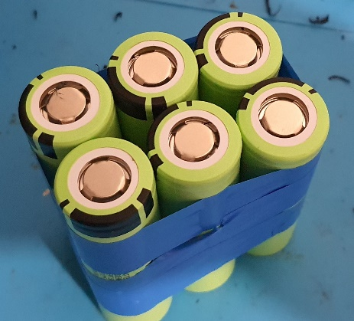

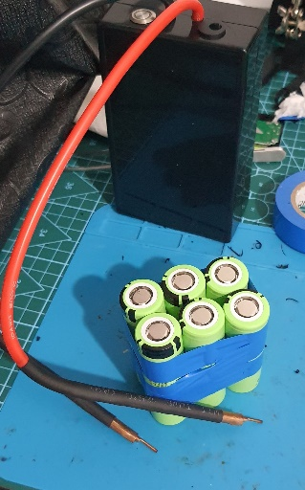2. We take spot welding

and nickel tape or

soldering iron and wires.

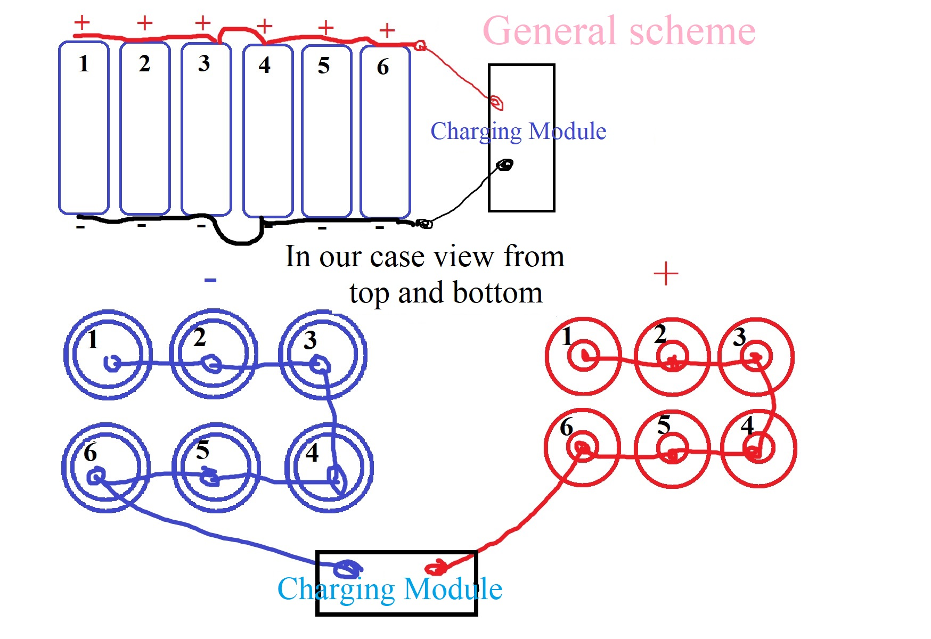

2.1. The scheme of connecting batteries to the charging module

(If it is clear, then we move to point 3).

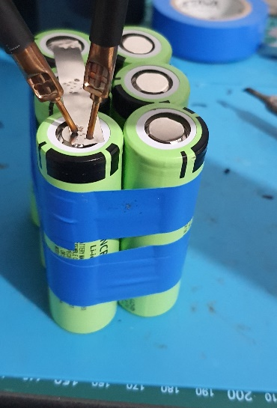3. Solder according to scheme 2.1. our top/bottom variant.

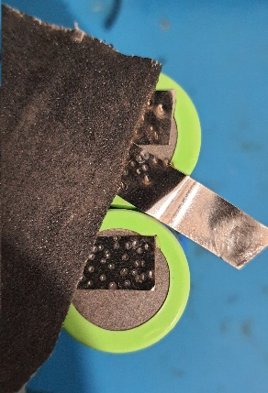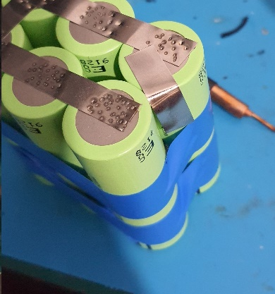

4. We take a small one

3 cm piece of nickel stripe, we scraping one end with sandpaper (to apply solder wire, lead, it will be clear later) and weld the other (up to the 6th battery).

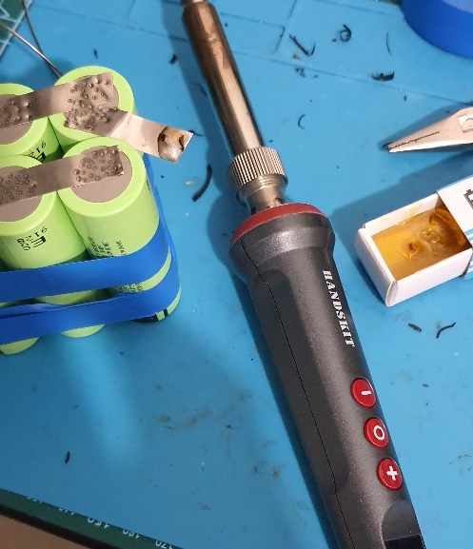

5. Apply a drop of lead to the scraped area of ​​the tape (it may fall off when it will be intensively in use. to increase adhesion).

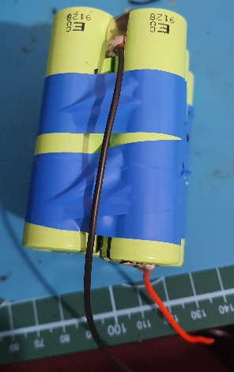

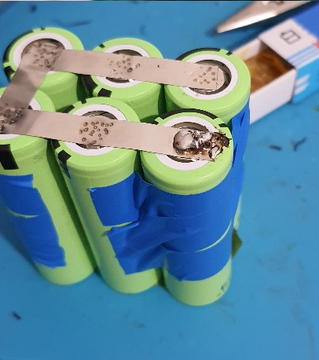

5.1. We repeat the actions from points 4 and 5, but already for the other pole of the batteries (in the example, we first made the minus, now we move to the plus).

A small piece of nickel stripe, optional as it is needed for the bottom pole to push the 6 batteries together into the case. And for the wire from the bottom to place it between them without getting troubles with fitting the batteries into place.

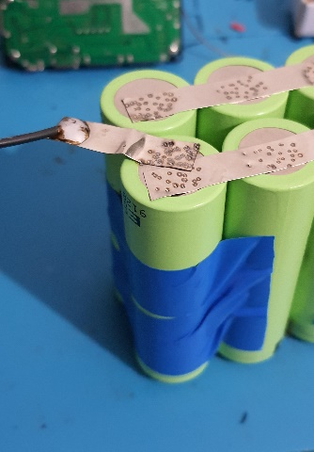7. We solder the negative wire (GND) 22awg, it is the lower part (in this case, you can, also, install the opposite side, there is no difference) Wire length of 15cm. (it is redundant for the further convenience of installing the cover).

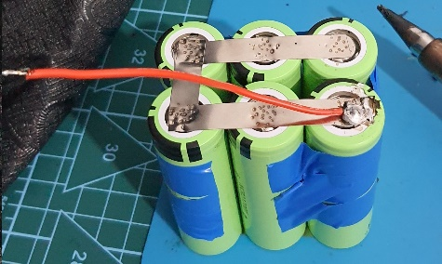

8. Repeat point 7 with a 22awg-10cm wire for the 3.7v pole of the solder.

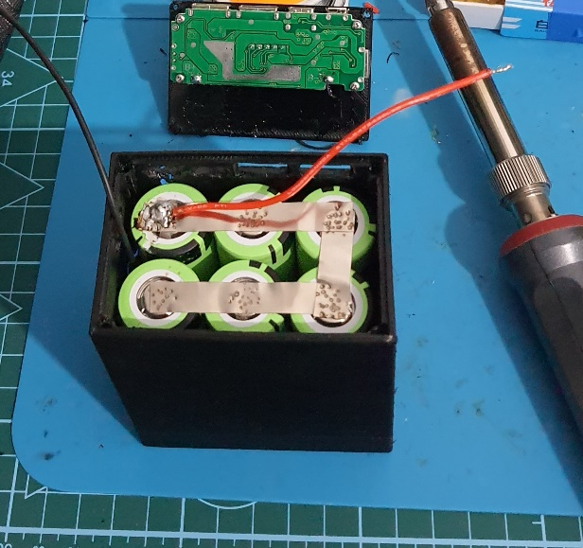

9. We insert the prepared batteries into the case (bottomPartPowerBank21700) (**Attention!** It is preferable to insert the positive wire in such a way that it is closer to the side where there are no USB holes, because, there may not be enough space for the charging module in the option shown in the photo).

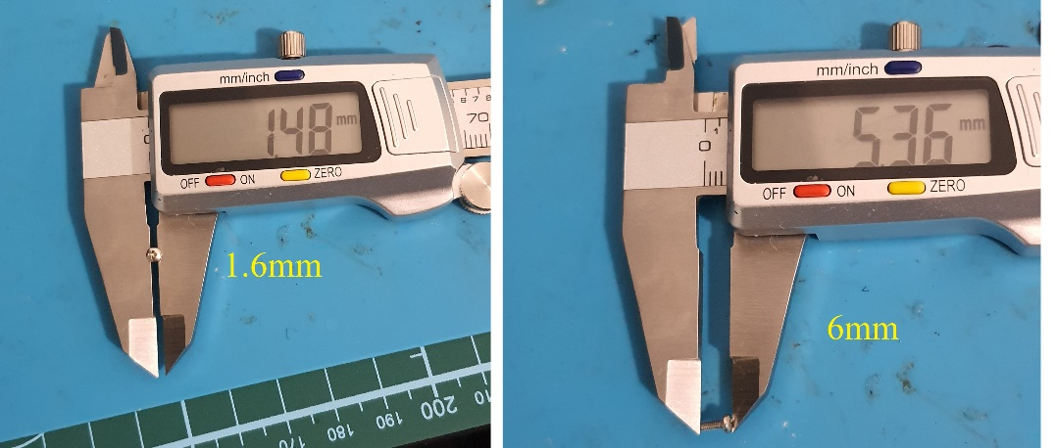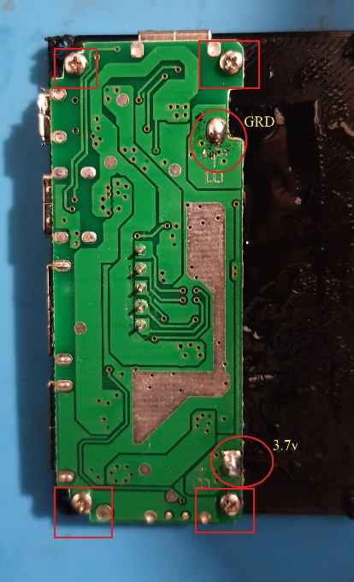10. We screw the charging module to the cover (topLidPartPowerBank21700), M1.6 x 6mm bolts, apply lead drops to GRD and 3.7v (**first read item 13.1.**).

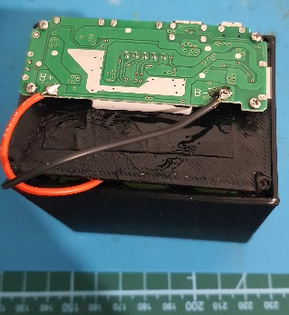11. We solder the workpiece to the charging module in accordance with the polarity.

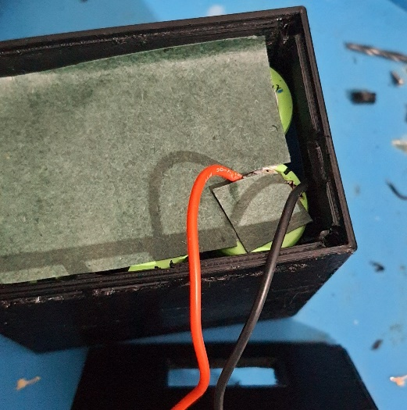

12. It is advisable**\*2** to stick a thin insulating material on top of the battery contacts to prevent short circuits.

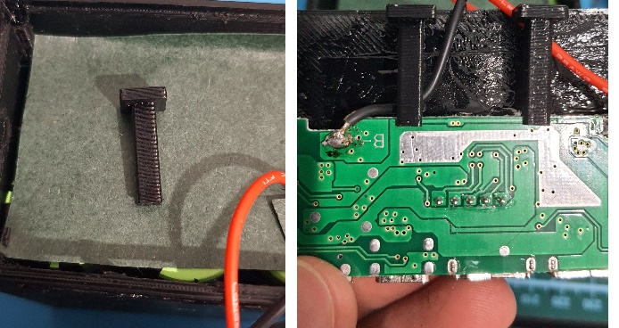

13. We install brackets**\*3** for support (bracketInsidePartPowerBank21700 ) in their place and the button (buttonPowerBank21700) is on the left side, when we are looking from the front at the USB holes.

13.1. Before screwing on the cover, if desired, treat the perimeter of the cover and all openings along the perimeter, including the hole for the screen, with a special agent**\*4** to prevent excess penetration of moisture and dust.

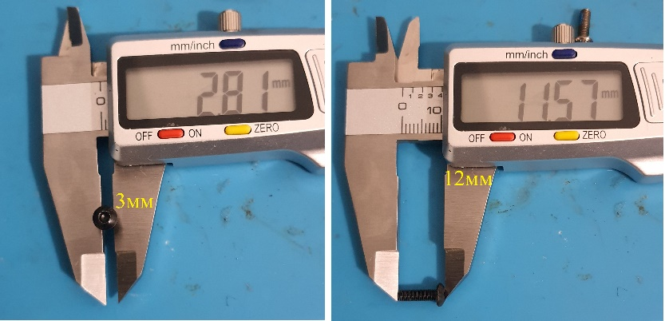

14. We screw the cover (topLidPartPowerBank21700) to the body with M3 x 12mm bolts.

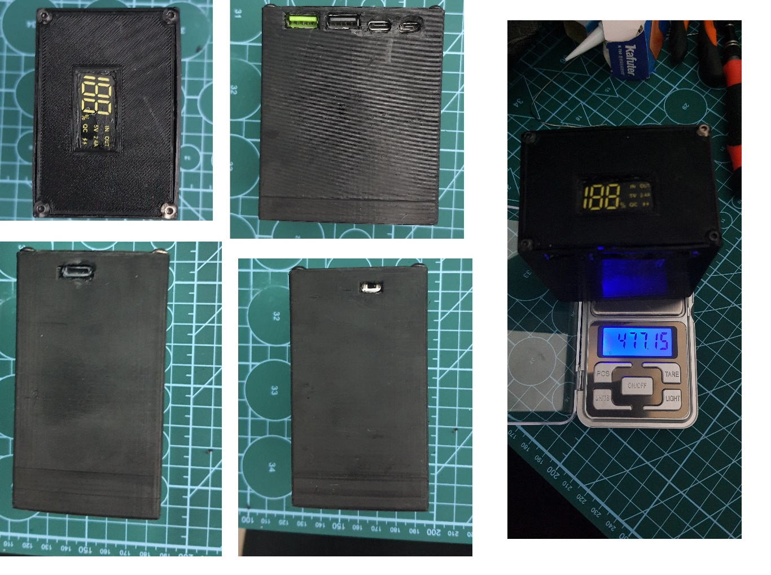

All the flaws in the sockets that are visible. In the .stl files have been eliminated (updated files), it was impossible to fit everything without a trial power bank.

The weight is almost 500 grams (it depends a lot on the batteries), if the elements are 5000 mAh each, then you get a 30000mAh power bank, which I think is not bad... The cost of production is much lower than buying a ready-made analogue. The main thing is high-quality 21700 batteries.

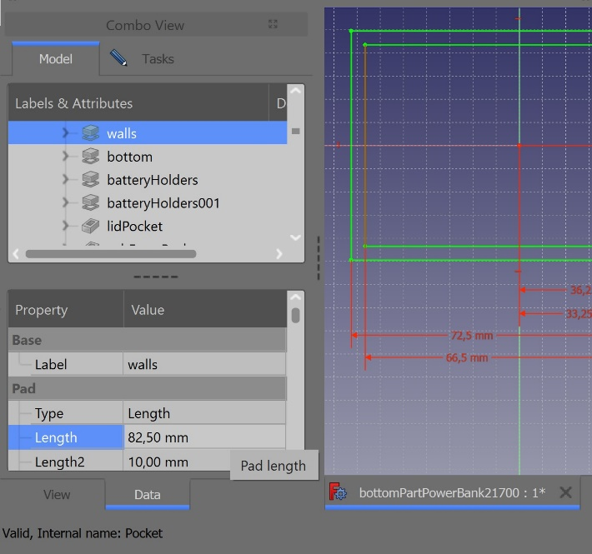

*1-file - bottomPartPowerBank2170**/walls** – parameter **length**, increase by the thickness of the wires used for soldering.

*2- you can use insulating tape or special films (shorturl.at/awNV6).

*3- during long-term operation, the charging module may fall inside, to prevent this, we install these supports.

*4- industrial silicone or special silicone for electronics (shorturl.at/jlHN2).