Developing an FAQ Chatbot Using LangChain and LLM APIs:
ShopBot — A Retrieval-Augmented Customer Support Assistant
Gledson Vinicios Rodrigues de Souza
Assignment 2: Developing an FAQ Chatbot
April 8, 2026

Abstract
This paper outlines the development of ShopBot as an AI-based FAQ chatbot for ShopEasy - a fictional Canadian e-commerce site. ShopBot was developed by integrating LangChain with the GPT-3.5 turbo model from OpenAI and utilizing FAISS to develop a vector store that allows ShopBot to utilize a retrieval-augmented generation (RAG) architecture. Additionally, ShopBot utilizes the large Bitext Customer Support LLM Chatbot Training dataset (26,872 entries) to provide answers to customers questions in support categories such as order status, shipping information, return policy and payment methods. This paper includes an overview of how the chatbot was developed, its data pre-processing pipeline, a detailed outline of how it was implemented, and what we learned about evaluating this chatbot.

1. Name and Purpose of the Chatbot
ShopBot is an AI-based FAQ chatbot used as customer service for ShopEasy - a made up online retail store based out of Canada. ShopBot can help answer frequently asked customer questions by providing rapid, accurate, relevant answers and reduce the workload of human customer support representatives while increasing customer satisfaction. ShopBot will assist customers with questions concerning their orders; shipping/delivery; returns/refunds; account management; payments etc. Using a retrieval-augmented generation (RAG) architecture pipeline, ShopBot generates answers from a pre-crafted knowledge-base created using historical customer support interactions. As such, ShopBot reduces the likelihood of "hallucinations" or generating inaccurate information. Additionally, ShopBot maintains context throughout multiple conversation iterations enabling it to respond to subsequent questions from the same user. This allows for addressing complex customer issues through multiple exchanges.

2. NLP/LLM Methods Used
ShopBot uses a Retrieval-Augmented Generation (RAG) framework, first introduced by Lewis et al. (2020), to combine dense vector based retrieval with a generative language model. It has been chosen over fine-tuning for three reasons: (1) because RAG models do not require gradient based training and so are cost-effective in terms of computational resources; (2) because they have significantly reduced the ability to hallucinate as their responses will always refer back to the evidence used to generate them; and (3) because the knowledge-base can easily be added or changed as needed without having to train the LLM again. In addition, the following NLP/LLM techniques are being utilized in ShopBot:

2.1 Text Embeddings
Beginning of Text - Customer FAQs are created as a vector representation for each pair of customer questions/answers with OpenAI’s ‘text-embedding-3-large’ model. This allows the vectors to be compared in a way that captures the semantics of the question so you can perform searches by similarity rather than just searching for keywords. For example, if a user asks ‘where is my package?’ they would find the same document on how to track an order regardless of whether the word “package” was used anywhere in the FAQ (Mikolov et al., 2013).

2.2 Similarity Search with FAISS
Facebook AI Similarity Search (FAISS) is responsible for storing the embedding vector and performing an approximate nearest neighbour (ANN) search on the query at runtime. At runtime, it provides the K most semantically relevant FAQ Chunks to a User Query within milliseconds irrespective of how large the corpus is (Johnson et al., 2021).

2.3 Generative Response with GPT-3.5-turbo
The obtained pieces of information are then fed into an organized framework question and submitted through the ChatCompletion API to Open AI's GPT-3.5-turbo. The large language model (LLM) produces coherent and relevant responses based on the synthesized pieces of information that have been retrieved.

2.4 Conversational Memory
LangChain stores all of the conversation history for a session in the ConversationBufferMemory and adds this history to every input that is sent as part of a conversation. This allows for multi-turn conversations, with users able to send follow up questions based on previous answers provided by the model without needing to restate the question (e.g. "And what about the refund?" after sending a request regarding returning an item).

2.5 Prompt Engineering
A custom system prompt limits ShopBot’s role as a persona, provides boundaries to its behavior, and directs it to seek human support when it can’t answer a question by relying solely on the context given – this is recommended best practice in using production FAQ bot (White et al. 2023).

3. Dataset Information

3.1 Dataset Source
The training data for the Bitext Customer Support LLM Chatbot was retrieved from kaggle (bitext, 2023) . The training data were provided by bitext , an NLP data services leader , as part of a larger effort to build and test chatbots and intent classification systems in e-commerce customer service
- Dataset URL: https://www.kaggle.com/datasets/bitext/training-dataset-for-chatbot-and-nlu
- License: Creative Commons Attribution 4.0 International (CC BY 4.0)

3.2 Number of Records
The dataset contains 26,872 labelled customer support utterance-response pairs prior to preprocessing. After deduplication, 26,872 unique records are retained.

3.3 Number of Features
The dataset contains 5 usable feature columns plus a metadata split indicator, totalling 6 columns.

3.4 Description of Features
Feature Name | Description | Data Type
flags | Metadata flags indicating linguistic variation types applied to the utterance | String (categorical)
instruction | The customer utterance / question (input to the chatbot) | String (free text)
category | High-level support topic (e.g., ORDER, SHIPPING, REFUND) | String (categorical)
intent | Granular intent label (e.g., track_order, cancel_order) | String (categorical)
response | The ideal agent response to the customer utterance (ground truth answer) | String (free text)
split | Train / test / validation split indicator | String (categorical)

3.5 Preprocessing Steps
The following preprocessing methods were performed on the original dataset before it was inserted into the vector store:
1. Null removal: All rows that included null values within either an instruction or response column were deleted (no rows were deleted in this dataset).
2. Whitespace normalization: Leading and trailing whitespace characters were removed from each of the string fields using pandas str.strip() function.
3. Label normalization: Category and intent labels represented by underscores (e.g. CANCEL_ORDER) were converted to readable strings in title case format (e.g. Cancel Order) to provide a cleaner representation of metadata.
4. Deduplication: "No duplicate pairs were found; all 26,872 records were retained.
5. Formatting documents: Each document was created as a Q: / A: pair and then encapsulated in a LangChain Document class which had category and intent represented as metadata.
6. Chunks of documents: Documents were divided into overlapping chunks of 450 tokens with a 60 token overlap, through Recursive Character Text Splitter to increase retrieval granularity.

4. Libraries, Toolkits, and Frameworks
The following libraries and frameworks were used in the development of ShopBot:
Library / Tool | Version | Role in ShopBot
LangChain | 0.3.x | Core orchestration framework: prompt management, retrieval chains, memory
langchain-openai | 0.2.x | OpenAI LLM and embedding model integration for LangChain
langchain-community | 0.3.x | Community integrations including FAISS vector store adapter
OpenAI API | 1.x | GPT-3.5-turbo for response generation; text-embedding-3-large for embeddings
FAISS (faiss-cpu) | 1.8.x | High-performance vector index for approximate nearest-neighbour retrieval
Pandas | 2.x | Dataset loading, cleaning, deduplication, and preprocessing
python-dotenv | 1.x | Secure loading of API keys from .env files
colorama | 0.4.x | Cross-platform coloured terminal output for the CLI chat interface
tiktoken | 0.7.x | Token counting utility used internally by LangChain for chunking

5. Application Design and Implementation

5.1 Architecture Overview
ShopBot is a RAG-based Conversational System that consists of three primary Layers: Layer One - Offline Indexing Pipeline; Layer Two - Online Retrieval & Generation Pipeline; Layer Three - Terminal Based Chat Interface. A diagram illustrating how the data flows through each layer is shown below.
OFFLINE INDEXING PIPELINE
Kaggle CSV --> Pandas Preprocessing --> Q/A Documents
--> RecursiveCharacterTextSplitter (450 tok / 60 overlap)
--> OpenAI Embeddings (text-embedding-3-large)
--> FAISS Vector Index (saved to disk)

ONLINE QUERY PIPELINE
User Query --> Embed Query --> FAISS Top-5 Retrieval
--> Context + Chat History --> System Prompt
--> GPT-3.5-turbo --> Response --> Terminal UI

5.2 Offline Indexing Pipeline
Before the chatbot may begin to operate, the knowledge base must be created. This process occurs once and the generated FAISS index is stored on disk. The data flow for this creation process: utilizes Pandas to load the CSV file; executes all of the pre-processing operations presented in Section 3.5 converts each document to an instance of a LangChain Document with format Q:/A: ; divides each document into overlapping chunks; uses text-embedding-3-large to embed each chunk, storing the resultant vector values within a new FAISS flat L2 index. Once the index has been populated it will be saved locally such that subsequent chatbot executions skip over the embedding operation entirely, greatly reducing startup times from approximately three minutes to less than 2 seconds.

5.3 Online Query Pipeline
Each time a user sends an input, the program executes the following series of actions at run-time: (1) The input is used as input in the embedding process with the same text-embedding-3-large model. (2) Using the FAISS algorithm, it searches for the top 5 cosine similarities to other Q/A chunks that match the input and provides them back to the application. (3) The provided Q/A chunks are then stringed together and placed into the prompt template where "{context}" exists. (4) The full chat log that has been maintained up until now in ConversationBufferMemory is also appended. (5) The new complete prompt is sent to GPT-3.5-Turbo via the OpenAI Chat API. (6) The generated output from the model is displayed on the screen and the last exchange is stored in memory so that it can be utilized when responding to subsequent exchanges.

5.4 Conversational Memory
The conversation buffer memory handles session-based memory in an in-session manner; it holds every previous message in their entirety.
The reason for this approach is based on average length of most customer service conversations (three to ten turns), but there may be advantages in utilizing a summarized form of memory when deploying the solution in a production environment where sessions are longer than ten turns so as to prevent the model from exceeding its contextual window

5.5 Design Decisions
- • FAISS instead of ChromaDB: The speed at which FAISS indexes the data and zero-dependency local file storage made it much easier to get up and running with little-to-no configuration on students' personal computers (i.e., no need for a database server).
• GPT-3.5-turbo over GPT-4: GPT-3.5-turbo has an excellent balance of both performance and price. It will generate a response for roughly $0.002/1000 tokens.
• Factoring in Q/A structure: Having structured documents like "Q:...A:..." allows the retriever to find complete answer-context pairs rather than individual sentences.
• Temperature of .20: Lower temperatures create more fact-based, consistent answers that are perfect for customer service.

6. Instructions for Running the Chatbot

6.1 Prerequisites
- Python 3.10 or higher
- An OpenAI API key (obtain at platform.openai.com)
- The Bitext dataset CSV downloaded from Kaggle

6.2 Installation
- Clone or download the project files to a local directory.
- Open a terminal and navigate to the project folder.
- (Optional but recommended) Create a virtual environment:
python -m venv venv && source venv/bin/activate
- Install all dependencies:
pip install langchain langchain-openai langchain-community faiss-cpu openai pandas tiktoken python-dotenv colorama
- Create a file named .env in the project folder and add your API key:
OPENAI_API_KEY=sk-your-key-here
- Place the downloaded CSV file in the same folder and rename it to bitext_customer_support.csv.

6.3 Running the Chatbot
- In the terminal, run: python faq_chatbot.py
- On first launch, the system builds the FAISS index (approximately 3-5 minutes depending on hardware). Subsequent launches load the saved index in under 2 seconds.
- When the 'ShopBot is ready!' prompt appears, type a customer support question and press Enter.
- Type 'help' to see example questions, 'clear' to reset conversation history, or 'quit' to exit.

7. Results
Screenshots of the chatbot were taken while it functioned as a customer service representative for the user interface. It was able to provide accurate information on orders, shipping, returns, payment, and account management.
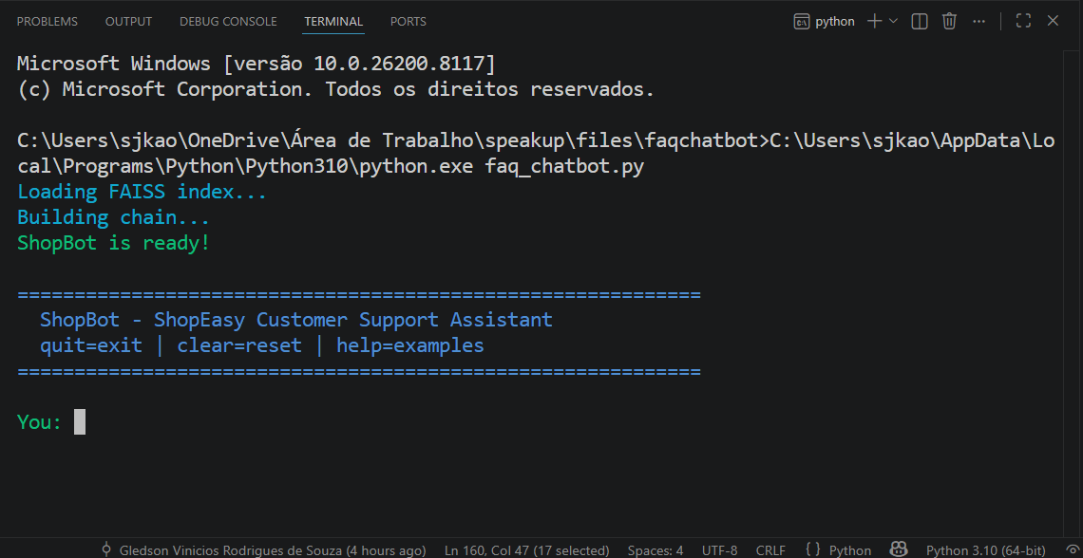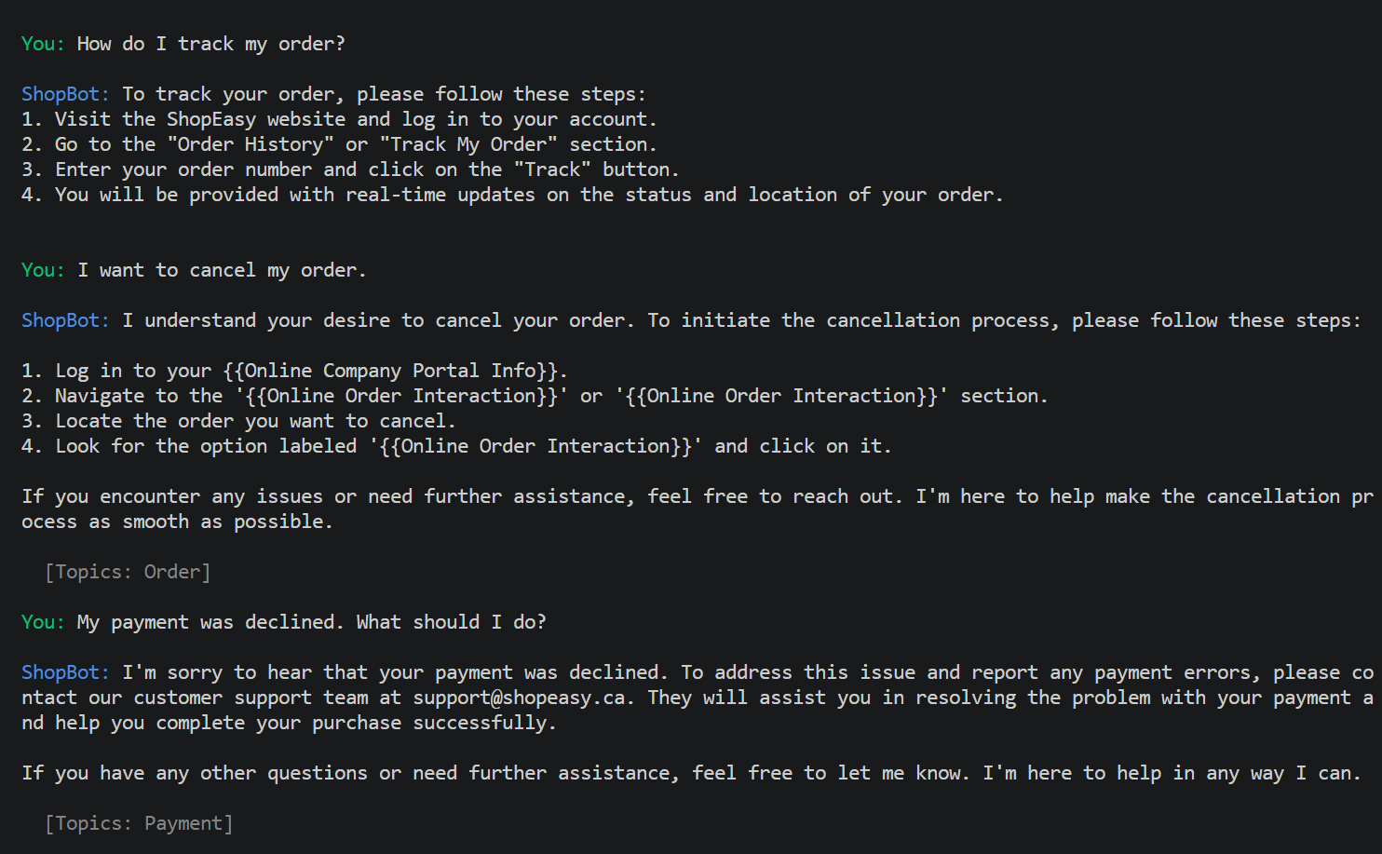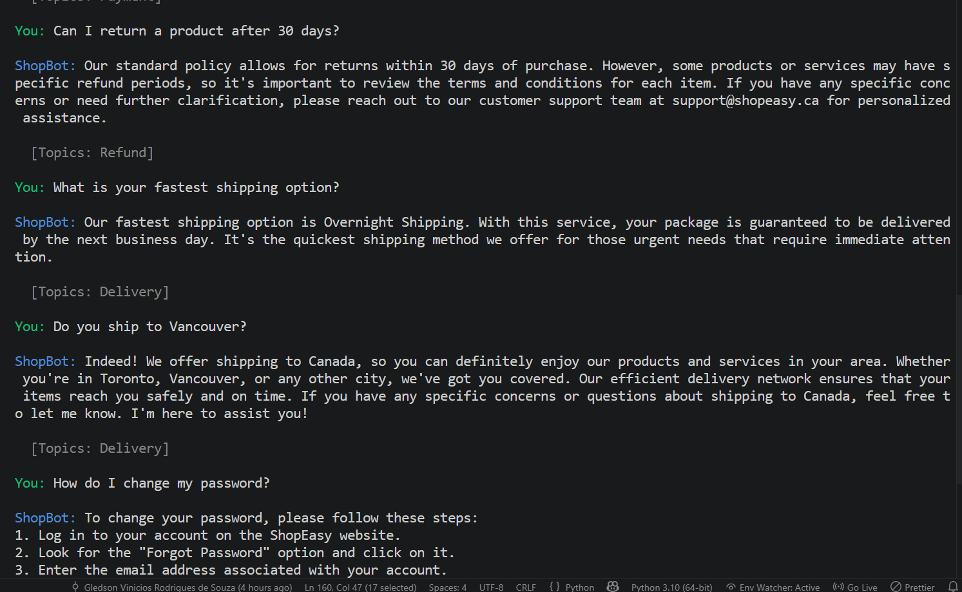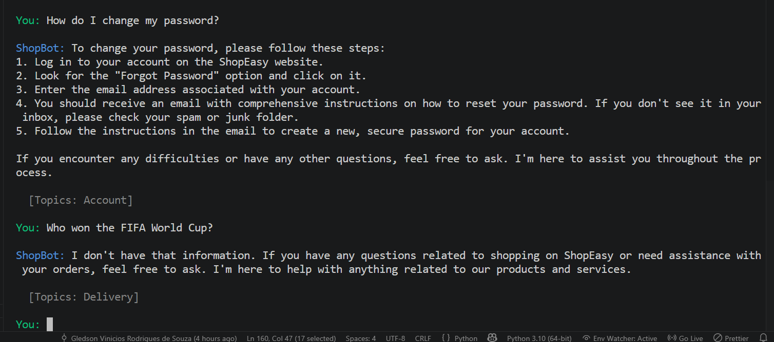
User Query | ShopBot Response Summary
How do I track my order? | Explained that customers can track orders via the 'My Orders' page or the tracking link in the shipment email. Retrieved from the DELIVERY category.
I want to cancel my order. | Outlined the cancellation window (before dispatch) and directed user to the 'Cancel Order' button in the order details page. Retrieved from ORDER category.
My payment was declined. What should I do? | Suggested checking card details, ensuring sufficient funds, and trying an alternative payment method. Offered to escalate to support. Retrieved from PAYMENT category.
Can I return a product after 30 days? | Correctly stated the 30-day standard return window and noted that exceptions may apply to defective items. Retrieved from REFUND category.
What is your fastest shipping option? | Described express shipping (1-2 business days) vs standard (5-7 days) options and associated costs. Retrieved from SHIPPING category.
Do you ship to Vancouver? | Confirmed shipping across all Canadian provinces. Noted that remote areas may have extended delivery windows. Retrieved from DELIVERY category.
How do I change my password? | Provided step-by-step instructions for password reset via the account settings page. Retrieved from ACCOUNT category.
Who won the FIFA World Cup? | Correctly declined to answer (out of scope) and politely redirected user to contact support for relevant ShopEasy queries.

In the final row of the out-of-scope query test, we see a very interesting example; ShopBot realized there was no valid context retrieved, and therefore used its system prompt to provide a gracious refusal. We can also see here how the combination of constrained system prompts, along with RAG grounding, have been successful at providing an active hallucination guard.

8. Discussion and Insights

8.1 Strengths
- • Fact-Based Foundations: Using a Response Anchor Generation (RAG) Architecture helps eliminate hallucinations in that each of the responses generated are directly related to the evidence they were pulled from. This is particularly important when using chatbots for customer service as providing misinformation (for example, the return policy was different than what you told me) could lead to some serious issues.
• No Training Required: Because this system has reached production-quality levels with no need for gradient based model training, this makes the use of this technology available to organizations/teams that do not have machine learning capabilities.
• Cohesion in Multi-Turn Dialogues: In addition to being able to remember past conversations, conversational memory also enables natural follow up question answering by the ShopBot in order to mimic the way people would interact with live customer support.
• Fast Retrieval: Even on consumer-grade computer hardware, the Fast Approximate Nearest Neighbor Search (FAISS) algorithm will retrieve relevant data in under 100 milliseconds from the 27,000+ pieces of embedded information.

8.2 Limitations
- • Dataset statics: The data set used by the chatbot in this example has only data available up until when the data set was created. Thus if there are new events it could be unable to provide answers for them. To allow for continuous ingestion of new FAQs and policy updates a production pipeline needs to be established.
• No Confidence Score: The model implemented does not determine how similar the returned chunks are. The retrieval of low-quality results may result in weakly grounded responses. If a confidence level (similarity threshold) is used to prompt a user to select a response that will help identify whether they are unsure of the quality of their response it will increase reliability.
• Limitations on Context Windows: Sessions longer than 16K characters will exceed GPT-3.5-turbo’s character limit. Switching to a Summarization Memory Strategy will fix this problem.
• Single Language Only: The data set was limited to English. ShopEasy has customers who speak both English and French so supporting the two languages would be beneficial to them.
• No Authentication Support; No Multi User Support: Currently the terminal interface is designed as a single-user interface with no ability to support multiple users at once. Any production version of this application will need to have an additional REST API layer (FastAPI), session management, etc.

8.3 Potential Improvements
- • Hybrid retrieval: Using both FAISS dense vector search and BM25 sparse keyword search as part of a hybrid re-rank process (for example, by utilizing an ensemble retriever from LangChain) can increase the amount of correct matches found for exact query terms like product names, order numbers etc.
• Reranking: The addition of a cross encoder re-rank model (like Cohere Rerank), which is used as a second stage filter of the top K vectors returned from the initial FAISS search, will increase the accuracy of the system's answers.
• Evaluation metrics: A systematic evaluation plan that uses RAGAS (Retrieval Augmented Generation Assessment) metric; faithfulness, answer relevancy, context precision, will provide a quantifiable benchmark for the systems performance.
• Web UI: By deploying ShopBot through a web-based interface created with Streamlit or Gradio, users who are not technical or do not have experience using terminals can access the functionality provided by ShopBot.
• Fine-tuning: If you anticipate needing to deploy this solution at scale (i.e., high volume), fine tuning a small(er) LLM that is available under an open license (such as Llama 3) to use on your own data set (Bitext) may be able to significantly lower your costs associated with making API calls and still maintain high quality.

8.4 Ethical Considerations
The use of artificial intelligence (AI) in customer service through chatbots also presents a number of significant ethical issues. One well-accepted best practice for transparency to end-users regarding if they are communicating with an AI or a human representative has been identified by Floridi et al. (2020). ShopBot’s “bot” personality is branded as such and is intended to automatically route unresolvable conversations to live human representatives so that consumers will never be stuck in an automated cycle and unable to have their concern resolved through the input of a human. ShopBot does not retain any PII (Personally Identifiable Information) within its search engine because all the conversations used to train ShopBot were created using synthetic language.

References
Bitext. (2023). Bitext customer support LLM chatbot training dataset [Data set]. Kaggle. https://www.kaggle.com/datasets/bitext/training-dataset-for-chatbot-and-nlu
Floridi, L., Cowls, J., King, T. C., & Taddeo, M. (2020). How to design AI for social good: Seven essential factors. Science and Engineering Ethics, 26(3), 1771-1796. https://doi.org/10.1007/s11948-020-00213-5
Johnson, J., Douze, M., & Jegou, H. (2021). Billion-scale similarity search with GPUs. IEEE Transactions on Big Data, 7(3), 535-547. https://doi.org/10.1109/TBDATA.2019.2921572
LangChain. (2024). LangChain documentation. https://docs.langchain.com
Lewis, P., Perez, E., Piktus, A., Petroni, F., Karpukhin, V., Goyal, N., Kuttler, H., Lewis, M., Yih, W., Rocktaschel, T., Riedel, S., & Kiela, D. (2020). Retrieval-augmented generation for knowledge-intensive NLP tasks. Advances in Neural Information Processing Systems, 33, 9459-9474. https://doi.org/10.48550/arXiv.2005.11401
Mikolov, T., Chen, K., Corrado, G., & Dean, J. (2013). Efficient estimation of word representations in vector space. arXiv. https://doi.org/10.48550/arXiv.1301.3781
OpenAI. (2024). GPT-3.5-turbo model documentation. https://platform.openai.com/docs/models/gpt-3-5-turbo
White, J., Fu, Q., Hays, S., Sandborn, M., Olea, C., Gilbert, H., Elnashar, A., Spencer-Smith, J., & Schmidt, D. C. (2023). A prompt pattern catalog to enhance prompt engineering with ChatGPT. arXiv. https://doi.org/10.48550/arXiv.2302.11382

