**Model Catapult Three Factor Design**

*By Nick Roy and* [Glen Barlow](mailto:ggbarlow@crimson.ua.edu)

## Executive Summary

For this experiment, we were tasked with conducting a controlled experiment to measure the effects of three factors that affect how far the catapult can launch a projectile: Launch Angle, Stop Position, and Band Tension. Launch angle is how far back the projectile is pulled before being released, Stop Position is the point where the projectile is released from the catapult, and Band Tension is how much force the catapult has to launch the projectile. We were then asked to analyze our results to construct a prediction model that allows the user to hit a target at a distance given in inches, and also informs the user of our confidence that they will hit the target. In order to accomplish this task, we developed an experimental design in JMP, minimized all sources of variation within the catapult that we were aware of, developed our model, validated our model, and finally quantified the predictive accuracy of our model.

## Design of Experiment

We designed our experiment with three very important factors in mind: consistency, efficiency, and accuracy. To ensure consistency, we implemented a new method for preventing our catapult from being moved around each shot. Instead of simply taping the catapult to the carpet which allows for miniscule and nearly unnoticeable movements between shots, we instead stacked numerous srips of tape around the base and right side of the catapult so that it could still move freely but we could now simply slide the catapult until is was flush up against the two thick strips[1].

The experiment we developed was a two-level factorial randomized design, replicated once (2^3 design with replication). This resulted in 16 runs, with an additional 4 runs at the center in order to test for curvature. Two pilot runs were done initially to ensure that the ball would clear the catapult and that distance could be accurately taken at all settings, and 6 validation runs were performed at the end (which will be discussed later). This resulted in 28 runs, which was three runs over the limit given to us. However, we will now prove that the increased costs of three extra runs would be made up for in accuracy and predictive power of our final model.

## Prediction Equation Estimation

After performing all of the runs and collecting the observations, we obtained a distance observation for each[2]. JMP was then used in order to create a prediction model for distance[3]. All factors were considered, as well as all two-way interaction terms. The three-way interaction term was not considered because the effect due to this term would not be explainable. In this model (which was significant itself), Launch Angle, Tension, and Stop Position * Launch Angle were significant at a level of .05, and all other factors were not significant. However, we did decide to keep Stop Position in our model even though it had a p-value of 0.1981 as we felt it vital to include all single factors in our model. There did not appear to be any outliers, but appendix B number three[4] shows that our model did violate several assumptions of OLS. The error term was correlated to the magnitude of the prediction, not centered about mean zero, and not normally distributed. Furthermore, after running our three validation runs we realized that the predictive power and accuracy were not nearly where we needed them to be.

While this model had a reasonable r-squared value, its Root Mean Square Error of 11.185 was simply too large for us to accept. To increase the predictive power of our model, we decided to perform a natural log transformation on the distance values. This would help standardize the values, as the range of distances was quite large. The resulting model’s Root Mean Square Error was notably better at 1.24 inches (e^0.214896). In this model, all factors were significant and remained in our model except the interaction terms between Stop Position and Band Tension as well as Launch Angle and Band Tension[5]. It should also be noted that the p-value of stop position fell from a worrisome 0.1981 to a much more acceptable 0.0395, allowing us to confidently include the term in our final model. However, our model still appeared to violate some of the assumptions of OLS[6]. The model error terms were still not centered about mean zero, normally distributed, or completely uncorrelated with the magnitude of prediction, but not nearly to the level of our initial model. Initially, our model’s error term and magnitude of prediction had a correlation of 0.165 with prediction magnitude having a coefficient of 0.1651 and an intercept of -11.35 when regressed on the error term. After performing the log transformation, our model’s error term and magnitude of prediction had a correlation of 0.104 with prediction magnitude having a coefficient of 0.002457 and intercept term of 0.849 when regressed on the error term. While this is still not where we wanted to be after fitting our final model, we simply had to accept it because we were out of runs to validate our models any further.

## Hitting a target at XX inches

Using the prediction equation from our final model, we were next tasked with determining the “best” input settings to hit a target a given amount of inches away. Our group decided to attempt to hit a target at 51.5 inches away (e^3.941539). To determine the best input settings to do this, the prediction profiler in JMP was used. The settings that the prediction profiler determined to be the best were: Stop Position 2, Launch Angle 170, and Band Tension 2. We decided to validate our model at these settings because we felt it would be a good challenge for our model to predict such an abnormal combination of effects that were not directly measured in our experimental runs.

## Prediction Validation

At this point, three validation runs were performed with the previously mentioned input settings, with our objective being to launch the projectile exactly 51.5 inches. Our three validation launches resulted in distances of 52, 53, 54.5 averaging to 53.17. With an MAD of 1.67 inches and a root mean squared error of 1.13, we are reasonably satisfied with our results. However, we were quite concerned with the fact that the direction of all three errors was the same and therefore our errors were not normally distributed about mean zero. However, as we have mentioned before, at this point in our experiment we were limited by the resources provided to us, having no more validation runs to test an improved model. Therefore, we decided to stick with the model we had, and instead focus our remaining resources on providing an accurate quantified confidence of our predictions and test for curvature in our data.

## Confidence of Prediction

After designing our experiment, collecting our data, fitting our model, and performing variable selection we were left with a reasonably sound model, with a reasonable ability to predict the distance the projectile will fly given launch angle, stop position, and tension strength. When attempting to use our prediction formula built from the relationships observed in our experiment to hit a target fifty and a half inches away, we were able to stay within about three inches of our target on average. However, there appears to be some bias in our model that is causing our predicted distance to be slightly too long. All three shots traveled further than our predicted distance of 50.5 inches and therefore our model overestimated distance, in this case, by an average of about an inch and a half. While this is by no means perfect, it is certainly not terrible either. To quantify this, a ninety-five percent confidence interval was constructed for the input setting used in validation. As we fit our model to log transformed distance observations, our confidence interval was computed as log values as follows [3.73352, 4.14956] centered at 3.941539. Converting these values back to their raw scale we get [41.826, 63.41] centered at 51.498.

Therefore, we can estimate a 21.5 inch range that our projectile will land in 95% of the time at the given settings.

## Test for Curvature

To check for curvature, we needed to compare the average of the responses at the factorial points versus the center points. If they were equivalent, no curvature was present. If there were differences, that would indicate the presence of curvature. To perform this test, a pooled t-test was done assuming equal variances. The results of this t-test were not significant at the .05 significance level, but the 95% confidence interval contained the values [-51.042, 9.417].[7] Note that 0 was included in this confidence interval, which implied that there was not a difference in means. We can tentatively conclude that there was no curvature present in our experiment, but further tests are needed in order to confirm this.

# Appendices

## Appendix A: Experimental Design Diagrams

### One - New Tape Design

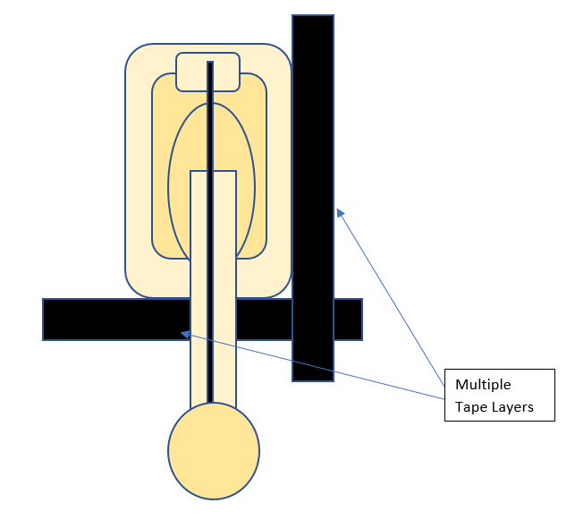

## Appendix B: JMP Screenshots

### One - DOE With Observations

### 

### Two - Initial Model With No Log Transformation

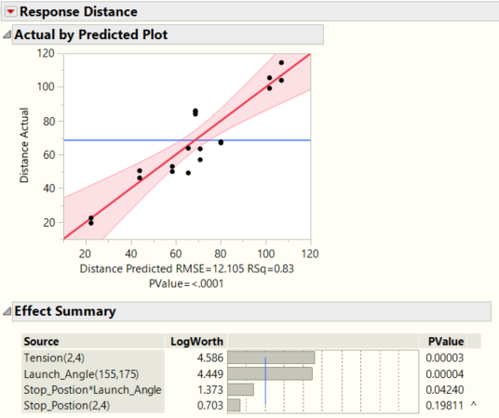

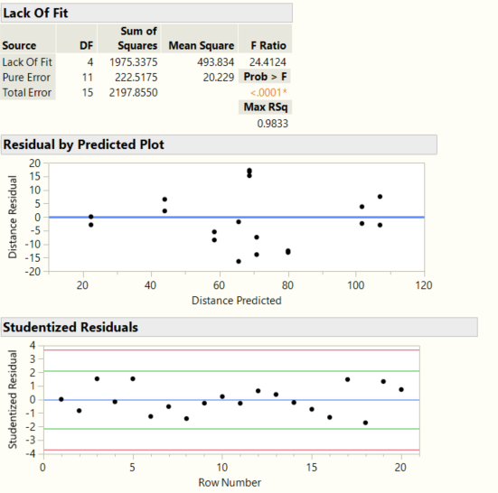

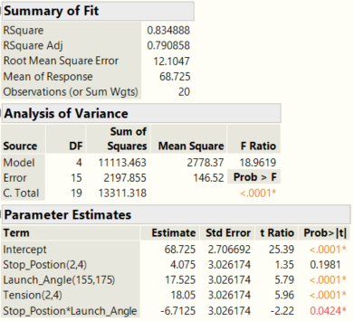

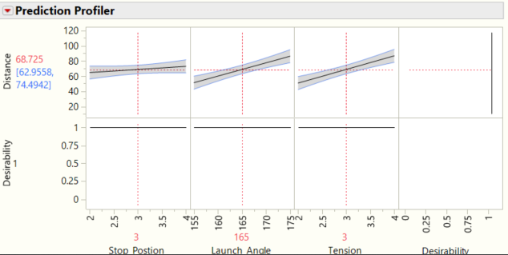

### 

### Three - Residual Vs Predicted Initial Model

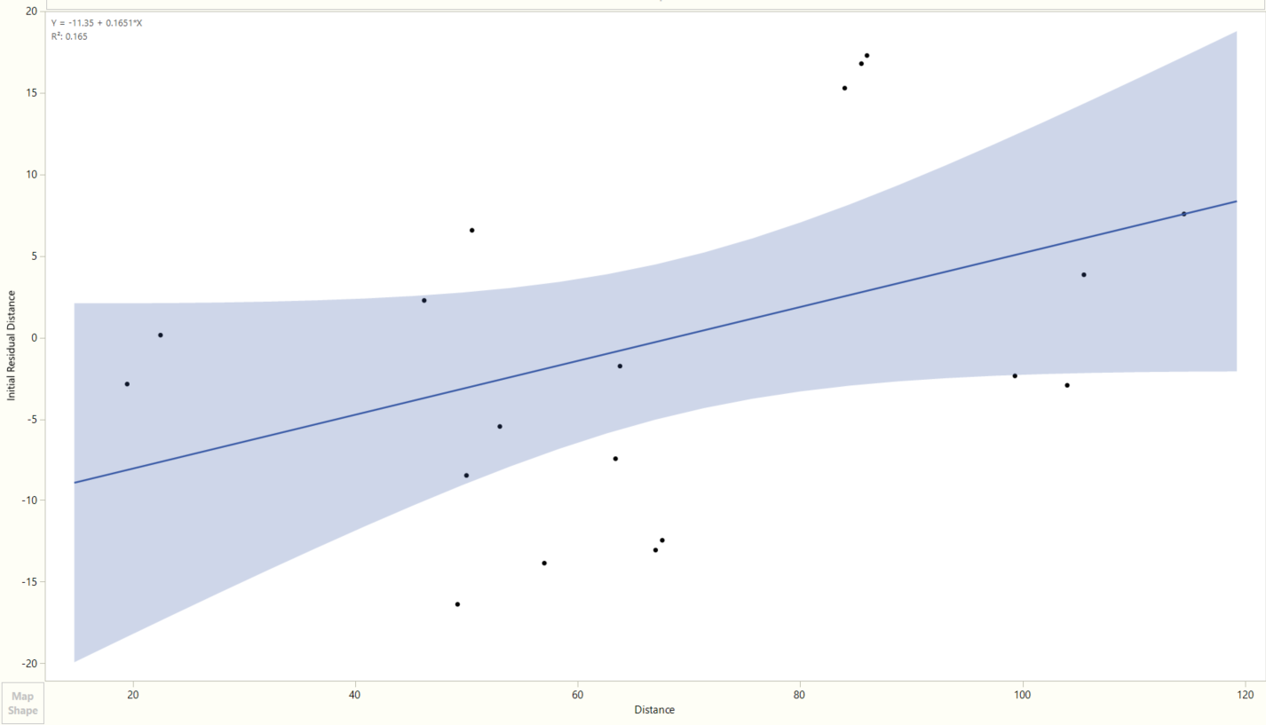

### Four - Model With Log Transformation

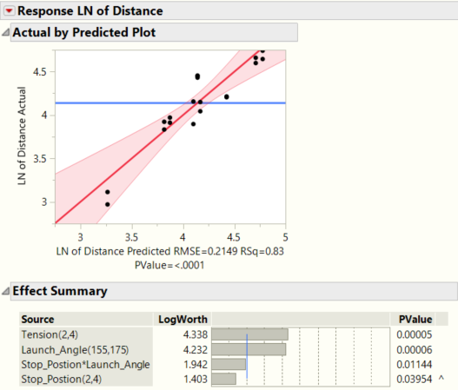

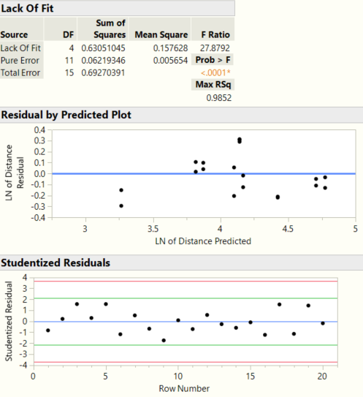

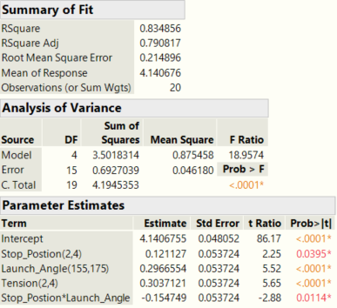

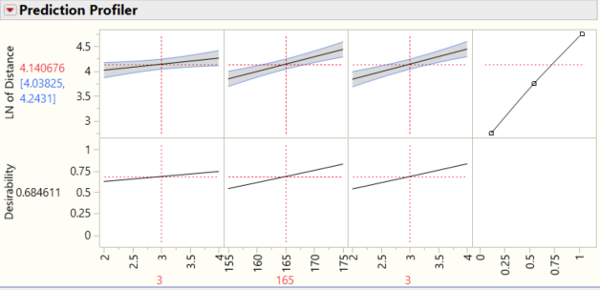

### Five - Actual Vs Residual Final Model

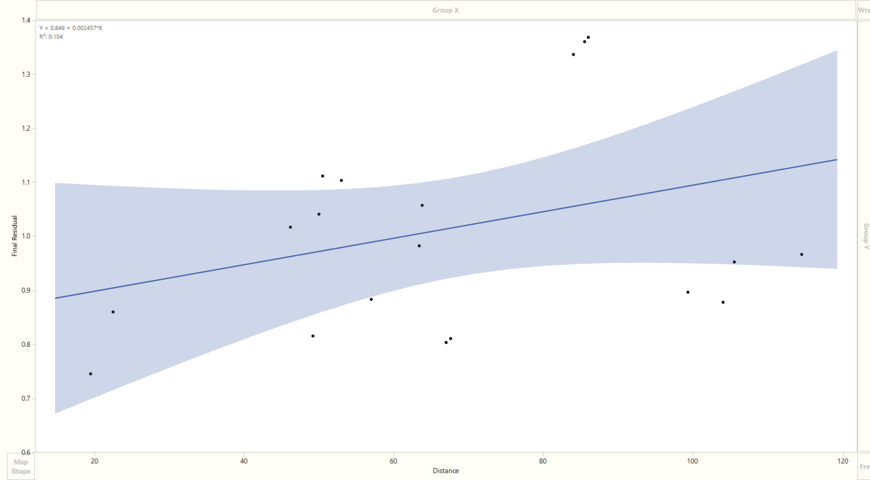

### Six - Test for Curvature

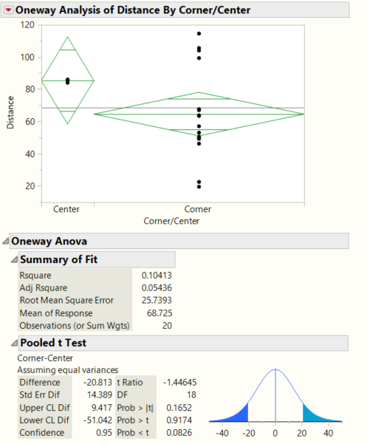

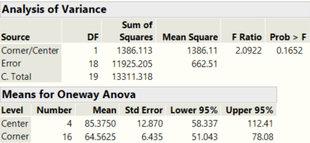

1. Appendix A: One - New Tape Design
2. Appendix B: One - DOE With Observations
3. Appendix B: Two - Initial Model With No Log Transformation
4. Appendix B: Three - Residual Vs Predicted Initial Model
5. Appendix B: Four - Model With Log Transformation
6. Appendix B: Five - Actual Vs Residual Final Model
7. Appendix B: Four - Test for Curvature