Lab1-R

Clayton Glenn

January 18, 2018

Table of Contents

# Tasks

## Task 1

### Get Working Directory

getwd()

## [1] "C:/Users/cglen/Documents/Stat Methods/Labs/Stats Lab1"

## Task 2

### Read DDT into Data Frame Object

ddt <- read.csv("DDT.csv", header = TRUE)  
head(ddt)

## RIVER MILE SPECIES LENGTH WEIGHT DDT  
## 1 FCM 5 CCATFISH 42.5 732 10  
## 2 FCM 5 CCATFISH 44.0 795 16  
## 3 FCM 5 CCATFISH 41.5 547 23  
## 4 FCM 5 CCATFISH 39.0 465 21  
## 5 FCM 5 CCATFISH 50.5 1252 50  
## 6 FCM 5 CCATFISH 52.0 1255 150

## Task 3

### What are the qualitative variables in “ddt”?

#### River and Species

### What are the quantitative variables in “ddt”?

#### Mile, Length, Weight, and DDT

### How many SPECIES are in the ddt data set?

#### 3 Species

### Subset of DDT With Large Mouth Bass and Weight > 800

lmb800 <- subset(ddt, (SPECIES=="LMBASS" & WEIGHT > 800))  
show(lmb800)

## RIVER MILE SPECIES LENGTH WEIGHT DDT  
## 141 TRM 345 LMBASS 30 856 2.2  
## 144 TRM 345 LMBASS 36 1433 1.9

### Subset of DDT With SCM and DDT > 4.0

scmddt <- subset(ddt, (RIVER=="SCM" & DDT > 4.0))  
show(scmddt)

## RIVER MILE SPECIES LENGTH WEIGHT DDT  
## 16 SCM 1 CCATFISH 45 984 9.1  
## 17 SCM 1 CCATFISH 43 965 7.8  
## 18 SCM 1 CCATFISH 45 1084 4.1

## Task 4

### Table of Rivers

rT <- with(ddt, table(RIVER))  
show(rT)

## RIVER  
## FCM LCM SCM TRM   
## 6 6 6 126

### Barplot of Rivers

rB <- barplot(rT, beside=TRUE, col=1:4)

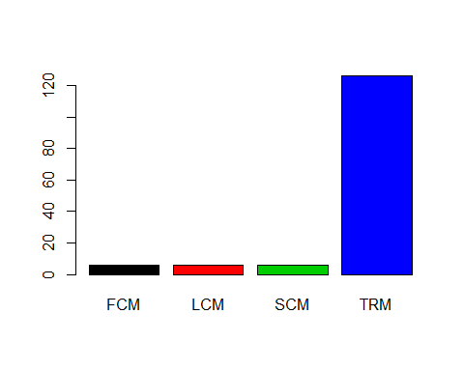

show(rB)

## [,1]  
## [1,] 0.7  
## [2,] 1.9  
## [3,] 3.1  
## [4,] 4.3

### Table of Rivers Crossed With Species

rsT <- with(ddt, table(RIVER, SPECIES))  
show(rsT)

## SPECIES  
## RIVER CCATFISH LMBASS SMBUFFALO  
## FCM 6 0 0  
## LCM 6 0 0  
## SCM 6 0 0  
## TRM 78 12 36

### Barplot of Rivers Crossed With Species

rcsB <- barplot(rsT, beside=TRUE, col=1:4)

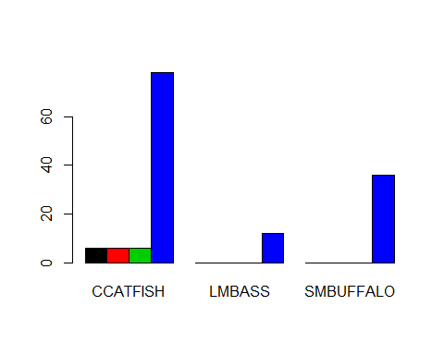

show(rcsB)

## [,1] [,2] [,3]  
## [1,] 1.5 6.5 11.5  
## [2,] 2.5 7.5 12.5  
## [3,] 3.5 8.5 13.5  
## [4,] 4.5 9.5 14.5

## Task 5

### PieCharts of Species and Rivers

sT <- with(ddt, table(SPECIES))  
layout(matrix(c(1, 2),nr=1,nc=2))  
pie(sT)  
pie(rT)

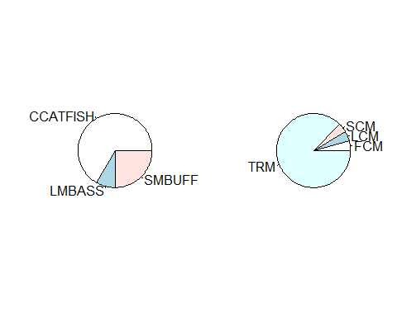

## Task 6

### BoxPlots of DDT, Weight, and Length

layout(matrix(c(1,2,3),nr=1,nc=3))  
with(ddt,boxplot(LENGTH,ylab="DDT",col="Blue",notch=TRUE))  
with(ddt,boxplot(WEIGHT,ylab="WEIGHT",col="Green",notch=TRUE))  
with(ddt,boxplot(MILE,ylab="LENGTH",col="Red",notch=TRUE))

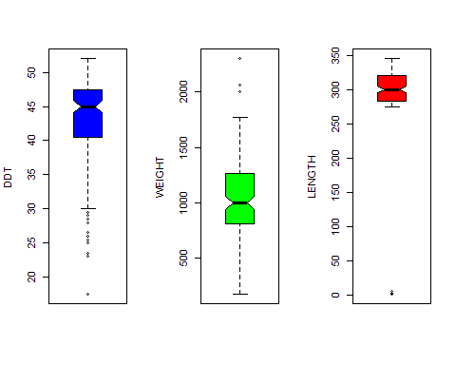

## Task 7

### Coplot of Length V Weight Given River

lwC <- coplot(LENGTH ~ WEIGHT | RIVER, ddt, col = 1:5)

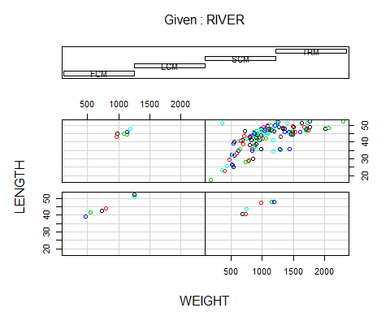

### Coplot of DDT V Weight Given Species

dwC <- coplot(DDT ~ WEIGHT | SPECIES, ddt, col = 1:4)

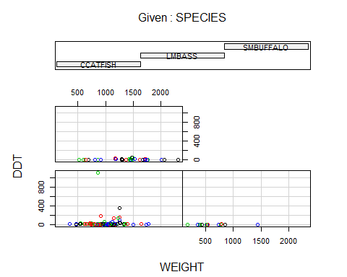

## Task 8

### ggplot Box Plot Given Species and Weight

library(ggplot2)  
swgg <- ggplot(ddt, aes(x=SPECIES, y=WEIGHT, color=RIVER, fill = RIVER))  
swgg <- swgg + geom_boxplot(colour = "#1F3552")  
swgg <- swgg + ggtitle("Clayton Glenn")  
show(swgg)

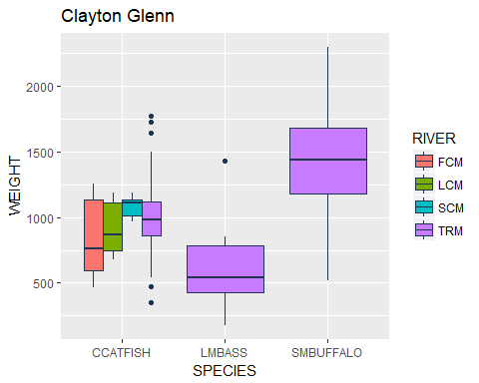

### Violin Plot given River and Length

library(ggplot2)  
rlgg <- ggplot(ddt, aes(x=RIVER, y=LENGTH, color=SPECIES, fill = SPECIES))  
rlgg <- rlgg + geom_violin(colour = "#1F3552")  
rlgg <- rlgg + ggtitle("Clayton Glenn")  
show(rlgg)

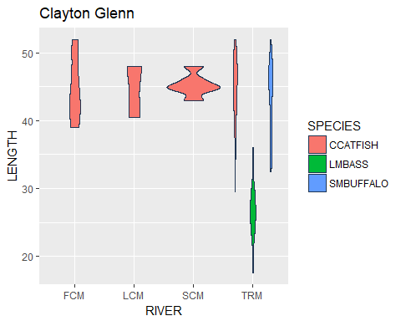

### gg Scatter Plot given Weight and Length

library(ggplot2)  
ggplot(ddt, aes(x=WEIGHT, y=LENGTH, color=SPECIES, fill = SPECIES)) + geom_point() + ggtitle("Clayton Glenn")

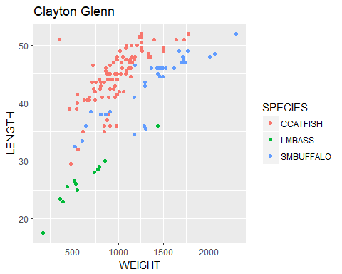

# Clicker Questions

## Length Mean

mean(ddt$LENGTH)

## [1] 42.8125

## Weight Standard Deviation

sd(ddt$LENGTH)

## [1] 6.882093