LAB10

Clayton Glenn

April 2, 2018

Table of Contents

# Task1

getwd()

## [1] "C:/Users/cglen/Desktop/Stat Methods/Labs/LAB10"

# Task2

$$L(p;x)=\frac{20!}{x!(20−x)!}p^{x}(1−p)^{20−x}$$

logbin=function(x,param) log(dbinom(x,prob=param,size=20))  
mymaxlik=function(lfun,x,param,...){  
 np=length(param)  
 z=outer(x,param,lfun)  
 y=apply(z,2,sum)  
 plot(param,y,col="Blue",type="l",lwd=2,...)  
 i=max(which(y==max(y)))  
 abline(v=param[i],lwd=2,col="Red")  
 points(param[i],y[i],pch=19,cex=1.5,col="Black")  
 axis(3,param[i],round(param[i],2))  
 ifelse(i-3>=1 & i+2<=np, slope<-(y[(i-2):(i+2)]-y[(i-3):(i+1)])/(param[(i-2):(i+2)]-param[(i-3):(i+1)]),slope<-"NA")  
 return(list(i=i,parami=param[i],yi=y[i],slope=slope))  
}  
mymaxlik(x=c(3,3,4,3,4,5,5,4),param=seq(0,1,length=1000),lfun=logbin,xlab=expression(pi),main="Binomial",cex.main=2)

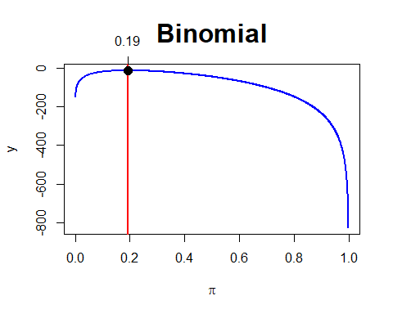

## $i  
## [1] 195  
##   
## $parami  
## [1] 0.1941942  
##   
## $yi  
## [1] -12.78734  
##   
## $slope  
## [1] 2.12579310 1.08781082 0.05802047 -0.96371372 -1.97752478

# Task3

$$P(y)=\frac{e^{−λ}λ^{y}}{y!}$$

$$L(λ:y)=\frac{e^{−nλ}λ^{\sum_{t}^{n}{=}0y_{t}}}{x_{1}!x_{2}!⋅⋅⋅x_{n}!}$$

$$l(λ:y)=log(L(λ:y))=log(e^{−nλ})+log(λ^{\sum_{t=0}^{n}{y_{t}}})$$

$$l(λ:y)=−nλlog(e)+\sum_{t=0}^{n}{y_{t}}log(λ)=\sum_{t=0}^{n}{y_{t}}log(λ)−nλ$$

logpoiss=function(x,param) log(dpois(x,lambda=param))   
mymaxlik(x=c(4,6,7,6,5),param=seq(0,20,length=1000),lfun=logpoiss,xlab=expression(lambda),main="Poisson",cex.main=2)

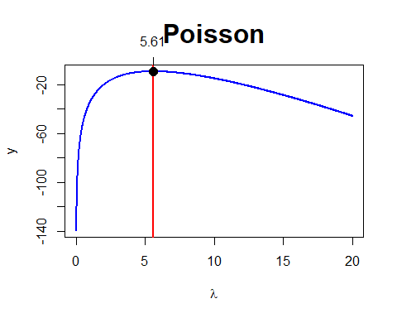

## $i  
## [1] 281  
##   
## $parami  
## [1] 5.605606  
##   
## $yi  
## [1] -9.411759  
##   
## $slope  
## [1] 0.040005454 0.021908448 0.003940937 -0.013898462 -0.031611116

myNRML=function(x0,delta=0.001,llik,xrange,parameter="param"){  
 f=function(x) (llik(x+delta)-llik(x))/delta  
 fdash=function(x) (f(x+delta)-f(x))/delta  
 d=1000  
 i=0  
 x=c()  
 y=c()  
 x[1]=x0  
 y[1]=f(x[1])  
 while(d > delta & i<100){  
 i=i+1  
 x[i+1]=x[i]-f(x[i])/fdash(x[i])  
 y[i+1]=f(x[i+1])  
 d=abs(x[i+1]-x[i])  
 }  
 layout(matrix(1:2,nr=1,nc=2,byrow=TRUE),width=c(1,2))  
 curve(llik(x), xlim=xrange,xlab=parameter,ylab="log Lik",main="Log Lik")  
 curve(f(x),xlim=xrange,xaxt="n", xlab=parameter,ylab="derivative",main= "Newton-Raphson Algorithm \n on the derivative")  
 points(x,y,col="Red",pch=19,cex=1.5)  
 axis(1,x,round(x,2),las=2)  
 abline(h=0,col="Red")  
 segments(x[1:(i-1)],y[1:(i-1)],x[2:i],rep(0,i-1),col="Blue",lwd=2)  
 segments(x[2:i],rep(0,i-1),x[2:i],y[2:i],lwd=0.5,col="Green")  
 list(x=x,y=y)  
}  
myNRML(x0=1,delta=0.000001,llik=function(x) log(dpois(12,x)*dpois(10,x)),xrange=c(0,20),parameter="lambda" )

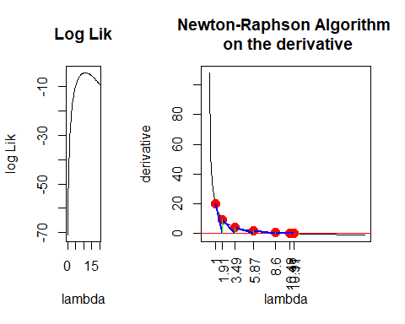

## $x  
## [1] 1.000000 1.908863 3.485981 5.867603 8.603229 10.481457 10.974386  
## [8] 11.000023 11.000000 10.999999  
##   
## $y  
## [1] 1.999999e+01 9.525183e+00 4.310992e+00 1.749401e+00 5.571793e-01  
## [6] 9.894478e-02 4.667942e-03 -4.244605e-06 -6.217249e-09 8.881784e-10

# Task4

logbin2=function(theta){log(dbinom(2,prob=theta,size=6)) + log(dbinom(4,prob=theta,size=10))}  
mymaxlikg=function(lfun="logbin2",theta) {  
 nth=length(theta)  
 thmat=matrix(theta,nr=nth,nc=1,byrow=TRUE)  
 z=apply(thmat,1,lfun)  
 zmax=max(which(z==max(z)))  
 plot(theta,exp(z),type="l")  
 abline(v=theta[zmax],col="Blue")  
 axis(3,theta[zmax],round(theta[zmax],4))  
 theta[zmax]  
}  
mymaxlikg(theta=seq(0,1,length=10000))

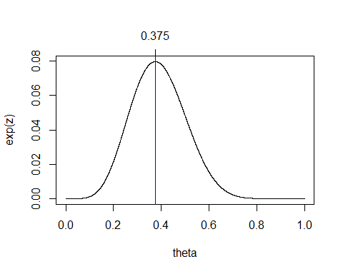

## [1] 0.3750375

# Task5

$$l(θ_{1}|θ_{2})=\sum_{t=0}^{n}{y_{t}}log(λ)−nλ−2log(x!)+log(n!)−log((n−x)!)+xlog(p)+(n−k)log(1−p)$$

logbinpois=function(theta1,theta2) log(dbinom(4,size=20,prob=theta1)) + log(dbinom(4,size=20,prob=theta1))+ log(dpois(4,lambda=theta2))  
  
maxlikg2=function(theta1,theta2,lfun="logbinpois",...){  
 n1=length(theta1)  
 n2=length(theta2)  
 z=outer(theta1,theta2,lfun)  
 contour(theta1,theta2,exp(z),...)  
 maxl=max(exp(z))   
 coord=which(exp(z)==maxl,arr.ind=TRUE)   
 th1est=theta1[coord[1]]  
 th2est=theta2[coord[2]]  
 abline(v=th1est,h=th2est)  
 axis(3,th1est,round(th1est,2))  
 axis(4,th2est,round(th2est,2),las=1)  
 list(th1est=th1est,th2est=th2est)  
}  
maxlikg2(theta1=seq(0,1,length=1000),theta2=seq(0,10,length=1000),nlevels=20)

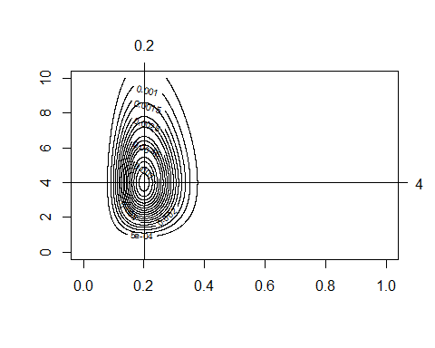

## $th1est  
## [1] 0.2002002  
##   
## $th2est  
## [1] 4.004004

# Task6

mymlnorm=function(x,mu,sig,...){   
 nmu=length(mu)   
 nsig=length(sig)  
 n=length(x)  
 zz=c()   
 lfun=function(x,m,p) log(dnorm(x,mean=m,sd=p))  
 for(j in 1:nsig){  
 z=outer(x,mu,lfun,p=sig[j])  
 y=apply(z,2,sum)  
 zz=cbind(zz,y)  
 }  
 maxl=max(exp(zz))  
 coord=which(exp(zz)==maxl,arr.ind=TRUE)  
 maxlsig=apply(zz,1,max)  
 contour(mu,sig,exp(zz),las=3,xlab=expression(mu),ylab=expression(sigma),axes=TRUE,  
 main=expression(paste("L(",mu,",",sigma,")",sep="")),...)  
 mlx=round(mean(x),2)   
 mly=round(sqrt((n-1)/n)*sd(x),2)  
 abline(v=mean(x),lwd=2,col="Green")  
 abline(h=sqrt((n-1)/n)*sd(x),lwd=2,col="Red")  
 muest=mu[coord[1]]  
 sigest=sig[coord[2]]  
 abline(v=muest, h=sigest)  
 return(list(x=x,coord=coord,maxl=maxl))  
}  
  
mymlnorm(x=c(10,12,13,15,12,11,10),mu=seq(10,14,length=1000),sig=seq(0.1,4,length=1000),lwd=2,labcex=1)

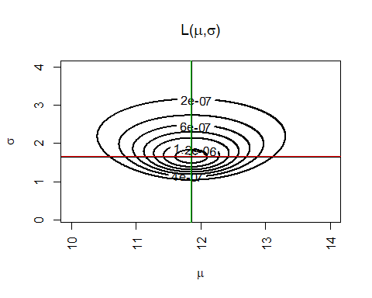

## $x  
## [1] 10 12 13 15 12 11 10  
##   
## $coord  
## row col  
## [1,] 465 396  
##   
## $maxl  
## [1] 1.513618e-06

# Task7

mymlbeta=function(x,alpha,beta,...){  
 na=length(alpha)  
 nb=length(beta)  
 n=length(x)  
 zz=c()   
 lfun=function(x,a,b) log(dbeta(x,shape1=a,shape2=b))  
 for(j in 1:nb){  
 z=outer(x,alpha,lfun,b=beta[j])  
 y=apply(z,2,sum)  
 zz=cbind(zz,y)  
 }  
 maxl=max(exp(zz))   
 coord=which(exp(zz)==maxl,arr.ind=TRUE)   
 aest=alpha[coord[1]]  
 best=beta[coord[2]]  
 contour(alpha,beta,exp(zz),las=3,xlab=expression(alpha),ylab=expression(beta),axes=TRUE,  
 main=expression(paste("L(",alpha,",",beta,")",sep="")),...)  
 abline(v=aest, h=best)  
 points(aest,best,pch=19)  
 axis(4,best,round(best,2),col="Red")  
 axis(3,aest,round(aest,2),col="Red")  
 return(list(x=x,coord=coord,maxl=maxl,maxalpha=aest,maxbeta=best))  
}  
x <- mymlbeta(x=rbeta(30,shape1=3,shape2=4),alpha=seq(1,5,length=100),beta=seq(2,8,length=100),lwd=2,labcex=1)

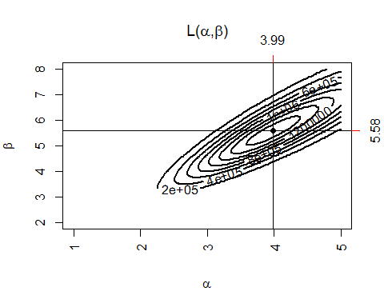

ax<-x$maxalpha  
ay <- x$maxbeta  
x <- mymlbeta(x=sample(x$x, replace=TRUE),alpha=seq(1,5,length=100),beta=seq(2,8,length=100),lwd=2,labcex=1)

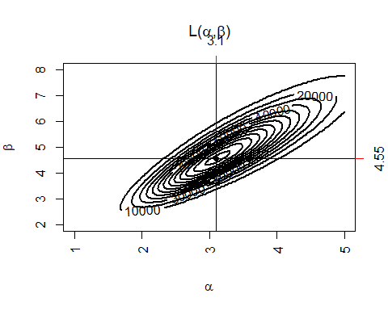

bx<-x$maxalpha  
by <- x$maxbeta  
x <- mymlbeta(x=sample(x$x, replace=TRUE),alpha=seq(1,5,length=100),beta=seq(2,8,length=100),lwd=2,labcex=1)

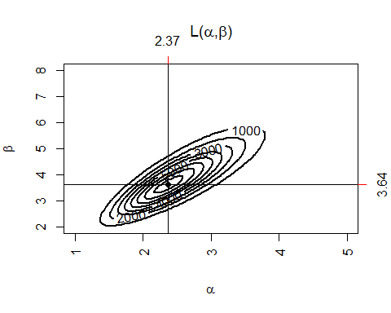

cx<-x$maxalpha  
cy <- x$maxbeta  
x <- mymlbeta(x=sample(x$x, replace=TRUE),alpha=seq(1,5,length=100),beta=seq(2,8,length=100),lwd=2,labcex=1)

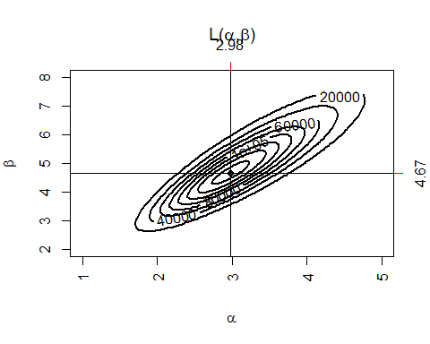

dx<-x$maxalpha  
dy <- x$maxbeta  
x <- mymlbeta(x=sample(x$x, replace=TRUE),alpha=seq(1,5,length=100),beta=seq(2,8,length=100),lwd=2,labcex=1)

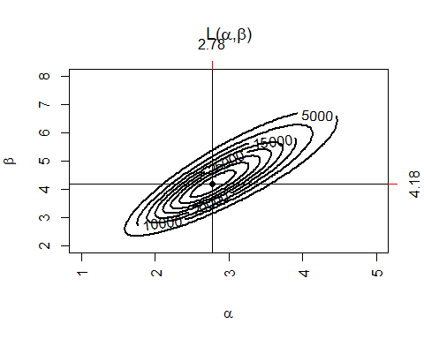

ex<-x$maxalpha  
ey <- x$maxbeta  
x <- mymlbeta(x=sample(x$x, replace=TRUE),alpha=seq(1,5,length=100),beta=seq(2,8,length=100),lwd=2,labcex=1)

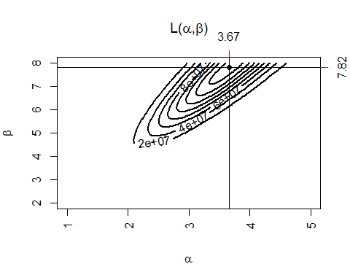

fx<-x$maxalpha  
fy <- x$maxbeta  
x <- mymlbeta(x=sample(x$x, replace=TRUE),alpha=seq(1,5,length=100),beta=seq(2,8,length=100),lwd=2,labcex=1)

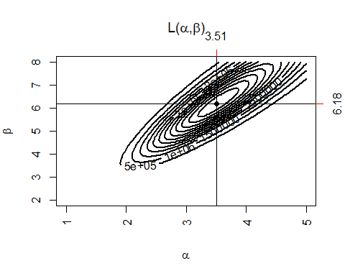

gx<-x$maxalpha  
gy <- x$maxbeta  
x <- mymlbeta(x=sample(x$x, replace=TRUE),alpha=seq(1,5,length=100),beta=seq(2,8,length=100),lwd=2,labcex=1)

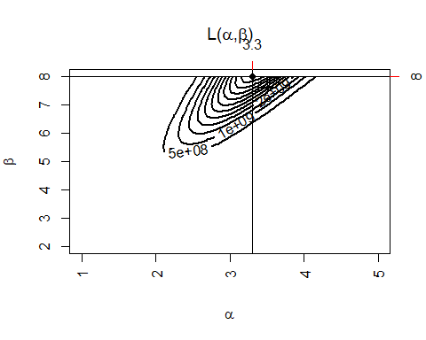

hx<-x$maxalpha  
hy <- x$maxbeta  
x <- mymlbeta(x=sample(x$x, replace=TRUE),alpha=seq(1,5,length=100),beta=seq(2,8,length=100),lwd=2,labcex=1)

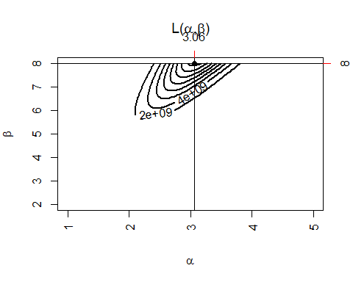

ix<-x$maxalpha  
iy <- x$maxbeta  
x <- mymlbeta(x=sample(x$x, replace=TRUE),alpha=seq(1,5,length=100),beta=seq(2,8,length=100),lwd=2,labcex=1)

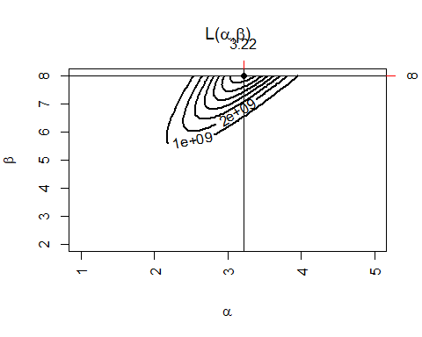

jx<-x$maxalpha  
jy <- x$maxbeta  
x <- mymlbeta(x=sample(x$x, replace=TRUE),alpha=seq(1,5,length=100),beta=seq(2,8,length=100),lwd=2,labcex=1)

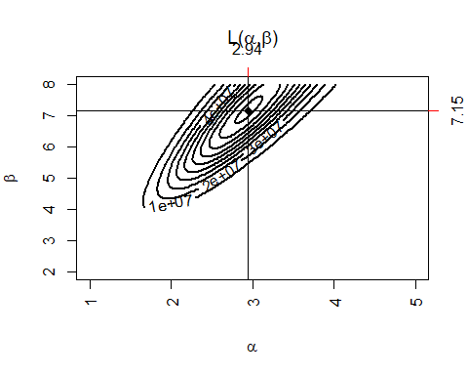

kx<-x$maxalpha  
ky <- x$maxbeta  
x <- mymlbeta(x=sample(x$x, replace=TRUE),alpha=seq(1,5,length=100),beta=seq(2,8,length=100),lwd=2,labcex=1)

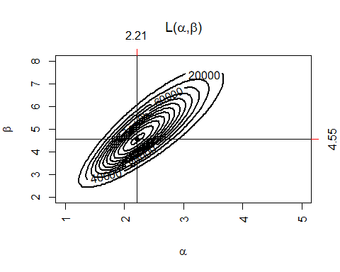

lx<-x$maxalpha  
ly <- x$maxbeta  
plot(c(ay,by,cy,dy,ey,fy,gy,hy,iy,jy,ky,ly)~c(ax,bx,cx,dx,ex,fx,gx,hx,ix,jx,kx,lx), ylab = "Max Beta", xlab = "Max Alpha", col="dark red")

