Lab2-R

Clayton Glenn

January 22, 2018

Table of Contents

# TASKS

## Task 1

### Show Working Directory

getwd()

## [1] "C:/Users/cglen/Documents/Stat Methods/Labs/LAB2"

## Task 2

### Read Data File

mpg.df=read.table("EPAGAS.csv",header=TRUE,sep=",")  
head(mpg.df)

## MPG  
## 1 36.3  
## 2 41.0  
## 3 36.9  
## 4 37.1  
## 5 44.9  
## 6 36.8

## Task 3

### Create Z vector from MPG

mpg=mpg.df$MPG  
z=scale(mpg)  
class(z)

## [1] "matrix"

### Verify Z-BAR and S^2vZ

apply(z,2,mean)

## [1] 9.706208e-17

apply(z,2,sd)

## [1] 1

### Find the values of mpg that are possible outliers

mpg[abs(z)>=2 & abs(z)<=3]

## [1] 30.0 42.1 31.8

### Find the values of mpg that defined as outliers

mpg[abs(z)>3]

## [1] 44.9

### Lattice Dotplot with outliers and possible outliers

mycol = ifelse(abs(z)>3, "Red",  
 ifelse(abs(z)>=2 &abs(z)<=3,"Blue", "Black"))   
library(lattice)  
dotplot(mpg,col=mycol)

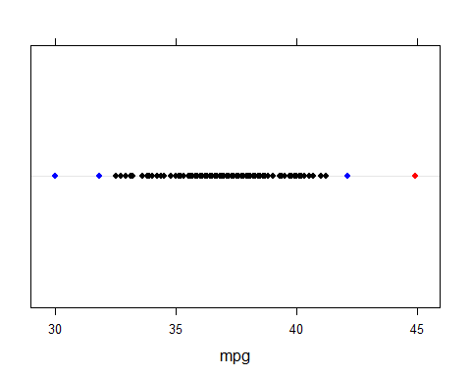

## Task 4

### Boxplot of MPG

boxplot(mpg, data=mpg, notch=TRUE, col=(c("green3")), main="Miles Per Gallon", horizontal = TRUE)

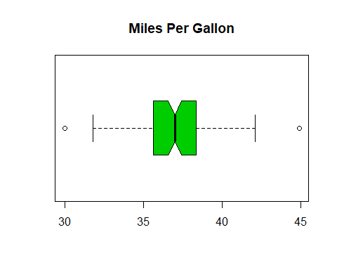

### Exact Proportion Within 2 STD’s of the Mean.

sprintf("%.0f%%", length(mpg[abs(z)<2])/length(mpg) * 100)

## [1] "96%"

### Chebyshev’s Theorum

(1 - 1/(#)^2) of the Data lies within 2 STD’s

sprintf("%.0f%%", (1 - 1/2^2)*100)

## [1] "75%"

According to the theorum, ATLEAST 75% of the data lies within 2 STD’s. In this case 96% of the lies within 2 STD’s, so Chevyshev’s theorum is correct and does agree with the data.

### Empirical Rule

Approximately 95% of Data lies within 2 STD’s of the Mean

sprintf("%.0f%%", 95)

## [1] "95%"

The Empirical Rule responds very well to the data, due to the fact that the rule states that APPROXIMATELY 95% of the data lies within 2 STD’s and according to the actual proportion of data, which is 96%, the Eprical Rule is a very close estimate to the real proportion.