Lab3-R

Clayton Glenn

January 29, 2018

Table of Contents

# Task 1

## Get Working Directory

getwd()

## [1] "C:/Users/cglen/Documents/Stat Methods/Labs/LAB3"

# Task 2

## Read Data from the Data File and Show the First 5 Lines

spruce.df <- read.table("SPRUCE.csv", header = TRUE, sep = ",")  
head(spruce.df)

## BHDiameter Height  
## 1 18.9 20.0  
## 2 16.6 18.8  
## 3 15.5 16.8  
## 4 15.5 16.9  
## 5 19.4 20.2  
## 6 13.7 16.3

# Task 3

## Scatter Plot of Data with X(Breast height Diameter) and Y(Height)

with(spruce.df, {  
 plot(Height ~ BHDiameter, bg = "Blue", pch = 21, cex = 1.2,   
 ylim = c(0, 1.1*max(Height)), xlim = c(0, 1.1*max(BHDiameter)))  
} )

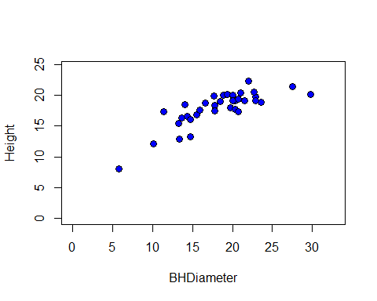

According to the Scatter Plot, a Straight Line isn’t likely to fit the data.

## S20X TrendScatter Plot of Height V BHDiameter

library(s20x)  
with(spruce.df, {  
 layout(matrix(1:3, nr = 3))  
 trendscatter(Height ~ BHDiameter,f=0.5)  
 trendscatter(Height ~ BHDiameter,f=0.6)  
 trendscatter(Height ~ BHDiameter,f=0.7)  
})

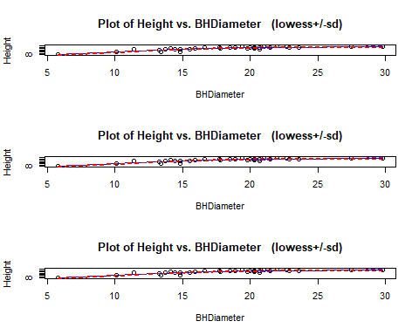

## Scatter Plot W/ Regression Line of Height V BHDiameter

spruce.lm <- with(spruce.df, lm(Height~BHDiameter))  
with(spruce.df,  
 plot(Height ~ BHDiameter, bg = "Blue", pch = 21, ylim = c(0, 1.1*max(Height)),   
 xlim = c(0, 1.1*max(BHDiameter)))  
)  
abline(spruce.lm)

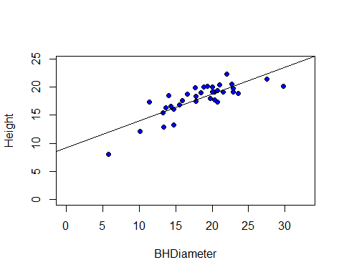

The data group follows a curve with a negative slope that tend towards zero. Therefore the data does not fit a straight line, instead, a smooth curve would fit the data better.

# Task 4

## Calculations of YHAT, MSS, TSS, and RSS

yhat <- with(spruce.df,predict(spruce.lm,data.frame(BHDiameter)))  
MSS <- with(spruce.df,sum((yhat-mean(Height))^2))  
TSS <- with(spruce.df,sum((Height-mean(Height))^2))  
RSS <- with(spruce.df,sum((Height-yhat)^2))

## Scatter Plots w/ Regression, Mean, and Expected

with(spruce.df, {  
 layout(matrix(1:4,nr=2,nc=2,byrow=TRUE))  
   
 plot(Height~BHDiameter,bg="Blue",pch=21,ylim=c(0,1.1*max(Height)),xlim=c(0,1.1*max(BHDiameter)))  
 abline(spruce.lm)  
 mtext("Linear Model")  
   
 plot(Height~BHDiameter,bg="Blue",pch=21,ylim=c(0,1.1*max(Height)),xlim=c(0,1.1*max(BHDiameter)))  
 segments(BHDiameter,Height,BHDiameter,yhat)  
 abline(spruce.lm)  
 mtext("Diff between Point and Expected")  
   
 plot(Height~BHDiameter,bg="Blue",pch=21,ylim=c(0,1.1*max(Height)),xlim=c(0,1.1*max(BHDiameter)))  
 abline(spruce.lm)  
 abline(h=mean(Height))  
 segments(BHDiameter,mean(Height),BHDiameter,yhat,col="Red")  
 mtext("Diff between Linear Model and Mean")  
   
 plot(Height~BHDiameter,bg="Blue",pch=21,ylim=c(0,1.1*max(Height)),xlim=c(0,1.1*max(BHDiameter)))  
 abline(h=mean(Height))  
 segments(BHDiameter,Height,BHDiameter,mean(Height),col="Green")  
 mtext("Diff between Point and Mean")  
})

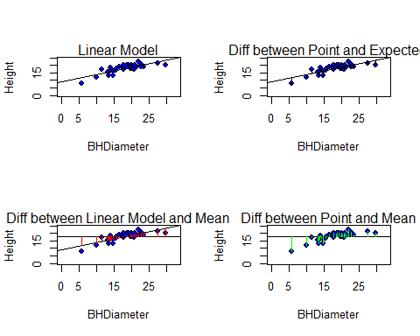

## Show All Sums of Squares and Calculations

TSS

## [1] 278.9475

MSS

## [1] 183.2447

RSS

## [1] 95.70281

MSS/TSS

## [1] 0.6569146

MSS+RSS

## [1] 278.9475

Total does in Fact Equal the Sum of Model and Residual. Total Sum of Squares / Model Sum of Squares is the slope of the Linear Model.

# Task 5

## Summary of Linear Model

summary(spruce.lm)

##   
## Call:  
## lm(formula = Height ~ BHDiameter)  
##   
## Residuals:  
## Min 1Q Median 3Q Max   
## -3.9394 -0.9763 0.2829 0.9950 2.6644   
##   
## Coefficients:  
## Estimate Std. Error t value Pr(>|t|)   
## (Intercept) 9.14684 1.12131 8.157 1.63e-09 ***  
## BHDiameter 0.48147 0.05967 8.069 2.09e-09 ***  
## ---  
## Signif. codes: 0 '***' 0.001 '**' 0.01 '*' 0.05 '.' 0.1 ' ' 1  
##   
## Residual standard error: 1.678 on 34 degrees of freedom  
## Multiple R-squared: 0.6569, Adjusted R-squared: 0.6468   
## F-statistic: 65.1 on 1 and 34 DF, p-value: 2.089e-09

Value of Slope is .6569. Value of Intercept is 9.14684. The equation of the Fitted Line is y=.6569x+9.14684.

## Coefficients of Linear Model

coef(spruce.lm)

## (Intercept) BHDiameter   
## 9.1468390 0.4814743

## Regression Analysis

anova(spruce.lm)

## Analysis of Variance Table  
##   
## Response: Height  
## Df Sum Sq Mean Sq F value Pr(>F)   
## BHDiameter 1 183.245 183.245 65.101 2.089e-09 ***  
## Residuals 34 95.703 2.815   
## ---  
## Signif. codes: 0 '***' 0.001 '**' 0.01 '*' 0.05 '.' 0.1 ' ' 1

## Predict Height @ 15, 18, 20

predict(spruce.lm, data.frame(BHDiameter=c(15,18,20)))

## 1 2 3   
## 16.36895 17.81338 18.77632

# Task 6

## GGPLOT of Data, Height V BHDiameter W/ Regression

library(ggplot2)  
 g <- ggplot(spruce.df, aes(x=BHDiameter,y=Height,colour=BHDiameter))  
 g <- g+geom_point() + geom_line()+ geom_smooth(method="lm")  
 g+ggtitle("Height Vs BHDiameter")

