Lab4

Clayton Glenn

February 12, 2018

Table of Contents

# Task 1

## Get Working Directory

getwd()

## [1] "C:/Users/cglen/Documents/Stat Methods/Labs/LAB4"

# Task 2

## Read Spruce Data File and Show Tail of Data

spruce.df <- read.csv("SPRUCE.csv", header=TRUE)   
tail(spruce.df)

## BHDiameter Height  
## 31 17.7 19.9  
## 32 20.7 19.4  
## 33 21.0 20.4  
## 34 13.3 15.5  
## 35 15.9 17.6  
## 36 22.9 19.2

# Task 3

## Trend Scatter of Height V BHD

library(s20x)  
trendscatter(Height ~ BHDiameter, f = 0.5, data = spruce.df)

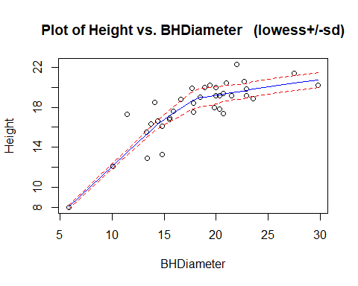

## Store Linear Model, Res, and Fit

spruce.lm <- lm(Height ~ BHDiameter, data = spruce.df)  
height.res <- residuals(spruce.lm)  
height.fit <- fitted(spruce.lm)

## Plot of Res v Fit

plot(height.res ~ height.fit)

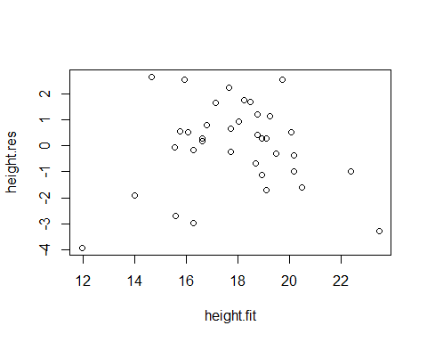

## Trend Scatter of Res v Fit

library(s20x)  
trendscatter(height.res ~ height.fit)

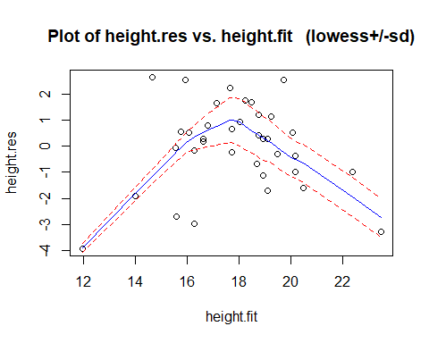

## Plot Residuals V Fitted with LM

plot(spruce.lm, which =1)

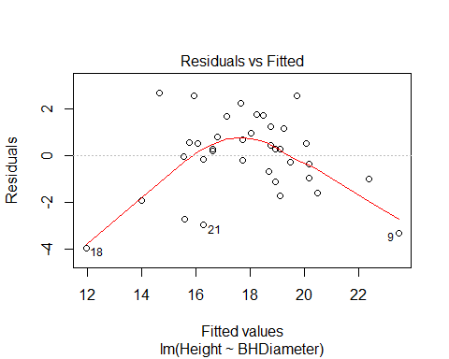

## Norm Check of Linear Model with Shapiro Walk

library(s20x)  
normcheck(spruce.lm,shapiro.wilk = TRUE)

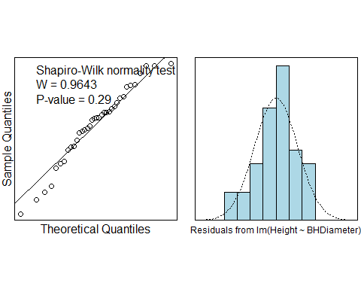

# Task 4

## Create Height v BHD Plot with new Quad Curve

quad.lm=lm(Height~BHDiameter + I(BHDiameter^2),data=spruce.df)  
myplot=function(x){  
 quad.lm$coef[1] +quad.lm$coef[2]*x + quad.lm$coef[3]*x^2  
}  
plot(Height~BHDiameter, data = spruce.df)  
curve(myplot, lwd=2, col="steelblue",add=TRUE)

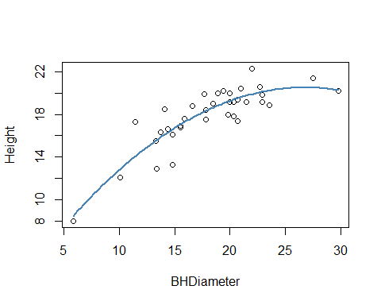

## Storing Res and Fit Variables

quad.fit <- fitted(quad.lm)  
quad.res <- residuals(quad.lm)

## Plot with Quadratic Residuals v Fitted Values

plot(quad.res ~ quad.fit)

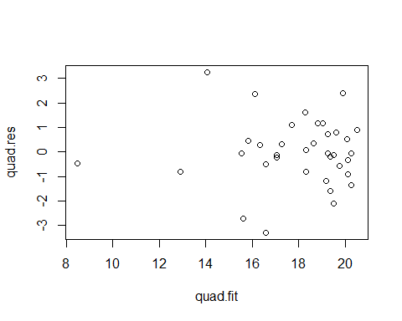

## Quadratic Norm Check and Shapiro

normcheck(quad.lm,shapiro.wilk = TRUE)

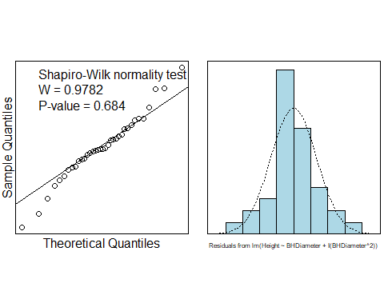

# Task 5

## Summary of Quadratic Model

summary(quad.lm)

##   
## Call:  
## lm(formula = Height ~ BHDiameter + I(BHDiameter^2), data = spruce.df)  
##   
## Residuals:  
## Min 1Q Median 3Q Max   
## -3.2966 -0.6245 -0.0707 0.7442 3.2541   
##   
## Coefficients:  
## Estimate Std. Error t value Pr(>|t|)   
## (Intercept) 0.860896 2.205022 0.390 0.698731   
## BHDiameter 1.469592 0.243786 6.028 8.88e-07 ***  
## I(BHDiameter^2) -0.027457 0.006635 -4.138 0.000227 ***  
## ---  
## Signif. codes: 0 '***' 0.001 '**' 0.01 '*' 0.05 '.' 0.1 ' ' 1  
##   
## Residual standard error: 1.382 on 33 degrees of freedom  
## Multiple R-squared: 0.7741, Adjusted R-squared: 0.7604   
## F-statistic: 56.55 on 2 and 33 DF, p-value: 2.182e-11

## Coefficients of Quad.lm

quad.lm$coef[1]

## (Intercept)   
## 0.8608958

quad.lm$coef[2]

## BHDiameter   
## 1.469592

quad.lm$coef[3]

## I(BHDiameter^2)   
## -0.02745726

## Predict 15,18,and 20 using Linear Model

predict(spruce.lm, data.frame(BHDiameter=c(15,18,20)))

## 1 2 3   
## 16.36895 17.81338 18.77632

## Predict 15,18,and 20 using Quadratic Model

predict(quad.lm, data.frame(BHDiameter=c(15,18,20)))

## 1 2 3   
## 16.72690 18.41740 19.26984

## Prediction of all Spruce Heights with Quad.lm

with(spruce.df,predict(quad.lm,data.frame(BHDiameter)))

## 1 2 3 4 5 6 7   
## 18.828182 17.690005 17.042969 17.042969 19.037171 15.840856 19.269837   
## 8 9 10 11 12 13 14   
## 20.510131 20.271601 19.378756 19.194478 20.115697 19.378756 16.123368   
## 15 16 17 18 19 20 21   
## 19.269837 12.902862 19.902612 8.460868 20.250678 19.516294 16.596623   
## 22 23 24 25 26 27 28   
## 18.320080 20.072189 14.045902 18.651105 16.329487 19.765011 15.623206   
## 29 30 31 32 33 34 35   
## 16.596623 18.320080 18.270594 19.516294 19.613682 15.549558 17.285943   
## 36   
## 20.115697

## Multiple R^2 Quadratic Fitted Values

(with(spruce.df, sum((Height-mean(Height))^2))-with(spruce.df, sum((Height-quad.fit)^2)))/with(spruce.df, sum((Height-mean(Height))^2))

## [1] 0.7741266

## Multiple R^2 Linear Fitted Values

(with(spruce.df, sum((Height-mean(Height))^2))-with(spruce.df, sum((Height-height.fit)^2)))/with(spruce.df, sum((Height-mean(Height))^2))

## [1] 0.6569146

## Compare Quad.lm and Spruce.lm with Anova

anova(spruce.lm,quad.lm)

## Analysis of Variance Table  
##   
## Model 1: Height ~ BHDiameter  
## Model 2: Height ~ BHDiameter + I(BHDiameter^2)  
## Res.Df RSS Df Sum of Sq F Pr(>F)   
## 1 34 95.703   
## 2 33 63.007 1 32.696 17.125 0.0002269 ***  
## ---  
## Signif. codes: 0 '***' 0.001 '**' 0.01 '*' 0.05 '.' 0.1 ' ' 1

anova(quad.lm)

## Analysis of Variance Table  
##   
## Response: Height  
## Df Sum Sq Mean Sq F value Pr(>F)   
## BHDiameter 1 183.245 183.245 95.975 2.701e-11 ***  
## I(BHDiameter^2) 1 32.696 32.696 17.125 0.0002269 ***  
## Residuals 33 63.007 1.909   
## ---  
## Signif. codes: 0 '***' 0.001 '**' 0.01 '*' 0.05 '.' 0.1 ' ' 1

anova(spruce.lm)

## Analysis of Variance Table  
##   
## Response: Height  
## Df Sum Sq Mean Sq F value Pr(>F)   
## BHDiameter 1 183.245 183.245 65.101 2.089e-09 ***  
## Residuals 34 95.703 2.815   
## ---  
## Signif. codes: 0 '***' 0.001 '**' 0.01 '*' 0.05 '.' 0.1 ' ' 1

## RSS, MSS, TSS, and MSS/TSS Calculations

RSS <- with(spruce.df, sum((Height-quad.fit)^2))  
MSS <- with(spruce.df, sum((quad.fit-mean(Height))^2))  
TSS <- with(spruce.df, sum((Height-mean(Height))^2))  
RSS

## [1] 63.00683

MSS

## [1] 215.9407

TSS

## [1] 278.9475

MSS/TSS

## [1] 0.7741266

# Task 6

## Cooks Plot of Quadratic Linear Model

library(s20x)  
cooks20x(quad.lm)

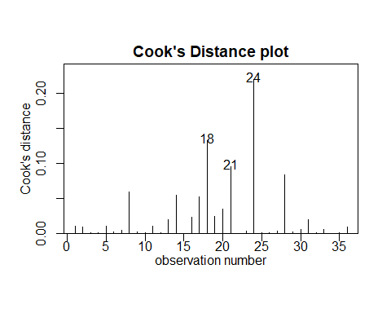

## Summary of Quadratic Linear Model Excluding 24th Datum

quad2.lm=lm(Height~BHDiameter + I(BHDiameter^2) , data=spruce.df[-24,])  
summary(quad2.lm)

##   
## Call:  
## lm(formula = Height ~ BHDiameter + I(BHDiameter^2), data = spruce.df[-24,   
## ])  
##   
## Residuals:  
## Min 1Q Median 3Q Max   
## -3.11233 -0.48227 0.01253 0.71727 2.59146   
##   
## Coefficients:  
## Estimate Std. Error t value Pr(>|t|)   
## (Intercept) -0.341500 2.068479 -0.165 0.87   
## BHDiameter 1.564793 0.226102 6.921 7.78e-08 ***  
## I(BHDiameter^2) -0.029242 0.006114 -4.782 3.74e-05 ***  
## ---  
## Signif. codes: 0 '***' 0.001 '**' 0.01 '*' 0.05 '.' 0.1 ' ' 1  
##   
## Residual standard error: 1.266 on 32 degrees of freedom  
## Multiple R-squared: 0.8159, Adjusted R-squared: 0.8044   
## F-statistic: 70.91 on 2 and 32 DF, p-value: 1.74e-12