Lab6-RMD

Clayton Glenn

February 22, 2018

Table of Contents

# Task 1

## Get working Directory

getwd()

## [1] "C:/Users/cglen/Documents/Stat Methods/Labs/LAB6"

# Task 2

## 4 Plots of the norms

layout(matrix(1:4, nr = 2, nc = 2))  
  
###Normal Density with mu = 10 and sd = 4  
curve(dnorm(x, mean = 10, sd = 4),  
 xlim = c(-10, 30),  
 ylab = "Normal Distribution")  
  
###Normal Density with mu = 10 and sd = 2  
curve(dnorm(x, mean = 10, sd = 2),  
 xlim = c(-10, 30),  
 ylab = "Normal Distribution")  
  
###Normal Density with mu = 5 and sd = 10  
curve(dnorm(x, mean = 5, sd = 10),  
 xlim = c(-30, 40),  
 ylab = "Normal Distribution")  
  
###Normal Density with mu = 5 and sd = .5  
curve(dnorm(x, mean = 5, sd = 1 / 2),  
 xlim = c(-10, 30),  
 ylab = "Normal Distribution")

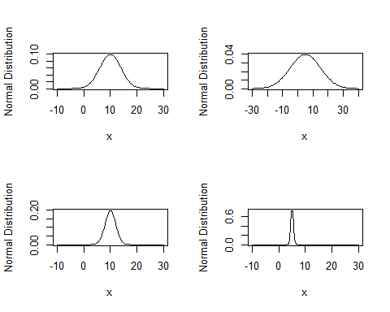

## Plot the norms and show probability

### Plot the norm of mean = 0 and sd = 1 and show probability of 2:30

curve(  
 dnorm(x, mean = 0, sd = 1),  
 xlim = c(-4, 4),  
 ylab = "Normal Distribution",  
 main = "Mean = 0, Standard Deviation = 1"  
)  
xcurve = seq(2, 30, length = 1000)  
ycurve = dnorm(xcurve, mean = 0, sd = 1)  
polygon(c(2, xcurve, 30), c(0, ycurve, 0), col = "Red")  
prob = pnorm(30, mean = 0, sd = 1) - pnorm(2, mean = 0, sd = 1)  
prob = round(prob, 4)  
text(x = 0,  
 y = 1 / 2 * dnorm(0, 0, 1),  
 paste("Area = ", prob, sep = ""))

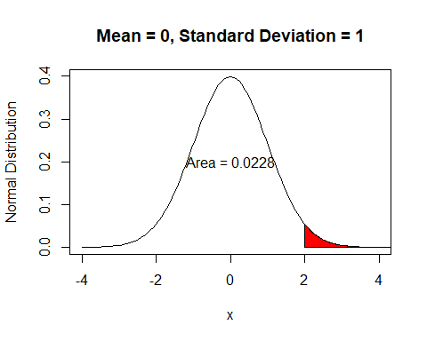

### Plot the norm of mean = 4 and sd = 2 and show probability of 1:5

curve(  
 dnorm(x, mean = 4, sd = 2),  
 xlim = c(-10, 20),  
 ylab = "Normal Distribution",  
 main = "Mean = 4, Standard Deviation = 2"  
)  
xcurve = seq(1, 5, length = 1000)  
ycurve = dnorm(xcurve, mean = 4, sd = 2)  
polygon(c(1, xcurve, 5), c(0, ycurve, 0), col = "Red")  
prob = pnorm(5, mean = 4, sd = 2) - pnorm(1, mean = 4, sd = 2)  
prob = round(prob, 4)  
text(x = 4,  
 y = 1 / 2 * dnorm(4, 4, 2),  
 paste("Area = ", prob, sep = ""))

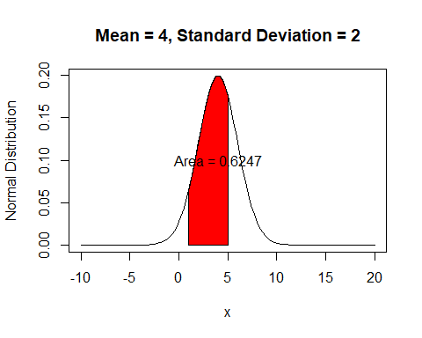

### Plot the norm of mean = 10 and sd = 4 and show probability of -30:10

curve(  
 dnorm(x, mean = 10, sd = 4),  
 xlim = c(-10, 30),  
 ylab = "Normal Distribution",  
 main = "Mean = 10, Standard Deviation = 4"  
)  
xcurve = seq(-30, 10, length = 1000)  
ycurve = dnorm(xcurve, mean = 10, sd = 4)  
polygon(c(-30, xcurve, 10), c(0, ycurve, 0), col = "Red")  
prob = pnorm(10, mean = 10, sd = 4) - pnorm(-30, mean = 10, sd = 4)  
prob = round(prob, 4)  
text(x = 10,  
 y = 1 / 2 * dnorm(10, 10, 4),  
 paste("Area = ", prob, sep = ""))

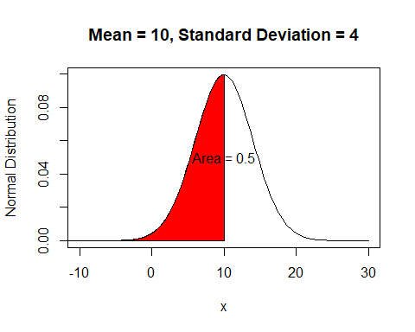

### Plot the norm of mean = -2 and sd = 0.5 and show probability of -3:-2

curve(  
 dnorm(x, mean = -2, sd = 1 / 2),  
 xlim = c(-4, 0),  
 ylab = "Normal Distribution",  
 main = "Mean = -2, Standard Deviation = 1/2"  
)  
xcurve = seq(-3, -2, length = 1000)  
ycurve = dnorm(xcurve, mean = -2, sd = 1 / 2)  
polygon(c(-3, xcurve, -2), c(0, ycurve, 0), col = "Red")  
prob = pnorm(-2, mean = -2, sd = 1 / 2) - pnorm(-3, mean = -2, sd = 1 / 2)  
prob = round(prob, 4)  
text(x = -2,  
 y = 1 / 2 * dnorm(-2, -2, 1 / 2),  
 paste("Area = ", prob, sep = ""))

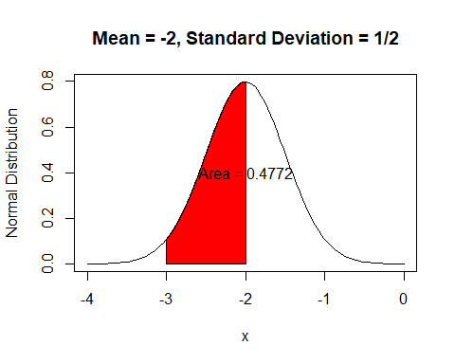

# Task 3

## Plot the Gamma Distribution

### Plot the gamma with shape = 1 and scale = 1

curve(  
 dgamma(x, shape = 1, scale = 1),  
 xlim = c(0, 10),  
 ylim = c(0, 1),  
 col = "Red",  
 lwd = 2,  
 ylab = "Gamma Density",  
 main = "Beta = 1"  
)  
text(x = 2, y = 0.8, paste("Alpha = ", 1))  
  
###Plot the gamma with shape = 3 and scale = 1  
curve(  
 dgamma(x, shape = 3, scale = 1),  
 xlim = c(0, 10),  
 ylim = c(0, 1),  
 add = TRUE,  
 lwd = 2  
)  
text(x = 3, y = 0.4, paste("Alpha = ", 3))  
  
###Plot the gamma with shape = 5 and scale = 1  
curve(  
 dgamma(x, shape = 5, scale = 1),  
 xlim = c(0, 10),  
 ylim = c(0, 1),  
 add = TRUE,  
 col = "Blue",  
 lwd = 2  
)  
text(x = 5, y = 0.3, paste("Alpha = ", 5))

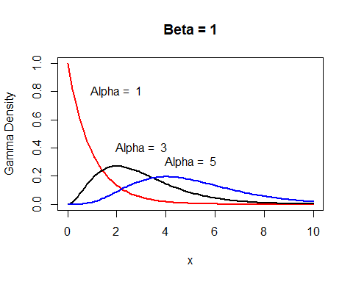

## Gamma Plots with Probabilities

### Plot the gamma with shape = 3 and scale = 2 and show probability of 2:5

curve(  
 dgamma(x, shape = 3, scale = 2),  
 xlim = c(-5, 20),  
 ylim = c(0, .5),  
 col = "Red",  
 lwd = 2,  
 ylab = "Gamma Density",  
 main = "Alpha = 3, Beta = 2"  
)  
xcurve = seq(2, 5, length = 1000)  
ycurve = dgamma(xcurve, shape = 3, scale = 2)  
polygon(c(2, xcurve, 5), c(0, ycurve, 0), col = "Red")  
prob = pgamma(5, shape = 3, scale = 2) - pgamma(2, shape = 3, scale = 2)  
prob = round(prob, 4)  
text(  
 x = (2 + 5) / 2,  
 y = 2 * dgamma(3, shape = 3, scale = 2),  
 paste("Area = ", prob, sep = "")  
)

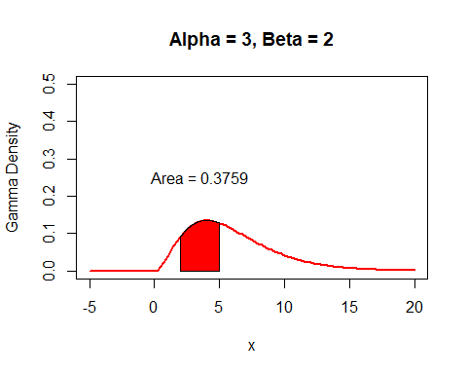

### Plot the gamma with shape = 6 and scale = 3 and show probability of 1:4

curve(  
 dgamma(x, shape = 6, scale = 3),  
 xlim = c(0, 10),  
 ylim = c(0, .1),  
 col = "Red",  
 lwd = 2,  
 ylab = "Gamma Density",  
 main = "Alpha = 6, Beta = 3"  
)  
xcurve = seq(1, 4, length = 1000)  
ycurve = dgamma(xcurve, shape = 6, scale = 3)  
polygon(c(1, xcurve, 4), c(0, ycurve, 0), col = "Red")  
prob = pgamma(4, shape = 6, scale = 3) - pgamma(1, shape = 6, scale = 3)  
prob = round(prob, 4)  
text(  
 x = (1 + 4) / 2,  
 y = 2 * dgamma(6, shape = 6, scale = 3),  
 paste("Area = ", prob, sep = "")  
)

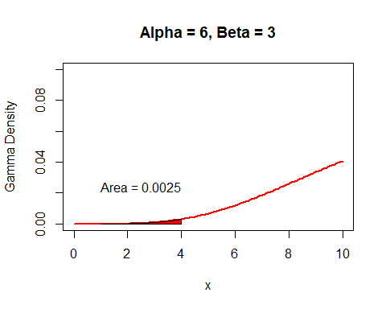

### Plot the gamma with shape = 2 and scale = 4 and show probability of 3:6

curve(  
 dgamma(x, shape = 2, scale = 4),  
 xlim = c(0, 10),  
 ylim = c(0, .2),  
 col = "Red",  
 lwd = 2,  
 ylab = "Gamma Density",  
 main = "Alpha = 2, Beta = 4"  
)  
xcurve = seq(3, 6, length = 1000)  
ycurve = dgamma(xcurve, shape = 2, scale = 4)  
polygon(c(3, xcurve, 6), c(0, ycurve, 0), col = "Red")  
prob = pgamma(6, shape = 2, scale = 4) - pgamma(3, shape = 2, scale = 4)  
prob = round(prob, 4)  
text(  
 x = (3 + 6) / 2,  
 y = 2 * dgamma(2, shape = 2, scale = 4),  
 paste("Area = ", prob, sep = "")  
)

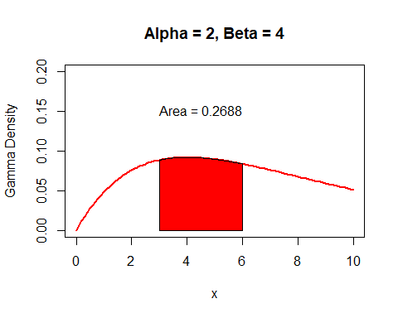

# Task 4

## 4 Plots of Chisq Density

layout(matrix(1:4, nr = 2, nc = 2))  
  
###Plot of Chisq Density with Degrees of Freedom = 1  
curve(  
 dchisq(x, df = 1),  
 xlim = c(0, 10),  
 ylim = c(0, 1),  
 col = "Blue",  
 lwd = 2,  
 ylab = "Chisq Density",  
 main = "DF = 1"  
)  
  
###Plot of Chisq Density with Degrees of Freedom = 2  
curve(  
 dchisq(x, df = 2),  
 xlim = c(0, 10),  
 ylim = c(0, 1),  
 col = "Blue",  
 lwd = 2,  
 ylab = "Chisq Density",  
 main = "DF = 2"  
)  
  
###Plot of Chisq Density with Degrees of Freedom = 4  
curve(  
 dchisq(x, df = 4),  
 xlim = c(0, 10),  
 ylim = c(0, 1),  
 col = "Blue",  
 lwd = 2,  
 ylab = "Chisq Density",  
 main = "DF = 4"  
)  
  
###Plot of Chisq Density with Degrees of Freedom = 20  
curve(  
 dchisq(x, df = 20),  
 xlim = c(0, 10),  
 ylim = c(0, 1),  
 col = "Blue",  
 lwd = 2,  
 ylab = "Chisq Density",  
 main = "DF = 20"  
)

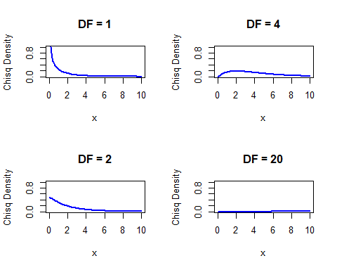

## Plot Chisq Density With Probabilities

### Plot of Chisq Density with Degrees of Freedom = 2 and show probability of 2:4

curve(  
 dchisq(x, df = 2),  
 xlim = c(0, 10),  
 ylim = c(0, 1),  
 col = "Blue",  
 lwd = 2,  
 ylab = "Chisq Density",  
 main = "Degrees of Freedom = 2"  
)  
xcurve = seq(2, 4, length = 1000)  
ycurve = dchisq(xcurve, df = 2)  
polygon(c(2, xcurve, 4), c(0, ycurve, 0), col = "Red")  
prob = pchisq(4, df = 2) - pchisq(2, df = 2)  
prob = round(prob, 4)  
text(x = (2 + 4) / 2,  
 y = 2 * dchisq(2, df = 2),  
 paste("Area = ", prob, sep = ""))

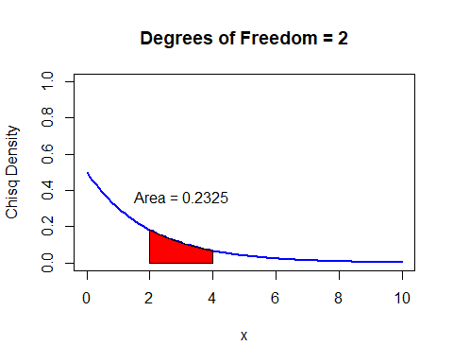

### Plot of Chisq Density with Degrees of Freedom = 3 and show probability of 3:5

curve(  
 dchisq(x, df = 3),  
 xlim = c(0, 10),  
 ylim = c(0, 1),  
 col = "Blue",  
 lwd = 2,  
 ylab = "Chisq Density",  
 main = "Degrees of Freedom = 3"  
)  
xcurve = seq(3, 5, length = 1000)  
ycurve = dchisq(xcurve, df = 3)  
polygon(c(3, xcurve, 5), c(0, ycurve, 0), col = "Red")  
prob = pchisq(5, df = 3) - pchisq(3, df = 3)  
prob = round(prob, 4)  
text(x = (3 + 5) / 2,  
 y = 2 * dchisq(3, df = 3),  
 paste("Area = ", prob, sep = ""))

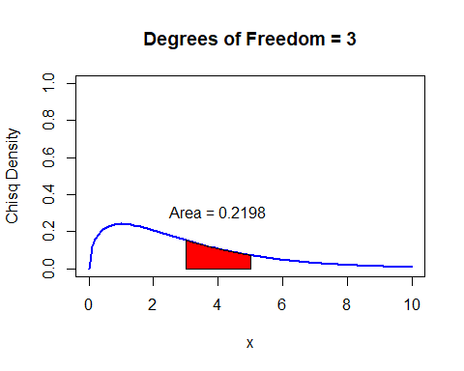

### Plot of Chisq Density with Degrees of Freedom = 20 and show probability of 10:21

curve(  
 dchisq(x, df = 20),  
 xlim = c(0, 25),  
 ylim = c(0, 1),  
 col = "Blue",  
 lwd = 2,  
 ylab = "Chisq Density",  
 main = "Degrees of Freedom = 20"  
)  
xcurve = seq(10, 21, length = 1000)  
ycurve = dchisq(xcurve, df = 20)  
polygon(c(10, xcurve, 21), c(0, ycurve, 0), col = "Red")  
prob = pchisq(21, df = 20) - pchisq(10, df = 20)  
prob = round(prob, 4)  
text(x = (10 + 21) / 2,  
 y = 2 * dchisq(10, df = 20),  
 paste("Area = ", prob, sep = ""))

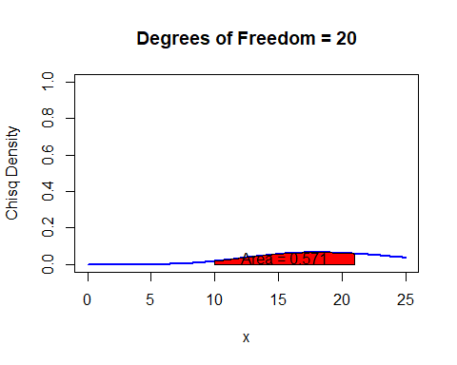

# Task 5

## Plots of Weibull Density with Probability

### Plot of Weibull Density with shape = 2 and scale = 1 and show probability of 1:2

curve(  
 dweibull(x, shape = 2, scale = 1),  
 xlim = c(0, 5),  
 ylim = c(0, 1),  
 col = "Blue",  
 lwd = 2,  
 ylab = "Weibull Density",  
 main = "Alpha = 2, Beta = 1"  
)  
xcurve = seq(1, 2, length = 1000)  
ycurve = dweibull(xcurve, shape = 2, scale = 1)  
polygon(c(1, xcurve, 2), c(0, ycurve, 0), col = "Red")  
prob = pweibull(2, shape = 2, scale = 1) - pweibull(1, shape = 2, scale = 1)  
prob = round(prob, 4)  
text(  
 x = 3,  
 y = 2 * dweibull(1.5, shape = 2, scale = 1),  
 paste("Area = ", prob, sep = "")  
)

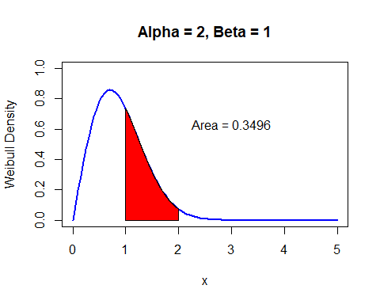

### Plot of Weibull Density with shape = 5 and scale = 4 and show probability of 3:5

curve(  
 dweibull(x, shape = 5, scale = 4),  
 xlim = c(0, 10),  
 ylim = c(0, 1),  
 col = "Blue",  
 lwd = 2,  
 ylab = "Weibull Density",  
 main = "Alpha = 5, Beta = 4"  
)  
xcurve = seq(3, 5, length = 1000)  
ycurve = dweibull(xcurve, shape = 5, scale = 4)  
polygon(c(3, xcurve, 5), c(0, ycurve, 0), col = "Red")  
prob = pweibull(5, shape = 5, scale = 4) - pweibull(3, shape = 5, scale = 4)  
prob = round(prob, 4)  
text(  
 x = 7,  
 y = 1 * dweibull(4, shape = 5, scale = 4),  
 paste("Area = ", prob, sep = "")  
)

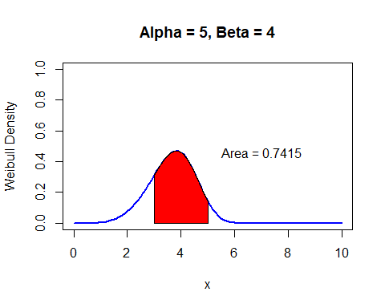

### Plot of Weibull Density with shape = 4 and scale = 10 and show probability of 8:9

curve(  
 dweibull(x, shape = 4, scale = 10),  
 xlim = c(0, 20),  
 ylim = c(0, 1),  
 col = "Blue",  
 lwd = 2,  
 ylab = "Weibull Density",  
 main = "Alpha = 4, Beta = 10"  
)  
xcurve = seq(8, 9, length = 1000)  
ycurve = dweibull(xcurve, shape = 4, scale = 10)  
polygon(c(8, xcurve, 9), c(0, ycurve, 0), col = "Red")  
prob = pweibull(9, shape = 4, scale = 10) - pweibull(8, shape = 4, scale = 10)  
prob = round(prob, 4)  
text(  
 x = 8,  
 y = 2 * dweibull(8, shape = 4, scale = 10),  
 paste("Area = ", prob, sep = "")  
)

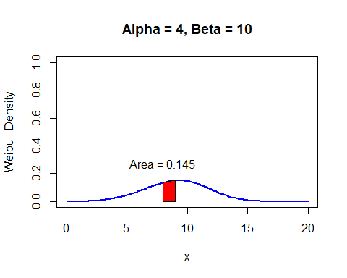

### Plot of Weibull Density with shape = 8 and scale = 8 and show probability of 7:9

curve(  
 dweibull(x, shape = 8, scale = 8),  
 xlim = c(0, 15),  
 ylim = c(0, 1),  
 col = "Blue",  
 lwd = 2,  
 ylab = "Weibull Density",  
 main = "Alpha = 8, Beta = 8"  
)  
xcurve = seq(7, 9, length = 1000)  
ycurve = dweibull(xcurve, shape = 8, scale = 8)  
polygon(c(7, xcurve, 9), c(0, ycurve, 0), col = "Red")  
prob = pweibull(9, shape = 8, scale = 8) - pweibull(7, shape = 8, scale = 8)  
prob = round(prob, 4)  
text(  
 x = 4,  
 y = 2 * dweibull(7, shape = 8, scale = 8),  
 paste("Area = ", prob, sep = "")  
)

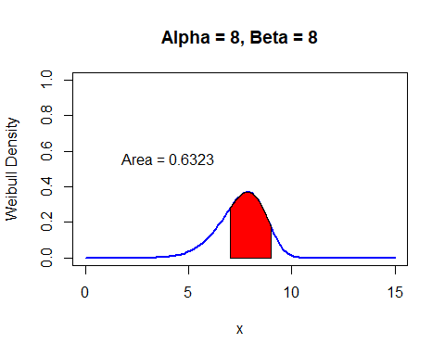

# Task 6

## Beta Plots with Distributions

### Plot of Beta Density with shape1 = 2 and shape2 = 1 and show probability of 0:1

curve(  
 dbeta(x, shape1 = 2, shape2 = 1),  
 xlim = c(0, 5),  
 ylim = c(0, 2),  
 col = "Blue",  
 lwd = 2,  
 ylab = "Beta Density",  
 main = "Shape1 = 2, Shape2 = 1"  
)  
xcurve = seq(0, 1, length = 1000)  
ycurve = dbeta(xcurve, shape1 = 2, shape2 = 1)  
polygon(c(0, xcurve, 1), c(0, ycurve, 0), col = "Red")  
prob = pbeta(1, shape1 = 2, shape2 = 1) - pbeta(0, shape1 = 2, shape2 = 1)  
prob = round(prob, 4)  
text(x = 3,  
 y = 0.8,  
 paste("Area = ", prob, sep = ""))

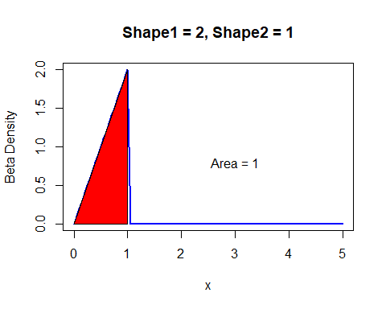

### Plot of Beta Density with shape1 = 1 and shape2 = 2 and show probability of .5:1

curve(  
 dbeta(x, shape1 = 1, shape2 = 2),  
 xlim = c(0, 5),  
 ylim = c(0, 2),  
 col = "Blue",  
 lwd = 2,  
 ylab = "Beta Density",  
 main = "Shape1 = 1, Shape2 = 2"  
)  
xcurve = seq(.5, 1, length = 1000)  
ycurve = dbeta(xcurve, shape1 = 1, shape2 = 2)  
polygon(c(.5, xcurve, 1), c(0, ycurve, 0), col = "Red")  
prob = pbeta(1, shape1 = 1, shape2 = 2) - pbeta(.5, shape1 = 1, shape2 = 2)  
prob = round(prob, 4)  
text(x = 3,  
 y = 0.8,  
 paste("Area = ", prob, sep = ""))

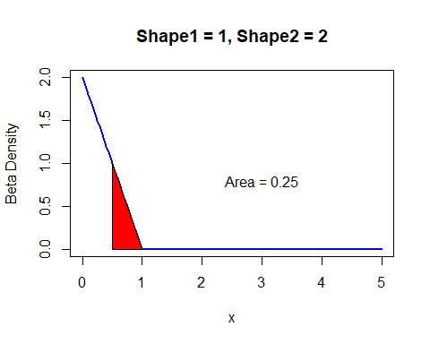

### Plot of Beta Density with shape1 = 5 and shape2 = 10 and show probability of .3:.6

curve(  
 dbeta(x, shape1 = 5, shape2 = 10),  
 xlim = c(0, 5),  
 ylim = c(0, 5),  
 col = "Blue",  
 lwd = 2,  
 ylab = "Beta Density",  
 main = "Shape1 = 5, Shape2 = 10"  
)  
xcurve = seq(.3, .6, length = 1000)  
ycurve = dbeta(xcurve, shape1 = 5, shape2 = 10)  
polygon(c(.3, xcurve, .6), c(0, ycurve, 0), col = "Red")  
prob = pbeta(.6, shape1 = 5, shape2 = 10) - pbeta(.3, shape1 = 5, shape2 = 10)  
prob = round(prob, 4)  
text(x = 3,  
 y = 0.8,  
 paste("Area = ", prob, sep = ""))

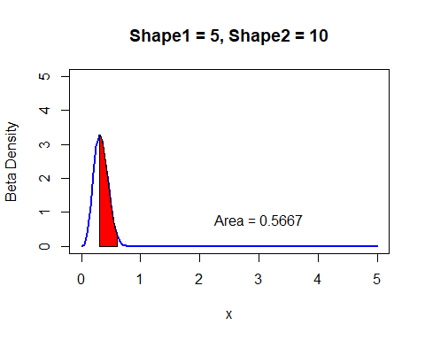

### Plot of Beta Density with shape1 = 10 and shape2 = 5 and show probability of 0:.5

curve(  
 dbeta(x, shape1 = 10, shape2 = 5),  
 xlim = c(0, 5),  
 ylim = c(0, 5),  
 col = "Blue",  
 lwd = 2,  
 ylab = "Beta Density",  
 main = "Shape1 = 10, Shape2 = 5"  
)  
xcurve = seq(0, .5, length = 1000)  
ycurve = dbeta(xcurve, shape1 = 10, shape2 = 5)  
polygon(c(0, xcurve, .5), c(0, ycurve, 0), col = "Red")  
prob = pbeta(.5, shape1 = 10, shape2 = 5) - pbeta(0, shape1 = 10, shape2 = 5)  
prob = round(prob, 4)  
text(x = 3,  
 y = 0.8,  
 paste("Area = ", prob, sep = ""))

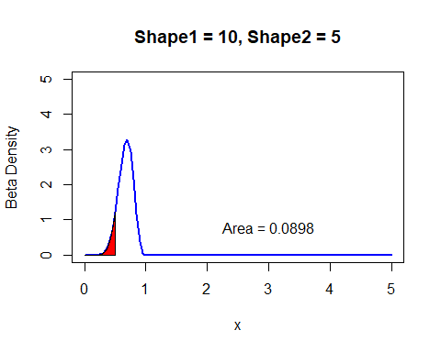

# Task 7

## Homemade function to take alpha and beta values to create an exponential plot

myexp = function(x, a, b) {  
 (a / b) * '^'(2.71828183,-(a * x / b))  
}  
  
##Show Both plots side by side to compare all x values  
layout(matrix(1:2, nr = 1, nc = 2))  
  
###Gamma->Exponential with 2:3  
curve(  
 myexp(x, 2, 3),  
 xlim = c(0, 5),  
 ylim = c(0, 5),  
 col = "Blue",  
 lwd = 2,  
 ylab = "Gamma->Exponential Density",  
 main = "Alpha = 2, Beta = 3"  
)  
  
###Exponential with rate 2/3  
curve(  
 dexp(x, rate = 2 / 3),  
 xlim = c(0, 5),  
 ylim = c(0, 5),  
 col = "Blue",  
 lwd = 2,  
 ylab = "Exponential Density",  
 main = "Rate = 2/3"  
)

