Lab8-RMD

Clayton Glenn

March 5, 2018

Table of Contents

# task1

getwd()

## [1] "C:/Users/cglen/Documents/Stat Methods/Labs/LAB8"

# task2

a=0  
b=5  
n=10  
y=runif(n,a,b)  
mu=(a+b)/2  
sigma_sq=(b-a)^2/12  
X_bar=sum(y/n)  
S_sq=sum(y-(mu))^2/(n-1)  
T=sum(y)  
Y_bar=T/n

### Mean

show(mu)

## [1] 2.5

### Sample Mean

show(X_bar)

## [1] 2.37184

### Variance

show(sigma_sq)

## [1] 2.083333

### Sample Variance

show(S_sq)

## [1] 0.1824997

### Sum T

show(T)

## [1] 23.7184

### The mean Ybar

show(Y_bar)

## [1] 2.37184

### Distribution of the sum of uniforms

myclt=function(n,iter,a=0,b=5){  
 y=runif(n*iter,a,b)  
 data=matrix(y,nr=n,nc=iter,byrow=TRUE)  
 sm=apply(data,2,sum)  
 h=hist(sm,plot=FALSE)  
 hist(sm,col=rainbow(length(h$mids)),freq=FALSE,main="Distribution of the sum of uniforms")  
 curve(dnorm(x,mean=n*(a+b)/2,sd=sqrt(n*(b-a)^2/12)),add=TRUE,lwd=2,col="Blue")  
 sm  
}  
w=myclt(n=10,iter=10000,a=0,b=5)

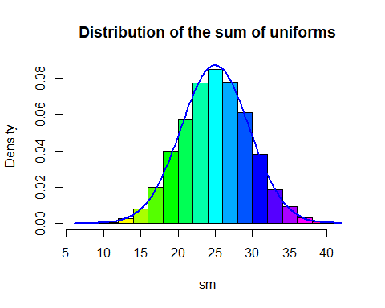

### Mean of W vector

mean(w)

## [1] 25.03298

### Variance of W vector

var(w)

## [1] 20.95107

### myclt with sample means

mymean=function(n,iter,a=0,b=5){  
 y=runif(n*iter,a,b)  
 data=matrix(y,nr=n,nc=iter,byrow=TRUE)  
 sm=apply(data,1,mean)  
 h=hist(sm,plot=FALSE)  
 hist(sm,col=rainbow(length(h$mids)),freq=FALSE,main="Distribution of the means")  
 curve(dnorm(x,mean=n*(a+b)/2,sd=sqrt(n*(b-a)^2/12)),add=TRUE,lwd=2,col="Blue")  
 sm  
}  
wmeans=mymean(n=10,iter=10000,a=0,b=5)

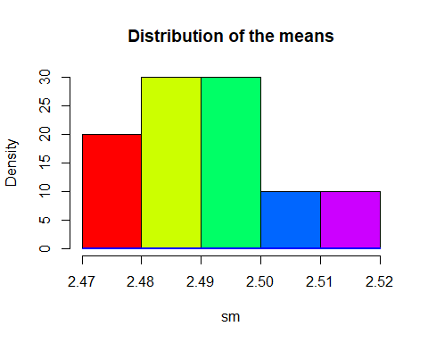

### mean of the vector of sample means

mean(wmeans)

## [1] 2.490683

### variance of the vector of sample means

var(wmeans)

## [1] 0.0001427376

# Task3

### Uniform distributions

mycltu=function(n,iter,a=0,b=10){  
 y=runif(n*iter,a,b)  
 data=matrix(y,nr=n,nc=iter,byrow=TRUE)  
 w=apply(data,2,mean)  
 param=hist(w,plot=FALSE)  
  
 ymax=max(param$density)  
 ymax=1.1*ymax  
 hist(w,freq=FALSE, ylim=c(0,ymax), main=paste("Histogram of sample mean",  
 "\n", "sample size= ",n,sep=""),xlab="Sample mean")  
 lines(density(w),col="Blue",lwd=3) # add a density plot  
 curve(dnorm(x,mean=(a+b)/2,sd=(b-a)/(sqrt(12*n))),add=TRUE,col="Red",lty=2,lwd=3)   
 curve(dunif(x,a,b),add=TRUE,lwd=4)  
   
}  
mycltu(n=1,iter=10000, a=0, b=10)

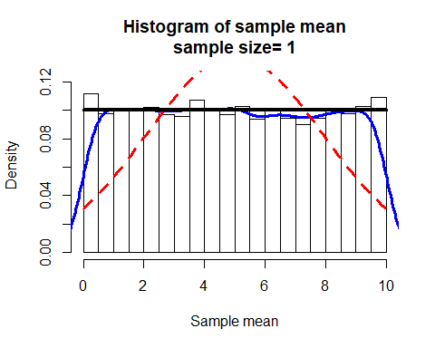

mycltu(n=2,iter=10000, a=0, b=10)

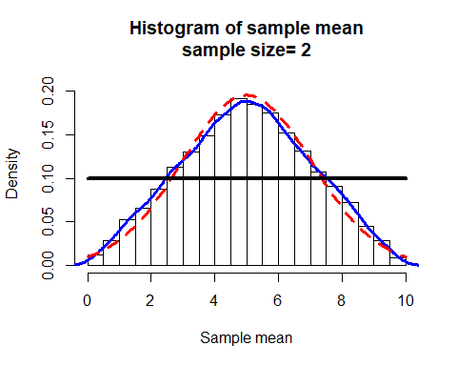

mycltu(n=3,iter=10000, a=0, b=10)

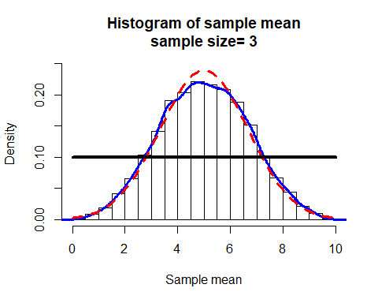

mycltu(n=5,iter=10000, a=0, b=10)

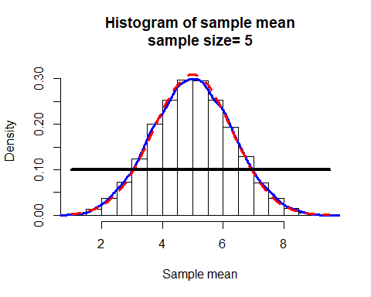

mycltu(n=10,iter=10000, a=0, b=10)

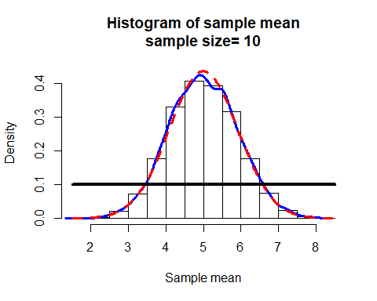

mycltu(n=30,iter=10000, a=0, b=10)

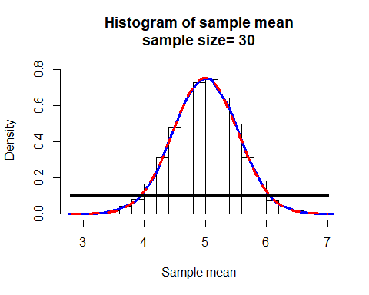

# Task 4

### Binomial Distributions

mycltb=function(n,iter,p=0.5){  
 y=rbinom(n*iter,size=n,prob=p)  
 data=matrix(y,nr=n,nc=iter,byrow=TRUE)  
 w=apply(data,2,mean)  
 param=hist(w,plot=FALSE)  
   
 ymax=max(param$density)  
 ymax=1.1*ymax  
 hist(w,freq=FALSE, ylim=c(0,ymax),  
 main=paste("Histogram of sample mean","\n", "sample size= ",n,sep=""),  
 xlab="Sample mean")  
 curve(dnorm(x,mean=n*p,sd=sqrt(p*(1-p))),add=TRUE,col="Red",lty=2,lwd=3)   
   
}  
  
mycltb(n=4,iter=10000,p=0.3)

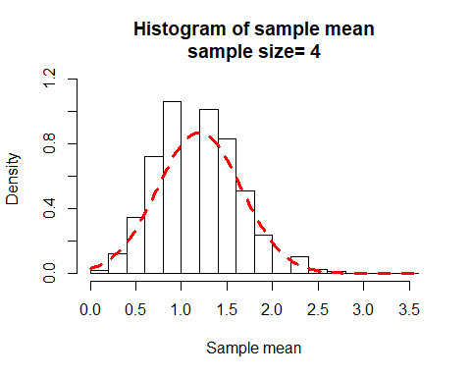

mycltb(n=5,iter=10000,p=0.3)

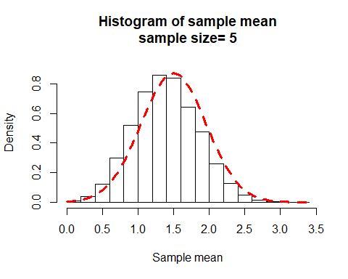

mycltb(n=10,iter=10000,p=0.3)

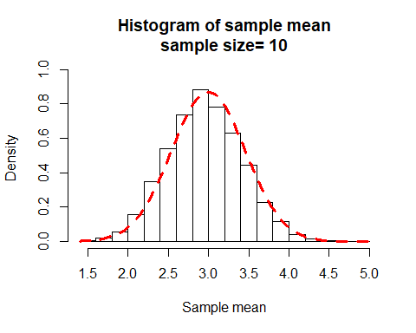

mycltb(n=20,iter=10000,p=0.3)

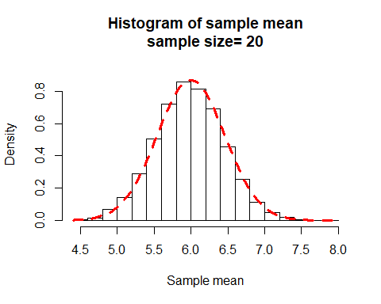

mycltb(n=4,iter=10000,p=0.7)

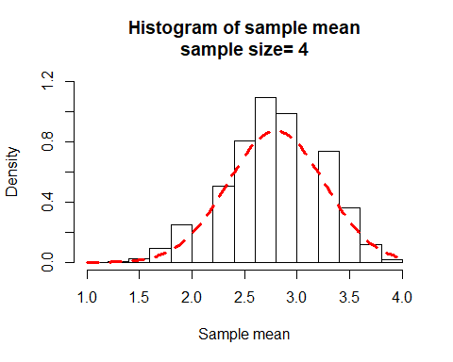

mycltb(n=5,iter=10000,p=0.7)

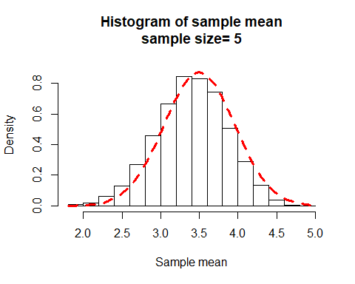

mycltb(n=10,iter=10000,p=0.7)

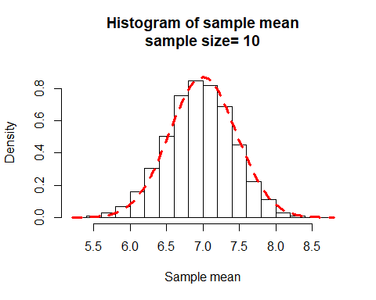

mycltb(n=20,iter=10000,p=0.7)

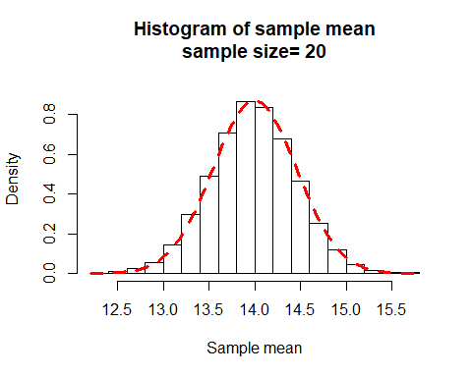

mycltb(n=4,iter=10000,p=0.5)

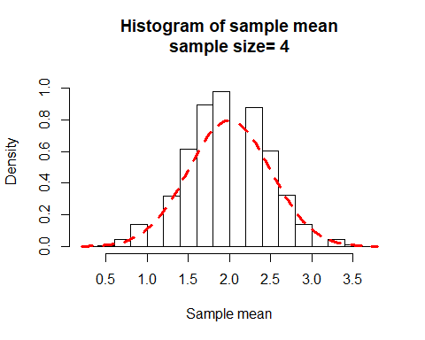

mycltb(n=5,iter=10000,p=0.5)

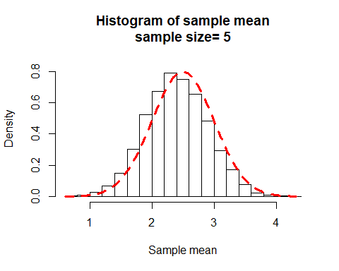

mycltb(n=10,iter=10000,p=0.5)

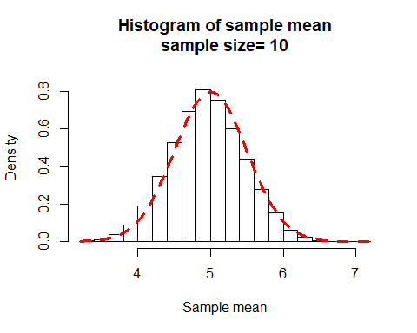

mycltb(n=20,iter=10000,p=0.5)

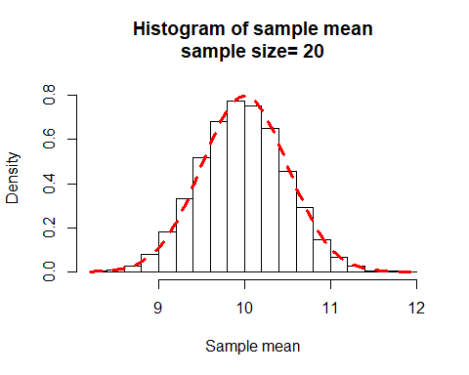

# Task 5

### Poisson Distributions

mycltp=function(n,iter,lambda=10){  
 y=rpois(n*iter,lambda=lambda)  
 data=matrix(y,nr=n,nc=iter,byrow=TRUE)  
 w=apply(data,2,mean)  
 param=hist(w,plot=FALSE)  
 ymax=max(param$density)  
 ymax=1.1*ymax  
 layout(matrix(c(1,1,2,3),nr=2,nc=2, byrow=TRUE))  
 hist(w,freq=FALSE, ylim=c(0,ymax), col=rainbow(max(w)),  
 main=paste("Histogram of sample mean","\n", "sample size= ",n," iter=",iter," lambda=",lambda,sep=""), xlab="Sample mean")  
 curve(dnorm(x,mean=lambda,sd=sqrt(lambda/n)),add=TRUE,col="Red",lty=2,lwd=3)  
 barplot(table(y)/(n*iter),col=rainbow(max(y)), main="Barplot of sampled y", ylab ="Rel. Freq",xlab="y" )  
 x=0:max(y)  
 plot(x,dpois(x,lambda=lambda),type="h",lwd=5,col=rainbow(max(y)),  
 main="Probability function for Poisson", ylab="Probability",xlab="y")  
}  
mycltp(n=2,iter=10000, lambda = 4)

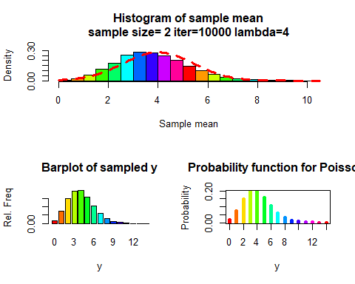

mycltp(n=3,iter=10000, lambda = 4)

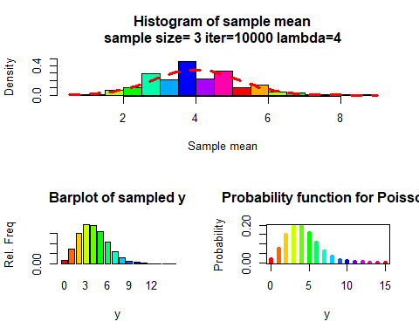

mycltp(n=5,iter=10000, lambda = 4)

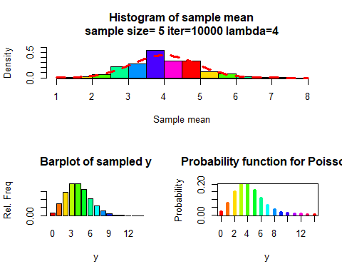

mycltp(n=10,iter=10000, lambda = 4)

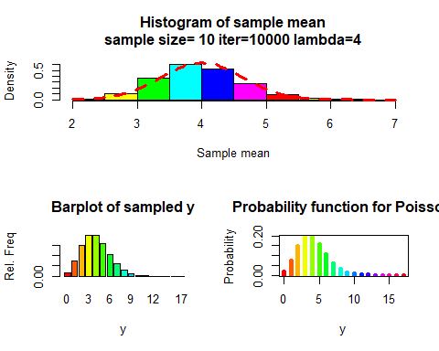

mycltp(n=20,iter=10000, lambda = 4)

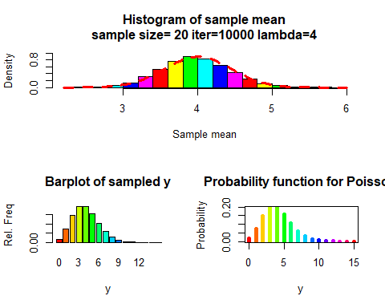

mycltp(n=2,iter=10000, lambda = 10)

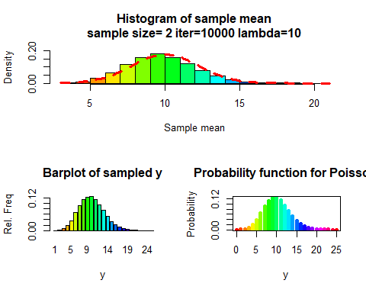

mycltp(n=3,iter=10000, lambda = 10)

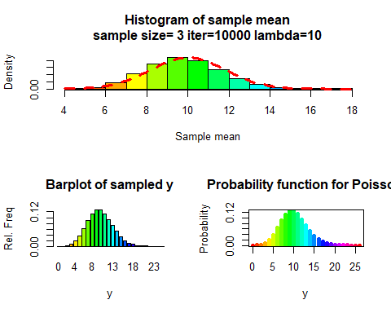

mycltp(n=5,iter=10000, lambda = 10)

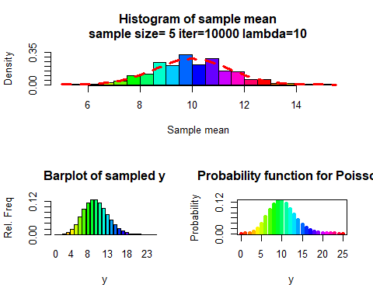

mycltp(n=10,iter=10000, lambda = 10)

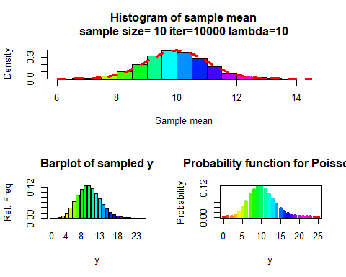

mycltp(n=20,iter=10000, lambda = 10)

