Lab9-RMD

Clayton Glenn

March 16, 2018

Table of Contents

# Task 1

getwd()

## [1] "C:/Users/cglen/Documents/Stat Methods/Labs/LAB9"

# Task 2

## Replacement

set.seed(35)  
sam = round(rnorm(20,mean=10,sd=4),2)  
unique(sample(sam,20,replace=TRUE))

## [1] 2.89 8.00 13.46 11.40 12.05 8.62 11.64 7.75 23.35 2.37 6.93  
## [12] 16.69

unique(sample(sam,20,replace=TRUE))

## [1] 8.62 23.35 9.86 11.64 14.76 2.37 8.43 10.53 16.69 11.40 12.05  
## [12] 13.46 17.35 6.93

unique(sample(sam,20,replace=TRUE))

## [1] 11.64 8.00 12.05 11.78 9.86 7.75 23.35 6.93 8.62 2.89 11.40  
## [12] 13.46 10.53 14.76

unique(sample(sam,20,replace=TRUE))

## [1] 11.78 8.43 8.62 14.76 9.82 17.35 10.53 23.35 6.93 11.64 14.26  
## [12] 9.86 7.75 13.46 2.89

unique(sample(sam,20,replace=TRUE))

## [1] 16.69 11.40 2.37 14.76 7.75 23.35 13.46 11.78 9.82 10.53 8.43

## No Replacement

unique(sample(sam,20,replace=FALSE))

## [1] 14.26 11.64 11.78 10.53 6.93 11.40 8.00 8.62 7.75 9.86 13.46  
## [12] 2.89 9.82 16.69 23.35 17.35 2.37 8.43 14.76 12.05

unique(sample(sam,20,replace=FALSE))

## [1] 6.93 11.40 10.53 2.37 9.82 11.78 14.26 14.76 11.64 2.89 16.69  
## [12] 13.46 12.05 7.75 17.35 8.62 9.86 8.43 23.35 8.00

unique(sample(sam,20,replace=FALSE))

## [1] 11.40 8.62 16.69 11.64 11.78 9.86 17.35 13.46 9.82 6.93 8.00  
## [12] 23.35 7.75 2.89 10.53 8.43 14.76 2.37 14.26 12.05

unique(sample(sam,20,replace=FALSE))

## [1] 7.75 13.46 9.86 14.76 2.37 11.78 6.93 8.62 17.35 23.35 8.43  
## [12] 9.82 16.69 2.89 8.00 11.40 11.64 14.26 10.53 12.05

unique(sample(sam,20,replace=FALSE))

## [1] 23.35 8.62 2.37 6.93 9.82 11.78 13.46 17.35 8.43 14.26 11.64  
## [12] 9.86 10.53 14.76 2.89 12.05 11.40 8.00 7.75 16.69

# Task 3

myboot2<-function(iter=10000,x,fun="mean",alpha=0.05,cx=1.5, xlab, col){   
 n=length(x)  
 y=sample(x,n*iter,replace=TRUE)  
 rs.mat=matrix(y,nr=n,nc=iter,byrow=TRUE)  
 xstat=apply(rs.mat,2,fun)  
 ci=quantile(xstat,c(alpha/2,1-alpha/2))  
 para=hist(xstat,freq=FALSE,las=1, main=paste("Histogram of Bootstrap sample statistics",  
 "\n","alpha=",alpha," iter=",iter,sep=""), xlab = xlab, col = col)  
 mat=matrix(x,nr=length(x),nc=1,byrow=TRUE)  
 pte=apply(mat,2,fun)  
 abline(v=pte,lwd=3,col="Black")  
 segments(ci[1],0,ci[2],0,lwd=4)   
 text(ci[1],0,paste("(",round(ci[1],2),sep=""),col="Red",cex=cx)  
 text(ci[2],0,paste(round(ci[2],2),")",sep=""),col="Red",cex=cx)  
 text(pte,max(para$density)/2,round(pte,2),cex=cx)  
 return(list(ci=ci,fun=fun,x=x))  
}

## 95% Intervals

set.seed(39); sam=rnorm(25,mean=25,sd=10)  
x = myboot2(10000,x=sam,fun="mean",alpha=0.05,xlab="mean",col="Purple",cx=1.5)

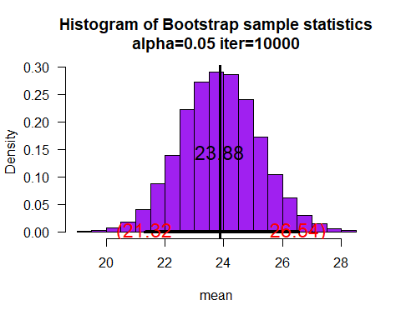

mean(x$ci) - mean(sam)

## [1] 0.04513323

set.seed(30); sam=rchisq(20,df=3)  
x = myboot2(10000,x=sam,fun="mean",alpha=0.05,xlab="mean",col="Purple",cx=1.5)

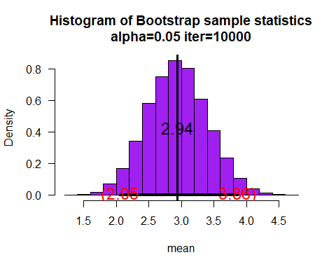

mean(x$ci) - mean(sam)

## [1] 0.01596072

set.seed(40); sam=rgamma(30,shape=2,scale=3)  
x= myboot2(10000,x=sam,fun="mean",alpha=0.05,xlab="mean",col="Purple",cx=1.5)

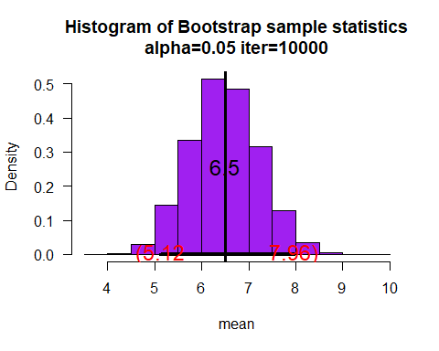

mean(x$ci) - mean(sam)

## [1] 0.04548117

set.seed(10); sam=rbeta(20,shape1=3,shape2=4)  
x=myboot2(10000,x=sam,fun="mean",alpha=0.05,xlab="mean",col="Purple",cx=1.5)

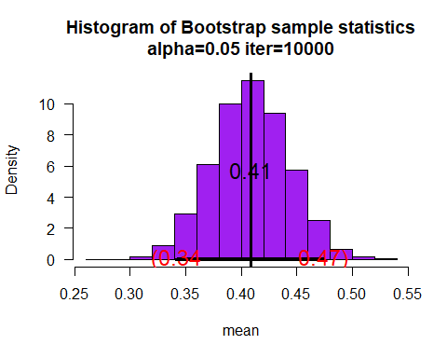

mean(x$ci) - mean(sam)

## [1] -0.0004515072

## 80% Intervals

set.seed(39); sam=rnorm(25,mean=25,sd=10)  
myboot2(10000,x=sam,fun="var",alpha=0.2,xlab="Variance",col="Purple",cx=1.5)

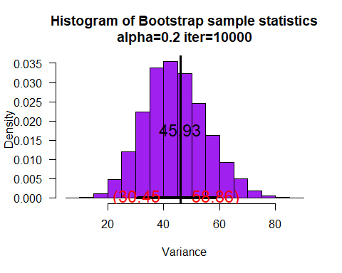

## $ci  
## 10% 90%   
## 30.45325 58.85675   
##   
## $fun  
## [1] "var"  
##   
## $x  
## [1] 23.14434 12.70757 20.72797 19.04018 29.67324 29.21639 14.78348  
## [8] 18.77523 33.37002 34.61627 26.04230 24.40206 32.03731 17.45030  
## [15] 19.54464 20.45388 23.83394 30.47815 25.79640 22.67536 10.27711  
## [22] 26.77487 37.10044 21.59809 22.50625

set.seed(30); sam=rchisq(20,df=3)  
myboot2(10000,x=sam,fun="var",alpha=0.2,xlab="Variance",col="Purple",cx=1.5)

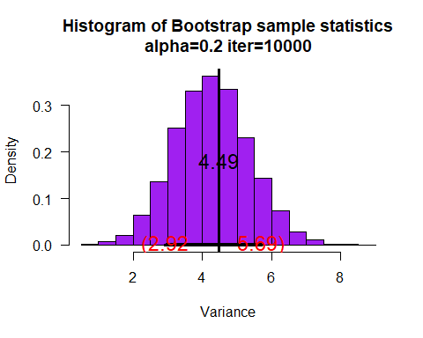

## $ci  
## 10% 90%   
## 2.922344 5.689590   
##   
## $fun  
## [1] "var"  
##   
## $x  
## [1] 0.2531032 1.6194423 5.3578133 7.3134789 0.1194100 5.0344239 5.8189991  
## [8] 4.3689673 1.6690814 3.2533362 0.9050305 2.5730754 1.9610329 2.9675027  
## [15] 1.5722396 1.6959031 1.9261106 3.9198072 6.0919801 0.4082447

set.seed(40); sam=rgamma(30,shape=2,scale=3)  
myboot2(10000,x=sam,fun="var",alpha=0.2,xlab="Variance",col="Purple",cx=1.5)

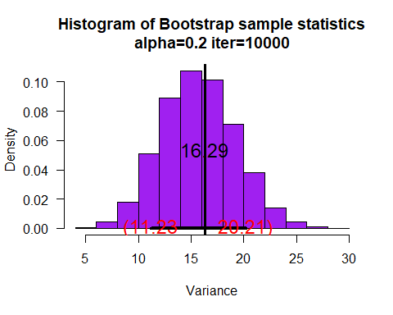

## $ci  
## 10% 90%   
## 11.22596 20.21214   
##   
## $fun  
## [1] "var"  
##   
## $x  
## [1] 6.4265012 6.5077401 1.8958495 5.3836641 1.4179366 0.7925928  
## [7] 8.0380097 14.7293204 5.2917468 2.7989621 7.9632983 2.8733832  
## [13] 7.4419824 2.2828464 5.9877646 12.9354365 1.4996069 1.7478044  
## [19] 12.3674161 8.4093535 10.2053201 8.0243948 6.5178039 7.9118846  
## [25] 1.6924333 10.7938057 5.7341134 15.1533278 3.8545321 8.1861897

set.seed(10); sam=rbeta(20,shape1=3,shape2=4)  
myboot2(10000,x=sam,fun="var",alpha=0.2,xlab="Variance",col="Purple",cx=1.5)

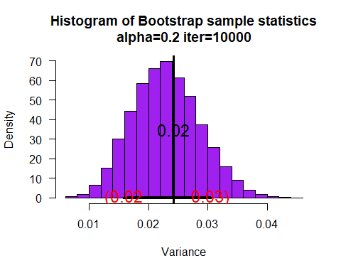

## $ci  
## 10% 90%   
## 0.01582077 0.03050548   
##   
## $fun  
## [1] "var"  
##   
## $x  
## [1] 0.4325491 0.3899825 0.1714409 0.3068918 0.4920588 0.5129946 0.1974398  
## [8] 0.3533577 0.1343329 0.3751208 0.6722481 0.5946901 0.3788602 0.6467397  
## [15] 0.5914547 0.4476104 0.2407876 0.3877302 0.5336340 0.3074436

# Task 4

mybootmed<-function(iter=10000,x,fun="median",alpha=0.05,cx=1.5, xlab, col){   
 n=length(x)  
 y=sample(x,n*iter,replace=TRUE)  
 rs.mat=matrix(y,nr=n,nc=iter,byrow=TRUE)  
 xstat=apply(rs.mat,2,fun)  
 ci=quantile(xstat,c(alpha/2,1-alpha/2))  
 para=hist(xstat,freq=FALSE,las=1, main=paste("Histogram of Bootstrap sample statistics",  
 "\n","alpha=",alpha," iter=",iter,sep=""), xlab = xlab, col = col)  
 mat=matrix(x,nr=length(x),nc=1,byrow=TRUE)  
 pte=apply(mat,2,fun)  
 abline(v=pte,lwd=3,col="Black")  
 segments(ci[1],0,ci[2],0,lwd=4)   
 text(ci[1],0,paste("(",round(ci[1],2),sep=""),col="Red",cex=cx)  
 text(ci[2],0,paste(round(ci[2],2),")",sep=""),col="Red",cex=cx)  
 text(pte,max(para$density)/2,round(pte,2),cex=cx)  
 return(list(xstat=xstat,ci=ci,fun=fun,x=x))  
}

sam=c(1,1,1,2,2,2,2,3,3,3,4,4)  
x = mybootmed(x=sam,fun="median", xlab = "Median", col = "Blue")

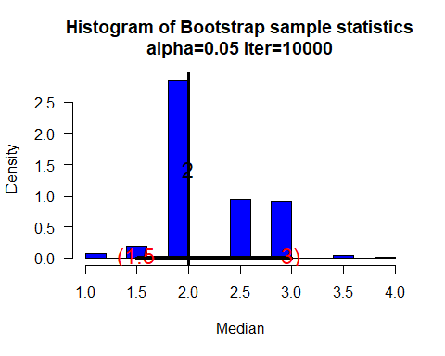

barplot(x$xstat)

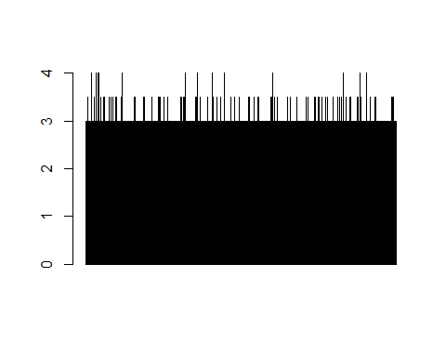

# Task 5

mybootdiv<-function(iter=10000,x,fun="mean",alpha=0.05,cx=1.5, xlab = "Mean/Median", col = "Orange"){   
 n=length(x)  
 y=sample(x,n*iter,replace=TRUE)  
 rs.mat=matrix(y,nr=n,nc=iter,byrow=TRUE)  
 xstat=apply(rs.mat,2,fun)  
 ci=quantile(xstat,c(alpha/2,1-alpha/2))  
 para=hist(xstat,freq=FALSE,las=1, main=paste("Histogram of Bootstrap sample statistics",  
 "\n","alpha=",alpha," iter=",iter,sep=""), xlab = xlab, col = col)  
 mat=matrix(x,nr=length(x),nc=1,byrow=TRUE)  
 pte=apply(mat,2,fun)  
 abline(v=pte,lwd=3,col="Black")  
 segments(ci[1],0,ci[2],0,lwd=4)   
 text(ci[1],0,paste("(",round(ci[1],2),sep=""),col="Red",cex=cx)  
 text(ci[2],0,paste(round(ci[2],2),")",sep=""),col="Red",cex=cx)  
 text(pte,max(para$density)/2,round(pte,2),cex=cx)  
 return(list(xstat=xstat,ci=ci,fun=fun,x=x))  
}

## 95% Intervals

set.seed(39); sam=rnorm(25,mean=25,sd=10)  
x= mybootdiv(10000,x=sam, alpha=0.05,xlab="mean/median",cx=1.5)

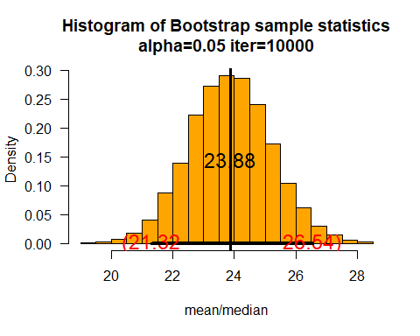

set.seed(30); sam=rchisq(20,df=3)  
x=mybootdiv(10000,x=sam,alpha=0.05,xlab="mean/median",cx=1.5)

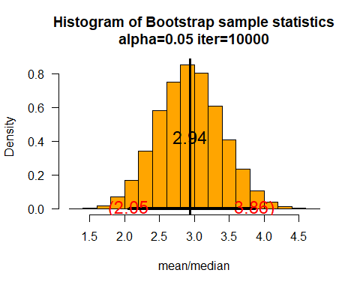

set.seed(40); sam=rgamma(30,shape=2,scale=3)  
x=mybootdiv(10000,x=sam,alpha=0.05,xlab="mean/median",cx=1.5)

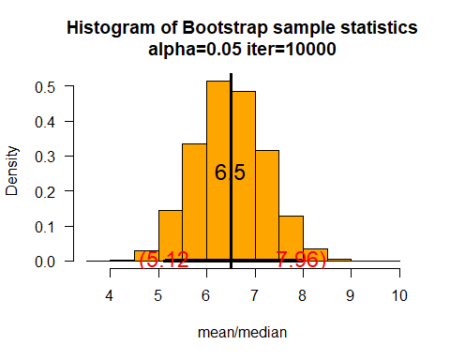

set.seed(10); sam=rbeta(20,shape1=3,shape2=4)  
x=mybootdiv(10000,x=sam,alpha=0.05,xlab="mean/median",cx=1.5)

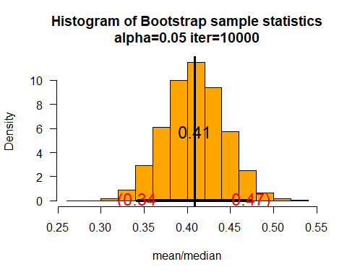

## 70% Intervals

set.seed(39); sam=rnorm(25,mean=25,sd=10)  
x=mybootdiv(10000,x=sam,alpha=0.3,xlab="mean/median",cx=1.5)

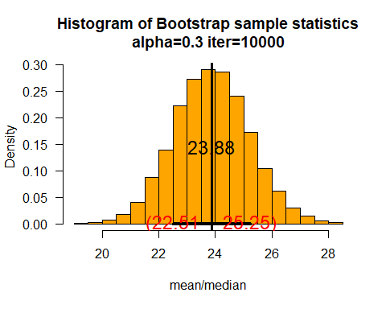

set.seed(30); sam=rchisq(20,df=3)  
x=mybootdiv(10000,x=sam,alpha=0.3,xlab="mean/median",cx=1.5)

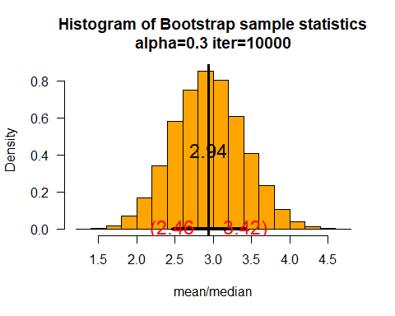

set.seed(40); sam=rgamma(30,shape=2,scale=3)  
x=mybootdiv(10000,x=sam,alpha=0.3,xlab="mean/median",cx=1.5)

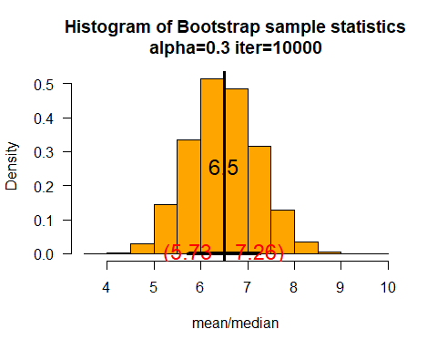

set.seed(10); sam=rbeta(20,shape1=3,shape2=4)  
x=mybootdiv(10000,x=sam,alpha=0.3,xlab="mean/median",cx=1.5)

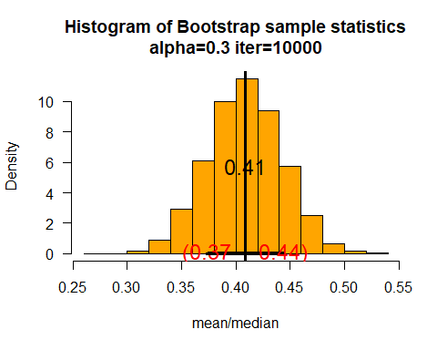

# Task 6

set.seed(39); sam=rcauchy(20,location = 0, scale = 2)  
x = myboot2(10000,x=sam,fun="mean",alpha=0.2,xlab="mean",col="Green",cx=1.5)

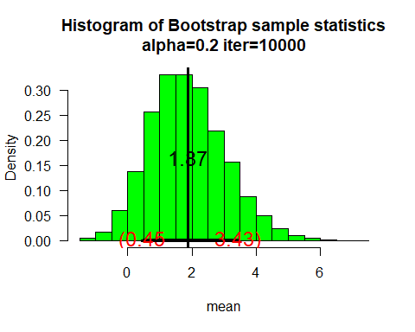

set.seed(39); sam=rpois(20, lambda = 4)  
x = myboot2(10000,x=sam,fun="mean",alpha=0.2,xlab="mean",col="Green",cx=1.5)

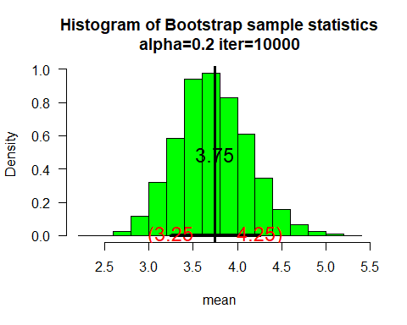

set.seed(39); sam=rf(20,df1 = 1,df2 = Inf)  
x = myboot2(10000,x=sam,fun="mean",alpha=0.2,xlab="mean",col="Green",cx=1.5)

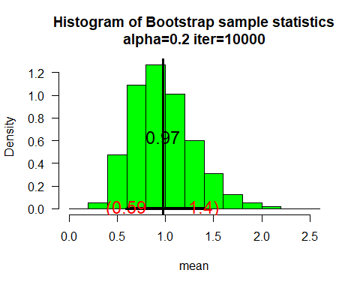

set.seed(39); sam=rlnorm(20, meanlog = 0, sdlog = 1)  
x = myboot2(10000,x=sam,fun="mean",alpha=0.2,xlab="mean",col="Green",cx=1.5)

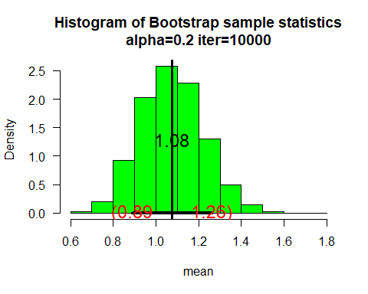

# Task 7

set.seed(68); sam=rnorm(20,mean=10,sd=4)  
x = myboot2(10000,x=sam,fun="sd",alpha=0.05,xlab="sd",col="Yellow",cx=1.5)

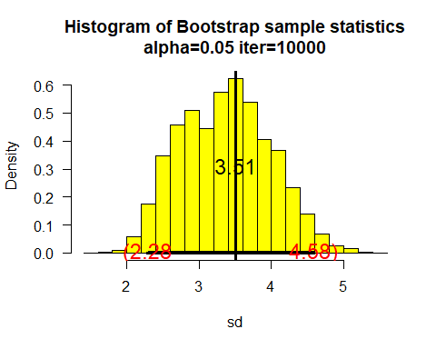

x = myboot2(10000,x=x$x,fun="sd",alpha=0.05,xlab="sd",col="Yellow",cx=1.5)

