Year 2

Hospital Patient Management System

Semester 4 Project

ITT Dublin | Old Blessington Rd, Dublin 24.

user Requirements

X00131787, X00101556.

Table of Contents

Introduction 2

Interview of Key Users / Project Proposer 3

Introduction 3

Interview Questions and Analysis 3

Analysis 5

Survey Questions and Results 6

User Requirements Capture for Proposed System 13

System Narrative 13

System Features 13

Patient Information 13

Security 13

System Calendar 14

Payment Control 14

Patient Archiving 14

Help 14

List of Requirements 15

Patients 15

Appointments 15

Visits 15

Payment 16

Management 16

Use Case Model 17

Use Case Diagram 17

Use Case Descriptions 19

Class Model 0

Class Diagram 0

# Introduction

The document you are about to read will detail the four tasks that will be completed before building of the system will begin. These four tasks being;

* Interview of key users of the system and analysis.
* A user requirements capture for the proposed system.
* A use case model along with use case descriptions of the system.
* A class model of the system.

The system that will be built will be a hospital patient management system (HPMS) with the end goal of making staff members jobs easier and protecting patients from mismanaged physical copies of valuable information pertaining to them. With the goal of reducing patient harm.

HPMS systems are very common in hospitals and there is already lots of valuable information to be gleamed from the successes and failures of these systems. Therefore, this document will be more on the specifics of these successes and failures and less on the overall implementation as this is already well documented and would be pointless to start from square one and ignore this information.

The first topic will be an interview of key users of these systems and getting feedback, which will be analysed and used when it is time to build the system. This will begin on the next page with an interview of a person who uses this system in their regular day of work.

**Interview of Key Users / Project Proposer**

Introduction

The focus of our interview questions was to determine how a typical patient management system works and how a user interprets the functions and concepts. We intended to deduce from the interview a basis from which we could draw up our survey questions, and establish a scope for the core functionality of the project. We interviewed an employee in the admissions and discharges department of an Irish hospital based in Dublin. We felt that the understanding a user in this role would have of their system would benefit the initial development of our patient management system, as their position covers an average patient’s entire experience within a hospital.

Interview Questions and Analysis

1. **How efficient is your current system? Do you feel it fails at any aspect?**

**Ans**: No. The system used in the hospital is not slow and works very well.

1. **Is there anything you would like to see that you feel would make your day easier?**

**Ans**: The user felt that it is not helpful that only one user can view a patient’s info at any one time. He felt it would be more beneficial if this was not a restriction.  
There is also a new function being implemented. The insurance forms are currently the last paper aspect of the administrative role which involved paperwork. The hospital’s web development department, or the department who maintain their system, are including a form, which will have input fields identical to the typical insurance form filled out by every patient.

1. **Do you work off one system that records patient information? Or do you find that everything done with paper?**

**Ans**: In the hospital, there is only one system used in administrative roles. When working in the reception area, there is also a ticketing system in place which displays which tickets have been taken and which patient is next to be seen. This is separate to patient management system, but no patient information is stored it is simply a first in, first out system.

1. **Are there any issues you see in the hospital, with any department, that you feel could be removed with better communication?**

Ans: Yes. Overcrowding and the standby list system. See below

1. **Given the current overcrowding crisis in hospitals, as someone who both sees the high volume of patients and hears the complaints of patients, are there any ways, other than hiring more staff and getting more beds, that you feel could help better manage this issue?**

Ans: Currently have a standby list which involves keeping track of patients who are waiting on a bed. This list is kept on a whiteboard. I offered a method whereby we can develop an algorithm that will decide the next patient based on level of illness and consultant, as the user confirmed that this system is not automated as it is not based on a first in, first out basis.

1. **Are there ever times in your working day where it would be beneficial for you to be able to directly contact a doctor in the hospital?**

Ans: Again, the standby list flows from nurse/bed manager to administration staff through the form of a phone call. The administration staff receive a call from a nurse stating that a patient is to be discharged. This is input on the system, but there is no record or statistic showing that there is a bed available. The bed manager then calls the appropriate consultant in relation to the next patient on the standby list. The user agreed that a method whereby the doctor was notified, by text, that a bed is free in a certain ward when they have a patient in the standby list who is waiting on a bed in that ward. This could shorten the patient waiting time on beds.

1. **Do you have direct access to sensitive patient information or does your current system limit that to the access of doctors only? What amount of access to the patient’s records do you have?**

Ans: The user has full access to all billing, insurance and patient information. However administrative staff do not have access to any medical records. This includes bloodwork, prescriptions or operations. The only medical information administrative staff can see is in the initial information page, where it shows admission reason, and a non-descript note.

1. **Is your system linked with any other medical facilities? So, that a patient’s full medical history is available to the correct authorities.**

Ans: No. The only method of gaining any previous medical history on the patient outside of the hospital is by asking the patient and accepting their answer.

1. **Are all prescriptions, operations, and actions manually input to your system by each doctor daily? If not how often are your records updated? And finally, who updates them?**  
   Ans: The user does not know for certain, however from what he has seen, he has reason to believe that all medical records are stored on paper charts. There seems to be no digital record input or used by doctors, and there have been cases of ‘Rogue’ charts, where the record of a patient’s stay, bloodwork, prescriptions and /or operations completed have been misplaced.
2. **Are meals tracked and confirmed? If a patient does not eat for a day or two is it noted in your systems?**  
   Ans: Yes, but again this information is recorded on the physical charts, which only the doctors and nurses have access to, and which can be misplaced.
3. **Is there any aspect of your current system, where there is a sensitivity alert for a patient with special requirements e.g. allergies, gender assumption?**

Ans: No, but there have been many occasions where a patient has been upset or insulted by outdated information on the system which the user has had to confirm, such as religion, next of kin, marital status etc.

Analysis

The results we derived from the interview were the first source of information which gave us a direction we could follow. From the answers, we learned that a typical patient management system covers insurance, contact information, general practitioner information, next of kin details, reason for admittance, previous illnesses and medical record number. The medical record number is a number generated for the customer upon addition to the system, and functions as a primary key for the patient. We will implement this concept in our system. The answers we gathered from the interview also produced the concept of the standby list and the automation of this list, which we will implement into the core functionality. Unfortunately, we were unable to interview anyone who works directly with patient medical records. This disadvantage meant that we must use what information we can gather from external sources in relation to what information medical staff deal with specifically. However, we did deduce clear levels of access, and what content of patient information non-medical staff members work with. This should be enough for us to clearly define two levels of access in our system.

## Survey Questions and Results

Our survey was conducted with members of staff in a few different hospitals and local clinics that use patient management systems in their day to day activities around the hospital. It was difficult to get a lot of responses but we feel the responses we did get back were very helpful in the design of our future hospital patient management system.

1. Our first question was just a basic opening question to gauge how often staff members would be interacting with the system during the day. This will let us plan for things such as system load. The question was a one to five scale, one being rarely and five being very often.

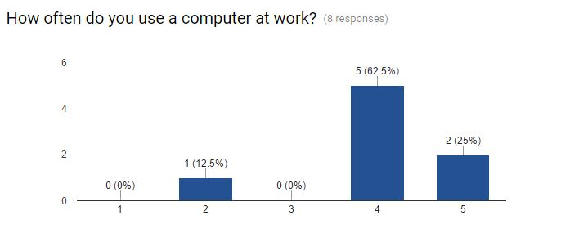

Figure 1

1. The second question was about how easy to use their system is. The results were quite interesting as it varied quite a bit from hospital to hospital. Some systems were very easy to use while others were very difficult. This could also mean that the level of comfort with computers varied among our results. Question 3 explores this further.

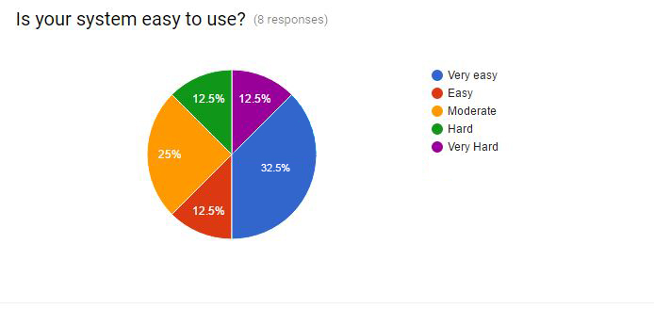

Figure 2

1. The third question was a follow up to the second which asked the user depending on what they answered why their system was hard or easy to use. We got some very good information from this question as a lot of responses we got back had to do with navigation. The systems that were easy to use were the ones that were easily navigable.

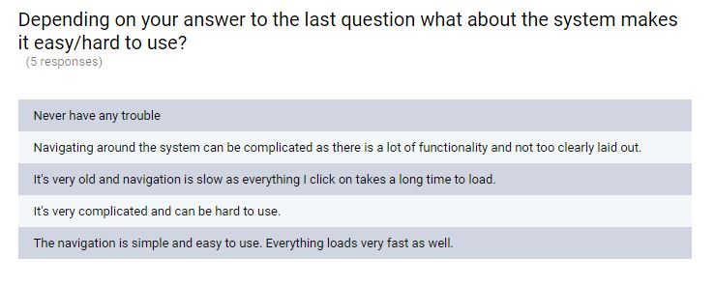

Figure 3

1. Fourth question was a ‘yes’ or ‘no’ question to help gauge the need for the system we are intending to build. The responses we got back clearly stated that the patient management system made their day to day tasks easier in the clear majority of responses we got.

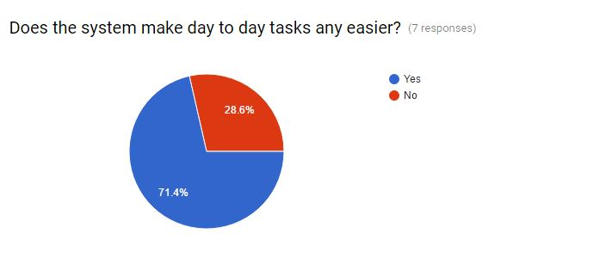

Figure 4

1. Our fifth question was asked to see what kind of support the people in the hospital have if the system was to have any kind of issues. This would tell us how much we would need to support our system after installing it in a hospital. Our results came back with 50% of the answers being staff of a hospital with an IT department who had developed their system and would manage the system if needed and 50% of answers being staff of hospitals who outsourced their patient management system or staff who seek support from management or elsewhere rather than an IT department.

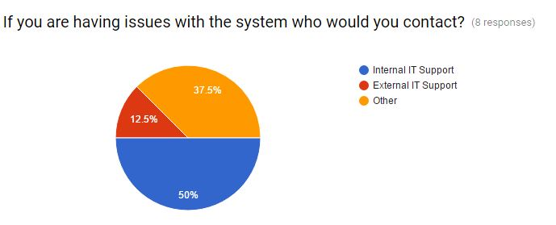

Figure 5

1. The sixth question focused on the integrity of the information in their current system and if they would trust it. This would let us know how much we need to focus on reminders and making sure information is up to date in our own system. The results were quite mixed with some responses being happy with trusting the system and others not so much. This question was a one to five scale with one being Inaccurate or outdated and five being very accurate.

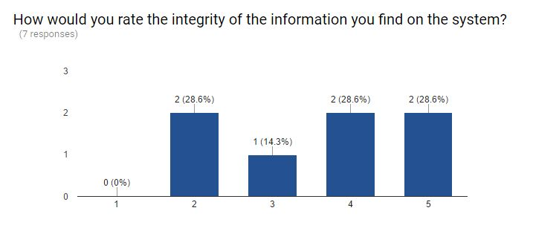

Figure 6

1. The seventh question was a simple question to see if patient invoices where a common thing in their patient management systems. The result was quite evenly split with 60% of responses not having any patient invoice system and 40% having one. While the results of this question were not definitive, we decided that we will implement this function in our system.

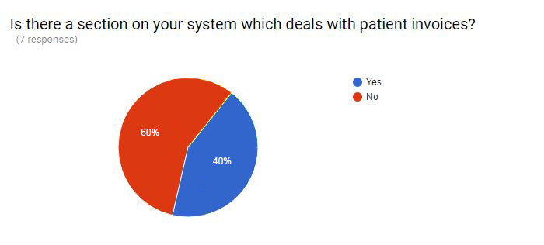

Figure 7

1. The eight-question focused on the efficiency of the system. This includes how well it displays data and how quickly the system works. This was gauged on a scale from one to five, one being the least efficient. The results showed that on average, patient management systems function relatively efficiently.

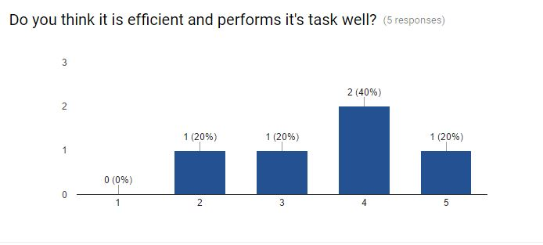

Figure 8

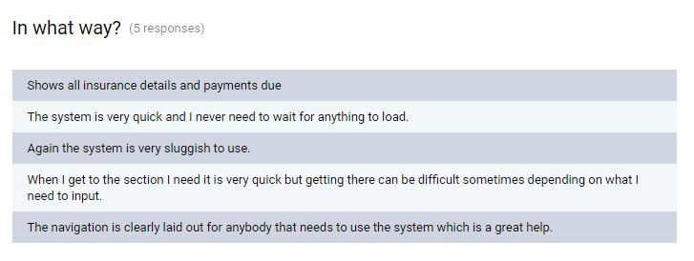

Figure 9

1. The ninth question was in relation to scheduling in the hospital. We wanted to see how important good scheduling systems are within current systems like this and how important it is for the people using these systems to know where the consultants are at any given moment of the day. The responses we got back were very different, some systems had very bad scheduling while others were very good. From our interview with a user of a patient management system like this it was clear that it is very important to have up to date and correct scheduling within a system like this and we will be incorporating that into our own.

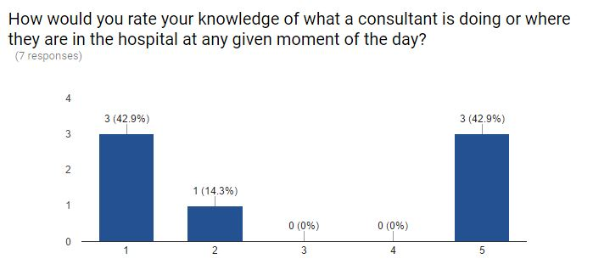

Figure 10Our tenth question was asking if the person using the system would like an in-built help system. Most the responses back would like a function like this and we will try to incorporate it into our own.

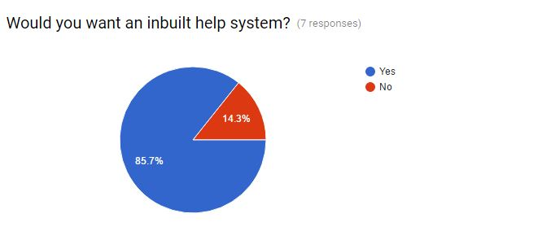

Figure 11

1. Our eleventh and final question was the most important of all and it was asking the user if they would want any functionality built into their current system that they don’t currently have. Some interesting responses that we will be trying to incorporate into our own system would be the timetabling, medication saving and personal accounts.

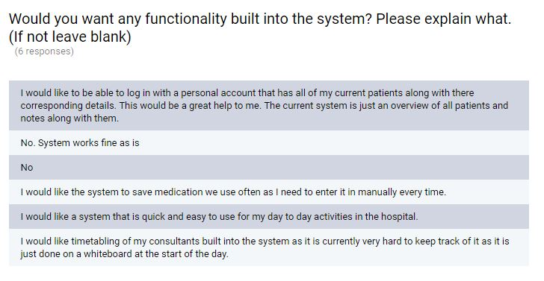

Figure 12

# User Requirements Capture for Proposed System

## System Narrative

The system will provide a hospital with the opportunity to control and track the processes within the building remotely and simply, offering wide amounts of functionality for members of staff who will use the system.

This system will be able to alleviate the high reliance on physical copies of patient information that are prone to being misplaced or lost, leading to patient frustration or harm if this information is not correctly documented. It will offer consultants simple ways of documenting patient information through digital means which will be stored and backed up immediately and does not impede a worker’s ability to input this information into the system due to a wide number of devices this system will be able to be used on (Desktops, PCs, Tablets, Large Scale Phones).

### System Features

The HPMS will offer security for a variety or users and will ensure only authorised users have access to information that is for them.

The first level of logins will be for consultants who will have access to all patient medical information on their patients that they have been assigned to. They will be able to edit this information and check the times of their consultation meetings that have been assigned to them. The inbuilt scheduling systems will ensure consultants keep to their schedules without needing to resort to outdated means of scheduling that current hospitals have installed.

The top layer of logins will be for the administrators of the system or the head of IT at the hospital. This security level of user will have access to input patients into the system, confirm and change current information stored about patients, check and input consultant’s timetables, admit and discharge patients and clarify payment methods and insurance policy, finally schedule patients in for consultations. Patients who are discharged will be automatically archived off to reduce system clutter and to easily pull this patient information up if they are to return to the hospital.

We may implement a management feature into the system later which will offer the person with this role the ability to manage payroll within the hospital. They would not have access to any of the functionality mentioned above.

### Patient Information

The system will offer a large variety of options for inputting patient information and will notify the consultant if certain information has not yet been received by the patient. Such as allergy information or previous medical history. This will be readily available to the people that have access to this information through the wide variety of devices this system can run on as mentioned in the opening paragraph. The core functionality of the patient information module on the system will be the wide variety of input fields (Such as previous medical history, blood type, current general practitioner etc.) referring to the patient that will be able to be expanded on if needs be.

### Security

With a system like this security is the up-most of responsibilities, since the system will be available on such a variety of devices it is vital to ensure information that is not intended for un-authorized users to be able to be viewed. This security will be achieved through password encryption, varying levels of access to the system and training of individuals to use the system safely and the importance of keeping passwords secret.

### System Calendar

The robust scheduling that will be in the system allows members of staff to keep on top of their daily schedules and notifies the user of the system if there are clashes in scheduling and to change times of consultations. The consultants will have the ability to view this information and the administrators of the system will be able to edit this information.

### Payment Control

Will offer simple ways of tracking costs of medical expenses using an inbuilt database that will store the cost of all medical procedures that a patient may have when they are at the hospital. The consultant will simply enter the procedure or medication that the patient is receiving and it is automatically added to their total bill, which is sent to the patient when they are discharged from the hospital. The information pertaining to the patient’s status of insurance will also be included, and the amount of which will be covered by it, if at all. The final amount will be emailed to the patients email address and a physical copy mailed to their home address for payment at a later date.

### Patient Archiving

When a patient is discharged from the hospital and no longer has active appointments they will automatically be archived off in the system. This will achieve two goals.

1. Reduce system clutter so patients that are no longer at the hospital and have no more appointments are not viewable unless you specifically go to the archived section of the system.
2. If the patient is to return to the hospital all their details are available and a flag will be set off to pull the patient out of archive and back into the main system.

### Help

The system will offer a variety of ways to contact the people who run the system. It offers robust error checking and helpful hints to general users if they are inputting something they should not be doing and will offer ways of getting in touch with people that run the system if there are problems the general user cannot fix or if functionality needs to be installed into the system.

## List of Requirements

Patients  
On the arrival of a patient to the hospital, the system will handle whether the patient is new or has had an episode previously in the hospital. If the patient has never been before, the member of staff at the desk will walk them through a series of questions, which will be displayed on the system. These questions will include contact details, details of next of kin, general practitioner info, previous illnesses, medical card status and insurance information. The system will then generate a medical record number for the patient, which will be used as the primary key for the patient. If the patient has been in the hospital previously, their information will appear on screen for the member of staff at the initial point of contact to be confirmed with the patient. There will also be an archive flag, which will be used to store a patient’s record in a secure location upon the status of the flag. This flag will only be true when there are no appointments or ongoing visits for the patient, and will be automatically set to false upon booking of appointment or admission to the hospital.

Appointments  
If patients are not in the hospital at the referral of their general practitioner, they will be looking to see a doctor in relation to an illness. The member of staff at the desk will take note of this, as reason for admittance, on the system. If the patient was referred by their general practitioner, this will be taken note of and it will be necessary for the consultant to contact the general practitioner for details of the admittance. Appointments will be handled using an algorithm designed to order patients by severity of illness and consultant required. The consultant’s availability will also be considered, based on a timetabling system implemented on the system. During an appointment, a diagnosis will be made and prescription added to the patient’s chart in the system. Alternatively, if necessary, a patient will be requested to stay overnight for more tests, or to return if there are no free beds in the appropriate ward. An automated check will be in place running every night to see if patients who were admitted that day were staying overnight. If not, there discharge date will be set to the same day, and that patient’s records archived if there are no more action for the patient.   
  
Standby List  
In some cases it may be necessary to send a patient home with an appointment for them to return to the hospital. The return of the patient will be handled by the system, by storing patients in a buffer, to be handled upon the next appropriate patient’s discharge. The buffer will be called a standby list, and these patients will be handled by an algorithm that checks the consultant and ward, and notifies the patient on the discharge of a patient in that ward and assigned to that consultant, thus preventing overcrowding. There will be a standby list for each ward.

Visits Will detail the location of a patient in the hospital, by ward. They will also show the consultant assigned to that patient. Visits will be considered ongoing until the patient is discharged by their consultant. The events which occur during the visit will be only visible to the consultants and other medical staff on the patient’s chart.

Payment

Initially, bills will be generated based on a flat rate for appointments, visits and prescriptions. We would like to implement a costing system for each of these and apply it to the billing in the future. A bill will be generated as mentioned, and when a patient intends to pay an invoice will be generated by the system, deducting the amount covered by the Insurance company and the portion covered by the medical card. If both cover the cost of the entire bill, this function will return an informative message stating that the bill is covered. The bill will be generated from the information stored in the chart.  
  
SearchThere will be a search function intended for patients, which will allow administration personnel to search archived patients by contact details and medical personnel to search by any medical criteria, including consultant.

ManagementOnce the patient management is complete and working, we would like to add a level of access for management, which allow for the addition and subtraction of staff members, as well as overriding and setting the access of other staff members. There will also be a function to view payroll, contact information and medical history in relation to each member of staff.

# Use Case Model

## Use Case Diagram



Figure 13

The above is the Use Case Diagram of the system we are implementing. It details the basic functions which the system will be aimed at performing, and the actors who will interact with the system both directly and indirectly.



Figure 14

We have also speculated on the functions which we would like to add to the system, but this will depend entirely on the success of the initial implementation.

## Use Case Descriptions

|  |  |
| --- | --- |
| Case Name | Search Patients |
| Overview | Staff search for patient on system based on set criteria |
| Actors | Patient, Staff |
| Pre-requisite cases | Add Patient |
| Post cases | Make Appointment, Pay Excess, Admit Patient, Add Patient, Change Details |
| Use Case Description | 1. Patient supplies info including first name, last name, phone number, and home address which are entered into the system. 2. System searches database for patients with the same name and returns several rows showing rest of the information for that patient in subsequent columns. 3. Staff member finds row with all correct information 4. Staff Member proceeds with next case |
| Alternate Scenarios | 1. Patient does not have relevant information 2. System does not find any patients with the relevant information. If the potential patient wishes to proceed then the staff member will carry out the Add Patient case |

|  |  |
| --- | --- |
| Case Name | Add Patient |
| Overview | Add a Patient/Potential Patient to the database |
| Actors | Patient, Staff |
| Pre-requisite cases | Search Patient |
| Post cases | None |
| Use Case Description | 1. Patient requesting services is searched on the system and not found. 2. Staff Member asks Patient questions regarding all information stored on Patients in the system. 3. Staff member adds this information (name, phone number home address, symptoms etc.) and creates a new Patient in the system. |
| Alternate Scenarios | 1. Patient is already on system 2. Patient is not willing to provide details. |

|  |  |
| --- | --- |
| Case Name | Change Details |
| Overview | Change the existing details of a patient on the system |
| Actors | Patient, Administration |
| Pre-requisite cases | Search Patient, Add Patient |
| Post cases | None |
| Use Case Description | 1. Patient notifies administration staff that they would like to change details on the system 2. Staff searches patient 3. Staff changes detail (name, phone number home address, symptoms etc.) |
| Alternate Scenarios | 1. Patient can’t be found on the system. 2. Detail had already been changed |

|  |  |
| --- | --- |
| Case Name | Make Appointment |
| Overview | Patient makes an appointment to see a Consultant |
| Actors | Patient, Administration, Consultant |
| Pre-requisite cases | Search Patient, Add Patient |
| Post cases | Add to Standby List, Admit Patient, Write Prescription |
| Use Case Description | 1. Patient states that they would like to speak to a consultant 2. Administration staff makes an appointment based on the availability of the Consultant. Which is input into the system. 3. Patient returns on the agreed time and date |
| Alternate Scenarios | 1: Patient specifies nature of illness and a specific consultant is chosen accordingly  2 and 3: Administration directs Patient to A&E if the illness is severe (appointment date set to today)  5: Consultant adds them to the standby list if the relevant ward is full. |

|  |  |
| --- | --- |
| Case Name | Pay Excess |
| Overview | Patient pays the extra medical costs after insurance deductions. |
| Actors | Patient, Insurance Company, Administration |
| Pre-requisite cases | Make Appointment, Admit Patient, Discharge Patient. |
| Post cases | None |
| Use Case Description | 1. When insurance has been deducted, final bill is sent to patient. 2. Patient receives bill through email This is sent by the system. 3. Bill for patient is stored in their patient information in the system. 4. Patient pays excess through online system. |
| Alternate Scenarios | 1: Insurance has fully covered the cost of medical expenses, no excess needs to be paid.  3: Patient has no way of paying through online system sends cheque instead. |

|  |  |
| --- | --- |
| Case Name | Add to Standby List |
| Overview | No beds available for patient on specific ward. Patient put on standby list. |
| Actors | Patient, Medical Staff |
| Pre-requisite cases | Add Patient, Make Appointment. |
| Post cases | Admit Patient, Discharge Patient |
| Use Case Description | 1. Patient makes appointment to see consultant. 2. Ward that patient needs to go to is full. 3. Patient is put on standby list by administrator through the system. 4. Patient is given bed once a spot is free. |
| Alternate Scenarios | 2: Patient needs emergency medical aid. Patient is admitted to A&E for appointment today. |

|  |  |
| --- | --- |
| Case Name | Admit Patient |
| Overview | Once an appointment has been made the patient is admitted to a ward. |
| Actors | Patient, Medical Staff |
| Pre-requisite cases | Make Appointment |
| Post cases | Discharge Patient |
| Use Case Description | 1. Once the patient makes an appointment the ward is checked by the system to see if a bed is free. 2. If the bed is free the patient is notified on what ward they will be in. 3. A bed is given to that patient until appointment time comes. |
| Alternate Scenarios | 2: If there are no beds the patient is put on the standby list. |

|  |  |
| --- | --- |
| Case Name | Discharge Patient |
| Overview | After patient receives treatment and is cured they are discharged from the hospital. |
| Actors | Patient, Medical Staff |
| Pre-requisite cases | Make Appointment, Admit Patient |
| Post cases | None |
| Use Case Description | 1. The patient attends appointments with consultant. 2. The patient receives appropriate treatment. 3. Medical staff clear patient for discharge. 4. Patient information is archived in the system. |
| Alternate Scenarios | 2: Patient is not yet cured and schedules another appointment.  4: There is still action to be taken with the patient, and so their information is not archived. |

|  |  |
| --- | --- |
| Case Name | Write Prescription |
| Overview | The patient needs medication that needs to be prescribed. |
| Actors | Patient, Consultant |
| Pre-requisite cases | Make Appointment, Admit Patient |
| Post cases | None |
| Use Case Description | 1. The patient meets with the consultant. 2. The illness the patient has needs prescribed medication. 3. The consultant checks the allergies of the patient. 4. The consultant prescribes the medication to the patient. |
| Alternate Scenarios | 3: The Patient is allergic to the medication that is needed.  4: Consultant prescribes medication that the patient is not allergic to. |

# Class Model

## Class Diagram



Figure 15