Data Structure and Algorithm

Laboratory Activity No. 2

Algorithm Analysis and Flowchart

|  |  |
| --- | --- |
| *Submitted by:* | *Instructor:* |
| Elpedes, Glen Jorge A. | Engr. Maria Rizette H. Sayo |

JULY, 26, 2025

# Objectives

Introduction

Data structure is a systematic way of organizing and accessing data, and an algorithm is a step-by-step procedure for performing some task in a finite amount of time. These concepts are central to computing, but to be able to classify some data structures and algorithms as “good,” we must have precise ways of analyzing them.

This laboratory activity aims to implement the principles and techniques in:

* Writing a well-structured procedure in programming
* Writing algorithm that best suits to solve computing problems to improve the efficiency of computers
* Convert algorithms into flowcharting symbols

# Methods

* 1. Explain algorithm and flowchart

-x, x<0

x, x ≥ 0

* 1. Write algorithm to find the result of equation: f (x) = and draw its flowchart
  2. Write a short recursive Python function that finds the minimum and maximum values in a sequence without using any loops

# Results

Present the visualized procedures done. Also present the results with corresponding data visualizations such as graphs, charts, tables, or image . Please provide insights, commentaries, or explanations regarding the data. If an explanation requires the support of literature such as academic journals, books, magazines, reports, or web articles please cite and reference them using the IEEE format.

Please take note of the styles on the style ribbon as these would serve as the style format of this laboratory report. The body style is Times New Roman size 12, line spacing: 1.5. Body text should be in Justified alignment, while captions should be center-aligned. Images should be readable and include captions. Please refer to the sample below:

Algorithm

An algorithm is a set of step-by-step instructions used to solve a specific problem or complete a particular task. It tells you exactly what to do, in what order, to achieve the desired outcome.

Flowchart

A **flowchart** is a **diagram** that represents an algorithm or a process using different shapes connected by arrows. Each shape has a specific meaning and helps visualize the flow of steps clearly.

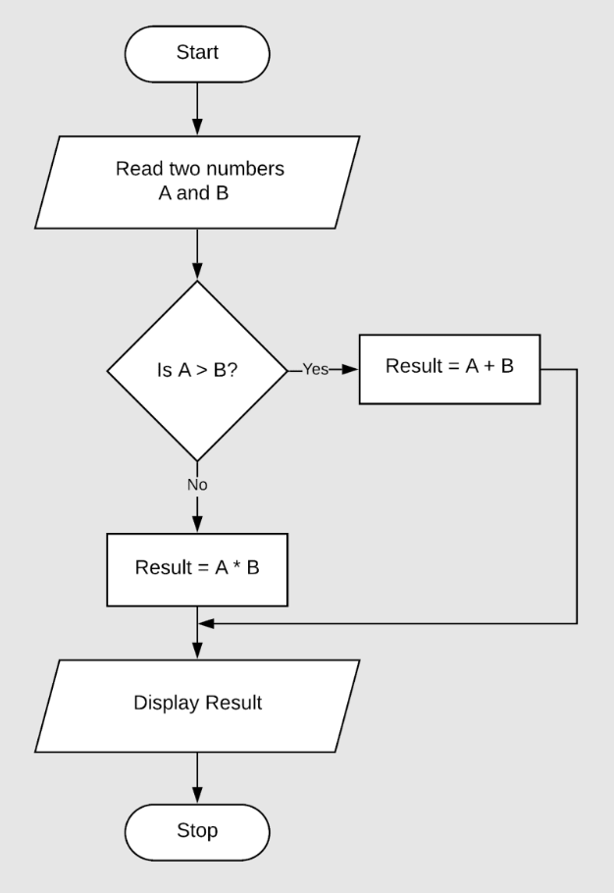

Figure 1. flowchart

**B.**

Algorithm

**Step 1:** Start

**Step 2:** Input of value of x

**Step 3:** If x < 0, then set f = -x

**Step 4:** Else, set f = x

**Step 5:** Output

**Step 6:** Stop

Flowchart

1.Start

2.Input the value of x

3.x < 0?

4.If yes, head to 6

5.If no, head to 7

6.f = -x

7.f = x

8.Output of f

9.Stop

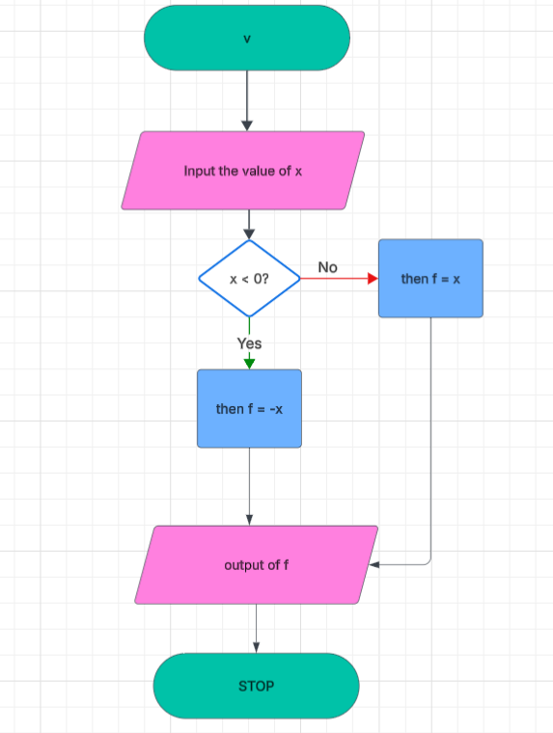

Figure 2. Flow Chart

C.

def find_min_max_helper(seq, index, current_min, current_max):

    if index == len(seq):

        return current_min, current_max

    current_min = min(current_min, seq[index])

    current_max = max(current_max, seq[index])

    return find_min_max_helper(seq, index + 1, current_min, current_max)

def find_min_max(seq):

    if not seq:

        raise ValueError("Sequence is empty")

    return find_min_max_helper(seq, 1, seq[0], seq[0])

numbers = [10, 30, 20, 9, 7, 35, 11]

minimum, maximum = find_min_max(numbers)

print(f"Min: {minimum}")

print(f"Max: {maximum}")

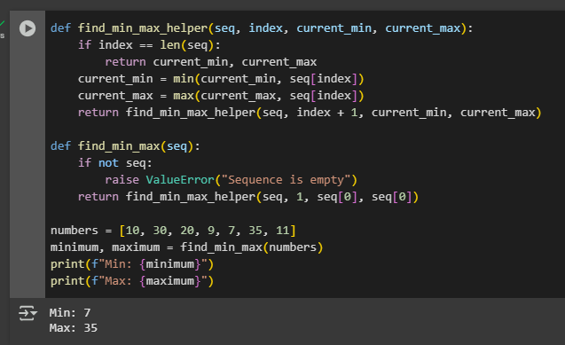

# Conclusion

This version of the code still finds the smallest and largest numbers in a list, just like the original but it does things a bit smarter. Instead of breaking the list into smaller pieces every time (which uses more memory), it keeps track of where it is using an index and updates the minimum and maximum as it goes. This makes the function more efficient and better for longer lists. In simple terms, it still gets the job done, just in a cleaner and more thoughtful way.

**References**

<https://www.bing.com/newtabredir?url=https%3A%2F%2Fwww.rechargecolorado.org%2Falgorithm-and-flowchart-for-addition-of-two-numbers-in-excel%2F>