Data Structure and Algorithm
Laboratory Activity No. 13

Tree Algorithm

Submitted by: | Instructor:
Elpedes, Glen Jorge A. | Engr. Maria Rizette H. Sayo

November, 08, 2025

Objectives
Introduction
An abstract non-linear data type with a hierarchy-based structure is a tree. It is made up of links connecting nodes (where the data is kept). The root node of a tree data structure is where all other nodes and subtrees are connected to the root.

This laboratory activity aims to implement the principles and techniques in:
- To introduce Tree as Non-linear data structure
- To implement pre-order, in-order, and post-order of a binary tree
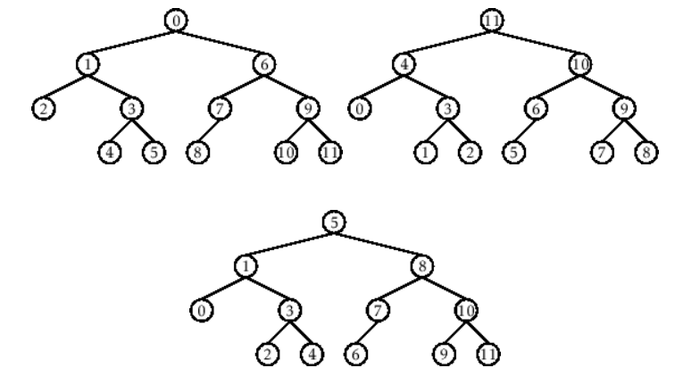

- Figure 1. Pre-order, In-order, and Post-order numberings of a binary tree

Methods
  - Copy and run the Python source codes.
  - If there is an algorithm error/s, debug the source codes.
  - Save these source codes to your GitHub.
  - Show the output

    - Tree Implementation

class TreeNode:
def __init__(self, value):
self.value = value
self.children = []

def add_child(self, child_node):
self.children.append(child_node)

def remove_child(self, child_node):
self.children = [child for child in self.children if child != child_node]

def traverse(self):
nodes = [self]
while nodes:
current_node = nodes.pop()
print(current_node.value)
nodes.extend(current_node.children)

def __str__(self, level=0):
ret = " " * level + str(self.value) + "\n"
for child in self.children:
ret += child.__str__(level + 1)
return ret

# Create a tree
root = TreeNode("Root")
child1 = TreeNode("Child 1")
child2 = TreeNode("Child 2")
grandchild1 = TreeNode("Grandchild 1")
grandchild2 = TreeNode("Grandchild 2")

root.add_child(child1)
root.add_child(child2)
child1.add_child(grandchild1)
child2.add_child(grandchild2)

print("Tree structure:")
print(root)

print("\nTraversal:")
root.traverse()

Questions:
- When would you prefer DFS over BFS and vice versa?
- What is the space complexity difference between DFS and BFS?
- How does the traversal order differ between DFS and BFS?
- When does DFS recursive fail compared to DFS iterative?

Results
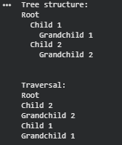
Figure 1: Tree Structure

1. I would prefer DFS over BFS when memory is concern, when finding paths between two nodes in a tree, if the memory is concern, and if you need to check connectivity or cycles. If I would prefer BFS over DFS if you need the shortest path in a graph\tree if it level order traversal in trees, when you need find all nodes at specific distance, when the graph is shallow but wide.
2. The space complexity difference between DFS and BFS in a tree are DFS it can be used in a tree for knowing the maximum height or depth then BFS it can be used in a tree for knowing the maximum width.
3. In DFS explores as deep as possible along one branch before backtracking. It goes down one path completely before moving to the next path and In BFS it explores all nodes at the same level before moving deeper. It goes level by level through the tree\graph.
4. Recursive DFS may not work in very deep trees, including skewed trees with only one child per node. Because it depends on the system's call stack, which has a finite depth and may result in a stack overflow error, this occurs. However, Iterative DFS can safely handle many deeper trees since it makes use of an explicit stack in heap memory. For big or unbalanced trees, iterative DFS is therefore more dependable, even though recursive DFS is simpler.

Conclusion
To clear up, both DFS and BFS can be essential graph and tree traversal algorithms that are appropriate for many uses. While BFS investigates level by level and is perfect for finding the shortest path in unweighted graphs, DFS uses less memory in deep but narrow structures by exploring as far as feasible along a branch before turning around. While iterative DFS, which employs an explicit stack, is safer for big or skewed structures, recursive DFS is easier to build but can fail in very deep trees due to stack overflow. In general, the problem's memory efficiency, traversal order, and graph depth requirements determine which of DFS, BFS, and their implementations to use.

References
[1] GeeksforGeeks, “Difference between BFS and DFS,” GeeksforGeeks, Nov. 01, 2025. https://www.geeksforgeeks.org/dsa/difference-between-bfs-and-dfs/
[2] Wikipedia contributors, “Depth-first search,” Wikipedia, Oct. 23, 2025. https://en.wikipedia.org/wiki/Depth-first_search
[3] AlgoDaily, “AlgoDaily - Daily coding interview questions. Full programming interview prep course and software career coaching.” https://www.algodaily.com/lessons/dfs-vs-bfs

