Data Structure and Algorithm
Laboratory Activity No. 14

Tree Structure Analysis

Submitted by: | Instructor:
Elpedes, Glen Jorge A. | Engr. Maria Rizette H. Sayo

November, 08, 2025

Objectives
Introduction
An abstract non-linear data type with a hierarchy-based structure is a tree. It is made up of links connecting nodes (where the data is kept). The root node of a tree data structure is where all other nodes and subtrees are connected to the root.

This laboratory activity aims to implement the principles and techniques in:
- To introduce Tree as Non-linear data structure
- To implement pre-order, in-order, and post-order of a binary tree
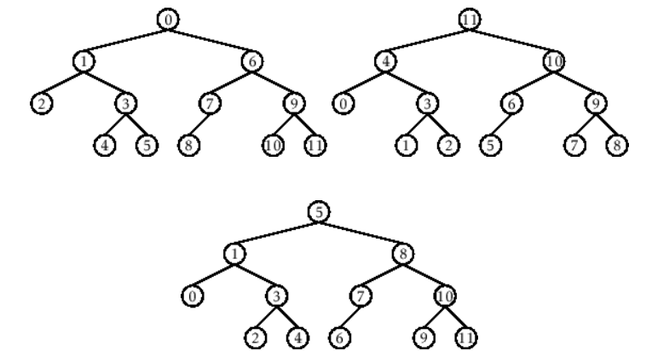

- Figure 1. Pre-order, In-order, and Post-order numberings of a binary tree

Methods
  - Copy and run the Python source codes.
  - If there is an algorithm error/s, debug the source codes.
  - Save these source codes to your GitHub.
  - Show the output

    - Tree Implementation

class TreeNode:
def __init__(self, value):
self.value = value
self.children = []

def add_child(self, child_node):
self.children.append(child_node)

def remove_child(self, child_node):
self.children = [child for child in self.children if child != child_node]

def traverse(self):
nodes = [self]
while nodes:
current_node = nodes.pop()
print(current_node.value)
nodes.extend(current_node.children)

def __str__(self, level=0):
ret = " " * level + str(self.value) + "\n"
for child in self.children:
ret += child.__str__(level + 1)
return ret

# Create a tree
root = TreeNode("Root")
child1 = TreeNode("Child 1")
child2 = TreeNode("Child 2")
grandchild1 = TreeNode("Grandchild 1")
grandchild2 = TreeNode("Grandchild 2")

root.add_child(child1)
root.add_child(child2)
child1.add_child(grandchild1)
child2.add_child(grandchild2)

print("Tree structure:")
print(root)

print("\nTraversal:")
root.traverse()

Questions:
- What is the main difference between a binary tree and a general tree?
- In a Binary Search Tree, where would you find the minimum value? Where would you find the maximum value?
- How does a complete binary tree differ from a full binary tree?
  - What tree traversal method would you use to delete a tree properly? Modify the source codes.

Results
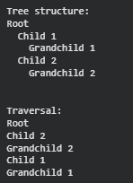
Figure 1: Tree Structure
1. In a binary tree, each node can have only up to two children, typically referred to as the left child and the right child. This structure makes binary trees efficient for operations like searching and sorting, as seen in binary search trees. On the other hand, a general tree allows each node to have any number of children, making it more flexible for representing hierarchical data such as file systems or organizational charts. Therefore, while binary trees are more structured and limited, general trees provide greater versatility in data organization.

2. Because each value on the left of a node in a Binary Search Tree is less than the node itself, the minimum value is located at the node on the left. You keep going to the left child until there are no more left nodes in order to locate it. In a similar vein, as all values to the right are greater than the present node, the maximum value is located at the node on the right. To find it, keep going to the right kid until you get to the final node on that side.

3. In exception of the last degree, which is filled from left to right without any gaps, a complete binary tree is one in which every level is fully filled. On the other however, no node in a full binary tree has a single child; instead, each node has either 0 or 2 children. This implies that all internal nodes in a full binary tree must have two children, and that the nodes' placement or filling is what matters in a complete binary tree. As a result, not all complete binary trees are full, and not all full binary trees are complete.

4. The best technique for correctly deleting a tree is a post-order traverse. In languages that need human memory management, this guarantees that all child nodes are processed and eliminated before their parent, avoiding orphaned nodes and memory leaks. This method explicitly specifies the de-referencing order even in Python, where garbage collection manages memory. I've included a delete_tree method that applies this idea to your TreeNode class. Additionally, I've included a brief example to show how to utilize it.

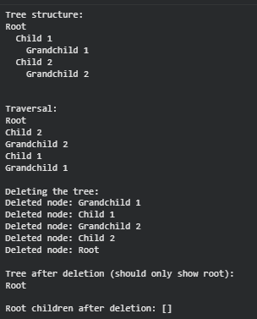

Conclusion
In conclusion, a post-order traversal approach in which all child nodes are removed before their parent node should always be used when deleting a tree. This avoids memory problems or partial deletions and guarantees that no references to child nodes are lost. The tree can be safely and totally erased by changing the code to include a delete_tree() method that recursively eliminates children first. This method emphasizes how crucial traversal order is for handling hierarchical data structures, such as trees.
.

References
[1] GeeksforGeeks, “Difference between Full and Complete Binary Tree,” GeeksforGeeks, Jul. 23, 2025. https://www.geeksforgeeks.org/dsa/difference-between-full-and-complete-binary-tree/
[2] GeeksforGeeks, “Minimum in a binary search tree,” GeeksforGeeks, Oct. 11, 2025. https://www.geeksforgeeks.org/dsa/find-the-minimum-element-in-a-binary-search-tree/
[3] “W3Schools.com.” https://www.w3schools.com/dsa/dsa_data_binarysearchtrees.php

