Data Structure and Algorithm
Laboratory Activity No. 11

Implementation of Graphs

Submitted by: | Instructor:
Elpedes, Glen Jorge A. | Engr. Maria Rizette H. Sayo

October, 18, 2025

Objectives
Introduction
A graph is a visual representation of a collection of things where some object pairs are linked together. Vertices are the points used to depict the interconnected items, while edges are the connections between them. In this course, we go into great detail on the many words and functions related to graphs.
An undirected graph, or simply a graph, is a set of points with lines connecting some of the points. The points are called nodes or vertices, and the lines are called edges.

A graph can be easily presented using the python dictionary data types. We represent the vertices as the keys of the dictionary and the connection between the vertices also called edges as the values in the dictionary.
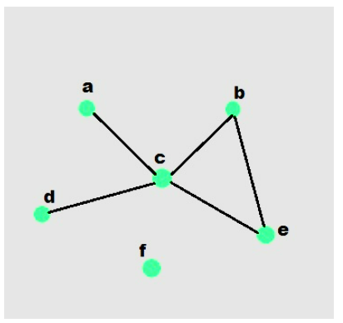

Figure 1. Sample graph with vertices and edges

This laboratory activity aims to implement the principles and techniques in:
- To introduce the Non-linear data structure – Graphs
- To implement graphs using Python programming language
- To apply the concepts of Breadth First Search and Depth First Search

Methods
  - Copy and run the Python source codes.
  - If there is an algorithm error/s, debug the source codes.
  - Save these source codes to your GitHub.

from collections import deque

class Graph:
def __init__(self):
self.graph = {}

def add_edge(self, u, v):
"""Add an edge between u and v"""
if u not in self.graph:
self.graph[u] = []
if v not in self.graph:
self.graph[v] = []

self.graph[u].append(v)
self.graph[v].append(u) # For undirected graph

def bfs(self, start):
"""Breadth-First Search traversal"""
visited = set()
queue = deque([start])
result = []

while queue:
vertex = queue.popleft()
if vertex not in visited:
visited.add(vertex)
result.append(vertex)
# Add all unvisited neighbors
for neighbor in self.graph.get(vertex, []):
if neighbor not in visited:
queue.append(neighbor)
return result

def dfs(self, start):
"""Depth-First Search traversal"""
visited = set()
result = []

def dfs_util(vertex):
visited.add(vertex)
result.append(vertex)
for neighbor in self.graph.get(vertex, []):
if neighbor not in visited:
dfs_util(neighbor)

dfs_util(start)
return result

def display(self):
"""Display the graph"""
for vertex in self.graph:
print(f"{vertex}: {self.graph[vertex]}")

# Example usage
if __name__ == "__main__":
# Create a graph
g = Graph()

# Add edges
g.add_edge(0, 1)
g.add_edge(0, 2)
g.add_edge(1, 2)
g.add_edge(2, 3)
g.add_edge(3, 4)

# Display the graph
print("Graph structure:")
g.display()

# Traversal examples
print(f"\nBFS starting from 0: {g.bfs(0)}")
print(f"DFS starting from 0: {g.dfs(0)}")

# Add more edges and show
g.add_edge(4, 5)
g.add_edge(1, 4)

print(f"\nAfter adding more edges:")
print(f"BFS starting from 0: {g.bfs(0)}")
print(f"DFS starting from 0: {g.dfs(0)}")

Questions:
    - What will be the output of the following codes?
    - Explain the key differences between the BFS and DFS implementations in the provided graph code. Discuss their data structures, traversal patterns, and time complexity. How does the recursive nature of DFS contrast with the iterative approach of BFS, and what are the potential advantages and disadvantages of each implementation strategy?
    - The provided graph implementation uses an adjacency list representation with a dictionary. Compare this approach with alternative representations like adjacency matrices or edge lists.
    - The graph in the code is implemented as undirected. Analyze the implications of this design choice on the add_edge method and the overall graph structure. How would you modify the code to support directed graphs? Discuss the changes needed in edge addition, traversal algorithms, and how these modifications would affect the graph's behavior and use cases.
    - Choose two real-world problems that can be modeled using graphs and explain how you would use the provided graph implementation to solve them. What extensions or modifications would be necessary to make the code suitable for these applications? Discuss how the BFS and DFS algorithms would be particularly useful in solving these problems and what additional algorithms you might need to implement.

Results
Present the visualized procedures done. Also present the results with corresponding data visualizations such as graphs, charts, tables, or image . Please provide insights, commentaries, or explanations regarding the data. If an explanation requires the support of literature such as academic journals, books, magazines, reports, or web articles please cite and reference them using the IEEE format.

1.
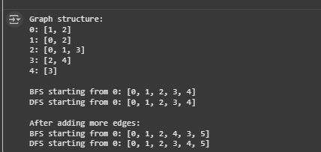

2. The primary distinction between BFS and DFS is the data structure they use, which dictates their traversal. BFS uses an iterative approach with a Queue to guarantee a level-by-level search, making it ideal for finding the shortest path in an unweighted graph. Conversely, DFS uses recursion and the Call Stack to perform a deepest-first exploration, quickly diving down branches. Although both algorithms have the same O (V + E) time complexity, the iterative BFS is more memory-stable than the recursive DFS, which risks a stack overflow on very deep graphs.

3. An adjacency list, which maps each vertex to a list of its neighbors, is the most efficient representation for sparse graphs due to its O (V + E) space complexity. In contrast, an adjacency matrix enables O (1) edge lookups but consumes O(V²) space, making it inefficient for graphs with few edges. While an edge list is space-efficient at O(E), it performs poorly for operations like neighbor lookups. Overall, the adjacency list strikes the best balance for traversals like BFS and DFS.

4. The graph is currently undirected because the add_edge(u, v) method adds connections in both directions. To make it directed, you can remove the line that adds the reverse edge (self.graph[v].append(u)), so edges go only from u to v. This change makes reachability one-way, which is useful for modeling asymmetric relationships like workflows or one-way streets. BFS and DFS will still work correctly by following the existing outgoing edges.

5. Social networking and road navigation are two real-world problems well-suited for the given graph structure. In social networks, users are vertices and friendships are undirected edges; DFS can find connected communities, while BFS helps determine degrees of separation. For road navigation, intersections are vertices and roads are edges, and modifying add_edge to create directed, weighted edges allows modeling one-way streets and travel times. In that case, BFS would no longer be sufficient

Conclusion

This Laboratory activity successfully illustrated the main difference between the Depth
First Search (DFS) and Breadth-First Search (BFS) algorithms, which is found in their underlying data structures: a Call Stack for DFS (via recursion) that explores as deeply as possible before backtracking, and a Queue for BFS that allows a level-by-level traversal perfect for finding shortest paths. Furthermore, sparse graphs, like those in the experiment, were effectively represented by using an adjacency list. The add_edge method must be modified to support directed and weighted graphs in order to model more complicated, real-world issues like road networks, as the original implementation only handled undirected edges, making it most appropriate for symmetric relationships.

References
[1] GeeksforGeeks, “Difference between BFS and DFS,” GeeksforGeeks, Jul. 11, 2025. https://www.geeksforgeeks.org/dsa/difference-between-bfs-and-dfs/
[2] “DFS vs BFS Algorithm (All Differences With Example),” WsCube Tech. https://www.wscubetech.com/resources/dsa/dfs-vs-bfs
[3] Raj, “Adjacency matrix vs. adjacency list,” HeyCoach Blog, May 28, 2025. https://heycoach.in/blog/adjacency-matrix-vs-adjacency-list/

