# Learning Objectives

1. To work on stimulus placement on screen
2. To work more independently using previous resources to support you
3. To build upon the methodology section from Week 3 to work on your assessment in class

# Activity 6.0

## Positioning Stimuli on Screen

**For your assessment you will be using pairs of words as your stimuli and you will need to position them on screen. This activity will show you how to position three images on screen, and the information can be extrapolated to help you position your text stimuli too. The principles are exactly the same.**

For this example, you are going to create a simple experiment called a Flanker task.

There will be three images presented simultaneously and the participant must decide if the stimulus in the centre is facing left or right and press z for left, and m for right. The outside ‘flanking’ stimuli will either be congruent (face the same way as the centre stimulus), or incongruent (face the opposite direction to the stimulus). See Figure 5 for four possible sample stimulus presentations (*there are more possibilities but for now we will just use the four shown*)

Figure

Incongruent Right

Congruent Left

Congruent Right

Incongruent Left

The trial visualisation looks like Figure 6

these stimuli change on every repeat

+

250ms

until keypress

(z or m)

300ms blank

Figure

1. What is the IV ___________________________________________________________________
2. What are the DVs ___________________________________________________________________
3. What might you hypothesise for this task? ___________________________________________________________________
4. Create a new root folder and call it **Flanker**. Inside create a **stims** folder and download the [**left and right images from this link here**](https://drive.google.com/drive/folders/158kQAzNQRaUoAxMNoiB5HvMpfEX-Xujs?usp=sharing) make sure they are placed into the correct folder on your computer
5. Create a **conds.xlsx** file and complete it as per Figure 7

Figure

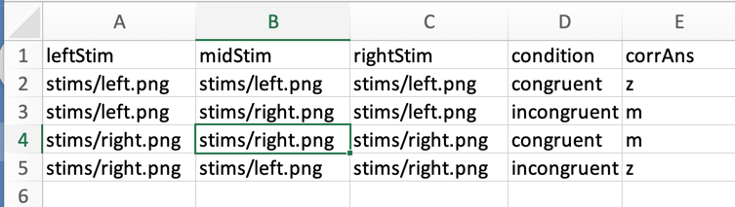

1. You can see from the **(logically named)** column headers where you will be positioning your stimuli, and each stimulus is named corresponding to the direction that the arrow is facing. Remember the **corrAns** relates to the **midStim.**

**You need to think carefully about the column headers for your assessment.**

1. Using your understanding from the first few weeks of EDP seminars, set up the bones of the experiment with a fixation routine, a trial routine and a blank screen routine, according to the visualisation
2. On the trial routine you will need **three image components**, and a **keyboard response** and you should complete all the appropriate properties to display the stimuli on screen
3. Set up the keyboard response to collect data for the correct answer
4. Add a **loop** to surround the three routines that comprise your trial
5. Add the **conds** file to the **loop**
6. **Save** and **Run**

**Do not worry about positioning the stimuli just yet, at the moment your stimuli will effectively be ‘sitting on top of one another’ in the centre of the screen**

# Activity 6.1

**Remember in Seminar 1 we told you that the monitor settings would be important? Well, here it is.**

Positioning stimuli can be tricky at times. We will be using pixels to position our stimuli but given that our monitors will all have different screen resolutions, which are measured in pixels, you may need to play about with the image component position properties to ensure the stimuli are positioned well on your screen.

In PsychoPy Builder the centre of the screen is represented as (0, 0) in the properties for anything that you want to be presented centrally, both horizontally and vertically on the screen. The x-axis is the horizontal axis, the y-axis is the vertical, and depending upon your monitor settings the numbers associated with the x and y axes will vary.

My monitor is (x) 1440 px wide, by (y) 900 px high. **You need to refer back to the Monitor settings video for more info.**

We want to place the stimuli centrally on the y-axis but vary the position to the left or right on the x-axis. To help us position the left and right stimuli, we need to know the image size, in this case it is (202, 209), then deduct the image width size from 0 on the x-axis, and then we will allow some extra pixels for padding between the stimuli.

1. The position of **midStim** should remain as **(0, 0)**
2. Change the position of the **leftStim** to **(-220, 0)**
3. Change the position of the **rightStim** to **(220, 0)**
4. If you were positioning your stimuli on the y-axis you can use Figure 4 for the screen layout, and the +/- directions each axis

Figure 4

x-axis

y-axis

**(0, 0)**

**([-pixels], 0)**

**(0, [-pixels])**

**(0, [pixels])**

**([pixels], 0)**

**(x, y)**

**(x, y)**

**(x, y)**

**(x, y)**

1. Using the skills from last week (Method 2 for height units), you should try to position your Flanker stimuli using height instead of pixels

# Activity 6.2

1. Add instructions and debrief
2. Add a practice block
3. Increase the number of reps of trials to 30, save and run