DAY 1 – Implementing Memory Map

Memory Map and Data Allocation:
- Scheduler 512 bytes
- Each task 1024 bytes
- ARM Cortex M Fully descending stack model grows towards lower memory addresses. Therefore, we initialize stack pointer at high memory address.
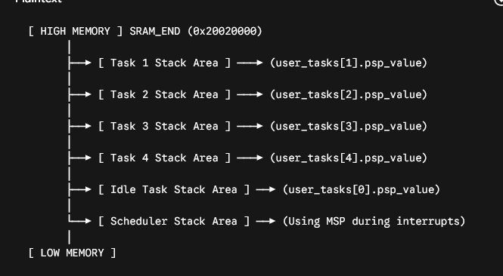
When it comes to deciding where the scheduler stack, idle task stack must live, it all comes down to a design choice. Technically, they can be anywhere.

Now, in our implementation, we’re going to use 3 states:
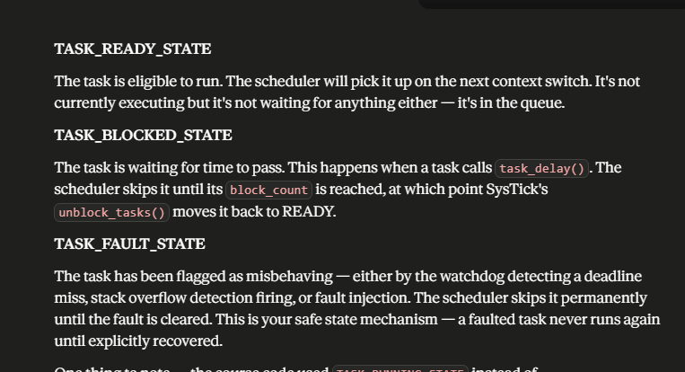
We also have some extra fields in the TCD struct:
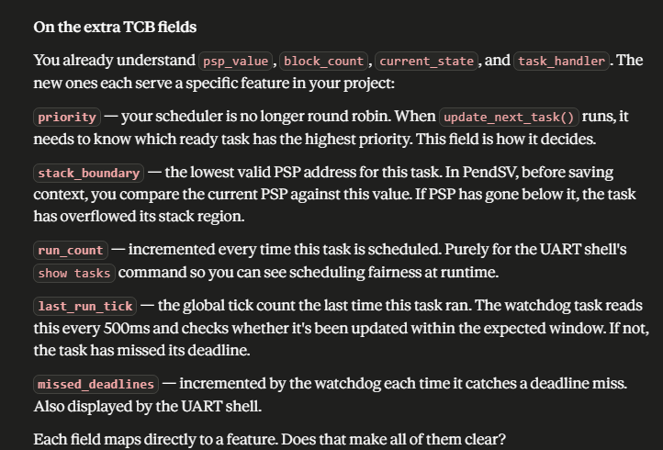

Now we being our implementation of init_tasks_stack()
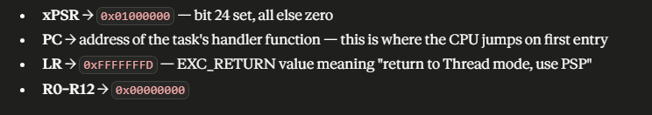
Wrt to why we use that EXC_RETURN value:
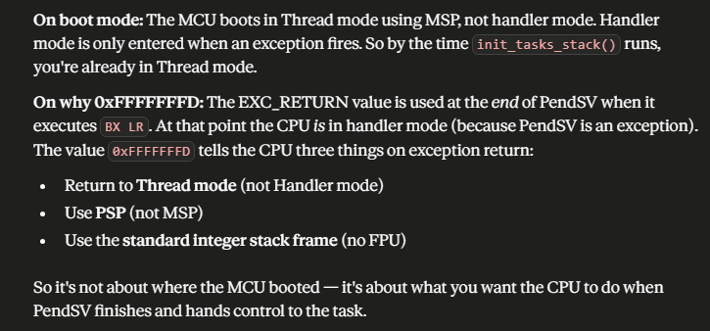

- The main reason we use inline assembly is because C has no way to directly access CPU registers like MSP, PSP or CONTROL. Anything touching those registers directly needs inline assembly.
- The main reason we use attribute naked functions is because compiler generates stack setup ode (prologue and epilogues) which can modify the state of the registers.

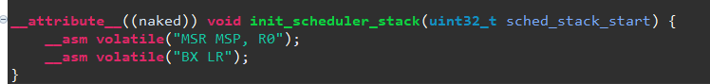
- Remember, according to AAPCS, R0 holds the first argument of the function.

Remember, up intil switch_sp_to_psp() is called, everything is running on MSP. MSP is for scheduler stack i.e kernel and ISR. User tasks must run on PSP, so switch_sp_to_psp is the transition point
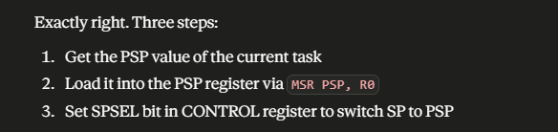
- When it comes to changing the SP to PSP, above are the steps that we need to do.

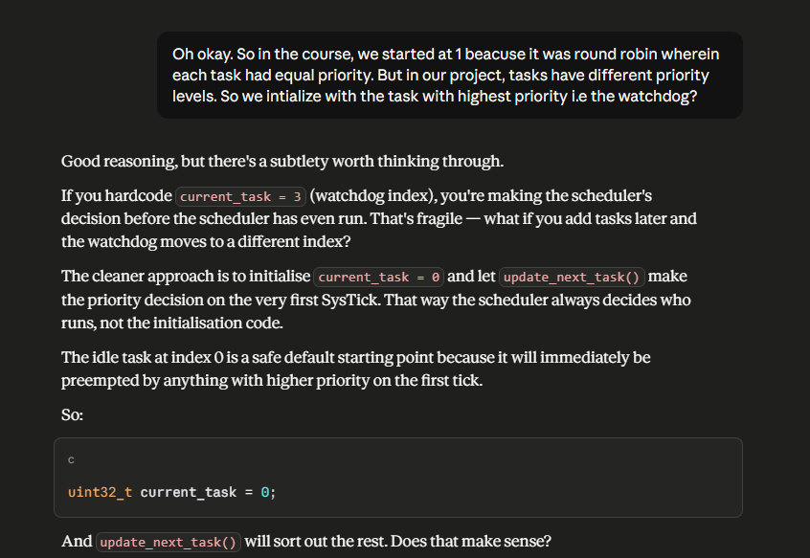
- Small detail regarding initializing of current_task. Should be set to 0 as a safe default.

MOV vs LDR in switch SP to PSP:
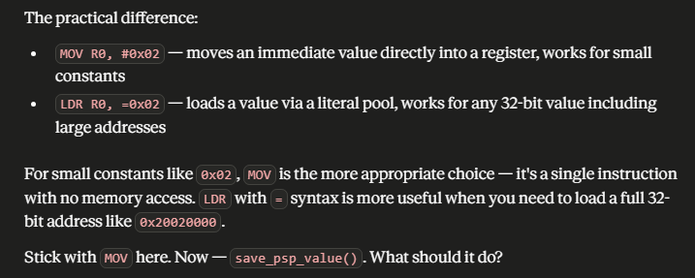
So basically, LDR is more appropriate when dealing with larger numbers

Now, we implement PendSV handler (context switching and retrieving)
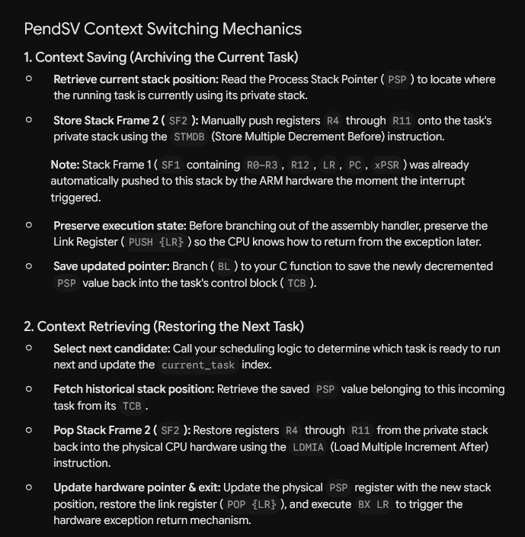
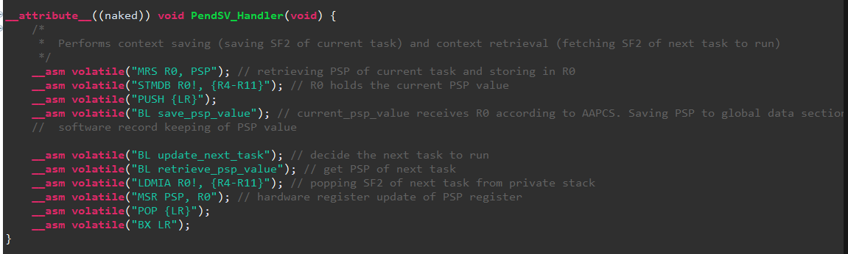
- BL save_psp_value we used this just for software record keeping. Stores the PSP value in the TCB struct in RAM so the scheduler remembers where this task’s stack is
- MSR PSP, R0 since this is the next task that is to run, we update the actual PSP CPU register.

