Unit 1 : My First Day

What is your name?

What is this?

Please (line up/sit down/stand up).

Hello!
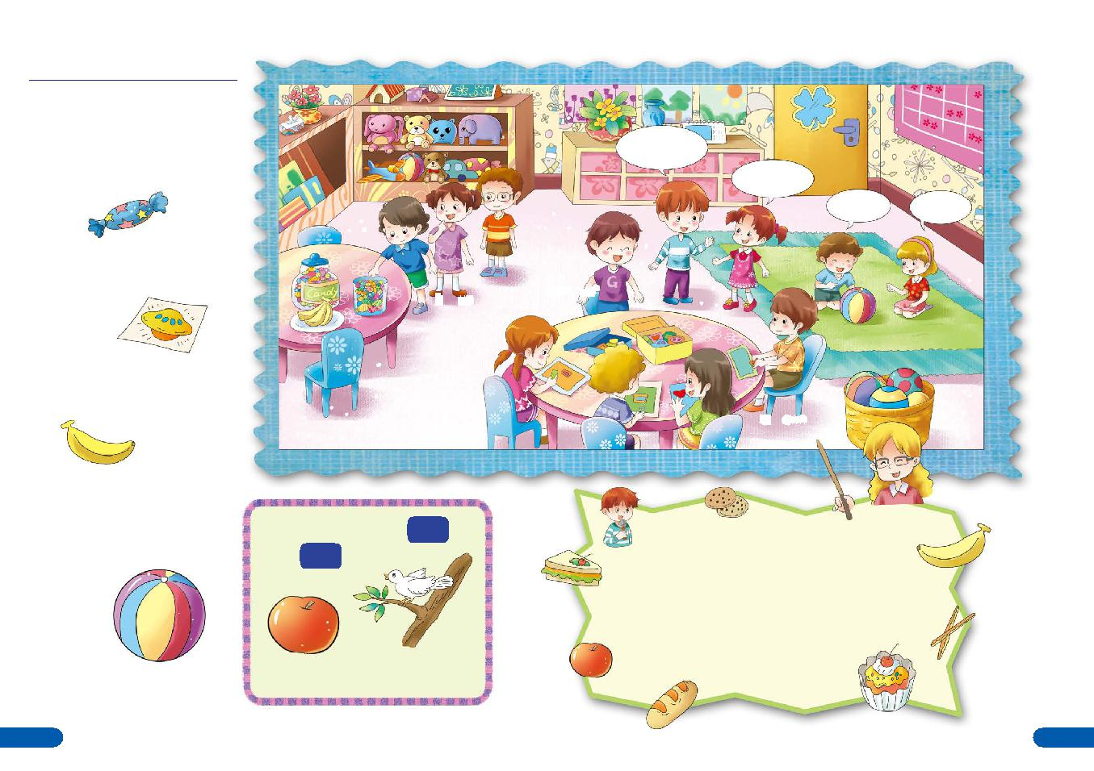
My name is Curt.

Hi! I am Cindy.

What is this? It is a ball!

candy

line up | stand up

sticker

banana

B

A

ball

Apple Bird

sit down

Snack Song

I like snacks, They are fun!

I will eat them till I'm done, Snack time, snack time, it is great! Snack time, snack time, I can't wait! "May I eat now?"

"Yes, you may."

1 2

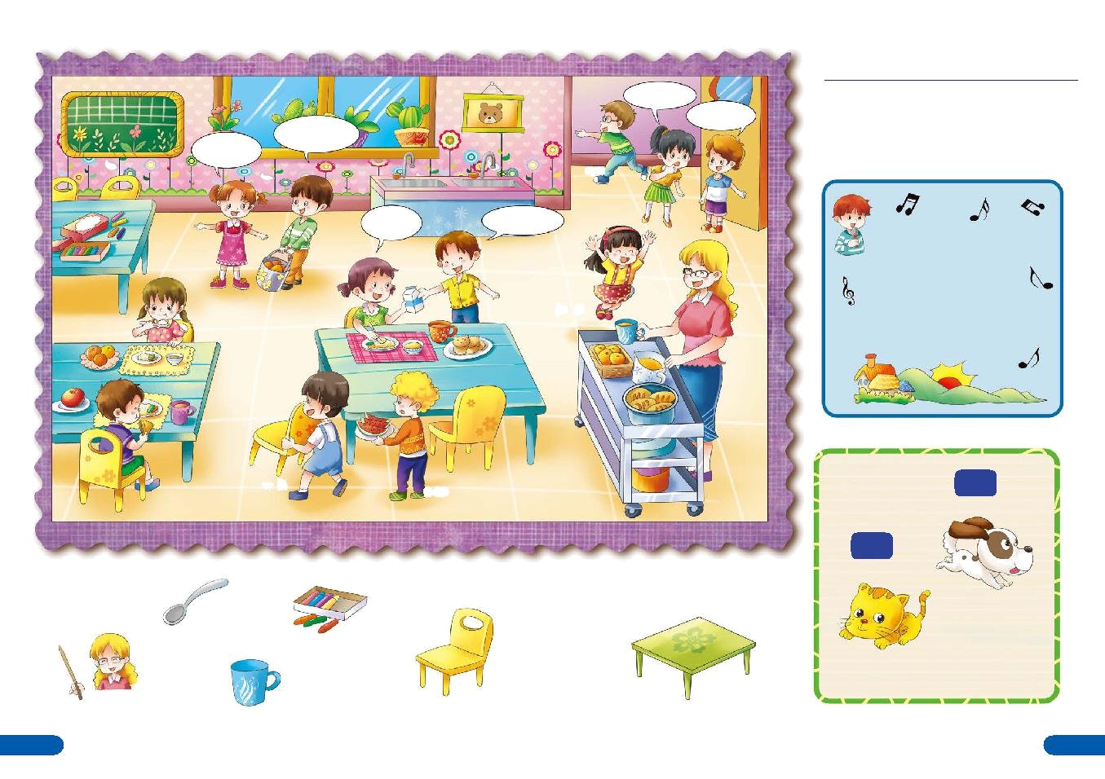

May I come in?

Yes, you may.

Where is the table?

There it is.

run

Thank you. You are welcome.

jump

walk | stop
Unit 2 : Thank You Week

May I ______?

Where is the _____?

Show me how to (walk/run/stop/jump).

Good Morning Song

Good morning to you,

Good morning to you,

Good morning, dear teacher.

Good morning to you.

D

C

Dog

spoon | crayons
Cat

teacher | cup | chair | table

3 4

