Student ID : 6212578
Student Name: Almeda Glenn Paolo Maestro

Interpreted Requirements of the program
- Program should be able to tell whether input provided by user is wrong and act accordingly.
- Program should be set up such that it can be maintained in the future.
- Create a black box container (MissionPlan) that controls all other classes.
- Display the relevant output using formulae that is not overly complicated.

Summary of Implementation of Modules
- Application
  - This is the main program where all of the components are joined together.
  - Any errors detected will always go into MissionPlan class. The MissionPlan class will then pinpoint the location of the error.
- LocationData
  - The location data class that is part of PointTwoD class.
  - This is a container class that contains the statistics related to the star system (sun type, num earth planets, num earth moons, particle & plasma density).
  - It has a function to check if sunType input is valid [bool CheckSunTypeInput(string input)].
  - It calculates the civilization index of the system based on the star system components [CalculateCivIndex(string sunType, int noOfEarthLikePlanets, int noOfEarthLikeMoons, float aveParticleDensity, float avePlasmaDensity)].
- PointTwoD
  - The main class referenced by MissionPlan class to perform its tasks.
  - It contains mainly the coordinates of the star system.
  - It contains the LocationData class to extend on its original functionality which enables the class to do calculations like “Distance from Space Centre” and “Civilization Index”.

- NewEntryInput
  - This class handles the first interaction of MissionPlan class - input new statistical data.
  - The creation of this class is to address the complexity of error checking of user input.
  - While it is possible to do it in MissionPlan class, MissionPlan class will end up being too big to be able to be maintained properly.
  - This class also makes use of the concept of “Finite State Machine”, an Artificial Intelligence term where the program will run through different “states” that will influence the outcome of the program’s interaction with the user.
  - The system of this class is as follows:
    - 1) Display output asking for input from user
    - 2) Once the user enters his input, it will check the input depending on where the input stage is (starting with coordinate X and ends with plasma density)
    - 3) If input does not conform to the required type (eg. sunType input is invalid), the program will display an error output and request for new input
    - 4) If input is successful, it will move on to the next required data
    - 5) If there are no more new data to be captured, the class will construct a new PointTwoD object and LocationData object and return it to the MissionPlan class to store the new entry

Diagram of Program Design

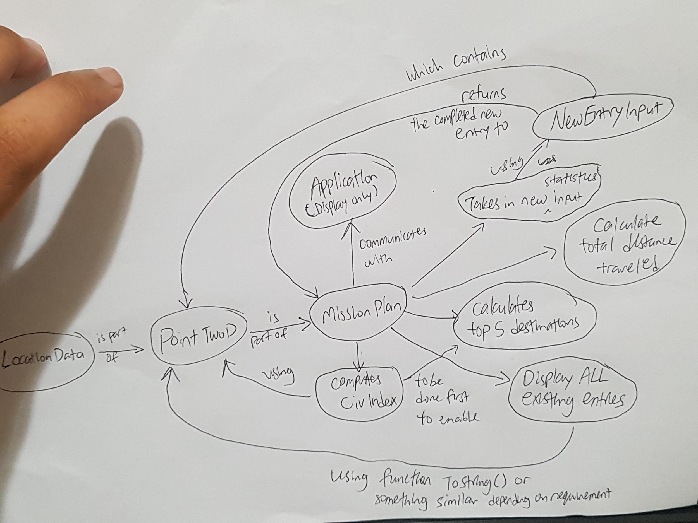

The most important thing to note in this diagram is that:
- All of the interactions from user will be handled by MissionPlan class.
- MissionPlan class will delegate tasks to other classes depending on the request.
- Application holds the int main() function which is primarily to provide the interface for interaction.

Reflections

- Assumptions Made
  - MissionPlan will be the center of the program
  - Doing the error checking in the input of new data will be easy
  - Things learnt from C# can be carried over (syntax and techniques)

- Design Assumptions
  - MissionPlan class was intended to be the main driver of the application
    - NewEntryInput, PointTwoD and LocationData classes are all part of this main class
  - Common code should be condensed into one flexible function to save maintenance time
    - This serves as a means to ensure I maintain only 1 set of code. So once the function works, it is expected to work in other scenarios.
  - Functions should be written with a meaningful name
    - Comments should also be included to improve the understanding of what the code is intended to do

- Difficulties Faced
  - C++ is not easy to pick up.
    - Even with the extensive knowledge on C# and Java, there were difficulties translating the pseudo code written on paper too C++ code.
    - What is legal in C# and Java might not be legal in C++, therefore it requires a lot of conscious error checking as the development of the program continues.
  - Error checking is not straightforward
    - A human can differentiate between a float, an integer and a string but the program cannot without proper error checking logic.
    - Creating the error checking logic requires a good amount of effort which took the most time out of this assignment.
    - While it is the most difficult component of the program, creating some form of error checking element is essential to prevent the program from crashing or misbehaving.

- Lessons Learnt
  - Trying out the code snippets in the lecture notes helped ground understanding on how to complete this assignment.
  - The need to ensure the code is organized while building the program required a lot of discipline
  - Always plan before jumping into coding. It saves a lot of headache and time later on.
  - Seek help when needed.

- Possible Enhancements
  - Use a text file to display the output instead of hard coding it with cout
  - Provide a graphical interface of the star system in grid form

