**INFLUENCE OF HIGHER END ALCOHOLS ON VCR ENGINE PERFORMANCE AND EMISSION CHARACTERISTICS USING WASTE COKKING OIL**

A PROJECT REPORT

# Submitted by

**AJAY GOVIND.R SELVAMANIKANDAN.P SHARMA.S**

**JEYA DEEPAN.H**

# in partial fulfillment for the award of the degree Of

**BACHELOR OF ENGINEERING**

IN MECHANICAL ENGINEERING

# ANNA UNIVERSITY REGIONAL CAMPUS TIRUNELVELI

**JUNE 2022**

**ANNA UNIVERSITY: CHENNAI 600 025**

**BONAFIDE CERTIFICATE**

Certified that this project report **“INFLUENCE OF HIGHER END ALCOHOLS ON VCR ENGINE PERFORMANCE AND EMISSION CHARACTERISTICS**

**USING WASTE COKKING OIL”** in the bonafide work of **AJAY GOVIND.R , SELVAMANIKANDAN.P , SHARMA.S , JEYA DEEPAN.H** who carried out the

project work under my supervision. Certified further, that to the best of my knowledge the work reported here in does not form part of any other project report or dissertation on the basis of which a degree or award was conferred on an earlier occasion on this or any other candidate.

|  |  |
| --- | --- |
| **HEAD OF THE DEPARMENT** | **SUPERVISOR** |
| **Dr. K.KARUPASAMY M.E.,Ph.D.** | **Dr. K.KARUPASAMY M.E.,Ph.D.** |
| Assistant Professor, | Assistant Professor, |
| Department of Mechanical  Engineering | Department of Mechanical  Engineering |
| Anna University Regional Campus | Anna University Regional Campus |
| Tirunelveli – 627002. | Tirunelveli – 627002. |

Submitted for the viva – voce examination held on

|  |  |
| --- | --- |
| INTERNAL EXAMINER | EXTERNAL EXAMINER |

**ABSTRACT**

Many studies have been conducted in recent years, and the scope of the field now encompasses all facets of combustion. There has been a rapid increase in global warming and environmental concerns regarding toxic emissions. The purpose of this article is to investigate the impact of higher end alcohols on VCR diesel engine performance and emissions utilising waste cooking oil..Under varying loads, this approach is used to maximise fuel economy. To reduce the viscosity of the oils esterification is followed. Four samples of same ratio were prepared as 30% biodiesel and 60% diesel then tested at different higher end alcohols(10%). For effective use of biodiesel fuel in a diesel engine, a solution is required to figure out the long term span to lower NOx emission for better use of biodiesel fuel in a diesel engine. the performance and emission characteristics of a diesel engine in terms of specific fuel consumption (SFC), brake thermal efficiency(BTHE), and emissions like hydrocarbon (HC), carbon monoxide(CO), and oxalate (Ox) on a 3-KW single-cylinder, 4-stroke water-cooled VCR computerized diesel engine using bio diesel at various higher end alcohols. Throughout the experiment, an engine running at 1500 revolutions per minute was kept at a constant pace. Experiment results showed an increase in oxygen, a decrease in nitrogen emissions and a minor influence other pollutants when comparing sample 1 to diesel, as well as an increase in brake thermal efficiency and a specific fuel usage. Sample 4 has a lower specific fuel consumption than diesel and a higher brake thermal efficiency.

**ACKNOWLEDGEMENT**

First and foremost we praise and thank the almighty who have been a promising source of strength and courage, inspiration and enlightened me &complete this project work

We wish to express our gratitude to **Dr. SHENBAGA VINAYAGA MOORTHY, M.E.,Ph.D** Dean Anna University Regional Campus Region Tirunelveli for rendering our team moral support and educating our team

We have a pleasure in expressing our sincere and heartful thanks to **Dr. K.KARUPPASAMY M.E.,Ph.D** Assistant Professor, Head of the Department of the department of Mechanical engineering for his valuable suggestion, advice and all his activities which has resulted in the completion in the project

We have a pleasure in expressing our sincere and heartful thanks to our guide**, Dr. K.KARUPPASAMY M.E.,Ph.D,** Assistant Professor, Department of the Mechanical engineering for his valuable suggestion, advice and all is activities which has resulted in the completion in the project

We are very thankful to our department Staff Members for their kind suggestion and also for extending their good guidance for the completion of my project

Finally we would like to record our heartful thanks to our friends and well wishers for their help, encouragement and support throughout this project

# AJAY GOVIND.R , SELVAMANIKANDAN.P , SHARMA.S , JEYA DEEPAN.H

**TABLE OF CONTENTS**

|  |  |  |
| --- | --- | --- |
| **CHAPTER NO** | **TITLE** | **PAGE NO** |
|  | **ABSTRACT** | **v** |
|  | **LIST OF TABLES** | **ix** |
|  | **LIST OF FIGURES** | **x** |
|  | **LIST OF ABBREVIATION** | **xi** |
| **1.** | **INTRODUCTION** | **1** |
|  | 1.1 EXHAUST GAS RE-CIRCULATION | 2 |
|  | 1.1.1 Classification of EGR Systems | 3 |
|  | 1.2 ENGINE SOFTWARE | 4 |
|  | 1.3 BIO FUELS | 4 |
|  | 1.4 BIO DIESEL | 5 |
|  | 1.4.1 Advantages of Bio Diesel | 5 |
|  | 1.4.2 Disadvantages of Bio Diesel | 6 |
|  | 1.5 OIL | 6 |
|  | 1.5.1 waste cooking oil | 6 |
|  | 1.6 TRANS ESTERIFICATION | 7 |
|  | 1.7 PERFORMANCES | 8 |
|  | 1.7.1 Brake Thermal Efficiency (BTHE) | 8 |
|  | 1.7.2 Brake Power (BP) | 9 |
|  | 1.7.3 Specific Fuel Consumption (SFC) | 9 |
|  | 1.8 PROPERTIES | 10 |
|  | 1.8.1 Flash Point | 10 |
|  | 1.8.2 Fire Point | 10 |
|  | 1.8.3 Calorific Value | 11 |
|  | 1.8.4 Viscosity | 11 |
| **2.** | **LITERATURE REVIEW** | **13** |
| **3.** | **AIM AND SCOPE OF**  **PRESENT INVESTIGATION** | **18** |

|  |  |  |
| --- | --- | --- |
| **CHAPTER NO** | **TITE** | **PAGE NO** |

|  |  |  |
| --- | --- | --- |
|  | 3.1 AIM | 18 |
|  | 3.2 SCOPE | 18 |
| **4.** | **EXPERIMENTAL AND METHODS** | **19** |
|  | 4.1 BIO DIESEL PREPARATION | 19 |
|  | 4.1.1 Sample Preparation | 19 |
|  | 4.2 EXPERIMENTAL SETUP | 20 |
|  | 4.3 VCR DIESEL ENGINE | 22 |
|  | 4.4 ENGINE SPECIFICATIONS | 23 |
|  | 4.5 ENGINE TESTING SOFTWARE | 24 |
|  | 4.6 TEST RUN WITH COMPUTERIZED  MULTI CYLINDER ENGINE SETUPS | 25 |
|  | 4.7 ONLINE DATA ACQUISITION | 26 |
|  | 4.8 GAS ANALYZER | 28 |
| **5.** | **RESULTS, DISCUSSION ANDPERFORMANCE ANALYSIS** | **30** |
|  | 5.1 NOX EMISSIONS | 30 |
|  | 5.2 CO2 EMISSIONS | 32 |
|  | 5.3 O2 EMISSIONS | 34 |
|  | 5.4 HC EMISSIONS | 36 |
|  | 5.5 CO EMISSIONS | 38 |
|  | 5.6 BTHE (BRAKE THERMAL EFFICIENCY) | 40 |
|  | 5.7 SFC (SPECIFIC FUEL CONSUMPTION) | 42 |
| **6.** | **SUMMARY AND CONCLUSION** | **44** |
|  | 6.1 SUMMARY | 44 |
|  | 6.2 CONCLUSION | 44 |
|  | **REFERENCES** | 46 |

# LIST OF TABLES

|  |  |  |
| --- | --- | --- |
| **TABLE NO.** | **TITLE** | **PAGE NO** |
| 5.1 | NOx Emissions of S1, S2, S3, S4, Diesel with  loads | 31 |
| 5.2 | CO2 Emissions of S1, S2, S3, S4, Diesel with  loads | 33 |
| 5.3 | O2 Emissions of S1, S2, S3, S4, Diesel with  loads | 35 |
| 5.4 | HC Emissions of S1, S2, S3, S4, Diesel with  loads | 37 |
| 5.5 | CO Emissions of S1, S2, S3, S4, Diesel with  loads | 39 |
| 5.6 | BTHE Values of S1, S2, S3, S4, Diesel with  loads | 41 |
| 5.7 | SFC Values of S1, S2, S3, S4, Diesel with  loads | 43 |

**LIST OF FIGURES**

|  |  |  |
| --- | --- | --- |
| **FIGURE NO.** | **TITE** | **PAGE NO** |
| 4.1 | Experimental Setup | 21 |
| 4.2 | VCR Diesel Engine | 22 |
| 4.3 | Engine Specifications | 23 |
| 4.4 | Engine Testing Software | 24 |
| 4.5 | Gas Analyzer Reading | 29 |
| 5.1 | NOX Vs BP | 30 |
| 5.2 | CO2 Vs BP | 32 |
| 5.3 | O2 Vs BP | 34 |
| 5.4 | HC Vs BP | 36 |
| 5.5 | CO Vs BP | 38 |
| 5.6 | BTHE Vs BP | 40 |
| 5.7 | SFC Vs BP | 42 |

# LIST OF ABBREVIATIONS

|  |  |  |
| --- | --- | --- |
| BP | - | Brake Power |
| BTHE | - | Brake Thermal Efficiency |
| CO | - | Carbon Monoxide |
| CO2 | - | Carbon Dioxide |
| HC | - | Hydrocarbon |
| NOx | - | Nitrogen Oxides |
| O2 | - | Oxygen |
| SFC | - | Specific Fuel Consumption |
| VCR | - | Variable Compression Ratio |

**CHAPTER 1**

# INTRODUCTION

It was Dr. Rudolf Diesel who, in 1892, first devised the compression ignition engine and earned the honour of being the inventor. Compression ignition (CI) engines, which are often used in buses, vehicles, locomotives, tractors, and other stationary industrial applications, have become an increasingly prominent primary mover in recent years. One of the most pressing environmental issues we face today is the threat of climate change, which is exacerbated by pollution caused mostly by human activities such as driving automobiles. In light of the apparent steady depletion of fossil fuels, it seems clear that an alternate source of energy is required. A study by academics shows that biodiesel is becoming more popular due of its reduced environmental effect and greater potential. Carbon monoxide (CO), carbon dioxide (CO2), and hydrocarbon (HC) emissions have been reported to be minimized when utilising biodiesel due to an increase in oxygen content and fuel characteristics. Because diesel engines create more NOx than any other kind of engine, it is vital to lower the amount of NOx in the exhaust gas in order to comply with environmental regulations. Recent experiments have shown that incorporating exhaust gas recirculation into compression ignition engines increases the likelihood of reducing emissions.

It's clear that the EGR process has a positive impact on reducing NOx emissions. According to this study, EGR has a marginally positive impact on engine efficiency. There is a decrease in engine performance and an increase in NOx emissions when biodiesel is used as a source of power. If biodiesel is added to the exhaust gas after treatment (EGR), engine performance will improve and emissions will be reduced more dramatically.

Emissions from the burning of diesel fuels are regulated by the EPA in the United States (EPA). A fuel system must be able to manage the burning of the fuels as well as the ease of emissions in order to meet EPA standards. The generation of diesel emissions is being gradually reduced using a variety of modern technologies. This may be accomplished by using a combination of exhaust gas recirculation and diesel particulate filter technology.

Cooled EGR systems have been utilized to minimize the emissions of nitrogen oxides from diesel engines, which have been shown to be effective. These systems reroute 5-30% of an engine's exhaust stream via a cooler before returning it to the combustion chamber, depending on the engine's operating circumstances. Fuel efficiency is based on the amount of EGR recirculated into the combustion chamber.

# ENGINE SOFTWARE

For the purpose of monitoring engine performance, Apex Innovations Private Limited created Engine Software, a Lab view-based software suite. Monitoring, reporting, data input, and data recording are all functions that may be performed by Engine Software.

Efficiency, power, fuel consumption, and heat emission are all evaluated by the programme. In accordance with the engine's specifications, it has been set up. Variations in operating circumstances lead to a wide range of graphs to be produced. On RUN mode, the engine's essential signals are read, recorded, and shown in a graph during online testing. Graphs and tabular data may be seen by opening a stored data file. Printouts of the data and graphics are available. In the Excel format, the data may be analyzed further.

# BIO FUELS

Biofuels are used to produce bioenergy. There are two types of biofuels: direct and indirect. Direct biofuels are created from plant and animal waste, whereas indirect biofuels come from biomass. Over the whole world's energy needs, bioenergy accounts for almost all of it. The vast majority of this comes from unprocessed biomass, such as fuelwood, charcoal, and animal dung 2, which accounts for a large portion of this and is the primary source of energy for many people in poor nations. Biofuels may now be extracted from resources such as wood, crops, and waste matter thanks to more modern and cost-effective technology.

Despite the fact that the word "biofuel" is usually used in the literature in a very narrow sense to refer primarily to liquid biofuels for

transportation, biofuels will be solid, gassy, or liquid. Agricultural crops may also be used to produce biofuels, as well as specific energy crops. In addition to by-products and waste from the agro-industry, food service, and the food business, biofuels may be obtained from biological sources, agricultural or piscatory products, or municipal trash. Primary and secondary biofuels become distinct from one another.

Wood, chipped and pelleted biofuels like fuelwood and wood chips may be used in an unprocessed form principally to generate heat or generate power, primarily. Liquid biofuels like fermentation alcohol and biodiesel, which may be used in automobiles and industrial activities, are secondary biofuels, which are the byproducts of the biomass conversion process.

80% of bioenergy is used at home, while just 18% is used in business. Liquid biofuels, on the other hand, play a limited role in transportation (2 percent

). Only around 0.2 to 0.3 percent of the world's total energy consumption is accounted for by the production of liquid biofuels for transportation, which has grown rapidly in recent years.

# BIO DIESEL

In order for a country's economic development to continue, it is highly reliant on the long-term supply of energy. The energy sources should be environmentally friendly and safe. Prim movers for generating electricity favors diesel engines because of their easy manoeuvrability and superior thermal efficiency. Diesel engines Despite their benefits, they generate greater quantities of emissions. Which have a substantial impact on the health of human beings.

In order to meet the global energy demand, we must find a replacement for fossil fuels, which are becoming more scarce. In the absence of diesel fuel, biodiesel is one of the most viable options. Nox emission is a

bigger hazard for biodiesel- powered diesel engines than HC and CO. Thus, in order to fulfil environmental regulations and minimise emissions, it is extremely important to lower the quantity of NOX in the exhaust gas when biodiesels are used in diesel engines.

|  |  |  |
| --- | --- | --- |
|  | **1.3.1** | **Advantages of Bio Diesel** |
|  | * Reducing Foreign Oil Dependency. |
|  | * Health Benefits. |
|  | * Positive Economic Impact. |
|  | * Reducing Greenhouse Gases. |
|  | * Sustainability. |
|  | * High-Quality Engine Performance. |
| **1.3.2** | **Disadvantages of Bio Diesel** |
|  |  | * Variation in Biodiesel Quality. |
|  |  | * This product should not be used below 32 degrees Fahrenheit. |
|  |  | * Rubber housings on certain engines are susceptible to |
|  |  | being damaged. |
|  |  | * As a rule of thumb, biodiesel costs more than petroleum. |
|  |  | * Lack of food. |
|  |  | * Fertilizer consumption has increased. |

This experiment procedure consists of oil named waste cooking oil in which they undergo esterification to lower the viscosity and to make a perfect blend of residue it is processed in sonicator.

# OIL

* + 1. **Waste Cooking Oil**

Cooking oil is plant, animal, or synthetic liquid fat used in frying, baking, and other types of cooking. It is also used in food preparation and flavoring not involving heat, such as salad dressings and bread dips, and may be called edible oil.

Waste cooking oil (WCO) is a type of domestic waste generated as the result of cooking and frying food with edible vegetable oil [1]. WCO refers mainly to frying oil used at high temperatures, edible fat mixed in kitchen waste and oily wastewater directly discharged into sewers

# ESTERIFICATION

Using gravity settling, the glycerol by-product is eliminated after each step of the esterification procedure. In each step, Hydrodynamics has installed a Shockwave Power Reactor. There will be two liquid phases in each gravity settling process. Biodiesel and methanol mix in the top layer. The glycerol byproduct, methanol, and catalyst will be found in the bottom phase. Ion exchange is used to remove any leftover catalyst and soaps from the biodiesel purification train after distillation removes the methanol.

Since then, it's been rebranded as ASTM grade biodiesel. Using distillation, the glycerol waste product is cleaned up. The biodiesel has a surplus of methanol. In order to eliminate any remaining water, the glycerol distillation columns are put through a second distillation and then reused. Glycerol, water, catalyst, and methanol are separated from the biodiesel in the gravity settler, which is delivered to an exchanger to cool it down to a suitable temperature for successful phase separation. The bottom liquid phase is then carried off for storage for further processing.

Sensing a signal from a level transmitter and then controlling the liquid phase are used to regulate the liquid level over the first gravity settler. In order to keep the interface level at a predetermined level, a matching flow control valve on the appropriate drain leg must be adjusted. Glycerol, methanol, and catalyst are collected from the bottom liquid phase of the second gravity settler and joined with the first settler's glycerol stream to be refined before it is delivered to the glycerol distillation column for purification.

Liquids are kept at their target interface level in this gravity settler by detecting some form of signal from an associated level transmitter, and then using an appropriate flow control valve over an associated drain leg to maintain this level. The biodiesel purification portion receives the second stage settler's top phase, which is biodiesel.

# PERFORMANCES

* + 1. **Brake Thermal Efficiency (BTHE)**

It was determined that the braking thermal efficiency of biodiesel and its blends was marginally greater than that of diesel under different load levels. Exhaust gas temperature increases as the biodiesel mix is increased. The brake thermal efficiency is a kind of engine thermal

efficiency that measures the ratio of braking power at the engine crankshaft to the power produced by the combustion of the fuel.

The thermal efficiency of the brakes reveals how much of the total power created by the burning of fuel is spent by the engine crankshaft's power consumption.

The engine's braking thermal efficiency is determined by

ηBrake = Brake power \ Fuel power Where the fuel power is the product of the fuel mass flow rate and the calorific value.

Hence,

ηBrake = Brake power/mf×Cv

# Brake Power (BP)

The engine's crankshaft power is what determines brake power.

The product of the crankshaft angular speed and the crankshaft torque is used to calculate it.

In a mathematical sense, it is known,

B.P. = TCrankshaft × ωCrankshaft

B.P. = 2×π×N×Tcrankshaft602×π×N×Tcrankshaft60

Here,

N = RPM of the crankshaft TCrankshaft = F Crank pin * R cran

# Specific Fuel Consumption (SFC)

Biodiesel's specific fuel consumption was greater than diesel's, but the biodiesel's brake thermal efficiency was marginally better than diesel's.

When using biodiesel as a fuel, CO and HC emissions were lower than when using diesel, and NOx emissions were also lower.

There are several ways to calculate SFC, which is a measure of an engine's fuel economy when it comes to producing rotational power. The SFC value is a measure of the engine's efficiency in converting the fuel it receives into usable energy.

The calorific value of biodiesel is an important factor in determining its performance on SFC.

As the calorific value of a fuel decreases, so does the amount of fuel required to generate the same amount of power. As a consequence, a lower calorific value fuel requires more fuel to produce.

Even though biodiesel has a greater calorific value than diesel, it nevertheless has a lower SFC than diesel at all loads because of this. In addition to the quantity of oxygen in the fuel, additional factors determine the performance characteristics of biodiesel.

This is because biodiesel has a larger oxygen concentration, which aids in the combustion process. Research into biodiesel's performance properties will benefit greatly by varying the engine's loads.

# PROPERTIES

* + 1. **Flash Point**

The flash point of a diesel fuel is critical not only for its operability, but for its storage and handling as well. Because diesel fuels are considered non-volatile, special measures do not need to be taken while storing them.

Diesel fuel contamination with more volatile compounds may be detected by looking at the fuel's flash point.

# Fire Point

Fire point refers to the lowest temperature at which a fuel may sustain combustion for a brief amount of time after the first spark.

Fire points and flash points are typically 10 degrees apart, however this may vary. In order to determine a substance's firing point, we may use the "open cup apparatus."

# Calorific Value

Food and fuel's calorific value is the amount of heat energy contained in the food or fuel, and it is calculated by the full combustion of a defined quantity under constant pressure and under normal circumstances. It's also known as calorific power or thermal energy. Calorimetric values are expressed in kilo joules per kilogramme (KJ/kg).

# Viscosity

At a given pace, viscosity is a measure of how much resistance a fluid has to being deformed.

In an informal sense, it's the same as the thickness of a liquid. When compared to water, syrup is more viscous.

Viscosity is a measure of the internal frictional force between adjacent layers of fluid that are in motion.

As an example, when a viscous fluid is pushed through a tube, it flows more swiftly along the tube's axis than it does near the walls.

Experiments reveal that a pressure differential between the two ends of the tube is required to maintain the flow of fluid. A force is necessary to overcome the friction between the moving fluid layers, which is why this is the case.

There are several variables that affect the viscosity of an object, such as the temperature of the fluid and the pace at which it changes shape. However, in certain circumstances, these qualities have a minor effect.

There is no considerable change in the viscosity of a Newtonian fluid, for example, if the rate of deformation is high. In order to satisfy the second rule of thermodynamics, all fluids must have a positive viscosity. An ideal or inviscid fluid is one that has zero viscosity.

Viscosity of diesel: 2.5 to 3.2

Viscosity of bio diesel:6 before esterification 3.5 after esterification

**CHAPTER 2 LITERATURE REVIEW**

Increased exhaust gas recirculation (EGR) results in lower combustion temperatures, resulting in higher CO emissions, according to a study done by P. V. Ramana and his colleagues on the Effect of EGR on HCCI engines using hydrogen as fuel. Lessening the temperature at which fuel burns leads to an increase in HC emissions.

Based on the results of Nitin M. Sakhare and team's experiment on the effect of EGR on a stationary VCR diesel engine running on cotton seed biodiesel (B2O), it seems that EGR reduces nitrogen oxides (NOx) by 4 percent and 6 percent while increasing CO and HC emissions somewhat.

Di injection diesel engine performance, combustion and emissions were studied by N. Ravi Kumar and his team in a series of experiments done at various compression ratios and EGR rates (0–10 percent) under varying loads.

Hydrotreated Jatropha oil produced lower emissions and better performance than refined palm olein oil and Petro diesel, according to a study conducted by Hemanand Janarthanam and his colleagues in India. 25 A 14.26 percent reduction in CO emissions was observed for HTRPMB100 and HTJATB100, respectively. There was a 57.5 percent reduction in the HC emissions of HTJATB100 and HTRPMB100.

According to Sridhar Raja and team's experiment on the synthesis of chicken slaughter waste biodiesel in DI diesel engines, the biofuel generated has a low emission rate and a decreasing fuel price. As a by-product of the experiment, nitrogen-rich biochar might be utilised as a bio-fertilizer to enhance soil quality. When compared to pure diesel, the mix generates fewer HC

emissions, with a yield of 9.68 percent at 100 percent load.

At increased loads, engine temperature drops by 2°, NOx and CO levels drop by 2°, and the exhaust temperature and HC both rise somewhat, according to research conducted by J. Hemanandh and his colleagues (J. Refined 26 palm- olein biodiesel, when mixed with diesel by adjusting the pressure, resulted in the required emission pattern in the tests carried out

BTHE can be improved by operating the engine under conditions A1B3C1D3, A3B3C1D1, and A3B2C1D2, according to the work of Ganesan Subbiah and his team. x for low Specific fuel consumption and CO, an experiment should be conducted with MgO in 45 ppm, BP in 3KW, 200 23 bar of injection pressure, and L.B in 10% for low HC, and for low NOx with MgO in 15

S. Ganesan and his team's Taguchi-based optimization of diesel engine parameters with blends of lemon grass oil and zinc oxide shows that the activation energy of zinc oxide acts to burn off carbon deposits within the engine cylinder at the wall temperature and prevents the deposition of non-polar compounds on the cylinder wall, resulting in reduced HC emissions. For diesel- biodiesel mix, the experiments found that zinc oxide nanoparticles may increase combustion and cut exhaust emissions greatly by optimizing the multi-response parameters via grey relational analysis and transforming them into a single response. Use of Taguchi's approach was used to analyze the experimental results. Both the average grey grade and the signal to noise ratio main effects plot show that A3B1C3 is the optimal combination. According to the experimental results, the engine performance will be equivalent to that of diesel, and the pollutants will also be lower than diesel.

As a result, there is a rise of 55 percent in the SFC, 9 percent improvement in brake thermal efficiency, a 76 percent decrease in hydrocarbon emissions, and a 10 percent reduction in carbon dioxide emissions. Reduction of NOx emissions by Rajasekar Rajendran and colleagues employing exhaust gas recirculation technology with low viscosity biofuel, In comparison to the other two blends, it was found that BE-3 with 75% diesel, 22% LG, 5% DEE, and 500ppm pyrogallol with 25% EGR had better performance and emission characteristics.

In this study, S. P. Venkatesan and his team find a way to properly dispose of plastic waste while also discovering a viable diesel substitute. To extract the waste plastic oil from the plastic trash, scientists employ the catalyst zeolite in a pyrolysis process. Results reveal that a mix with an equal volume proportion of n-hexanol, diesel, and waste plastic oil performs better than any other blend in the experiment. Based on the results of the experiment, the following conclusion is reached: To compare with pure diesel and WPO at full load, the braking thermal efficiency of the D50WPO30H20 mix was determined to be 1.265 percent higher and 14.285 percent higher than the other blends. NOx emissions are reduced by 4.04 percent and 8.96 percent when using D50WPO30H20 mixes as opposed to pure diesel and WPO, respectively. Smoke emissions were found to be 30 percent less diesel and 40 percent less WPO when the engine's power source was a combination of D50WPO30H20 and diesel.

Hemanandh Janarthanam and his colleagues found that using Hydrotreated Waste cooking oil as a fuel reduced CO, HC, CO2, NOx, Smoke, brake specific fuel consumption, and Brake thermal efficiency (BTHE) compared to using Petro diesel as a fuel. Thus, we can infer that, using 100% hydrotreated waste cooking oil as fuel does not need any engine modifications, resulting in lower emissions and

improved engine performance.

With the help of the study conducted by Dr. R. Rajasekar and his colleagues, we have learned that the excessive levels of carbon monoxide and nitrogen oxide (NOx) emitted by diesel engines may be mitigated by modifying catalytic converters. The catalytic converter's usage of zirconium and alumina coated catalysts helped reduce carbon monoxide and NOx exhaust emissions dramatically. Carbon monoxide and nitrogen oxides emissions were reduced due to an increase in the number of catalyst cells in use. The improved design of the catalytic converter is capable of reducing exhaust pollution levels.

S. Ganesan and his colleagues studied the emissions characteristics of diesel engines using a variety of engine process factors, such as Citronella oil, injection pressure, braking power, and ZnO. Engine performance and emissions are taken into consideration while determining the best signal to noise ratio combination. Engine performance is equivalent to diesel in this combination, according to experimental data. Diesel emits less pollutants than other fuels.

Our understanding from Satish Kumar and his team's research is that grey relational analysis primarily focuses on the goal of optimizing a response that is impacted by several independent factors. In the combustion process of the engine, homogenous combustion catalysts are those additives dissolved into diesel fuels in order to perform their catalytic job. Alternative fuels like lemon distilled oil might be a good choice in the future because of its safety and ease of use. Biodiesel mix accounts for 16%, BP 11%, and injection pressure (I.P.) 9% of the total based on ANOVA findings. The CeO2 composition of the engine and the Lemongrass oil mix are the two most crucial parameters that determine engine performance.

Experiments on biodiesel, piston geometry, and EGR design are carried out by

Vemuri Sai Srikanth and his colleagues in this study. A four-stroke, water- cooled, computerized test rig of the diesel engine CI is used for the experiments. When compared to a conventional engine, the BSFC with RPOME 15% EGR is reduced by around 8%. This ensures that the combustion geometry maintains adequate air-fuel mixing. When compared to a conventional engine, the BSFC with an RPOME 15% EGR has an 8 percent reduction. In the geometry of combustion, this means keeping adequate air-fuel mixing.

From Devaraj Rangabashiam and team's experiment on Influence of CNG emissions on copper coated catalytic converter in 4-stroke S.I engine. Metal catalyst copper was electroplated onto stainless-steel wire mesh, resulting in a material that has excellent conductivity, can sustain high temperatures, and is flexible. Coated SS-304 19 wire mesh has lowered bike emissions, such as CO2, HC, NOx, and CO (carbon monoxide and nitrogen oxide).

It has been determined that wheat germ oil and its mixes may be used in a DI diesel engine to investigate its combustion, performance, and emissions properties. There are fewer CO2 emissions for all diesel-biodiesel blends, but sample 6 (70 percent diesel+30 percent biofuel+30 ppm TiO2) has the greatest reduction in CO2 emissions. When compared to diesel, it has a more than a 35% lower percentage decrease.

Gossypium arboretum biodiesel was tested by S. Ganesan and his colleagues and found to be superior in terms of efficiency and CO2 emissions reduction when mixed with diesel oil, making it the ideal option for Gossypium arboretum oil blend GAOB20 and GAOB30, according to the researchers.

# CHAPTER 3

**AIM AND SCOPE OF PRESENT INVESTIGATION**

# AIM

The primary aim of this paper is to study the emissions, performance characteristics and effect of EGR at different loads in VCR diesel engine using dual fuel (Brazil nut oil and Mongongo nut oil). Brake thermal efficiency (BTHE) and Specific fuel consumption (SFC) are also studied.

# SCOPE

The VCR Diesel engine's performance was examined in terms of SFC, Brake Thermal Efficiency (BTHE), and emissions parameters such as HC, CO, CO2, O2, and NOx at various rated power levels. Using a heterogeneous catalyst, the bio oils are trans esterified and combined with petroleum diesel and antioxidants like TBHQ. An engine equipped with a VCR Diesel is used to evaluate the biofuel's performance. It was allowed to operate at no load at the beginning of the experiment to record emission and performance parameters for a sample at different load circumstances in EGR, which decreases NOx, and analysis is altered from one to another.

# CHAPTER 4

**EXPERIMENTAL AND METHODS**

# BIO DIESEL PREPARATION

Bio oils named Brazil nut oil and Mongongo nut oil were used for preparation of bio diesel. Diesel viscosity is approx. 2.5 – 3.2 whereas our oils viscosity is 6. So, the challenging part here is we have to reduce viscosity of our oils and should make a marginal value or approx. to diesel.

To achieve this Transesterification method is followed where the oils were added with tri glyceroids sodium hydroxide, methanol, potassium hydroxide and then heated for 2 hours at 60 degrees temperature.

Through this process the molecules will be split and unwanted part is removed. After heating the residue left is biodiesel and it is placed in sonicator for a perfect blend. Which was placed and then vibrated at most possible speed and then the perfect biodiesel is prepared. The biodiesel prepared is converted into four samples with partial ratios in each sample and remaining is diesel.

# Sample Preparation

S1 – 30%BIODIESEL+ 60%DIESEL + 10% Propanol

S2 – 30%BIODIESEL +60%DIESEL+ 10% butanol S3 – 30%BIODIESEL+ 60%DIESEL +10% pentanol

S4 – 30%BIODIESEL +60%DIESEL + 10% methanol– methyl ester

The sample ratio is same for all samples but the EGR load is varied and it is implemented to reduce the NOx emissions and other harmful gases and also to study the efficiency, performance and emissions of the engine.

# EXPERIMENTAL SETUP

Dual fuel was tested in a single cylinder, constant speed VCR Diesel engine

In a wide range of EGR loads, the diesel operates at a constant speed 1500 rpm with the same mix ratio of diesel and gasoline.

Directly connected to the diesel engine, an eddy current dynamometer was used to change the load from zero percent (0%) to 100% (100 percent) (100 percent ).

The engine load may be modified from 0%, 25%, 50%, 75%, and 100% depending on the engine's power. An eddy current dynamometer was used to manually adjust the engine loads.

Flow rates of air and fuel were determined using a calibrated orifice in an air drum and a volumetric burette technique, respectively.

Two fuel tanks were utilised to evaluate fuel flow; one tank contained pure diesel, while the other contained trans esterified Dual fuel biodiesel.

Smoke opacity and exhaust gas temperatures were measured using an AVL smoke meter. The AVL Indi-micro software placed on the test rig allows for a wide range of readings and data to be obtained throughout the operation.

The exhaust gas was analyzed using a five-gas analyzer to determine the HC, CO, CO2, O2, and NOx levels.

Compression ratio was set to 17.5 and rated power was used for the performance and emission testing.

The engine's performance is tested in terms of Specific Fuel Consumption, Brake Thermal Efficiency, and emissions parameters such as HC, CO, CO2, and NOx at various varying power levels.

# Fig. 4.1: Experimental Setup

The following figure depicts the experimental setup where the samples were passed through inlet and then the procedure is started at no

The fuel is combusted and then converted into energy which runs engine and the emissions released were shown in the AVL gas analyzer and the performance and efficiency of the samples were shown in the engine software.

# VCR DIESEL ENGINE

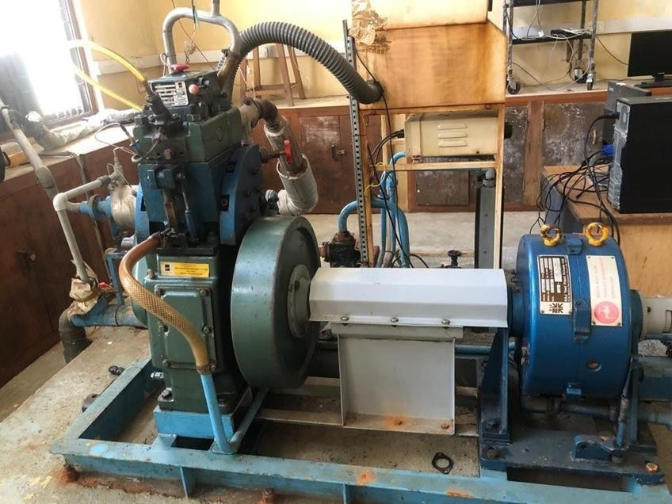

**Features**

***Fig. 4.2: VCR Diesel Engine***

* CR changing without stopping the engine
* No alteration in Combustion chamber geometry
* Water cooled EGR
* Electric start with battery and charger

# Range of Experiments

* VCR engine performance can be studied in Computerized mode
* Study of combustion with different fuel blends
* Study of indicated power and pressure volume plot

# Utilities Required Electric supply

230 +/- 10 VAC, 50 Hz, 1 phase

# Computer

IBM compatible with standard configuration

* Tabulated results, performance plots and PΘ - PV plots
* Configurable graphs, data logging, editing, printing and export
* IP,IMEP,FP indication, combustion analysis

# ENGINE SPECIFICATIONS

***Fig. 4.3: Engine Specification***

30

The following figure depicts the specs of the engine used where it briefs type of cylinder, strokes, power, rpm, bore, CC, Fuel tank capacity, dynamometer, calorimeter, load indicator, load sensor, temperature sensor, air flow transmitter, fuel flow transmitter, pump, piezo powering unit and crank angle sensor etc.,

# ENGINE TESTING SOFTWARE

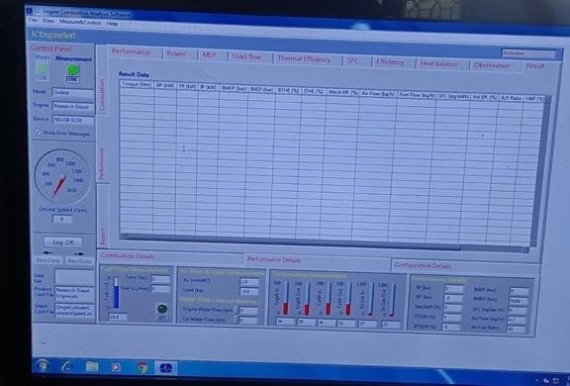

**Fig. 4.4: Engine Testing Software**

Apex innovations private limited has created a lab view-based engine software for engine performance monitoring. Engine software can handle the majority of the reporting, data entering, data recording, and monitoring requirements of engine testing. Power, efficiency, and heat emission are all taken into consideration in the programme. It may be

adapted to the engine's specifications. It was possible to get distinct graphs due to the varying operation circumstance.

An on-line test of an engine in RUN mode generates a graph showing all of the relevant data. The stored data file may be accessed to examine the data in both graphical and tabular versions. Printouts of the data and charts are available. Further analysis may be performed on the data in the excel format.

# TEST RUN WITH COMPUTERIZED MULTI CYLINDER ENGINESETUPS

* Tighten all engine, dynamometer, propeller shaft, and bass farm nut bolts.
* The sump tank of the engine must have enough lubricating oil in it at all times Using the level stick, you can see whether this is the case.
* Check to see whether the tank has enough gas in it. Remove the air from the fuel line.
* Make sure the AX- 409 Piezo powering unit, AX-155 Dynamometer loading unit are connected to the power source. Now turn on the Voltmeter and the Load Indicator to see how much power is being used.
* Open ICEngineSoft and double-click on the ICEngineSoft icon on the desktop and select: File-Configure-Product.
* select Load Default In Configure the product window.
* Under the Select File choose your setup from the drop down menu.
* study the parameters under Engine Sensors can be seen under "Set Parameters ”, Click on "OK” at Combustion and Performance tabs.
* Changing the Parameters.
* If any parameter needs to be changed then click on New(or)Change. Then change the parameter under respective tabs after all changes were done click Save & Apply. Click "OK” to save changes.
* Click "OK” again to reconfigure changes.
* Reconfiguring the graphs.
* Select File| Configure Graph Under "Configure” the Graphs window "Select a Configuration" from the drop-down menu.
* Study the preset configuration of X axis and Y axis. graph ranges, for the selected graphs. Click on CLOSE and SET. Configure the necessary parameters, ranges, as required. Click on SAVE and then CLOSE and SET.
* Note three vertical tabs viz. These combustion performance reports under vertical combustion tab horizontally following tabs are available: Cylinder Pr. PV, Combustion and Log PV and RPR etc. Under other vertical tabs we get more horizontal tabs similarly. Turn on the water pump. Adjust the flow rate of "Rotameter (Colorimeter)" to 200-250 LPH and "Rotameter (Engine)" to 900-1000 LPH by adjusting the respective globe values offered at the rotameter intake. Make sure that water is flowing through the dynamometer at a pressure of 0.5 to 1 kg/cm2 Hydraulic dynamometer at 1.5 to 2 Kg/cm2 pressure
* Keep the DLU knob at the minimal setting. The fuel cock has to be moved from Measuring to Tank.
* Start the engine using the starting key switch and let it run for 4-5 minutes at idle before cleaning the air filter.

# ONLINE DATA ACQUISITION

* toggle switch by clicking it The device communication may be started or stopped. The colour green denotes that the light is on. Toggle the "Measurement" switch to begin or stop data collection. The colour green denotes that the switch is turned on.
* Verify that the PC's display of temperature, speed, and manometer

readings is accurate. Readings from the engine panel should be compared to these values.

* The load may be raised by moving the DLU knob and verifying the load reading on the indicator and computer are same across the engine.
* While keeping a 2000-2600 RPM engine speed, gradually raise the throttle to full open state.
* The RPM and the Load must remain constant for 3 minutes while you wait for steady state. The tank position of the fuel cock must be switched to the measuring position. Select "Log on" from the "Log on" drop-down menu. There will be a 60-second delay before the fuel meter is turned on. Enter the engine during the first 30 seconds. After recording fuel on and reading water flow through the calorimeter jacket cooling water flow in LPH, click on OK to save the record. The name of the file where the records are to be kept must be supplied. The data from the initial reading has been recorded. Changing the fuel cock's position from Measuring to Tank is necessary.
* Each observation should be recorded in 500-RPM increments, with the maximum speed being reached at 4000 RPM.
* Decrease the engine's load by DLU when all readings have been completed concurrently. Reduce the throttle gradually until it reaches the closed position.
* Toggle the switch Stop data capture in PC when the Green colour shows that the PC is on. Toggle the Mode switch to turn off the device's communication.
* Stop the engine by hitting the key, then choose File-Data-Close to close the file. To keep the engine cool, let the water run for approximately five minutes before shutting off the pump.
* Select the File-Data-Open menu option. "OK" is all that is required to save readings to a computer file. Click "Next Data" to see the next chapter. All three displays will show the findings.
* Printing of reports To generate a performance report, click the "Report" tab. Specify a filename in the "Report File" box. Select Combustion Report from the drop-down menu that appears. Results data, observations data, graphs just or graphs and tables are all examples of the Report Requirements.
* For printing purposes, the size of the Combustion Report output file must be reduced. Excel may be used to see it. After printing and verifying your work, go to File->Data->Close. To finish the procedure, click on Exit and then shut down the computer.

# 4.7 GAS ANALYZER

* Kindly fill the details (Engine No, Model, Engine Type, Engine Speed) in respective text boxes given on the form.
* Click on "Connect button” to connect the PC with equipment and wait for 2-3 minutes. if the readings are not coming it show the message in red color CO, HC power not communicating kindly check the following.
* Be sure that gas analyzer settings in "MAHA Euro" mode.
* Connect to COM port settings with PC and the software.
* RS232 Cable is working properly and connected with equipment.
* Readings are coming with equipment and display on panel.
* After 6 seconds readings are automatically saved in database and status bar strip moving according to readings save in database.
* After taking the readings click on “Disconnect button”. it disconnects the communication with equipment and show the message Saved Database.
* Click on report button to take a part of the test.
* Print: Click on print button to take the printout of screen as bitmap image.

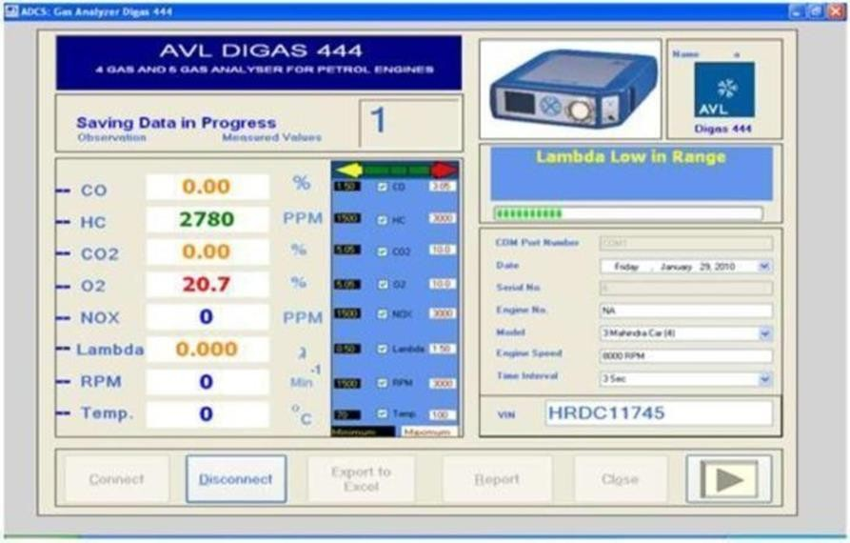

# Fig. 4.5: Gas Analyzer Reading

The following figure depicts the gas analyzer readings which is showing the CO, HC, NOx, O2 and CO2 emissions. RPM and temperature were being shown.

As all samples at different load conditions were processed the emission readings were taken by AVL gas analyzer which helps us to check over the emission levels and temperature of each sample used.

# CHAPTER 5

**RESULTS, DISCUSSION AND PERFORMANCE ANALYSIS**

Fueled with four volumetric mixes with various EGR, the engine's performance and emission analyses were compared with diesel fuel operation at varied loads.

# EMISSION ANALYSIS

* 1. **NOX EMISSIONS**

The experiment on is done with 5 samples named S1 - Sample 1, S2 Sample 2, S3 - Sample 3, S4 – Sample 4 and Diesel. Here, four samples consist of 30%BD 70%D whereas at last 100% Diesel is used for test purpose. The testing is done at 5 load conditions the minimum load is 0 and the maximum load is 3.5 and it is measured in BP (KW) brake power labeled in x-axis and NOx is measured in ppm and labeled in y-axis. Graph is presented with 5 different colors.

900

800

700

600

500

400

300

200

100

**NOx Vs BP**

S1 S2 S3 S4

Diesel

0 0.875 1.75 2.62 3.5

***Fig. 5.1: NOX Vs BP***

**NOx (ppm)**

# Table 5.1: NOx Emissions of S1, S2, S3, S4, Diesel with loads

|  |  |  |  |  |  |
| --- | --- | --- | --- | --- | --- |
| BP (KW) | 0 | 0.87 | 1.75 | 2.6 | 3.5 |
| S1 (ppm) | 42 | 138 | 290 | 312 | 559 |
| S2 (ppm) | 53 | 170 | 345 | 469 | 720 |
| S3 (ppm) | 65 | 159 | 364 | 470 | 748 |
| S4 (ppm) | 76 | 226 | 393 | 525 | 798 |
| Diesel (ppm) | 56 | 156 | 289 | 310 | 750 |

The following table depicts the change in NOx emissions for S1, S2, S3, S4, and Diesel with BP (KW) of 0, 0.87, 1.75, 2.6 and 3.5 loads. Nitrogen oxide emissions were significantly lower compared to diesel when load is applied. S1 has recorded a little amount of emissions compared over other samples. Diesel has actually emitted less NOx when load isn’t applied. It gradually increased when more load is applied. During minimum load 0 BP S1 and D have emitted less NOx compared to diesel. At 0.87 BP S4 emitted more amount of NOx compared to all samples. Whereas Diesel emitted less amount of NOx compared to all other samples at 1.75 BP. S1 and Diesel have emitted less NOx at 2.6 BP from others. At 3.5 BP S1 has significantly improved and emitted less NOx compared to all. Among all samples S1 has emitted lower amount of nitrogen oxide emissions at all loads in comparison of other samples.

# CO2 EMISSIONS



**CO2 Vs BP**

4.5

3.5

2.5

1.5

S1 S2 S3 S4

Diesel

0.5

0.875

1.75

2.62

3.5

**C02 (%)**

**Fig. 5.2: CO2 Vs BP**

The following figure shows the emissions of carbon dioxide from the four samples S1, S2, S3, S4 and Diesel. Experimentation is done at different loads where the minimum load is 0, 0.87, 1.75, 2.6 and the maximum is 3.5. The X – axis over the graph is represented with BP (KW). Y – axis is labeled with CO2%. Emission analysis is shown with 5 different unique colors and the emission content for each bar at every load is labeled.

# Table 5.2: CO2 Emissions of S1, S2, S3, S4, Diesel with loads

|  |  |  |  |  |  |
| --- | --- | --- | --- | --- | --- |
| BP (KW) | 0 | 0.87 | 1.75 | 2.6 | 3.5 |
| S1 (%) | 1.42 | 1.61 | 2.14 | 2.6 | 2.84 |
| S2 (%) | 1.44 | 2 | 2.38 | 3.17 | 3.6 |
| S3 (%) | 1.62 | 2.25 | 2.85 | 3.3 | 3.8 |
| S4 (%) | 1.64 | 2.38 | 2.7 | 2.8 | 3.99 |
| Diesel (%) | 1.6 | 1.96 | 2.54 | 2.89 | 3.89 |

The following table depicts the change in CO2 emissions for S1, S2, S3, S4, and Diesel with BP (KW) of 0, 0.87, 1.75, 2.6 and 3.5 loads. As the load increased gradually it led to higher emissions of CO2. At minimum load 0 BP (KW) all samples and diesel have emitted less CO2 compared to other loads and S1, S2 have shown marginal emissions of CO2 with diesel. S4 has emitted the most CO2 at 0.87 BP (KW) whereas the S1 has released lower amount and S2, S3 has shown a bit higher compared to diesel. At 1.75 BP (KW) S1, S2 released lower levels of CO2 among other samples and diesel whereas S3 emitted the higher levels of CO2. S1, S4 have shown marginal emissions compared with other samples to diesel at 2.6 BP (KW). At 3.5 BP (KW) S1 has been able to lower the CO2 emissions significantly over others. Overall S1 has emitted less amount ofCO2 compared to other samples and diesel at all loads.

# O2 EMISSIONS

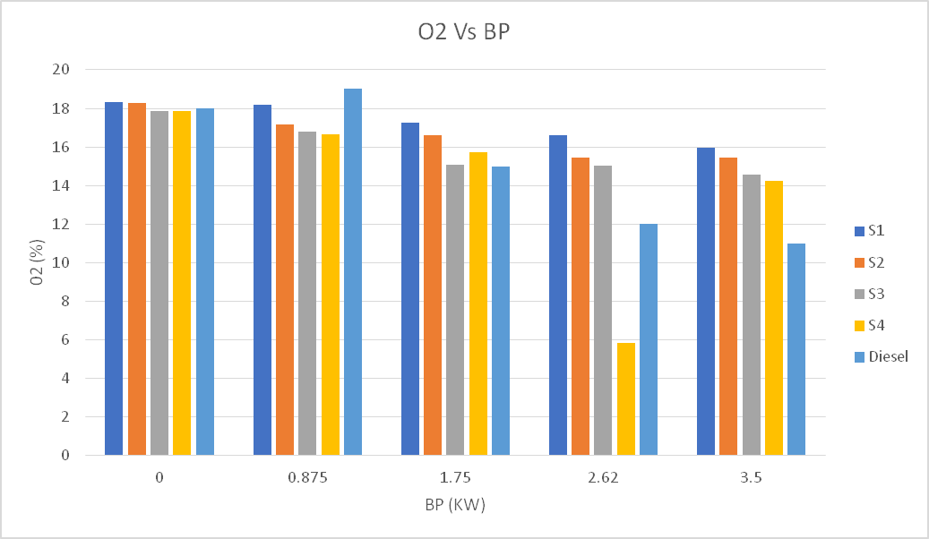

**Fig. 5.3: O2 Vs BP**

The following figure shows the emissions of oxygen from the four samples S1, S2, S3, S4 and Diesel. Experimentation is done at different loads where the minimum load is 0, 0.87, 1.75, 2.6 and the maximum is 3.5. The X – axis over the graph is represented with BP (KW). Y – axis is labeled with O2%. Emission analysis is shown with 5 different unique colors and the emission content for each bar at every load is labeled.

# Table 5.3: O2 Emissions of S1, S2, S3, S4, Diesel with loads

|  |  |  |  |  |  |
| --- | --- | --- | --- | --- | --- |
| BP (KW) | 0 | 0.87 | 1.75 | 2.6 | 3.5 |
| S1 (%) | 18.32 | 18.18 | 17.25 | 16.59 | 15.94 |
| S2 (%) | 18.27 | 17.15 | 16.6 | 15.45 | 15.43 |
| S3 (%) | 17.87 | 16.8 | 15.09 | 15.01 | 14.55 |
| S4 (%) | 17.86 | 16.67 | 15.74 | 5.83 | 14.25 |
| Diesel (%) | 18 | 19 | 15 | 12 | 11 |

The following table depicts the change in O2 emissions for S1, S2, S3, S4, and Diesel with BP (KW) of 0, 0.87, 1.75, 2.6 and 3.5 loads. Increasing the load reduced the amount of oxygen emissions of all samples and diesel. At minimum load 0 BP (KW) all samples including diesel have emitted higher amount of oxygen. Samples have shown a marginal effect in emission compared with diesel. Diesel emitted higher amount of O2 at 0.87 BP (KW) among other samples. S1 have emitted good amount of O2 at 1.75 BP (KW) and others have shown a minimal lower to S1 and diesel have emitted the least. At

2.6 BP (KW) S4 have drastically lowered the emission of O2 and S1 has emitted the most among other samples. All four samples have emitted approximately same amount of O2 at 3.5 BP (KW) and diesel emitted the least. Overall S1 have emitted good amount of oxygen at various loads compared to all other samples and diesel.

# 5.4 HC EMISSIONS

Hydrocarbon emissions from diesel engines tend to be minimal, on average. The majority of diesel hydrocarbon emissions are caused by modest loads, according to this study. Lean air–fuel admixture is the primary source of light load organic compound emissions. Low flame speeds in lean mixes may lead to excessive hydrocarbon emissions if combustion does not take place during the power stroke, or if the flames are too slow.

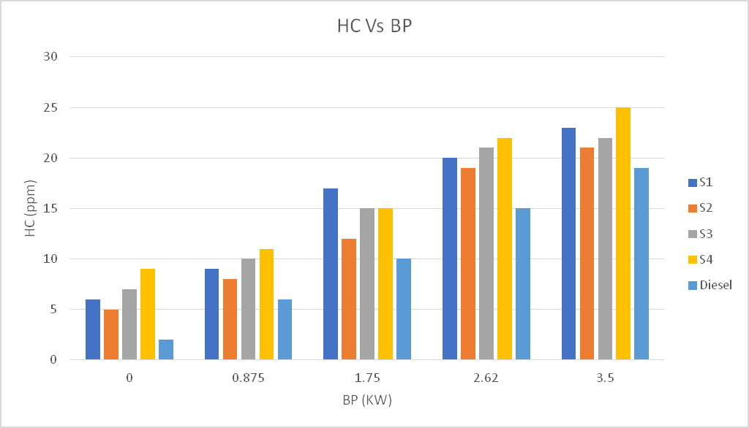

# Fig. 5.4: HC Vs BP

The following figure shows the emissions of hydro carbon from the four samples S1, S2, S3, S4 and Diesel. Experimentation is done at different loads where the minimum load is 0, 0.87, 1.75, 2.6 and the maximum is 3.5. The X – axis over the graph is represented with BP (KW). Y – axis is labeled with HC (ppm). Emission analysis is shown with 5 different unique colors and the emission content for each bar at every load is labeled.

# Table 5.4: HC Emissions of S1, S2, S3, S4, Diesel with loads

|  |  |  |  |  |  |
| --- | --- | --- | --- | --- | --- |
| BP (KW) | 0 | 0.87 | 1.75 | 2.6 | 3.5 |
| S1 (ppm) | 6 | 9 | 17 | 20 | 23 |
| S2 (ppm) | 5 | 8 | 12 | 19 | 21 |
| S3 (ppm) | 7 | 10 | 15 | 21 | 22 |
| S4 (ppm) | 9 | 11 | 15 | 22 | 25 |
| Diesel (ppm) | 2 | 6 | 10 | 15 | 19 |

The following table depicts the change in HC emissions for S1, S2, S3, S4, and Diesel with BP (KW) of 0, 0.87, 1.75, 2.6 and 3.5 loads. HC emissions were gradually raised along with the increased loads. At minimum load 0 BP (KW) diesel emitted the least amount of HC compared to all other samples and S4 has emitted the highest amount of HC. S4, S3 emitted more amount of HC compared to other samples and diesel at 0.87 BP (KW). S1 has emitted highest amount of HC at 1.75 BP (KW) whereas the S3, S4 shown the same amount of emissions. S4 emitted highest amount of HC among other samples at 2.62 BP (KW) and diesel emitted the least. At maximum load

3.5 BP (KW) S4 emitted the highest amount of HC compared to other samples. Overall Diesel has emitted quite less amount HC emissions at all the loads and compared to other samples diesel showed good improvement in reducing HC.

# CO EMISSIONS

Wherever the chemical reaction mechanism does not take place completely, carbon monoxide is produced by incomplete combustion. To put it another way, the quantity of excess-air () is most prominent in rich mixtures when the excess-air problem () amounts to less than one.0. In situations when rich mixes are required, this is especially true during engine start-up and acceleration. A lack of oxygen and chemical concentration prevent all of the carbon from being converted to carbon dioxide and forming CO concentration in the rich mixes.

CO Vs BP

0.05

0.045

0.04

0.035

0.03

0.025

S1

S2

0.02

0.015

S3

S4

Diesel

0.01

0.005

0

0

0.875

1.75

BP (KW)

2.62

3.5

C0 (%)

***Fig. 5.5: CO Vs BP***

The following figure shows the emissions of carbon monoxide from the four samples S1, S2, S3, S4 and Diesel. Experimentation is done at different loads where the minimum load is 0, 0.87, 1.75, 2.6 and the maximum is 3.5. The X –axis over the graph is represented with BP (KW). Y – axis is labeled with CO (%). Emission analysis is shown with 5 different unique colors and the emission content for each bar at every load is labeled.

# Table 5.5: CO Emissions of S1, S2, S3, S4, Diesel with loads

|  |  |  |  |  |  |
| --- | --- | --- | --- | --- | --- |
| BP (KW) | 0 | 0.87 | 1.75 | 2.6 | 3.5 |
| S1 (%) | 0.008 | 0.015 | 0.017 | 0.026 | 0.031 |
| S2 (%) | 0.004 | 0.008 | 0.019 | 0.028 | 0.035 |
| S3 (%) | 0.014 | 0.018 | 0.025 | 0.037 | 0.041 |
| S4 (%) | 0.012 | 0.027 | 0.022 | 0.039 | 0.046 |
| Diesel (%) | 0.008 | 0.013 | 0.018 | 0.023 | 0.029 |

The following table depicts the change in CO emissions for S1, S2, S3, S4, and Diesel with BP (KW) of 0, 0.87, 1.75, 2.6 and 3.5 loads. CO emissions were gradually raised along with the increased loads. At minimum load 0 BP (KW) S2 has emitted the least amount of CO compared to other samples and diesel. S4 has emitted the highest amount of CO at 0.87 BP (KW) whereas S2 has emitted the least among others and diesel. S1 has shown a marginal emission with diesel at 1.75 BP (KW) whereas other samples CO emissions were high. At 2.62 BP(KW) S3, S4 has emitted the highest amount of CO, other samples and diesel have emitted a bit lower compared to these samples. S4 has emitted the highest amount of CO at maximum load 3.5 BP (KW) and diesel has emitted the least amount of CO. Overall S1 and diesel has emitted least amount of CO compared to other samples and S4 has emitted the highest amount of CO emissions over other samples and diesel.

# PERFORMANCE ANALYSIS

BTHE (%)

* 1. **BTHE (BRAKE THERMAL EFFICIENCY)**



BTHE Vs BP

40

35

30

25

20

S1

S2

S3

15

S4

10 Diesel

5

0

0 0.5 1 1.5

2

BP (KW)

2.5

3

3.5

4

|  |  |  |  |  |  |  |  |
| --- | --- | --- | --- | --- | --- | --- | --- |
|  |  |  |  |  |  |  |  |
|  |  |  |  |  |  |  |  |
|  |  |  |  |  |  |  |  |
|  |  |  |  |  |  |  |  |
|  |  |  |  |  |  |  |  |
|  |  |  |  |  |  |  |  |
|  |  |  |  |  |  |  |  |
|  |  |  |  |  |  |  |  |

# Fig. 5.6: BTHE Vs BP

The following figure shows the performance of brake thermal efficiency of the four samples S1, S2, S3, S4 and Diesel. Experimentation is done at different loads where the minimum load is 0, 0.87, 1.75, 2.6 and the maximum is 3.5. The X axis over the graph is represented with BP (KW). Y – axis is labeled with BTHE (%). Performance analysis is shown with 5 different unique colors and the loads were labeled with dots over the performance lines.

# Table 5.6: BTHE Values of S1, S2, S3, S4, Diesel with loads

|  |  |  |  |  |  |
| --- | --- | --- | --- | --- | --- |
| BP (KW) | 0 | 0.87 | 1.75 | 2.6 | 3.5 |
| S1 (%) | 0 | 14.12 | 21.42 | 29.31 | 32.72 |
| S2(%) | 0 | 16.75 | 22.44 | 30.96 | 31.57 |
| S3 (%) | 0 | 15.8 | 22.61 | 28.38 | 31.18 |
| S4 (%) | 0 | 15.24 | 24.55 | 31.42 | 33.45 |
| Diesel (%) | 0 | 16.49 | 22.75 | 29.47 | 32.59 |

The following table depicts the change in BTHE performance for S1, S2, S3, S4, and Diesel with BP (KW) of 0, 0.87, 1.75, 2.6 and 3.5 loads. The performance test is started at minimal load 0 BP (KW) and maximum load is

3.5 BP (KW). At 0.87 BP (KW) S2 has shown highest amount of BTHE whereas the S1 has been least among other samples and diesel.S4 has shown the highest amount of BTHE over other samples and diesel at 1.75 BP (KW). S4, S2 and S1, Diesel has shown similarity in BTHE whereas S3 has the least at 2.6 BP (KW). At 3.5 BP (KW) S4 has the highest amount of BTHE over other samples and diesel.S3 has shown the least amount of BTHE at maximum load. Overall S4 has the highest amount of BTHE compared to other samples and diesel. The higher the BTHE the lower the fuel consumption and green house gases.

# 5.7 SFC (SPECIFIC FUEL CONSUMPTION)

Fuel efficiency of any prime mover that consumes fuel and generates rotational, shaft, power is often assessed using a quantity known as Brake Specific Fuel Consumption. It is often used to compare the efficiency of internal combustion engines that have a shaft output against those that do not. BSFC may be a measure of the fuel efficiency of any engine that burns fuel and provides movement power. The BSFC price, on the other hand, shows how efficiently the engine transforms fuel loaded with useful labour. The hot price is one of the most common indicators used to evaluate the biodiesel's properties on the BSFC.

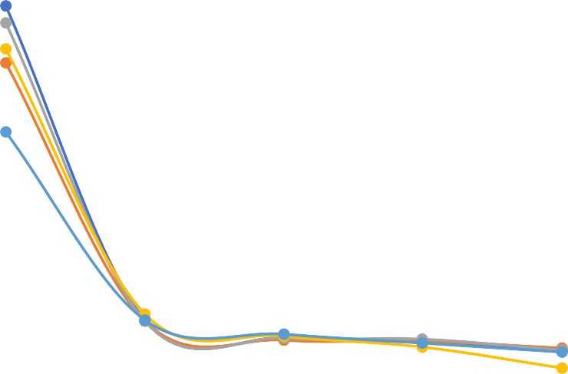

SFC Vs BP

4

3.5

3

2.5

2

S1

S2 S3

1.5

S4

1 Diesel

0.5

0

0 0.5 1 1.5

2

LOAD (%)

2.5

3

3.5

4

SFC (Kg/kWH)

|  |  |  |  |  |  |  |  |
| --- | --- | --- | --- | --- | --- | --- | --- |
|  |  |  |  |  |  |  |  |
|  |  |  |  |  |  |  |  |
|  |  |  |  |  |  |  |  |
|  |  |  |  |  |  |  |  |
|  |  |  |  |  |  |  |  |
|  |  |  |  |  |  |  |  |
|  |  |  |  |  |  |  |  |
|  |  |  |  |  |  |  |  |

The specific fuel consumption of the four samples S1, S2, S3, S4 and Diesel is shown in the figure below. Experimentation is done at different loads where the minimum load is 0, 0.87, 1.75, 2.6 and the maximum is 3.5. The X – axis over the graph is represented with LOAD (%). Y – axis is labeled with SFC (Kg/kWH). Performance analysis is shown with 5 different unique colors and the loads were labeled with dots over the performance lines.

# Table 5.7: SFC Values of S1, S2, S3, S4, Diesel with loads

|  |  |  |  |  |  |
| --- | --- | --- | --- | --- | --- |
| BP (KW) | 0 | 0.87 | 1.75 | 2.6 | 3.5 |
| S1 (Kg/kWh) | 3.66 | 0.52 | 0.34 | 0.3 | 0.21 |
| S2 (Kg/kWh) | 3.09 | 0.51 | 0.32 | 0.31 | 0.24 |
| S3 (Kg/kWh) | 3.49 | 0.51 | 0.34 | 0.33 | 0.22 |
| S4 (Kg/kWh) | 3.23 | 0.58 | 0.36 | 0.25 | 0.04 |
| Diesel(Kg/kWh) | 2.4 | 0.52 | 0.38 | 0.29 | 0.2 |

The following table depicts the change in SFC performance for S1, S2, S3, S4, and Diesel with LOAD (%) of 0, 0.87, 1.75, 2.6 and 3.5 loads. SFC gradually decreased with increase in load. At minimum load S1 has the highest SFC compared to other samples and diesel. SFC has drastically reduced at load 0.87 and diesel has the least.S2 has the least SFC at 1.75 whereas the diesel and other samples have the marginal performance. S4 has the least SFC compared to other samples and diesel at 2.6 and S3 has the most. At maximum load 3.5 S4 has lowest SFC compared to other samples and diesel. Overall S4 has shown good performance in SFC compared to other samples and diesel. Other samples shown the marginal performance compared to diesel. Lower SFC at higher loads cause less consumption of fuel.

# CHAPTER 6 SUMMARY AND CONCLUSION

* 1. **SUMMARY**

Biodiesel and its blends have been tested in a single cylinder, constant speed, direct injection engine to determine its performance and emissions. There was a noticeable difference in emissions between different blends of diesel and biodiesel, as shown by the results of this experiment. Variances were also detected in the quantity of useable heat received from the fuels, which might be indicative of the differences in the fuels energy contents.

# CONCLUSION

* + Among all samples S1 has emitted lower amount of nitrogen oxide emissions at all loads in comparison of other samples.
  + Overall S1 has emitted less amount of CO2 compared to other samples and diesel at all loads.
  + Overall S1 have emitted good amount of oxygen at various loads compared to all other samples and diesel.
  + Overall Diesel has emitted quite less amount HC emissions at all the loads and compared to other samples diesel showed good improvement in reducing HC.
  + Overall S1 and diesel has emitted least amount of CO compared to other samples and S4 has emitted the highest amount of CO emissions over other samples and diesel.
  + Overall S4 has the highest amount of BTHE compared to other samples and diesel.
  + Overall S4 has shown good performance in SFC compared to other samples and diesel.

**REFERENCE**

|  |
| --- |
| 1. Hemanandh Janarthanam, Ganesan Subbiah, Sridhar Raja, K. S., Senthilkumar Gnana Mani, Amarjit Roy, and Vineet Chougle, “Experimental and synthesis of chicken slaughter waste biodiesel in DI diesel engine”, Cite as: AIP Conference Proceedings 2311, 020014, 2020, https://doi.org/10.1063/5.0034144 Published Online: 07 December 2020. 2. Hemanandh Janarthanam, Lilly Mercy Jayaraman, Ganesan Subbiah, Devaraj Rangabashiam, Sridhar Raja, B. Rakesh Kumar Reddy, and Swamy Saran, “Influence of CNG emissions in copper coated catalytic converter in 4-stroke S.I”, engine Cite as: AIP Conference Proceedings 2311, 040015 (2020); https://doi.org/10.1063/5.0034201 Published Online: 07 December 2020 3. Hemanandh Janarthanam, Venkatesan Sorakka Ponnappan, Ganesan Subbiah, Purushothaman Mani, Suman, D., and Rajesh, M., “Performance and emission analysis of waste cooking oil as green diesel in 4S diesel engine”, Cite as: AIP Conference Proceedings 2311, 020022, 2020, https://doi.org/10.1063/5.0034194 Published Online: 07 December 2020. 4. Hemanandh Janarthanam, Venkatesan Sorakka Ponnappan, Purushothaman Mani, Ganesan Subbiah, Shanjiit, B., and Tejual Krishna, “Environmental emission control in CI engine using hydro treated bio-fuel in India”, Cite as: AIP Conference Proceedings 2311, 020021, 2020, https://doi.org/10.1063/5.0034184 Published Online: 07 December 2020. 5. Hemanandha, J., Ganesan, S., Sathya Sai Puneeth, C., and Venkata Sai Naga Manikankata Tejesh, G., “Vehicle Emission Analysis by using Refined Sunflower Oil as Alternate Fuel and Varying the Injection Timing in Diesel Engine”, Dept. of Mech. Engg., Sathyabama University, Chennai, India. 6. Rajasekar Rajendran, U., Logesh, N. S., Praveen, and Ganesan Subbiah, “Optimum design of catalytic converter to reduce carbon monoxide emissions on diesel engine”, Cite as: AIP Conference Proceedings 2311, 040011, 2020, https://doi.org/10.1063/5.0034427 Published Online: 07 December 2020. 7. Vemuri Sai Srikanth, Ganesan, S., and Vijaya Kumar Reddy, K., “Investigations on the impact of EGR with a modified combustion chamber for CI diesel engine using biodiesel”, Cite as: AIP Conference Proceedings 2311, 020004, 2020, https://doi.org/10.1063/5.0034514 Published Online: 07 December 2020. 8. Venkatesan, S. P., Jeya Jeevahan, J., Hemanandh, J., Ganesan, S., Rajakavieswaran, R., and Saravanan, V., “Performance and emission characteristics of diesel engine using waste plastic oil with N-hexanol as an additive”, Cite as: AIP Conference Proceedings 2311, 020025, 2020, https://doi.org/10.1063/5.0034393 Published Online: 07 December 2020. |
|  |
|  |
|  |
|  |
|  |