Issue:

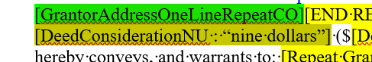

Solved:

