Dragon, Glenny Mae

ITE3

logo

Menu bar

Navigation panel

header

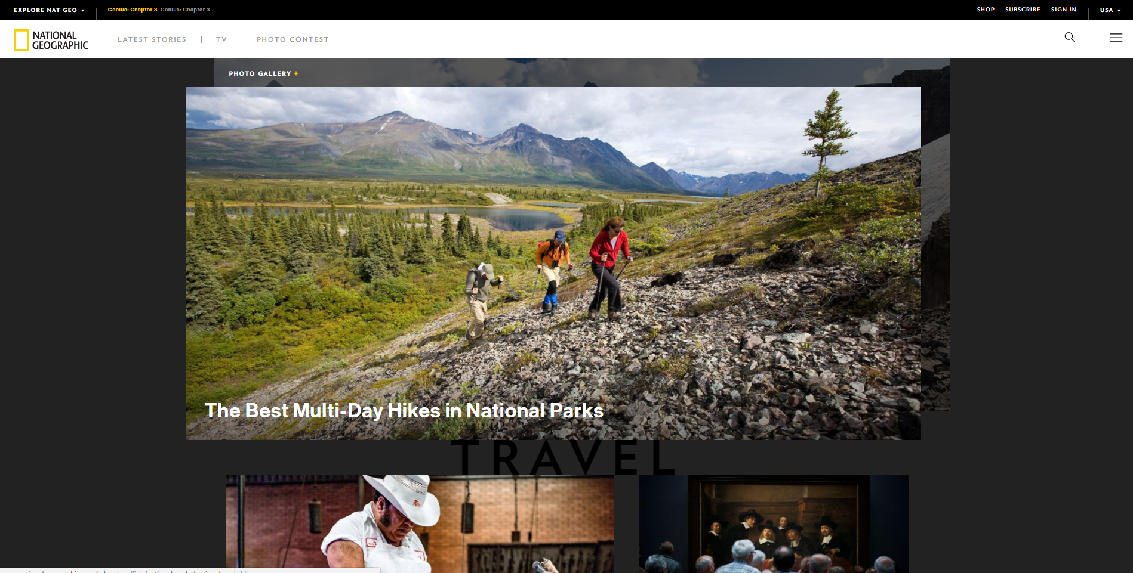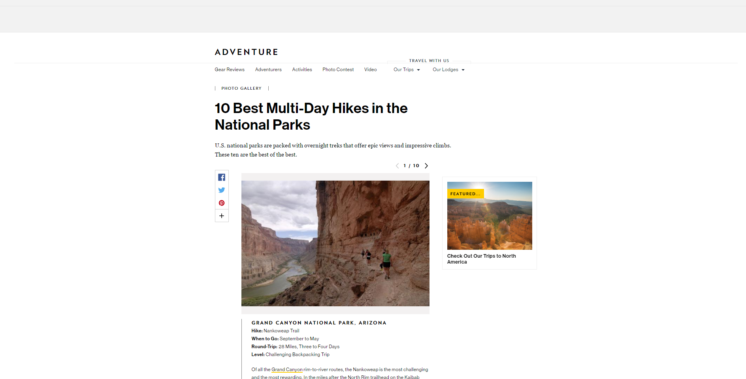

aside

Passive white space

Header image

Active white space

,1. everything in the website needs is there like the navigation bar so if people need more information about to their website they can just search it. The design is very simple the fonts is easily to read for readers and the images are high quality

2.

No menu bar and search bar

The bad choice of the background color is not good

Too much text

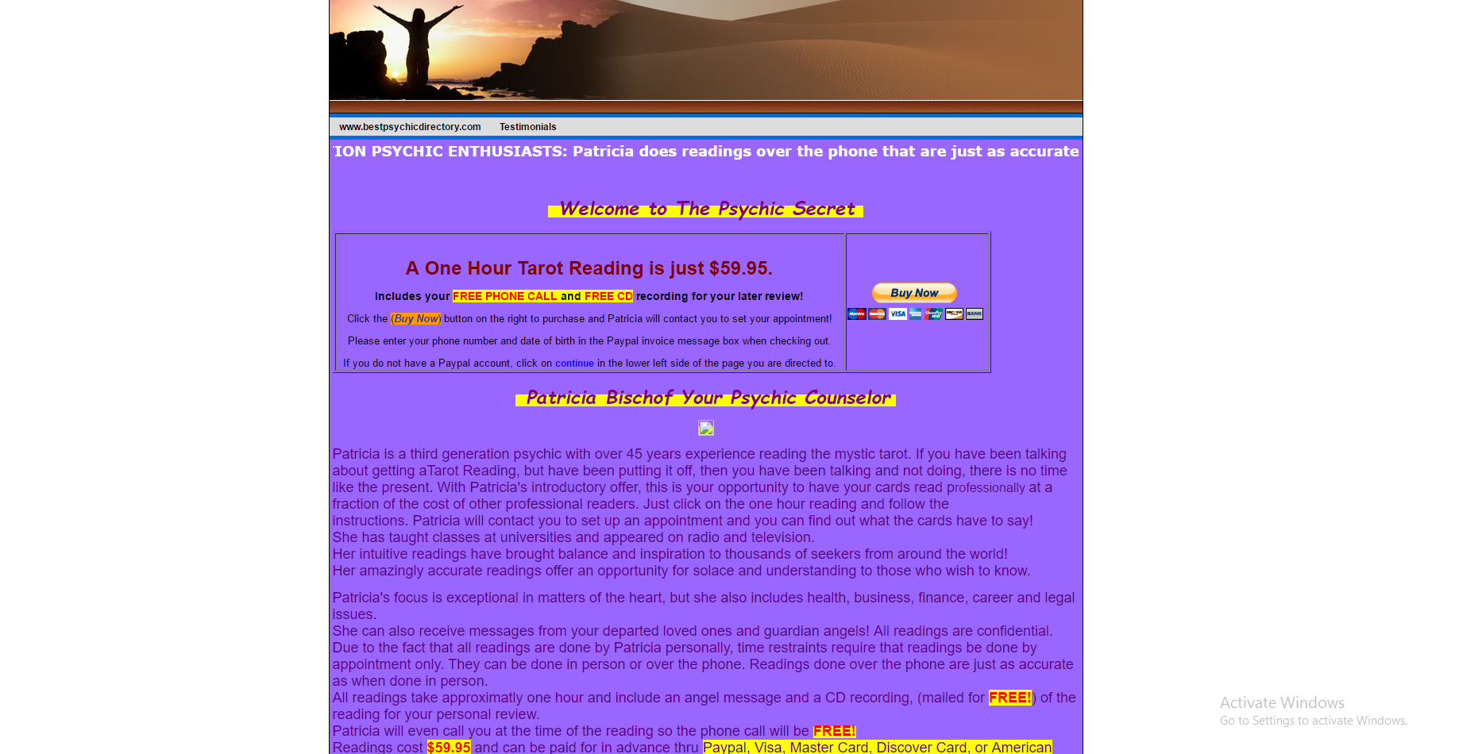

No images

Using inappropriate highlight

* The designer should choose the right color that is good for the eye of the reader and the text should easily to read.
* The body contain too much of text and it looks boring to read
* They should include pictures related to their article
* They shouldn't use some highlight in text
* Should include menu bar and search bar for more information

1. a website should be organize and the header should call the attention of a reader and their article should be related to their website it shouldn't have many pop out ads in their website it will disturb the reader. The header is also important it should contain menu bar, navigation bar, and their logo, etc.