Data Collection Sheet

Study information
Collecting researcher: Date: 2020 / /
Patient ID: Patient PIN:
Machine Type: Machine #:
Study initiation time:

Consent signed? Y N
Was consent delayed? Y N
If Yes, reason:

Randomization Group: Control Experimental

Demographic information
Gender: M F non-binary
Age:
Height:
Weight:

Does patient wear dentures? Y N
Does patient have facial hair? None Moustache Short beard Full beard Other

COVID status: Confirmed Pending Negative

Metabolic Data
 | 0 hours | 4 hours | 12 hours | 24 hours
Glasgow Coma Scale
(refer below)
Respiratory rate
Heart rate
pH
HCO3
PaCO2
PaO2
SpO2

Non-invasive ventilation data
 | 0 hours | 4 hours | 12 hours | 24 hours
Ventilation technique (BiPAP, CPAP)
IPAP
EPAP
Mask fit (1-5 scale, 1 = poor; 5 = excellent)
*If not excellent, state reason.
Patient tolerance of BiPAP mask
(1-5 scale; 1 = poor; 5 = excellent)

Adverse events data
 | 0 hours | 4 hours | 12 hours | 24 hours
Ulcer staging on face
(refer below)
Nasal or oral bleeding
Pneumothorax
Other concerns

Outcome at 24 hours: Intubated Still on NIV Discontinued from NIV Deceased

Total NIV time (hours):

Explain outcome above:

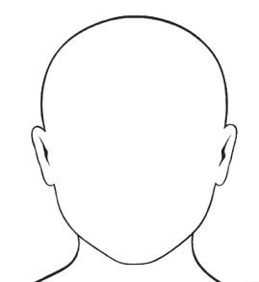
Disposition: If ulcer, indicate location:

Glasgow Coma Scale
Domain | Response | Score
Eye Opening | Spontaneous | 4
 | To speech | 3
 | To pain | 2
 | None | 1
Best Verbal Response | Oriented | 5
 | Confused | 4
 | Inappropriate | 3
 | Incomprehensible | 2
 | None | 1
Best Motor Response | Obeying | 6
 | Localizing | 5
 | Withdrawal | 4
 | Flexing | 3
 | Extending | 2
 | None | 1

Ulcer Score (NPUAP Staging System for Pressure Ulcers)
Stage |  | Description
0 | n/a | No ulcer
I | 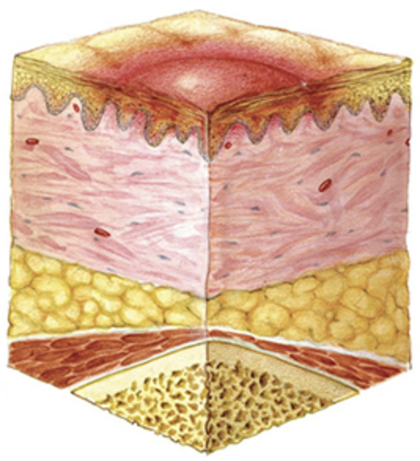 | Intact skin with non-blanching redness.
II | 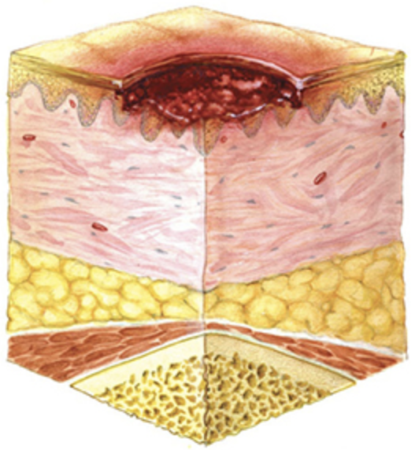 | Partial-thickness loss of skin or tissue presenting as a shallow open ulcer with a red-pink wound bed, without slough.
III | 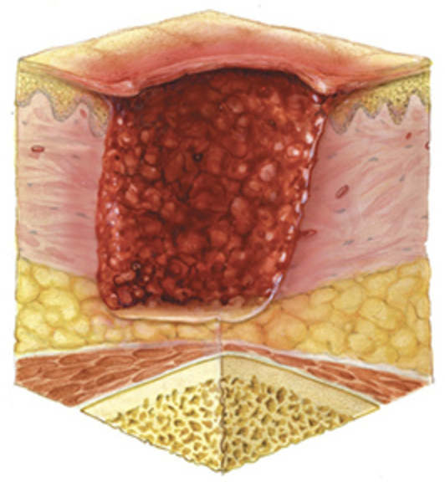 | Full-thickness skin loss; subcutaneous fat may be visible, but bone, tendon, or muscle is not exposed; slough may be present but does not obscure the depth of tissue loss; may include undermining and tunneling.
IV | 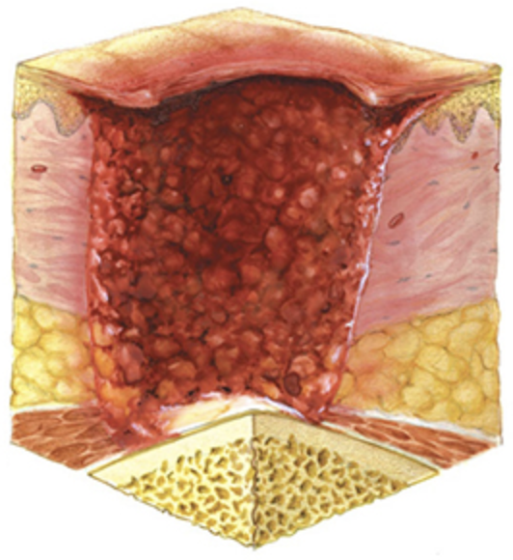 | Full-thickness tissue loss with exposed bone, tendon, or muscle; slough or eschar may be present; often includes undermining and tunneling.

