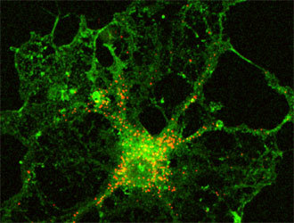
Glia
Equal care for all
The revolution has arrived: 3d free hardware/software medical tools
Business Plan
Prepared March 2015
Contact Information
Amy Miller
amy@gliax.org
15148126817
glia.org
London, Ontario, Canada

Table of Contents
Executive Summary 1
Overview of how it works/Risks assement for lawyers 1
What We Make 3
Who We Sell To 3
Financial Summary 4
Financial Plan 5
Revenue Forecast 5
Personnel Plan 7
Budget 8
Financial Statements 10
Who We Are 10
Profit and Loss Statement 11

Executive Summary

Overview of how it works/Risks assement for lawyers
1. We order the printed filament materials from http://orbi-tech.de/.
2. We put the filament in the 3d printer.
3. We tell the 3d printer what the design is.
4. We use generic tubing from the aquarium section of any hardware store and we stick the printed part into it
and the other printed part on the other end and then out comes a stethoscope. No further work will need to be done. It can be packaged and sent off
For the ECG and Pulse Ox, there are hardware components that need to be manually assembled and or can be programmed to be assembled to finish the product.
The electronic components are coming from large manufacturers via distributors. For example the processor on the pulseox comes from STmicro, they sell it to Mouser in giant reels, Mouser sells it to us in smaller quantities, we put it on boards
The idea is to have a flexible design that can be done either fully automatically on a traditional electronics assembly line or by a person.
5. We then move to a quality assurance step
6. We then sell the stethoscopes.
Our products that we will sell: 1) Actual products (in essence, indemnity; hospitals and ministries and individuals are customers); 2) licenses to make actual products with Health Canada certificates (largely companies are the customers); 3) Training to make products in-house (ministries of health and hospitals).
Beyond selling the products, we are considering offering consulting services to teach health departments of governments throughout the Global South, so they will have the capacity and training necessary to print the tools themselves.
This is very preliminary. In essence, there are three groups of people to whom we'd provide consulting:
1 Ministries of health, primarily developing countries
2. Hospitals, both developing and developed.
It would involve helping the group establish and maintain their production facility.
Profits from Glia will be funnelled back into R&D to develop more medical devices or to modify the existing software/hardware reference implementation.
Preliminary our plan is: Taking off-patent devices, re-engineering them to be easy to produce and ensure quality on. Also relevant modifications to make them useful lin developing settings (e.g., where electricity isn't abundant).
Future:Creating novel devices that answer the needs of developing countries.
We plan on using the following license, for each device, to allow individuals in the medical community to print the devices with their own 3d printer, should they choose.
:http://www.tapr.org/ohl.html
In essence, just as stated, people are free to recreate,distribute and use the equipment as they see fit. However, they are obligated to make derivatives available under The TAPR Open Hardware License ('The OHL)' as well. Incidentally, think of 3D printing as one of the tools. Some devices will be exclusively printed. Most devices will have little functional printing. 3D Printing just facilitates the work - it doesn't encompass it.

What We Make
Transforming the medical device industry, GliaX will design, manufacture, freely distribute and sell gold standard medical tools at extremely low costs, but also offer specialization and customization of these tools.
GliaX will initially research and develop to market three distinct medical tools built and created with free software/hardware reference implementation
- The Stethoscope, a device that is used to listen to the internal sounds of an animal or human body.
- The Pulse oximeter, a device that is used to monitor a person's oxygen saturation.
- The ECG, a device to measure the heart’s electrical conduction system.
The design and technology used to 3d print the hardware of these products will be 100% free software/hardware and registered with the proper legal channels in ways that will make it impossible for anyone else, including ourselves to patent the product. Each tool must go through an internal validation/verification process then must be approved by an ISO-approved lab before seeking approval by Health Canada.
GliaX products will match the market gold standards for a fraction of the price.

Who We Sell To
GliaX will initially focus on hospitals and medical centers across Canada, as well as building partnerships with international medical organizations such as Medicine Sans Frontier, who will be able to provide training of the 3d technology on the ground to for local communities, as well as buy the medical products in bulk for communities in need.

Financial Summary

Financial Highlights

Financial Highlights by Year
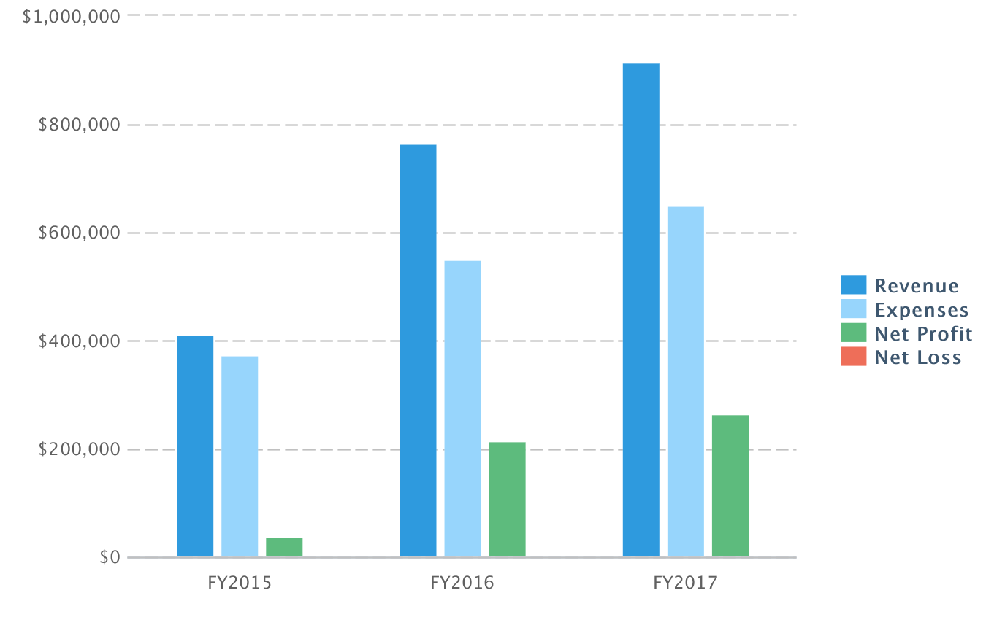

Financial Plan

Revenue Forecast

Revenue Forecast
 | FY2015 | FY2016 | FY2017
Revenue
Scientific Research and Experimental Development Tax Incentive Program | $135,000 | $135,000 | $135,000
Sale of ECG's | $105,010 | $300,000 | $300,000
Sale of Stethoscope | $57,500 | $125,000 | $175,000
Sale of Pulse Oximeter | $115,000 | $205,000 | $305,000
Total Revenue | $412,510 | $765,000 | $915,000
Direct Cost
Scientific Research and Experimental Development Tax Incentive Program | $6,000 | $6,000 | $6,000
Sale of ECG's | $57,500 | $100,000 | $100,000
Sale of Stethoscope | $34,500 | $75,000 | $105,000
Sale of Pulse Oximeter | $57,500 | $102,500 | $152,500
Total Direct Cost | $155,500 | $283,500 | $363,500
Gross Margin | $257,010 | $481,500 | $551,500
Gross Margin % | 62% | 63% | 60%

Revenue by Month
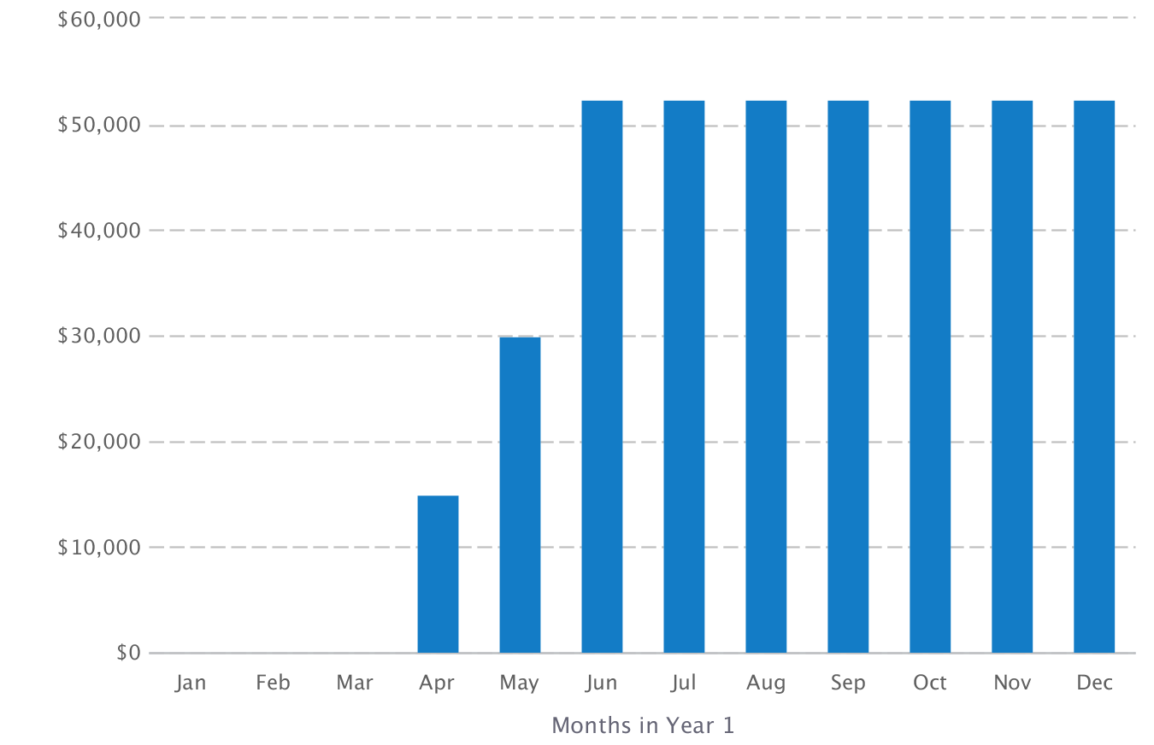

About the Revenue Forecast
SR&ED Investment Tax Credit: 15% federal tax credit for all qualifying R&D costs for eligible activities carried on in Canada. The credit rate is increased to 35% for small Canadian-controlled private corporations (on expenditures up to $3M per year. This 35% credit is fully refundable.
Provincial SR&ED Incentives: Tax credits ranging from 4.5% to 37.5% depending upon the provincial jurisdiction. Some provincial jurisdictions offer refundable credits.
The SR&ED program has the following service standards for processing SR&ED claims:
- refundable claims – 120 calendar days from filing
- non-refundable claims – 365 calendar days filing
- claimant-requested adjustments to refundable claims – 240 calendar days from filing
- claimant-requested adjustments to non-refundable claims – 365 calendar days from filing

Personnel Plan

Personnel Table
 | FY2015 | FY2016 | FY2017
Kliment Yanev, lead engineer | $50,000 | $51,750 | $53,561
Joachim Glauche | $15,000 | $15,525 | $16,068
Spencer Chambers | $15,000 | $15,525 | $16,068
Amy Miller, Coordinator | $50,000 | $51,750 | $53,561
Tarek Loubani, director, engineer | $50,000 | $51,750 | $53,561
Total | $180,000 | $186,300 | $192,819

About the Personnel Plan
This personnel plan was designed without knowledge of what salaries have been discussed and decided upon for each employee.

Budget

Budget Table
 | FY2015 | FY2016 | FY2017
Operating Expenses
Salary | $180,000 | $186,300 | $192,819
Employee Related Expenses | $15,000 | $15,525 | $16,068
Marketing & Promotions | $0 | $0 | $0
Rent | $0 | $0 | $0
Utilities | $0 | $0 | $0
Office Supplies | $0 | $0 | $0
Insurance | $1,000 | $1,000 | $1,000
Incorporation | $2,500 | $0 | $0
Accounting / payroll / tax filing | $5,000 | $5,000 | $5,000
Legal | $6,000 | $6,000 | $6,000
Total Operating Expenses | $209,500 | $213,825 | $220,887

Expenses by Month
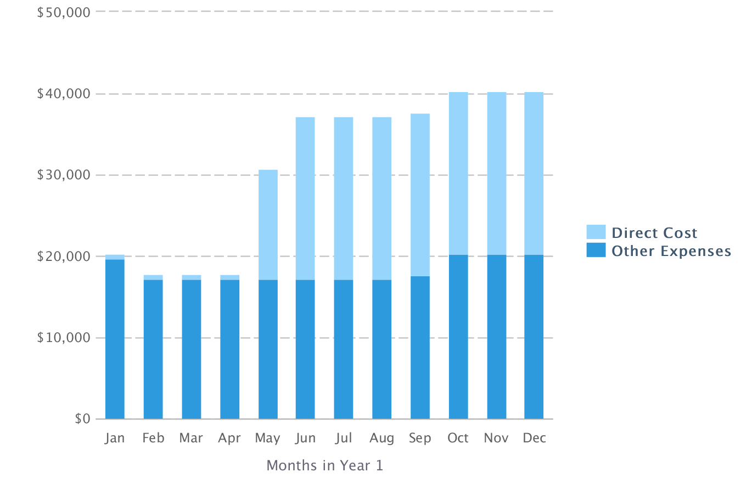

About the Budget
Payroll is by far the largest expense the company incurs. Revenue from the SR&ED Program is expected by April 2015.

Startup Costs
Total start-up requirements include legal costs, insurance and incorporation. The start-up costs are to be financed by the founder's investment.

Financial Statements

Who We Are
GliaX is a not-for-profit medical device development company to be launched in the coming month. It will design, market, lease and sell free software/hardware 3d medical tools to medical professionals around the world.
GliaX will be established as a not-for-profit corporation in January 2015 with founder Dr Tarek Loubani serving as Executive Director and a core engineer for products. GliaX's team has a strong mix of innovative, mechanical, and experiential experience that will ensure the overall success of the venture. Engineers include Kliment Yanev and Jenn Glauche, global leaders in 3d printing, along with MD candidate Spencer Chambers. Coordination will be ensured by Amy Miller, an experienced large scale project manager.

Profit and Loss Statement

Profit and Loss Statement
 | FY2015 | FY2016 | FY2017
Revenue | $412,510 | $765,000 | $915,000
Direct Cost | $155,500 | $283,500 | $363,500
Gross Margin | $257,010 | $481,500 | $551,500
Gross Margin % | 62% | 63% | 60%
Operating Expenses
Salary | $180,000 | $186,300 | $192,819
Employee Related Expenses | $15,000 | $15,525 | $16,068
Marketing & Promotions | $0 | $0 | $0
Rent | $0 | $0 | $0
Utilities | $0 | $0 | $0
Office Supplies | $0 | $0 | $0
Insurance | $1,000 | $1,000 | $1,000
Incorporation | $2,500 | $0 | $0
Accounting / payroll / tax filing | $5,000 | $5,000 | $5,000
Legal | $6,000 | $6,000 | $6,000
Total Operating Expenses | $209,500 | $213,825 | $220,887
Operating Income | $47,510 | $267,675 | $330,613
Income Taxes | $9,502 | $53,535 | $66,123
Total Expenses | $374,502 | $550,860 | $650,510
Net Profit | $38,008 | $214,140 | $264,490
Net Profit / Sales | 9% | 28% | 29%

Gross Margin by Year
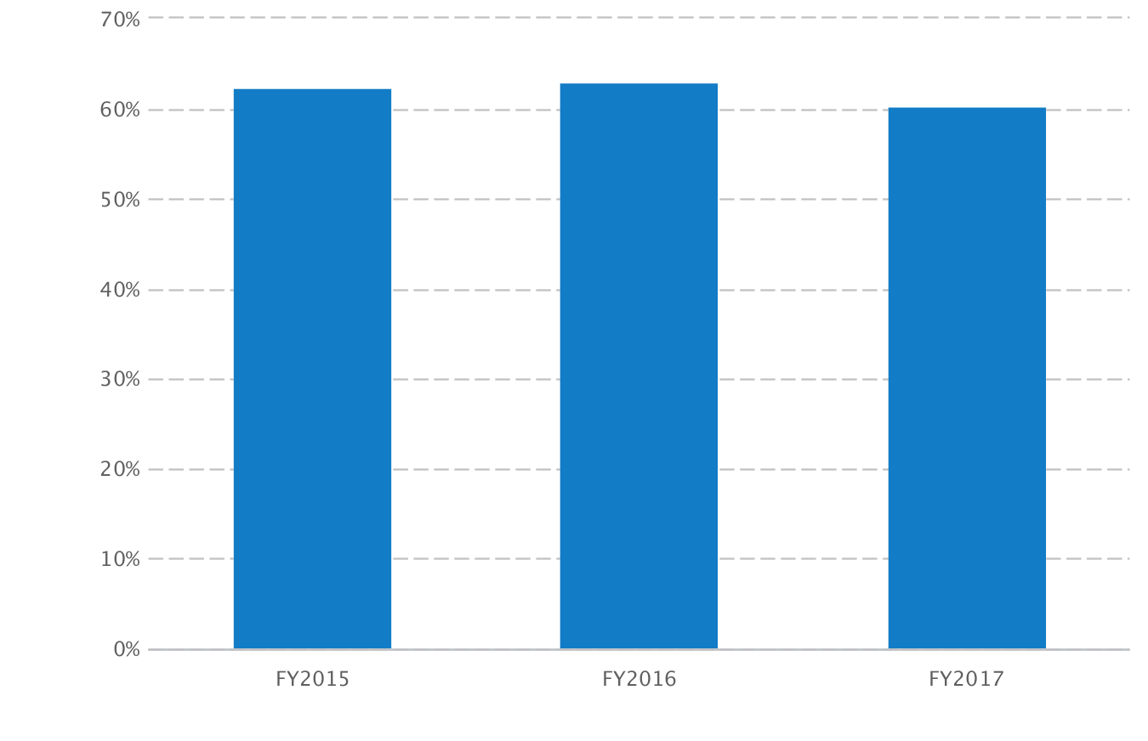

Net Profit (or Loss) by Year
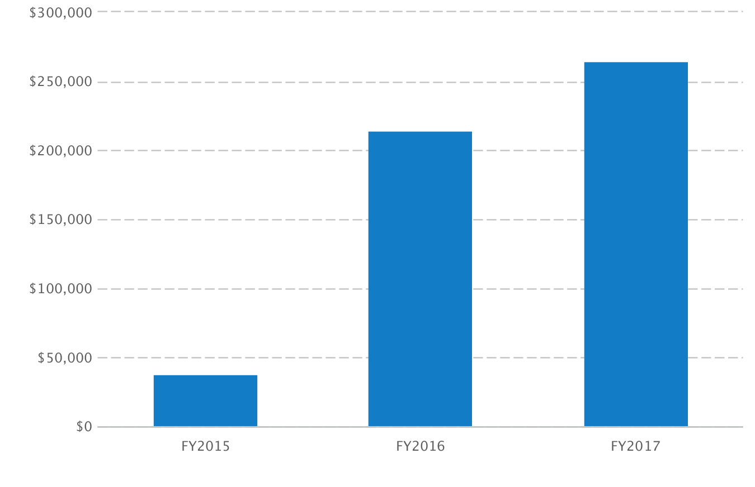

About the Profit and Loss Statement

