
Asset Detailed Specification
 | Manufacturer: | <<Airframe_Manufacturer_GP>>
 | Asset Type: | <<Aircraft_Asset_Variant_GP>>
 | Serial Number: | <<Aircraft_MSN_Number>>
 | Registration: | <<Aircraft_Registration_Number>>
 | Current Operator: | <<Lease_Operator_New>>
 | DOM: | <<Aircraft_Date_of_Manufacture__h>>
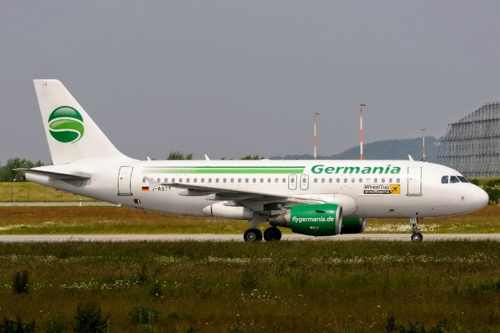

General Description
Asset Type | <<Aircraft_Asset_Type_GP>> | Airframe TSN | <<Airframe_TSN__00>> | Status Date | <<Aircraft_Last_TSN_CSN_Update_Date__h>>
Asset Variant | <<Aircraft_Asset_Variant_GP>> | Airframe CSN | <<Airframe_CSN>> | APU | <<APU_Serial_Number>>
Serial Number | <<Aircraft_MSN_Number>> | FH:FC | <<Airframe_FH_FC>> | Engine Variant | <<Aircraft_Engine_Variant_GP>>
Date of Manufacture | <<Aircraft_Date_of_Manufacture__h>>

Operational
Operator | <<Aircraft_Assigned_To_F>> | Delivery Date | <<Lease_Delivery_Date__h>>
Airworthiness Authority | <<Aircraft_Authority_of_Registration>> | Redelivery Date | <<Lease_Redelivery_Date__h>>
Country of Registration | <<Aircraft_Country_Of_Registry>> | Registration Number | <<Aircraft_Registration_Number>>

Fuel
Fuel Load Type |  |  |  | Capacity |  | Unit |  |  | Alternative Capacity |  |  | Alternative Unit
<<Spec_Fuel_Capacity_Fuel_Load_Type>> |  |  |  | <<Spec_Fuel_Capacity_Capacity>> |  | <<Spec_Fuel_Capacity_Unit>> |  |  | <<Spec_Fuel_Capacity_Alternative_Capacity>> |  |  | <<Spec_Fuel_Capacity_Unit_Alt>>
Interior Configuration
Interior Configuration | Description |  |  |  | Quantity |  | Manufacturer |  |  | Remarks
<<Cabin_Seat_Start>><<Cabin_Seat_Type>> | <<Cabin_Seat_Description_Local>> |  |  |  | <<Cabin_Seat_Qty>> |  | <<Cabin_Seat_Manufacturer>> |  |  | <<Cabin_Seat_Remarks>>

Airframe
Airframe TSN | <<Airframe_TSN__00>> | Status Date | <<Airframe_Status_As_Of__h>>
Airframe CSN | <<Airframe_CSN>> | Date of Manufacture | <<Aircraft_Date_of_Manufacture__h>>

Airframe Maintenance History | Last Event |  |  | Interval
 | Date | TSN | CSN | Months | FH | FC
<<Assembly_Eligible_Event_Start>><<Assembly_Eligible_Event_Event_Type>> | <<Assembly_Eligible_Event_End_Date__h>> | <<Assembly_Eligible_Event_TSN>> | <<Assembly_Eligible_Event_CSN>> | <<Assembly_Eligible_Event.Projected_Event_Interval_2_Months>> | <<Assembly_Eligible_Event.Projected_Event_Interval_2_Hours>> | <<Assembly_Eligible_Event.Projected_Event_Interval_2_Cycles>>

Landing Gear
LDG Maintenance Status |  | Nose |  | Left |  | Right
Status Date |  | <<Nose_LG_Last_TSN_CSN_Update_Date__h>> |  | <<Left_LG_Last_TSN_CSN_Update_Date__h>> |  | <<Right_LG_Last_TSN_CSN_Update_Date__h>>
Manufacturer |  | <<Nose_LG_Manufacturer_GP>> |  | <<Left_LG_Manufacturer_GP>> |  | <<Right_LG_Manufacturer_GP>>
Part Number |  | <<Nose_LG_Part_Number>> |  | <<Left_LG_Part_Number>> |  | <<Right_LG_Part_Number>>
Serial Number |  | <<Nose_LG_Serial_Number>> |  | <<Left_LG_Serial_Number>> |  | <<Right_LG_Serial_Number>>
TSN |  | <<Nose_LG_TSN__00>> |  | <<Left_LG_TSN__00>> |  | <<Right_LG_TSN__00>>
CSN |  | <<Nose_LG_CSN>> |  | <<Left_LG_CSN>> |  | <<Right_LG_CSN>>
Date Last Overhauled |  | <<Nose_End_Date__h>> |  | <<Left_End_Date__h>> |  | <<Right_End_Date__h>>
Overhaul Interval |  | <<Nose_Proj_Interval_2_Cycles__00>> FC / <<Nose_Proj_Interval_2_Months__00>> Months |  | <<Left_Proj_Interval_2_Cycles__00>> FC / <<Left_Proj_Interval_2_Months__00>> Months |  | <<Right_Proj_Interval_2_Cycles__00>> FC / <<Right_Proj_Interval_2_Months__00>> Months
Time Since Overhaul |  | <<Nose_LG_TSLSV__00>> |  | <<Left_LG_TSLSV__00>> |  | <<Right_LG_TSLSV__00>>
Cycles Since Overhaul |  | <<Nose_LG_CSLSV__00>> |  | <<Left_LG_CSLSV__00>> |  | <<Right_LG_CSLSV__00>>

Engine # 1 Maintenance Status
Engine Type | <<Engine1_Engine_Thrust>> |  | Manufacturer | <<Engine_Manufacturer_List>>
ESN (#1 Engine) | <<Engine1_Serial_Number>> |  | FH:FC Ratio | <<Engine1_FH_FC>> |  | Status Date |  | <<Engine1_Status_As_Of__h>>
TSN | <<Engine1_TSN__00>> |  | CSN | <<Engine1_CSN>> |  | Date of Manufacture |  | <<Engine1_Date_of_Manufacture__h>>
TSLSV | <<Engine1_Event_End_Date__h>> |  | CSLSV | <<Engine1_Event_End_Date__h>> |  | Date of Last SV |  | <<Engine1_Date_of_Manufacture__h>>
Cycle Limiter | <<Engine1_Lowest_LLP_Limiter_Current_TS>> |  | LLP Limiter | <<Engine1_Lowest_Limiter_LLP>>
Comments | <<Engine1_Comments>>
Engine Maintenance History |  | Date |  |  | TSN at Event |  | CSN at Event
<<Engine1_Event_Start>>«IF» |  | <<Engine1_Event_End_Date__h>> |  |  | <<Engine1_Event_TSN__00>> |  | <<Engine1_Event_CSN>>

Engine # 1 Disk Sheet

Module | Description | Part Number | Serial Number | CSN | Life Limit | Remaining Cycles
<<Eng1_Start>><<Eng1_Module_N>> | <<Eng1_Name>> | <<Eng1_Part_Number>> | <<Eng1_Serial_Number>> | <<Eng1_CSN_New>> | <<Eng1_Life_Limit>> | <<Eng1_Cycles_Remaining_TS>>

Engine # 2 Maintenance Status
Engine Type | <<Engine2_Engine_Thrust>> |  | Manufacturer | <<Engine_Manufacturer_List>>
ESN (#2 Engine) | <<Engine2_Serial_Number>> |  | FH:FC Ratio | <<Engine2_FH_FC>> |  | Status Date |  | <<Engine2_Status_As_Of__h>>
TSN | <<Engine2_TSN__00>> |  | CSN | <<Engine2_CSN>> |  | Date of Manufacture |  | <<Engine2_Date_of_Manufacture__h>>
TSLSV | <<Engine1_Event_End_Date__h>> |  | CSLSV | <<Engine1_Event_End_Date__h>> |  | Date of Last SV |  | <<Engine2EventCRS_End_Date__h>>
Cycle Limiter | <<Engine2_Lowest_LLP_Limiter_Current_TS>> |  | LLP Limiter | <<Engine2_Lowest_Limiter_LLP>>
Comments | <<Engine2_Comments>>
Maintenance History |  | Date |  |  | TSN at Event |  | CSN at Event
<<Engine2_Event_Start>>«IF» |  | <<Engine2_Event_End_Date__h>> |  |  | <<Engine2_Event_TSN__00>> |  | <<Engine2_Event_CSN>>

Engine # 2 Disk Sheet

Module | Description | Part Number | Serial Number | CSN | Life Limit | Remaining Cycles
<<Eng2_Start>><<Eng2_Module_N>> | <<Eng2_Name>> | <<Eng2_Part_Number>> | <<Eng2_Serial_Number>> | <<Eng2_CSN_New>> | <<Eng2_Life_Limit>> | <<Eng2_Cycles_Remaining_TS>>

APU
Part Number | <<APU_Part_Number>> | Status Date | <<APU_Last_TSN_CSN_Update_Date__h>>
Serial Number | <<APU_Serial_Number>> | Manufacturer | <<APU_Manufacturer_GP>>
APU TSN | <<APU_APU_TSN>> | APU CSN | <<APU_APU_CSN>>
Comments | <<APU_Comments>>
APU Maintenance History | Date | TSN at Event | CSN at Event
<<APU_Event_Start>>«IF» | <<APU_Event_End_Date__h>> | <<APU_Event_TSN__00>> | <<APU_Event_CSN>>

Equipment

ATA | Description | Qty | Manufacturer | Model/PN
<<Equipment_Start>><<Equipment_ATA_Text>> | <<Equipment_Description>> | <<Equipment_Quantity>> | <<Equipment_Vendor>> | <<Equipment_Part_Number>>

Modifications

Category | Type | P/N | Name | Installation Status | Comment
<<Spec_Configuration_Item_New_Start>><<Spec_Configuration_Item_New_Description>> | <<Spec_Configuration_Item_New_Type>> | <<Spec_Configuration_Item_New_Mods_P_N>> | <<Spec_Configuration_Item_New_Name>> | <<Spec_Configuration_Item_New_Status>> | <<Spec_Configuration_Item_New_Comment>>

LOPA
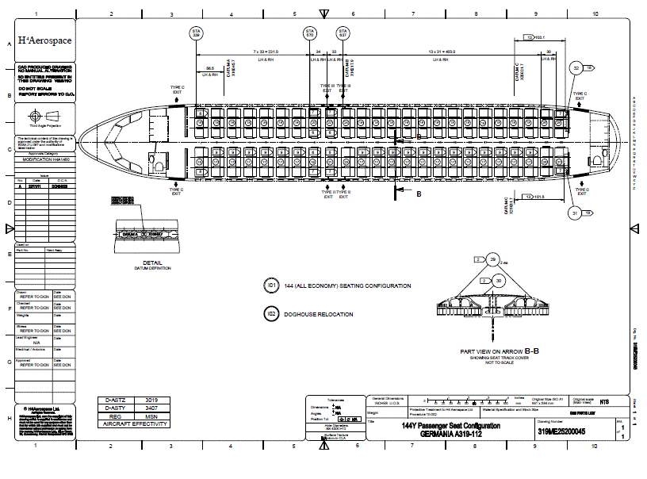

LOPA


EEL


EEL


