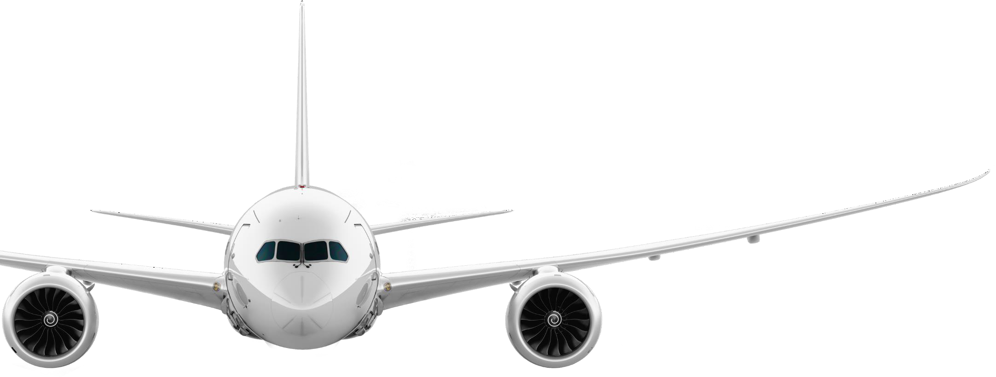Carlyle Aviation Commercial Priorities Call w/c <<Now__b>>

Report Contents

Contents
Report Contents 2
Prior 2 Weeks BAC Committee Approvals 6
Latest AD Meeting Records 6
AD and BAC Approval Pipeline - Next 30 days 7
Financing Projects 9
Asset Transition Report CPC 17
Ongoing Litigations: 32
Lessee Purchase Options 35

Prior 2 Weeks BAC Committee Approvals
Fund | Financing | Deal: Name | Description | Asset: Asset Type | MSN / ESN | Account | Commercial Weekly Summary Notes | BAC Approval Date | Expected BAC Approval Date
<<PriorBAC_Start>>

Latest ADM Meeting Records
Fund | Financing | Deal | Deal Summary | Asset Type | MSN /ESN | Airline / Counterparty | ADM Approval Date | Decision
<<LatestADM_Start>>

AD and BAC Approval Pipeline - Next 30 days
Next ADM's
Fund | Financing | Deal | Deal Summary | Asset Type | MSN | Airline / Counterparty | LOI signed date | Memo Being Prepared  By | Notes
<<NextADM_Start>>

Next 30 days BAC's
Fund | Financing | Deal | Description | Asset Type | MSN | Account | Commercial Weekly Summary Notes | BAC Approval Date | LOI Date
<<NextBAC_Start>>

Upcoming Board Meetings
Fund | Financing | Deal | Deal Summary | MSN | Airline / Counterparty | Relevant Entity | IC / BAC Approval Status
<<NxtBoardMeeting_Start>>

Recently Held Board Meetings
Fund | Financing | Deal | Deal Summary | MSN | Airline / Counterparty | Relevant Entity | Date Meeting Held
<<RecentBoardMeeting_Start>>

Financing Projects


 | 2025 New Aircraft Orderbook/SLB Pipeline
 | JAN | FEB | MAR | APR | MAY | JUN | JUL | AUG | SEP | OCT | NOV | DEC



 | 2026 New Aircraft Orderbook/SLB Pipeline
 | JAN | FEB | MAR | APR | MAY | JUN | JUL | AUG | SEP | OCT | NOV | DEC

2025 Aircraft Deliveries
MSN | Customer | A/C Type | Scheduled  Delivery | Delivery  Location | Comment | Delivery  Status

Awarded |  | Next Action | Contracts Deadline | Due Date
BAFO
Real Opportunity
Requires Proposal
Deal Pipeline - Early Stage Discussions / RFP expected / On Hold

POS | MSN | Type | Engine Contracted | Notified Delay Date | Contracted Spec Freeze HoV | Contracted Spec Freeze non HoV | Airline Customer | Status

Counterparty Deal Type Opportunity Fund Equity Timing Note BUYSIDE
Mandates

Deal Type | Fund | Counterparty | Opportunity | Current Stage | Timeline
BUYSIDE
Mandates
2nd Round Pricing Discussions
1st Round Pricing Discussions
Dead/ Trending Dead

Deal Type | Fund | Counterparty | Opportunity | Current Stage | Timeline
DIVESTMENTS
Mandates

Asset Transition Report CPC
Asset: Name | Operator | Financing | Owner | Estimated Redeliver Date | Estimated Delivery Date | Duration | Project  Stage | Location Information | Next Lessee/Customer: Account Name | Daily/Weekly Updates | Region | Project Type | Project State
<<AssetTransitionReport_Start>>

 | MSN / ESN | Engine Type | D.O.M. | Age at redelivery | Fund | Financing | Current Lessee | Contractual Expiry | Opp.s/Exten./Committed Lessee | Comments | AD / BAC status

MSN / ESN | Aircraft Type | Engine Type | D.O.M. | Age at redeli very | Fund | Financing | Current Lessee | Contractual Expiry | Opp.s/Exten./Committed Lessee | Contract ed | SCHEDULED  Delivery Date | Contractual FINAL Delivery Date | Comments | AD / BAC status

Deal Unique ID | Deal: Name | Probability | MSN (Report) | Marketing Representative | Asset Type & Qty | Commercial Weekly Summary Notes | Contracts/Legal Weekly Summary Notes | Deal Status | Deal Type | Deal Broad Region
<<MarketingDeals_Start>>

MSN / ESN | Aircraft Type | Engine Type | D.O.M. | Age at redeliver y | Fund | Financing | Current Lessee | Contractual Expiry | Likely Redeploy Type / Opportunities | Comments | AD / BAC status

Parent  MSN | MSN /  ESN | Asset Type | Fund /  Financing | Current or Latest  Lessee | Contractual  Expiry | Buyer | Price | Comments | Target Closing  Date | AD / BAC  status

Litigation: Litigation Name | Type Of Action | Legal Manager | Counterparty | Litigation Info | Latest Update | Last Update
<<OngoingLitigation_Start>>

Deal No. | Serial No | Lessee | LOC Type | Amount Held USD | Next Expiry Date | Auto Renew  Until | Comments

Fund | Financing | MSN / ESN | Current Lessee | Insurance Expiry Date | INSURANCE  Notes | Lease Expiry

Notices of Cancellation
Lessee | Aircraft MSNs | Date of Cancellation Per Notice | Agreed Value | Notes/Updates

Contract Name | Asset Type | Asset: Engine Type | Operator: Account Name | Contract End Date | Asset: Date of Manufacture | Lease Option Name | Option/Notice Start | Option/Notice End | Option Type
<<LeaseOptions_Start>>

