Asset Lease Summary
 | Operator | <<Lease_Trading_Alias>>
 | MSN | <<Aircraft_MSN_Number>>
 | Reg. Mark | <<Aircraft_Registration_Number>>
 | Manufacturer: | <<Airframe_Manufacturer_List>>
 | Aircraft type: | <<Aircraft_Type_Variant>>
 | Date of Issue | 26 Sep 2024
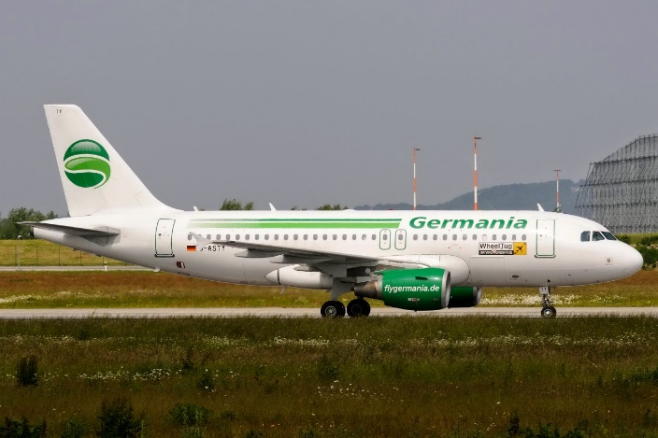

Summary
Lessee | <<Lease_Lessee>> | Contract Status | <<Lease_Lease_Type_Status>>
Aircraft type | <<Aircraft_Type_Variant>> | Portfolio | <<Lease_Portfolios>>
MSN | <<Aircraft_MSN_Number>> | Registration Number | <<Aircraft_Registration_Number>>
Manufacturer | <<Airframe_Manufacturer_List>> | Country of Registration | <<Aircraft_Country_Of_Registry>>
Engine Type | <<Aircraft_Engine_Type>> | Airworthiness Authority | <<Aircraft_Authority_of_Registration>>
ESNs | <<Engine1_Serial_Number>> (<<Engine1_Position>>) / <<Engine2_Serial_Number>> (<<Engine2_Position>>) | Date of Manufacture | <<Aircraft_Date_of_Manufacture__j>>
Engine Manufacturer | <<Engine1_Manufacturer_List>> | Cape Town | No
Previous Operator | <<Lease_Previous_Operator>>

Parties
Servicer | <<Lease_Managing_Company>> | Head Lessor | <<Lease_Head_Lesor>>
Lessee | <<Lease_Lessee>> | Lessor | <<Lease_Lesor>>
Sub Lessee | <<Lease_Sublessee>> | Operator | <<Lease_Operator>>
Owner | <<Lease_Ownr>> | Security Trustee | <<Lease_Security_Truste>>
Beneficial Owner | <<Lease_Beneficial_Owner_2>> | Lessor Guarantor | <<Lease_Guarantr>>
Lessee Guarantor | <<Lease_Lessee_Guarantor>>

Lease Term
Delivery Date | <<Lease_Delivery_Date__j>> | Contract Type | <<Lease_Lease_Type_Legal>>
Lease Contract Date | <<Lease_Lease_Contract_Date__j>> | Current Expiry | <<Lease_Lease_End_Date_New__j>>
Current Term | <<Lease_Lease_Term>> Months | Remaining Term | <<Lease_Remaining_Lease_Term_Mos>> Months

Options
Option Type | Party | Status | In Favour Of | Option Exercise Period |  | Option/Notice Start Date | Option/Notice End Date | Option Details
<<Lease_Options_Start>><<Lease_Options_Option_Type>> | <<Lease_Options_Option_Party>> | <<Lease_Options_Status>> | <<Lease_Options_In_Favour_Of>> | <<Lease_Options_Option_Exercise_Period>> |  | <<Lease_Options_Option_Notice_Start__j>> | <<Lease_Options_Option_Notice_End__j>> | <<Lease_Options_Option_Details>>

Security Deposit Details
Amount Due | <<SD_Security_Deposit_Cash>> | Interest Accrual? | No
Amount Received | <<SD_Deposit_Payments_Received>> | Stipulated Security Deposit (Cash) | <<SD_Security_Deposit_Cash>>
Remaining Amount to be Invoiced | <<SD_Remaining_Amount_to_be_Invoiced>> | Amount Held | <<SD_Security_Depo_Cash>>
Comment | <<Lease_Security_Deposit_Comment>>

Rent
Applicable Calendar |  | <<Calendar_summary>>
Period Start | Period End |  | Rent Type | Base | Rent Due Day | Cycle | Min Rate | Max Rate | Basis | From | PBH Rate
<<Final_Rent_Start>>

Legal Details
Governing Law | <<Lease_Governing_Law>> | Cape Town Convention Ratified | No
Jurisdiction / Venue | <<Lease_Jurisdiction_Venue>> | Geneva Convention Ratified | No
Illegality Provisions | <<Lease_Illegality_Provisions>> | Tax Residency Requirement Lessor | <<Lease_Tax_Residency_Requirement_Lessor>>
Process Agent | <<Lease_Process_Agent>> | Tax Residency Certificate Due | N/A
Sublease without Approval? | <<Lease_Sublease_without_Approval>> | Wet lease without Approval | <<Lease_Wet_lease_without_Approval>>
Arbitration | N/A | Engine Pooling | <<Lease_Engine_Pooling>>
General Contact | <<Lease_General_Contact>> | Notices | <<Lease_Notices>>
Transfer Requirements | <<Lease_Transfer_Requirements>>
Comment | <<Lease_Comment_Legal>>

Maintenance Rent Details
Maintenance Type | <<Lease_Reserve_Type>> |  |  | Due Date | <<Lease_MR_Inv_Pmt_Due_Day_Fix>>
Fund | Rate | Rate Unit | Last Escalation Date | Next Escalation Date | Escalation %
<<Final_MRs_Start>>

Ratio Table
Ratio Name |  | Derate Percentage | FH to FC Ratio | Rate
<<Ratio_Table_result_Start>>

Insurance
Type | Start Date |  | End Date | Agreed Value | Deductible Amount | Variability
<<Final_Insurance_Start>>

Lease Agreement Sections
Section Name | Details
<<Lease_Agreement_Start>><<Lease_Agreement_Name>> | <<Lease_Agreement_Comments>>

Aircraft Details
Date Acquired | <<Aircraft_Date_Acquired>>
Assembly Type |  | Manufacturer | Serial Number |  | Model / Part Number
<<Assemblies_final_Start>>

Redelivery Conditions
Engine Borescope | No | Max Power Assurance Run | No | APU Borescope | No
Engine Borescope Comments | <<Redelivery_Condition_Engine_Borescope_Comments_local>> | Max Power Assurance Run Comments | <<Redelivery_Condition_Max_Power_Assurance_Run_Comments_local>> | APU Borescope Comments | <<Redelivery_Condition_APU_Borescope_Comments_local>>
Redelivery Location | <<Redelivery_Condition_Redelivery_Location>>
C-Check Due (Type) | <<Redelivery_Condition_C_Check_Due_Type>>
Engine Thrust | <<Redelivery_Condition_Engine_Thrust>>
Livery | <<Redelivery_Condition_Livery>>
Original Assembly Required? | <<Redelivery_Condition_Original_ESN_APU_Landing_Gear_Requir>>
Holdover | <<Redelivery_Condition_Holdover>>
Storage Location / Duration / Cost | <<Redelivery_Condition_Storage_Location_Duration_Cost>>
COA / Export COA | <<Redelivery_Condition_COA_Export_COA>>
PMA Parts at Return | <<Redelivery_Condition_PMA_Parts_at_Return>>
DER Repairs | <<Redelivery_Condition_DER_Repairs>>
AD Clearance Period / Cost Sharing | <<Redelivery_Condition_AD_Clearance_Period_Cost_Sharing>>
Acceptance Flight | <<Redelivery_Condition_Acceptance_Flight>>
Interior | <<Redelivery_Condition_Interior>>
IFE | <<Redelivery_Condition_IFE>>
Comments | <<Redelivery_Condition_Comments>>

Name | Type | Life FC | Life FH | Life Months | Life Remaining | Comments
<<Ret_cond_life_Start>><<Ret_cond_life_Name>> | <<Ret_cond_life_Return_Condition_Type>> | <<Ret_cond_life_RC_FC>> | <<Ret_cond_life_RC_FH>> |  | <<Ret_cond_life_Life_Remaining>> | <<Ret_cond_life_Comments>>

