*Employee Management System*

***DESCRIERE****:*

*Proiectul “****Employee Management System****”* este o platform web pentru managementul resurselor, managementul proiectelor, gestionarea cheltuielilor si timesheet. Totodata, iti permite sa vizualizezi ierarhia in firma si managementul angajatior.

**Angajat**:

* Ponatre ore de lucru: anjajatul isi ponteaza orele de lucru la final de saptamana
* Cerere de request: angajatul face request catre manager pentru ai aproba cererea de conciediu vacanta/ conciediu medical/cresterea copilului etc.
* Decontare: angajatul isi creeaza o cerere pt a-si deconta abonamente, precum: abonament sala, training-uri, transport, etc.
* Vizulaizare profil + vizualizare ierarhie companie: angajatul poate vizualiza profilul personal, istoricul cererilor de concediu/decontare/pontare, etc.
* Creare cont propriu sau de catre un manager
* Autentificare cu user si parola

**Manager**:

* Managementul angajatilor: managerul poate adauga un nou angajata, poate schimba pozitia si nivelul angajatului, poate aproba cerere de concediu/decontare/pontare + poate asigna un angajat catre un proiect
* Ponatre ore de lucru: managerul isi ponteaza orele de lucru la final de saptamana
* Cerere de request: managerul face request catre un alt manager pentru ai aproba cererea de conciediu vacanta/ conciediu medical/cresterea copilului etc.
* Decontare: managerul isi creeaza o cerere pt a-si deconta abonamente, precum: abonament sala, training-uri, transport, etc.
* Vizulaizare profil + vizualizare ierarhie companie: managerul poate vizualiza profilul personal, istoricul cererilor de concediu/decontare/pontare, etc.
* Creare cont propriu sau de catre un manager
* Autentificare

**Diagrama use case:**

**Actori**: manager, anagajat

**Action**: Employ: sign in, sign up, trimitere cerere concediu/decontare/pontare, editare cere inainte de aprobare, view personal profile, edit profile, view history, view days available.

Manager: sign in, sign up, approve request(concediu/decontare/pontare), add employ, view employs

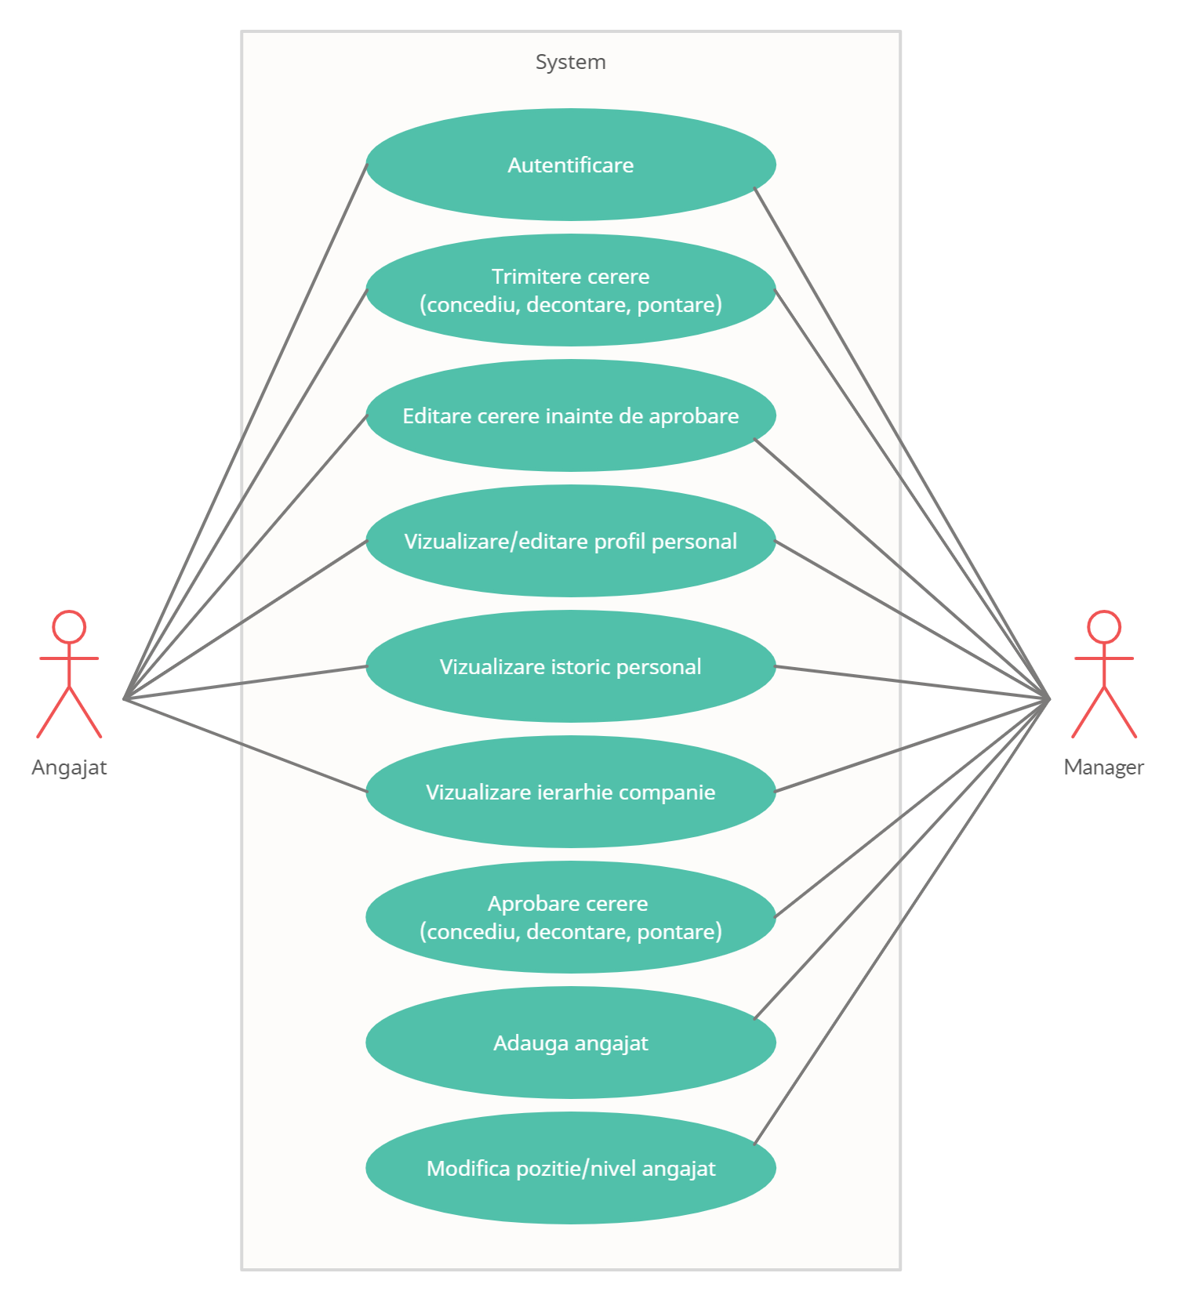

**Diagaram de clasa**

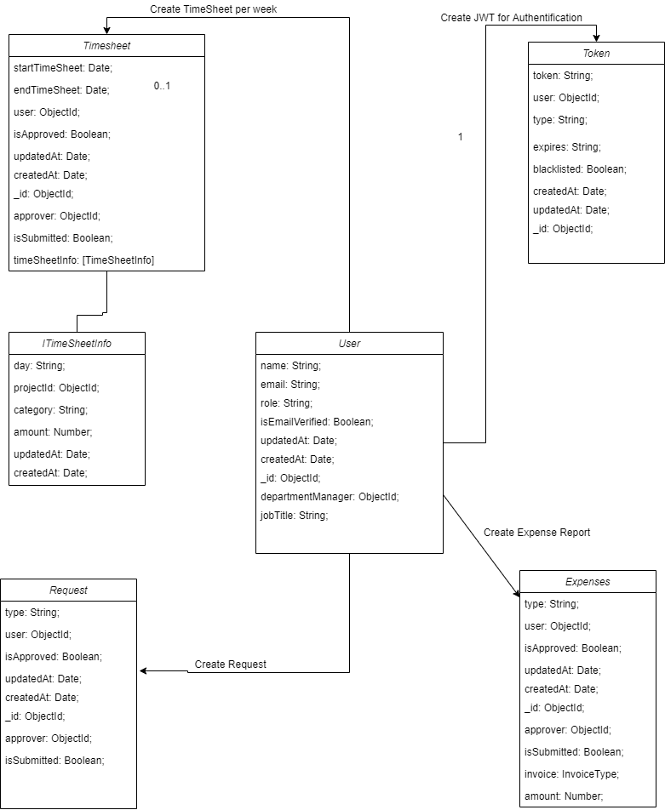

**User story:**

* [**Trello Bord**](https://trello.com/b/930xLFeM/employee-management-system)

**1.Send Request Time Off:** As logged-in user (employ), I can be able to send request , so that the website admin (manager) can review and / or approve the request.

**Acceptance criteria:** Given that I’m a logged-in user, I click on the Request Time Off Button at the top of the application, then the system will send the request to the website administrator who will can approve/review the content and the system shows the “Thanks for your request” message.

**2.Search function:** As a logged-in user, I want to able to search through the website, so that I can find the information I’m looking for.

**Acceptance criteria:** Given I'm a logged-in user, when I select the Search icon, a search field will overlay on the middle of the screen with a blinking text cursor. When I enter my query into the search field, press the Enter key on the keyboard, then the system will show users in the Search Result section with pages that match the entered search query.

**3.Sign in with Google:** As an existing user, I want to use my Google login credentials so that I can access my account quicker.

**Acceptance Criteria:**

Given I'm logged out user, when I open the website, click the “Sign-in with Google” button and enter my credentials in the username and password files, the system then signs me in.

**4.Approve Request Time Off:** As logged-in user (manager), I can be able to review and / or approve the requests so that the other users to receive the approval.

**Acceptance criteria:**

Given that I’m a logged-in user, I click on the Requests List Button at the top of the application, then the system will display all received requests. For each request, I can press the approve or revoke button and the system shows the “ The request was successfully approved/ revoke” message.

**5.Add employ:** As logged-in user (manager), I can be able to add in system a new user, so that the user can access the functionalities of web application.

**Acceptance criteria**

Given that I’m a logged-in user, I click on the Add employ Button at the navigation bar of the application, then the system will create a new user with the user and password and the system shows the “Employee successfully created” message.