**Installing the application**

1) Install Java 7+ JDK

2) Install Tomcat 8+

3) Install MySQL Server

- modify in the jdbc.properties files the user/password of the MySQL Server

4) Move the application war file inside the “webapps” directory of the Tomcat.

5) Populate the MySQL Datasbase using the “populateDB.sql” file

6) Start the Tomcat and access the application from <http://localhost:8080/SpringMVC-Udemy/>

**Using the application**

You can either create a new user

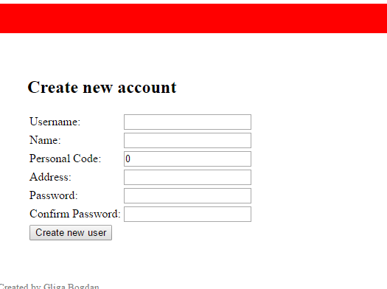

or use one of the existing whose passwords are all “test” by default using the log-in screen

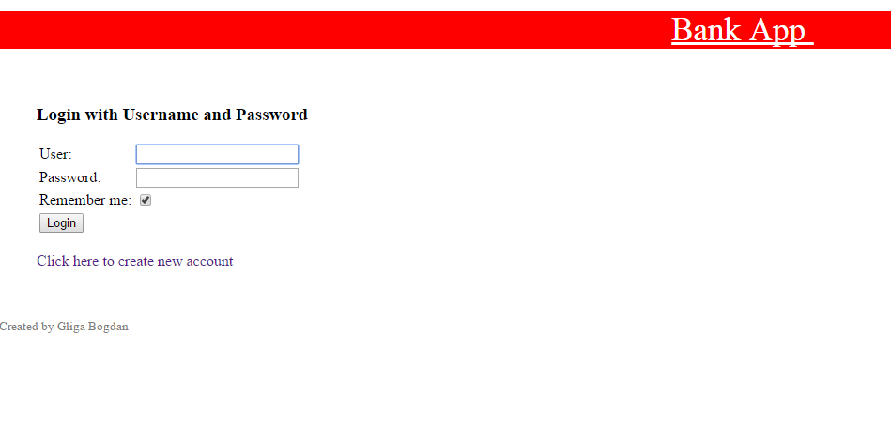

**Use-cases and implemented scenarios:**

1. Main Menu

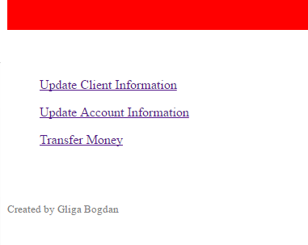

1. Update Client Info

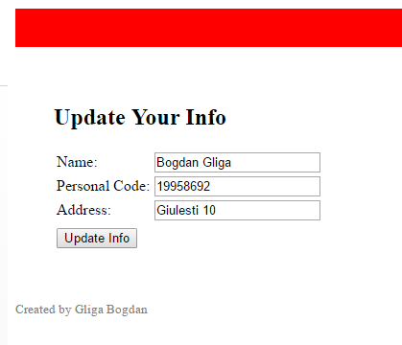

1. Update Account Info

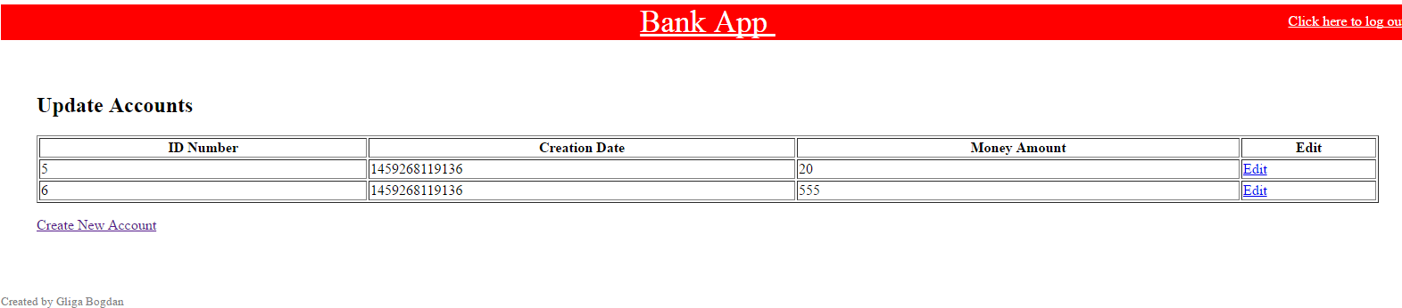

1. Transfer Money

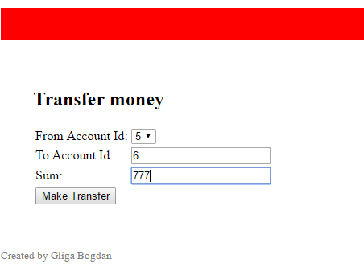

1. View all customers (Admin user only)

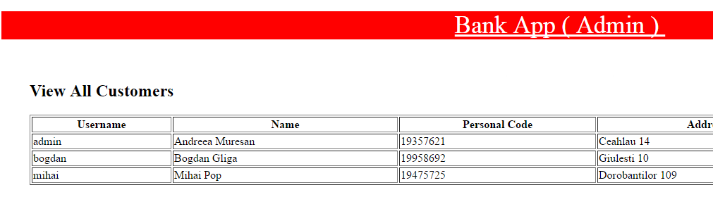

1. Generate user reports (Admin user only)

