**Installing the application**

1) Install Java 7+ JDK

2) Install Tomcat 8+

3) Move the application war file inside the “webapps” directory of the Tomcat.

4) Populate the MySQL Datasbase using the “populateDB.sql” file

5) Start the Tomcat and access the application from <http://localhost:8080/SpringMVC-Udemy/>

**Using the application**

You can either create a new user

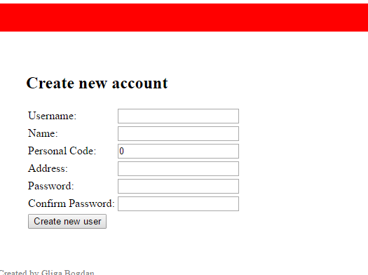

or use one of the existing whose passwords are all “test” by default using the log-in screen

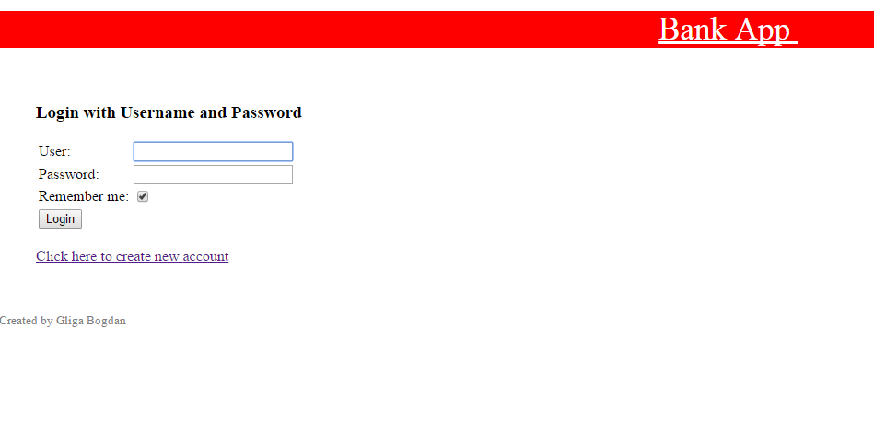

**Use-cases and implemented scenarios:**

1. Main Menu

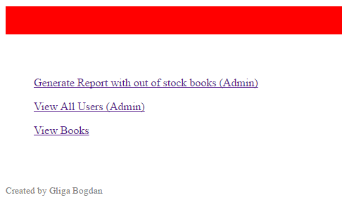

1. Generate Report with out of stock books

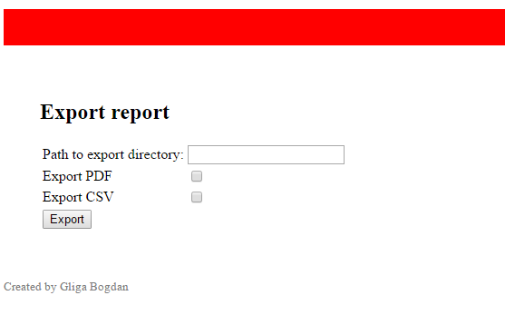

1. View All Users

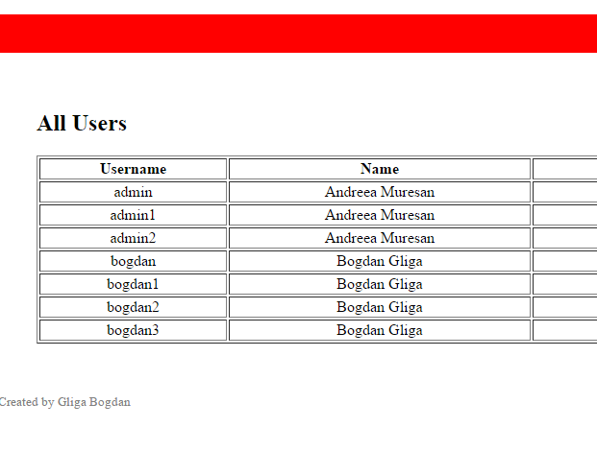

1. Edit User Data

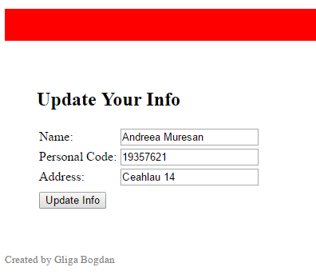

1. View Books

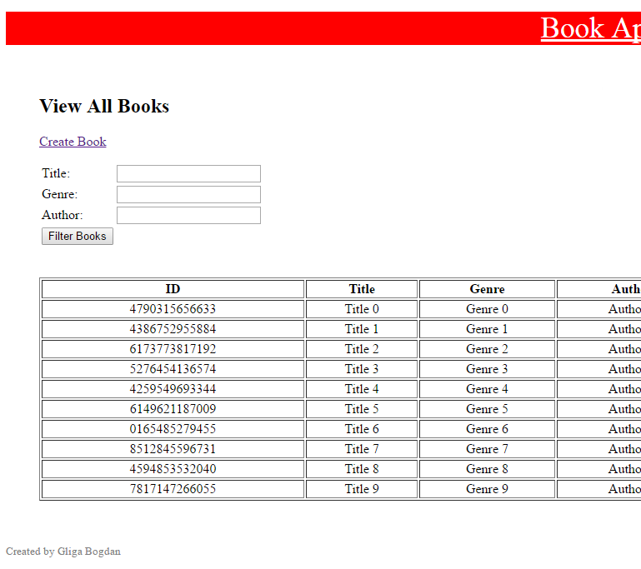

1. Create Book

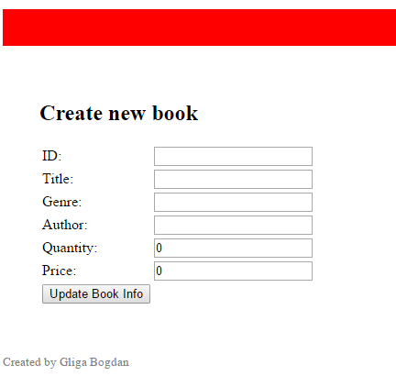

1. Search by fields

