**Installing the application**

1) Install Java 7+ JDK

2) Install Tomcat 8+

3) Install MySQL Server

- modify in the jdbc.properties files the user/password of the MySQL Server

4) Move the application war file “SpringMVC-Udemy” inside the “webapps” directory of the Tomcat.

5) Populate the MySQL Datasbase using the “populateHospitalDb.sql” file

6) Start the Tomcat and access the application from <http://localhost:8080/SpringMVC-Udemy/>

**Using the application**

Login using the login form

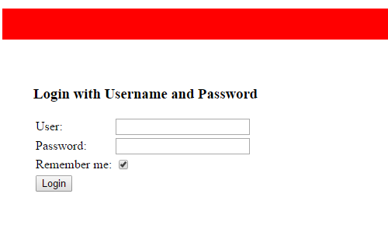

1. **As admin**
   1. 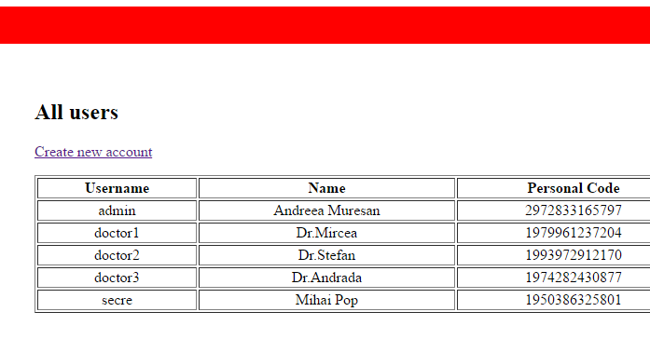View all users
   2. Edit/Delete user

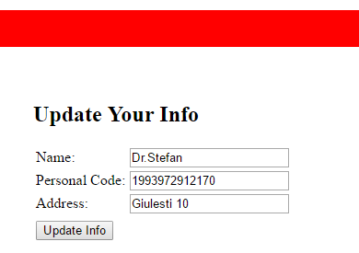

* 1. 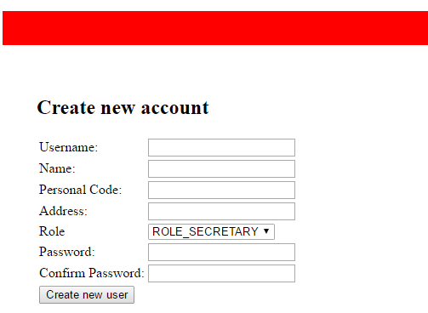Create new user

1. **As doctor**
   1. View patients

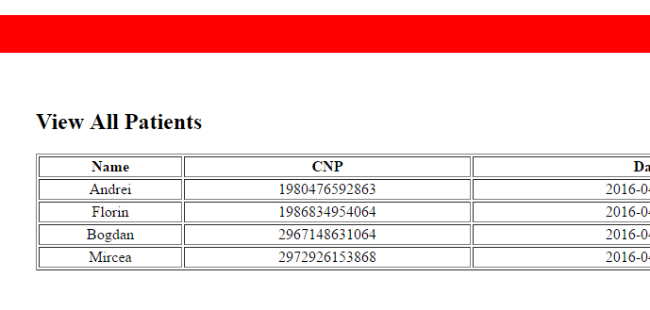

* 1. 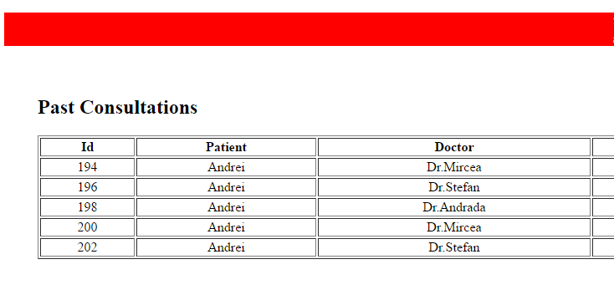View consultation history

1. **As secretary**
   1. 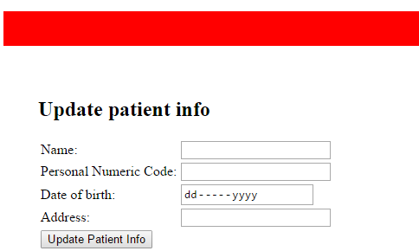Add patient
   2. Edit/Delete consultations

