

Functional Safety Concept Lane Assistance

**Document Version: [1.0]**

**Template Version 1.0, Released on 2017-06-21**



# Document history

**[Instructions: Fill in the date, version and description fields. You can fill out the Editor field with your name if you want to do so. Keep track of your editing as if this were a real world project.**

**For example, if this were your first draft or first submission, you might say version 1.0. If this is a second submission attempt, then you'd add a second line with a new date and version 2.0]**

|  |  |  |  |
| --- | --- | --- | --- |
| Date | Version | Editor | Description |
| 24 June 2019 | 1.0 | Guilin Zhu | First version for functional safety concept |
|  |  |  |  |
|  |  |  |  |
|  |  |  |  |
|  |  |  |  |

# Table of Contents

**[Instructions: We have provided a table of contents. If you change the document structure, please update the table of contents accordingly. The table of contents should show each section of the document and page numbers or links. Most word processors can do this for you. In** [**Google Docs**](https://support.google.com/docs/answer/116338?co=GENIE.Platform%3DDesktop&hl=en)**, you can use headings for each section and then go to Insert > Table of Contents.** [**Microsoft Word**](https://support.microsoft.com/en-us/help/285059/how-to-create-a-table-of-contents-by-marking-text-in-word) **has similar capabilities]**

Document history

Table of Contents

Purpose of the Functional Safety Concept

Inputs to the Functional Safety Analysis

Safety goals from the Hazard Analysis and Risk Assessment

Preliminary Architecture

Description of architecture elements

Functional Safety Concept

Functional Safety Analysis

Functional Safety Requirements

Refinement of the System Architecture

Allocation of Functional Safety Requirements to Architecture Elements

Warning and Degradation Concept

# Purpose of the Functional Safety Concept

**[Instructions: Answer what is the purpose of a functional safety concept?]**

The purpose of functional safety concept is to derive higher level functional safety requirements from safety goals, which are derived from hazard analysis and risk assessment as well as refine the system architecture.

# Inputs to the Functional Safety Concept

## Safety goals from the Hazard Analysis and Risk Assessment

**[Instructions:**

**REQUIRED:**

**Provide the lane departure warning and lane keeping assistance safety goals as discussed in the lessons and derived in the hazard analysis and risk assessment.**

**OPTIONAL:**

**If you expanded the hazard analysis and risk assessment to include other safety goals, include them here.**

**]**

|  |  |
| --- | --- |
| **ID** | **Safety Goal** |
| Safety_Goal_01 | Unintended oscillating torque shall be prevented/limited for LDW function |
| Safety_Goal_02 | LKA function shall detect/report driver hands off the wheel within certain amount of time |
| Safety_Goal_03 | LKA function shall keep in ego lane and unintended torque command shall be prevented |

## Preliminary Architecture

**[Instructions: Provide a preliminary architecture for the lane assistance item. Hint: See Lesson 3: Item Definition]**

The current lane assistance system architecture is shown below:

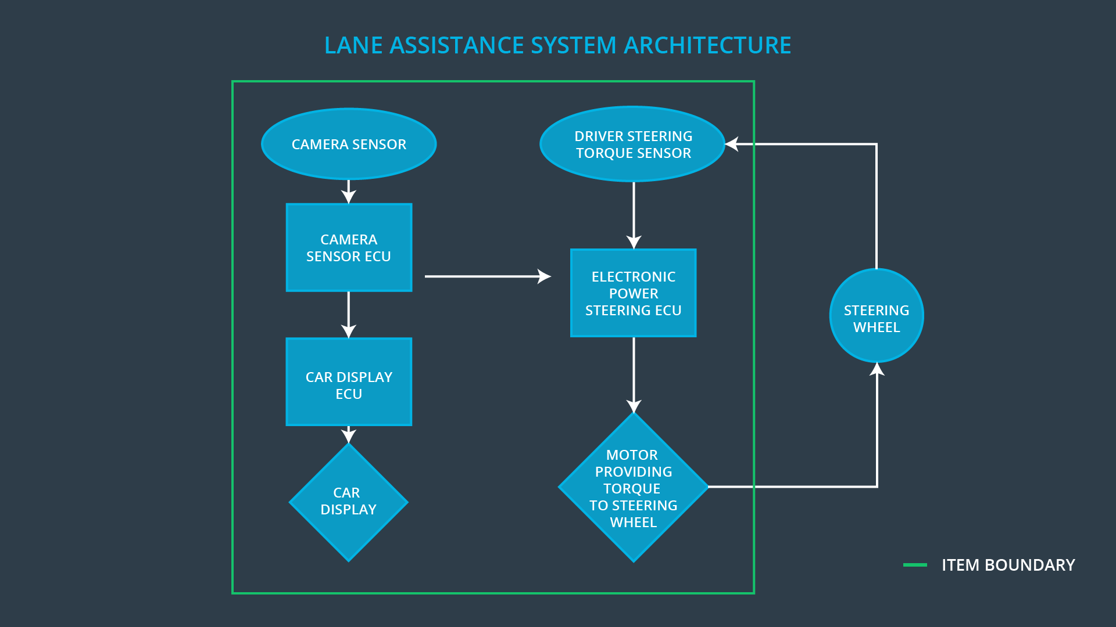

### Description of architecture elements

**[Instructions: Provide a description for each of the item elements; what is each element's purpose in the lane assistance item? ]**

|  |  |
| --- | --- |
| **Element** | **Description** |
| Camera Sensor | Responsible for detecting lane lines |
| Camera Sensor ECU | Responsible for determining when vehicle leaves the lane by mistake |
| Car Display | Responsible for displaying warning as to whether the vehicle is leaving the lane |
| Car Display ECU | Responsible for determining the warning coming from lane departure warning function |
| Driver Steering Torque Sensor | Detect driver’s intention/torque on the steering wheel |
| Electronic Power Steering ECU | Responsible for determining/calculating an appropriate amount of torque based on lane assistance system torque request |
| Motor | Responsible for providing the torque command from EPS ECU |

# Functional Safety Concept

The functional safety concept consists of:

* Functional safety analysis
* Functional safety requirements
* Functional safety architecture
* Warning and degradation concept

## Functional Safety Analysis

**[Instructions: Fill in the functional safety analysis table below.]**

|  |  |  |  |
| --- | --- | --- | --- |
| **Malfunction ID** | **Main Function of the Item Related to Safety Goal Violations** | **Guidewords (NO, WRONG, EARLY, LATE, MORE, LESS)** | **Resulting Malfunction** |
| Malfunction_01 | Lane Departure Warning (LDW) function shall apply an oscillating steering torque to provide the driver a haptic feedback | More | Lane departure warning (LDW) function applies an oscillating steering torque above the limit |
| Malfunction_02 | Lane Departure Warning (LDW) function shall apply an oscillating steering torque to provide the driver a haptic feedback | More | The lane departure warning function applies an oscillating torque with very high torque frequency (above limit) |
| Malfunction_03 | Lane Keeping Assistance (LKA) function shall apply the steering torque when active in order to stay in ego lane | No | Lane keeping assistance function has no hands on the steering wheel. |
| Malfunction_04 | Lane Keeping Assistance (LKA) function shall apply the steering torque when active in order to stay in ego lane | More | Lane Keeping Assistance (LKA) function applies more torque command than expected when active |

## Functional Safety Requirements

**[Instructions: Fill in the functional safety requirements for the lane departure warning ]**

Lane Departure Warning (LDW) Requirements:

|  |  |  |  |  |
| --- | --- | --- | --- | --- |
| **ID** | **Functional Safety Requirement** | **ASIL** | **Fault Tolerant Time Interval** | **Safe State** |
| Functional  Safety  Requirement  01-01 | The lane keeping item shall ensure the lane departure oscillating torque amplitude is below Max_Torque_Amplitude | C | 50ms | Lane assistance output ramp out to zero and disable LDW |
| Functional  Safety  Requirement  01-02 | The lane keeping item shall ensure that lane departure oscillating torque frequency is below Max_Torque_Frequency | C | 50ms | Lane assistance output ramp out to zero and disable LDW |

Lane Departure Warning (LDW) Verification and Validation Acceptance Criteria:

|  |  |  |
| --- | --- | --- |
| **ID** | **Validation Acceptance**  **Criteria and Method** | **Verification Acceptance**  **Criteria and Method** |
| Functional  Safety  Requirement  01-01 | The driver is able to control the vehicle when Max_Torque_Amplitude is set to different values | When fault is injected into torque amplitude signal and it exceeds the limit, the lane assistance output is set to zero within 50ms |
| Functional  Safety  Requirement  01-02 | The driver is able to control the vehicle when Max_Torque_Frequency is set to different values | When fault is injected into torque frequency signal and it exceeds the limit, the lane assistance output is set to zero within 50ms |

**[Instructions: Fill in the functional safety requirements for the lane keeping assistance]**

Lane Keeping Assistance (LKA) Requirements:

|  |  |  |  |  |
| --- | --- | --- | --- | --- |
| **ID** | **Functional Safety Requirement** | **ASIL** | **Fault Tolerant Time Interval** | **Safe State** |
| Functional  Safety  Requirement  02-01 | The lane keeping item shall ensure that LKA function is able to detect driver hands off the wheel for Max_duration | B | 200ms | System warning and LKA ramp out torque command, disable LKA |
| Functional  Safety  Requirement  02-02 | The lane keeping item shall ensure that LKA function torque output is below Max_Cmd | B | 200ms | System warning and LKA ramp out torque command, disable LKA |

Lane Keeping Assistance (LKA) Verification and Validation Acceptance Criteria:

|  |  |  |
| --- | --- | --- |
| **ID** | **Validation Acceptance**  **Criteria and Method** | **Verification Acceptance**  **Criteria and Method** |
| Functional  Safety  Requirement  02-01 | The Max_duration is chosen/tested in the vehicle | When driver’s hands off the steering wheel for more than Max_duration, the LKA function ramp out and disble the output. |

## Refinement of the System Architecture

**[Instructions: Include the refined system architecture. Hint: The refined system architecture should include the system architecture from the end of the functional safety lesson including all of the ASIL labels.]**

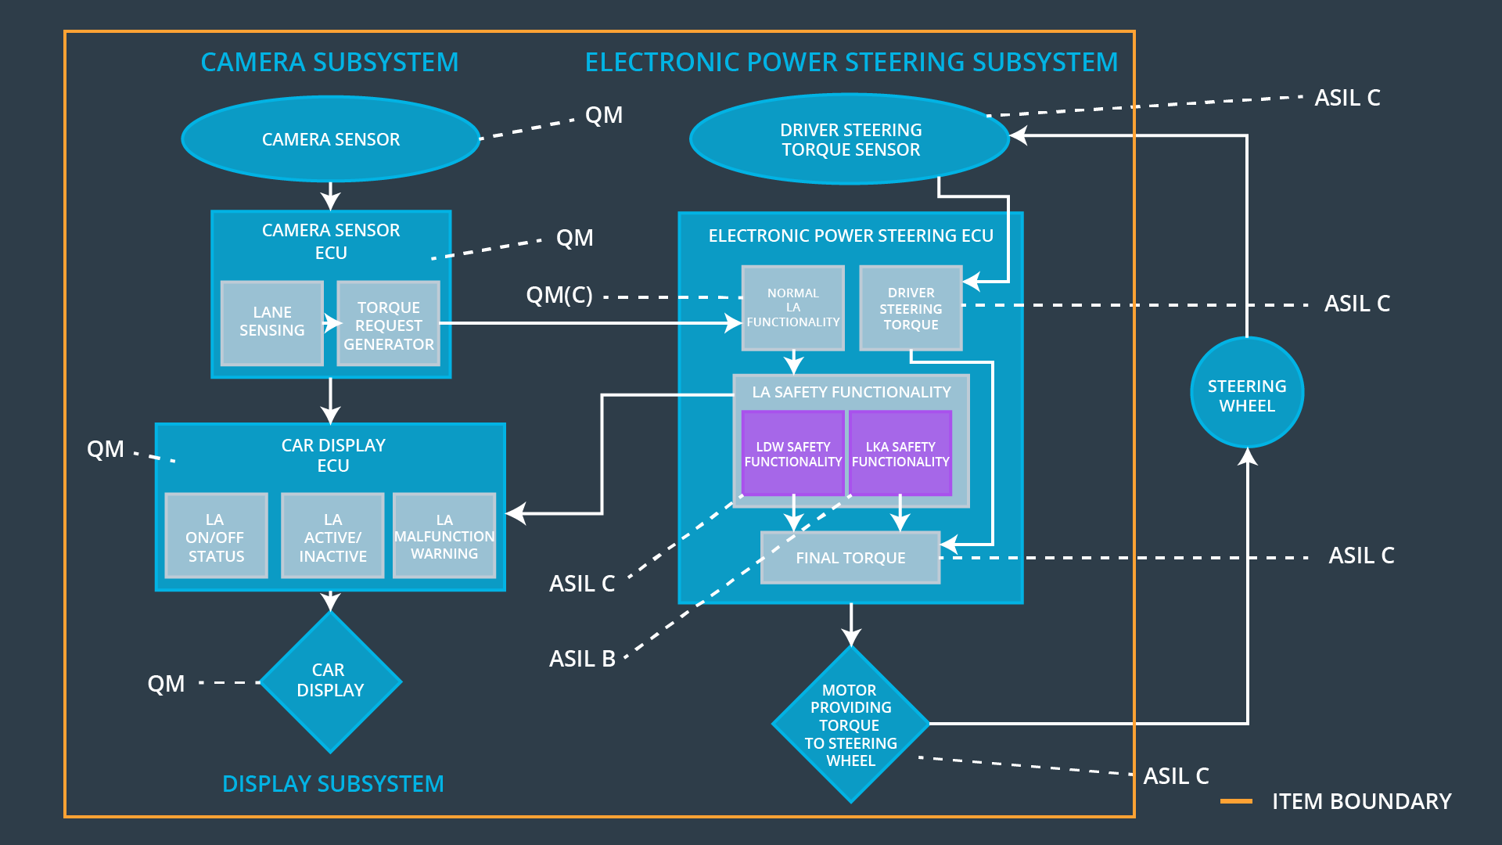

## Allocation of Functional Safety Requirements to Architecture Elements

**[Instructions: Mark which element or elements are responsible for meeting the functional safety requirement. Hint: Only one ECU is responsible for meeting all of the requirements.]**

|  |  |  |  |  |
| --- | --- | --- | --- | --- |
| **ID** | **Functional Safety Requirement** | **Electronic Power Steering ECU** | **Camera ECU** | **Car Display ECU** |
| Functional  Safety  Requirement  01-01 | The electric power steering ECU shall ensure the lane departure oscillating torque amplitude is below Max_Torque_Amplitude | **x** |  | **x** |
| Functional  Safety  Requirement  01-02 | The electric power steering ECU shall ensure that lane departure oscillating torque frequency is below Max_Torque_Frequency | **x** |  | **x** |
| Functional  Safety  Requirement  02-01 | The electric power steering subsystem shall ensure that LKA function is able to detect driver hands off the wheel for Max_duration | **x** |  | **x** |
| Functional  Safety  Requirement  02-02 | The EPS shall ensure that LKA function torque output is below Max_Cmd | x |  |  |

## Warning and Degradation Concept

**[Instructions: Fill in the warning and degradation concept.]**

|  |  |  |  |  |
| --- | --- | --- | --- | --- |
| **ID** | **Degradation Mode** | **Trigger for Degradation Mode** | **Safe State invoked?** | **Driver Warning** |
| WDC-01 | LDW function off | When the oscillating torque above the limit | Yes | The driver will be alerted by the Car display |
| WDC-02 | LKA function off | When driver’s hands off the steering wheel for more than Max_duration | Yes | The driver will be alerted by the Car display |