Lab-Project 10: Static Acquisition with BackTrack
What You Need for This Project
- VMware Player
- A BackTrack 5 R3 ISO file BT5R3-GNOME-32.iso, as handed out in class. Other versions, even back to Backtrack 4, works also.
Gathering the Files You Need
Download it at home from:
http://www.backtrack-linux.org/downloads
Click Start, Computer. Open the VMs drive. Open the folder with your name on it. Make a subfolder named YOURNAME-proj10.
Download the p10Evidence.zip file (or Lab-Proj.10_Evidence.zip from the instructor)
Right-click the p10Evidence.zip file and click "Extract All", Extract. A window opens containing a file named "Windows 2000 Professional-sparse.vmdk". Copy that file into the your YOURNAME-proj10 folder on the VMs drive. This is a virtual hard disk containing evidence.
Checking the Hash Value of the Evidence File
If Hashcalc is not installed, download and install it from http://slavasoft.com/hashcalc
Drag the "Windows 2000 Professional-sparse.vmdk" file and drop it on the HashCalc window.
Verify that the MD5 hash value matches the image shown below. This proves that your download worked properly.
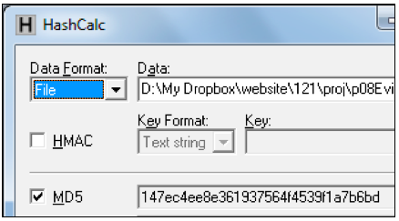
If you are using Mac OS X, use the command-line utility md5, as shown, e.g. below:
Creating a New Virtual Machine
Open VMware Player.
Click "Create a new Virtual Machine".
In the "New Virtual Machine Wizard", click the "I will install the operating system later" button, as shown below. Click Next.
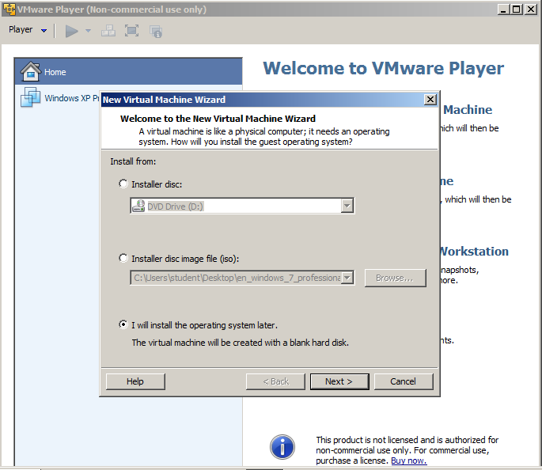
In the "Select a Guest Operating System" box, select Linux and Ubuntu, as shown below. Click Next.
Note: This is important so VMware will use the right mouse driver, especially on netbooks and systems with USB mice.
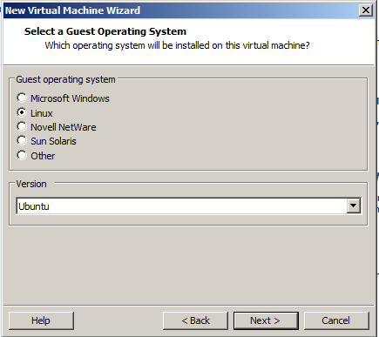
In the "Name the Virtual Machine" box, enter a Virtual machine name of YOURNAME-Proj10 as shown below.
Set the Location to the YOURNAME-proj10 folder on the VMs drive. Click Next.
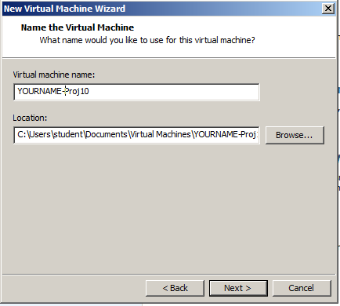
In the "Specify Disk Capacity" box, accept the default options and click Next.
In the "Ready to Create Virtual Machine" box, click Finish.
Connecting the Evidence Drive
In VMware Player, on the lower right, click "Edit virtual machine settings".
In the "Virtual Machine Settings" box, click the Add... button.
In the "Hardware Type" box, click "Hard Disk". Click Next.
In the "Select a Disk" box, click "Use an existing virtual disk". Click Next.
In the "Select an Existing Disk" box, click the Browse... button. Navigate to your "Windows 2000 Professional-sparse.vmdk" file and double-click it.
A box pops up asking if you want to 'Convert existing virtual disk to newer format?", as shown below.
This is the evidence drive, we certainly don't want to change anything, so click "Keep Existing Format".
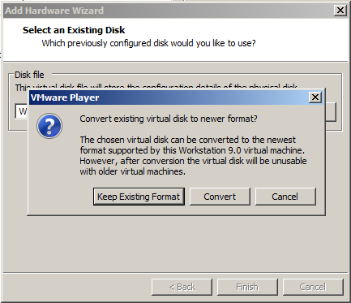
The "Virtual Machine Settings" box now shows a "New Hard Disk", as shown, e.g. below.
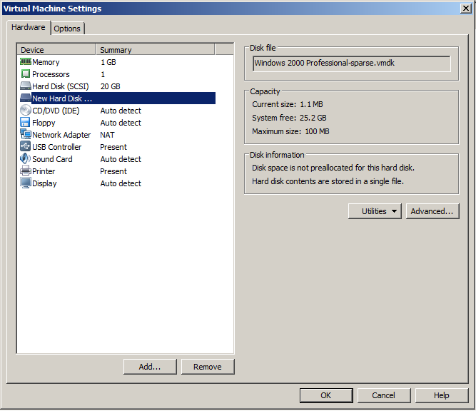
Disabling Networking
A fundamental rule of forensics is WORK IN ISOLATION - in other words, don't connect to the Internet while imaging drives.
To disable networking, in the "Virtual Machine Settings" box, in the left pane, click "Network Adapter".
On the right side, in the top section, clear the "Connect at power on" box.
On the right side, in the middle section, click the "Host-only" button, as shown below.
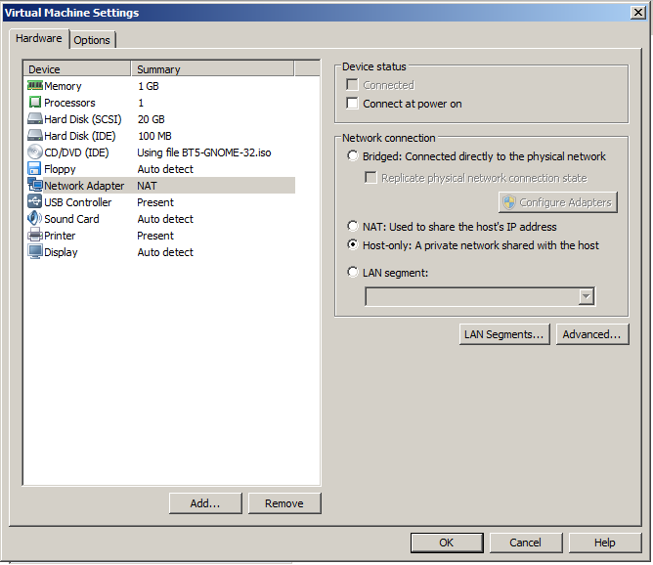
Booting from the BackTrack ISO File in Forensics Mode
In the "Virtual Machine Settings" box, in the left pane, click "CD/DVD (IDE)".
On the right side, click the "Use ISO image file" button.
Click the Browse button, navigate to your BT5R3-GNOME-32.iso file, and double-click it.
Your screen should resemble the image below, but with a later version of BackTrack.
Click OK.
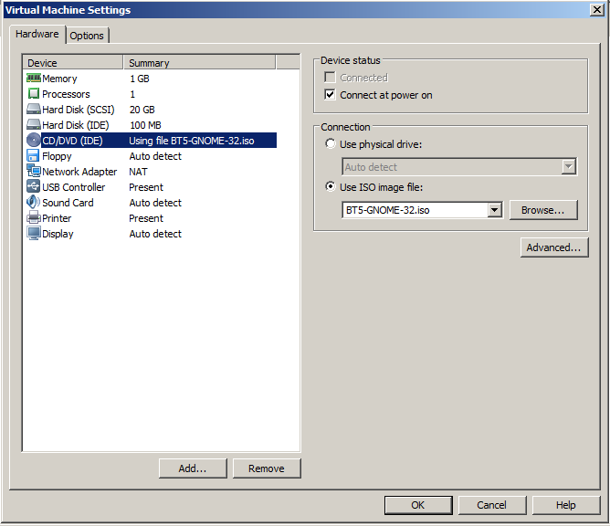
In VMware Player, on the lower right, click "Play virtual machine".
Quickly click in the virtual machine window as it starts up and press the F2 key.
The BIOS opens, as shown below. If it does not, in the upper left of the VMware Player window, click Player, Power, Reset, and try again.
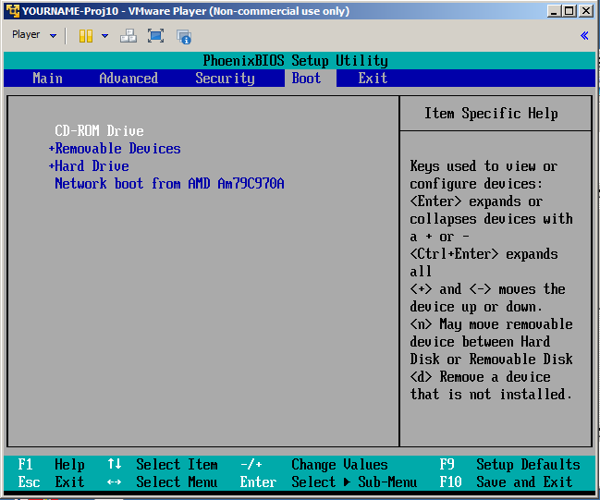
In the BIOS, use the arrow keys to adjust the boot order, moving the CD-ROM to the top, as shown above.
Press F10 and Enter to save the BIOS settings.
A prompt says boot:. Press Enter.
BackTrack starts, as shown below.
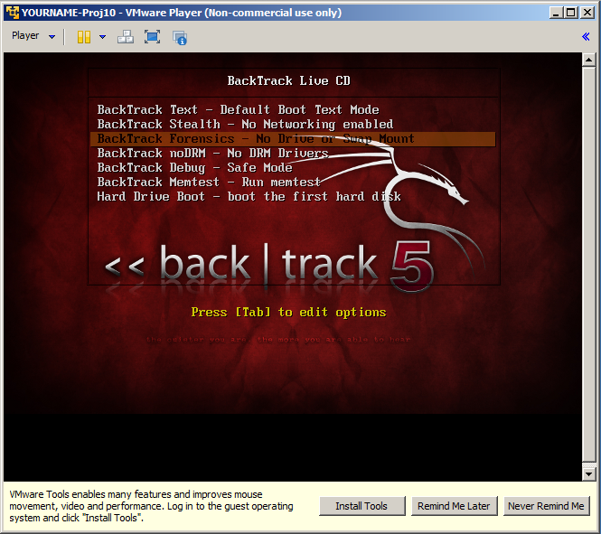
Click in the VM and use the down-arrow key to highlight the third item: "Backtrack Forensics" as shown above.
Press the Enter key to boot BackTrack.
When you see the root@bt:~# prompt, enter this command, followed by the Enter key:
startx
The BackTrack Desktop
When teh desktop loads, you will see a decorative desktop, as shown below on this page.
In the upper left, to the right of the word "System", click the black square icon to open a Terminal window.
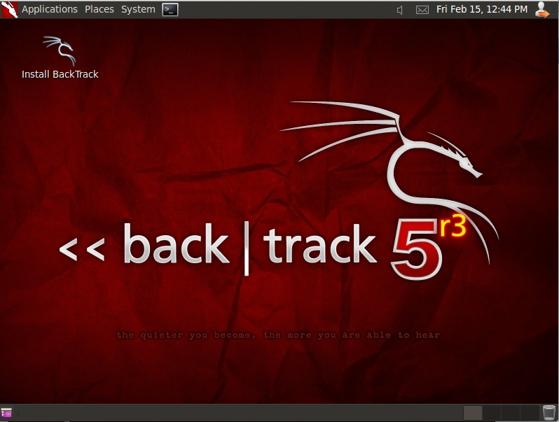
Identifying the Drives with parted
In the Terminal window, enter these commands, pressing the Enter key after each one:
parted
print devices
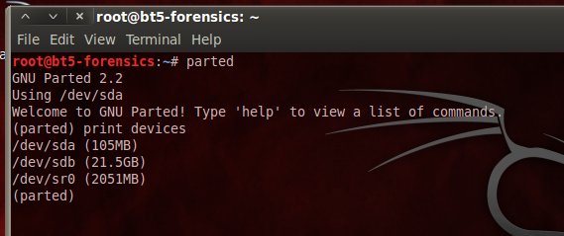
This lists the attached devices, as shown above on this page.
Find the evidence drive--it is 105 MB in size. When I did it, the evidence drive was /dev/sda.
The 21.5 GB empty hard drive available to perform collection was /dev/sdb.
Formatting the Empty Drive
We will use the empty drive to acquire an image of the evidence drive. It must be formatted first.
In the Terminal window, at the (parted) prompt, enter these commands, pressing the Enter key after each one.
These commands make a 500 MB partition on the empty drive.
In the first command, make sure you are selecting the empty drive, not the evidence drive!
select /dev/sdb
mklabel msdos
mkpartfs primary fat32 0.0 500.0
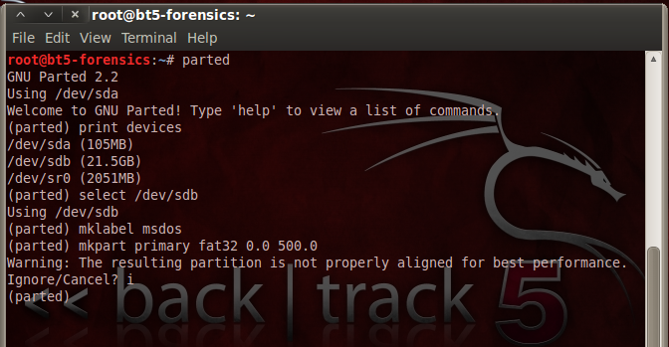
A message appears, saying: "The resulting partition is not properly aligned for best performance". Type i and press Enter, to ignore this warning.
In the Terminal window, at the (parted) prompt, enter this command, and then press Enter:
print all
A list of partitions appears, as shown below on this page.
You should see a 32.9 MB partition on the evidence drive (/dev/sda), and a 500 MB partition on the empty drive (/dev/sdb).
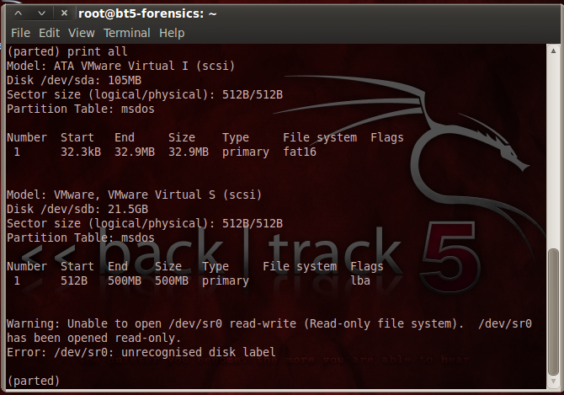
In the Terminal window, at the (parted) prompt, enter this command, and then press Enter:
quit
This closes parted and returns you to the normal Linux bash prompt.
Mounting the Partition
Now you must mount the new partition.
These are the missing steps in the classroom demo on 2-14-13. The earlier version of Backtrack I used previously automatically mounted the filesystem.
In the Terminal window, at the # prompt, enter these commands, and pressing Enter after each one:
mkdir /media/data
mount /dev/sdb1 /media/data
df
The last line shows the new volume with the filesystem /dev/sdb1 mounted at /media/data, as shown below.
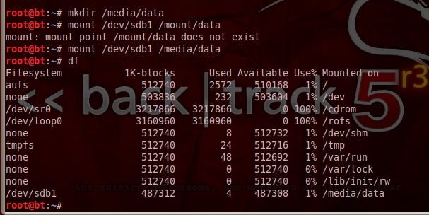
Testing the Working Partition
In the Terminal window, type these commands, pressing Enter after each one.
These commands change the working directory to the empty drive, create a small file on it, and display a directory of files.
Notice that the last command contains two lowercase "L" characters--they are not numeral "1" characters.
cd /media/data
echo test > foo
ls -l
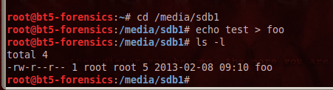
The directory shows the foo file, as shown above.
Your empty partition is ready to be used.
Acquiring an Image of the Whole Evidence Disk with dd
In the Terminal window, type these commands, pressing Enter after each one.
The dd command copies data from the evidence drive to a file named YOURNAME-dd. (Replace YOURNAME with your own name).
The md5sum command calculates the md5 hash and puts it in a file named YOURNAME-dd-hash.
The cat command prints the contents of the YOURNAME-dd-hash file.
dd if=/dev/sda of=YOURNAME-dd
md5sum YOURNAME-dd > YOURNAME-dd-hash
cat YOURNAME-dd-hash
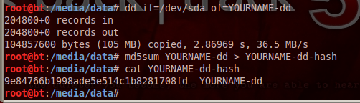
Your hash value should match the image shown above.
Comparing the Hash to the Hashcalc Value
This hash doesn't match the MD5 hash you calculated previously from the VMware hard disk file. That's OK, because the VMware hard disk format is not a simple dd of a hard drive. It adds headers, rollback data, and such, as explained here:
http://www.vmware.com/app/vmdk/?src=vmdk
Acquiring an Image of One Partition with dd
We could also capture only the partition from the drive, which might contain all the data we are interested in, or perhaps all the data we are authorized to collect.
In the Terminal window, type these commands, pressing Enter after each one.
dd if=/dev/sda1 of=YOURNAME-1-dd
md5sum YOURNAME-1-dd > YOURNAME-1-dd-hash
cat YOURNAME-1-dd-hash
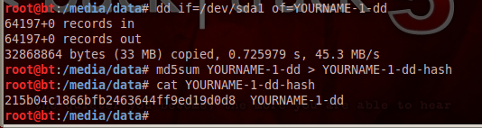
Your hash value should match the image shown above. This hash does not match the previous one, because it's an image of only one partition, not the whole drive.
Acquiring an Image of the Whole Evidence Disk with dcfldd
dcfldd is an enhanced version of dd developed by the U.S. Department of Defense Computer Forensics Lab. It's included in BackTrack.
In the Terminal window, type these commands, pressing Enter after each one.
dcfldd if=/dev/sda of=YOURNAME-dc hashlog=YOURNAME-dc-hash
cat YOURNAME-dc-hash
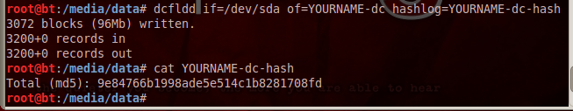
Notice that this is nicer--it shows a running count of blocks written to reassure you that it hasn't crashed.
The hash value should match the hash value you calculated earlier after the dd command.
In the Terminal window, type this command, followed by the Enter key. (The command contains two lowercase L characters, and no numerals.)
ls -l
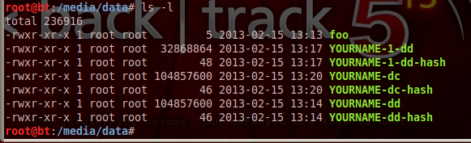
The directory shows the two acquisition files YOURNAME-dd and YOURNAME-dc. They are the same size. In fact, they are identical, because the md5 hashes match.
Using dcfldd to Verify the Image
In the Terminal window, type this command, followed by the Enter key:
dcfldd if=/dev/sda vf=YOURNAME-dd
The vf value points to an image which is compared to the if file.
The result is "Total: Match", as shown below on this page.
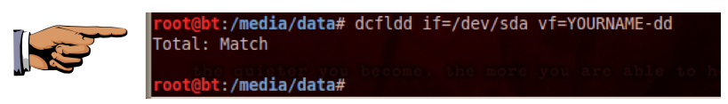
Saving a Screen Image
Make sure your screen shows "Total: Match", as shown above.
Press Ctrl+Alt to release the mouse from the Virtual Machine.
Press the PrintScrn key in the upper-right portion of the keyboard. That will copy the whole desktop to the clipboard.
YOU MUST SUBMIT AN IMAGE OF THE WHOLE DESKTOP TO GET FULL CREDIT!
Open Paint and paste in the image.
Save the image with the filename "Your Name Lab-Proj 10". Use your real name, not the literal text "Your Name".
Testing the Effects of an Error
What would happen if you made a mistake in a command, and wrote to the evidence drive?
In the Terminal window, type this command, followed by the Enter key:
echo test > /dev/sda
Did that corrupt the evidence? To see, run the verify command again:
dcfldd if=/dev/sda vf=proj10-dd
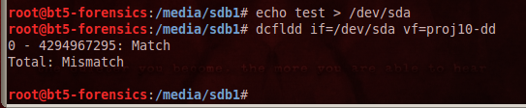
As you see, the file no longer matches the drive. The evidence has been altered! So, although this technique works, it is not as good as using a hardware write-blocker at all.
Turning in your Project
Email the image to the instructor as an email attachment. Send it to: xxx@fe.edu.vn with a subject line of "Lab-Proj 10 From Your Name", replacing Your Name with your own first and last name. Send a Cc to yourself.

