Lab-Project 14: Finding Items with NetWitness
Getting the PCAP File
Doanload this file and save it:
3items.pcap
Verify the MD5 hash of the file. The correct value is 45094695ea765c54bfe80393d2d68f24.
Task
Load the captured packets into NetWitness.
Find these items, and save an image of your whole desktop when you do.
FTP Download
Find an FTP download of a ZIP file.
Save an image like this one, showing the name of the downloaded file.
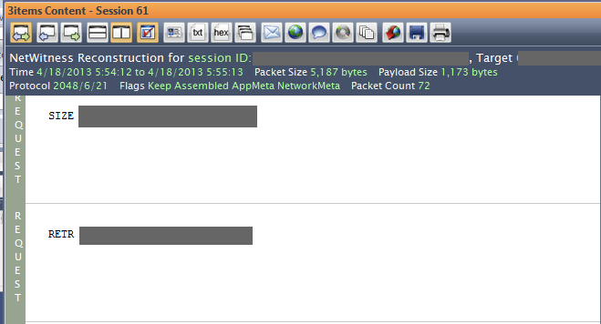
Yahoo Search
Find reconstructed Yahoo search page.
Save an image like this one, showing the term which was searched for.
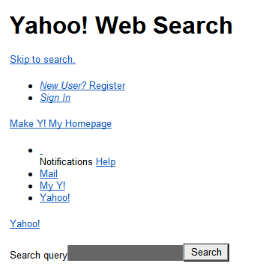
Gear Image
Find this image that was viewed in a reconstructed page. Your image should have some writing in the lower left corner which has been redacted from my sample image below.
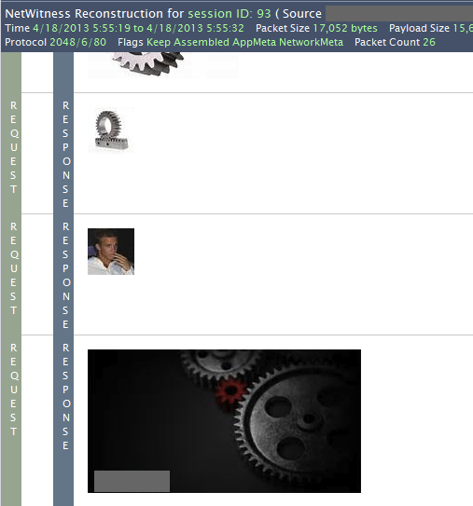
Turning in Your Project
Email the images to xxx@fe.edu.vn with a Subject line of Lab-Proj 14 from Your Name. Send a Cc: to yourself.

