Lab 1: Preparing a Virtual Windows Machine
What You Need for This Project
- A computer with VMware Player. You can use any host OS you like, and if you prefer to use some other virtual machine software like VirtualBox or Xen, that is fine too. You can download VMware Player here:
https://my.vmware.com/web/vmware/free#desktop_end_user_computing/vmware_player/5_0
- The instructions below assume you are using Windows 7. You can use VMware on the Mac and other operating systems, but the steps may be somewhat different.
- You need the DVD that was handed out in class, which contains a Windows XP SP 3 virtual machine. It also contains a machine named "Win XP Target" -- don't use that one.
Starting VMware Player
You can get VMware player here:
https://my.vmware.com/web/vmware/free#desktop_end_user_computing/vmware_player/5_0
VMware Player is installed. Double-click the "VMware Player" icon on the desktop to start it.
Opening your Virtual Machine
In the VMware Player window, click "Open a Virtual Machine". Browse to the VMs drive and open the folder with your name on it. Open the "WinXPSP3" folder and double-click the "Windows XP Professional.vmx" file.
In the VMware Player window, click the green "Play virtual machine" button.
VMware Player will pop up several dialog boxes, asking whether this machine was moved or copied, telling you details about the processor, etc. Just accept the default choice for all those boxes.
You should see a Windows XP desktop in the VMware Player window, as shown below:
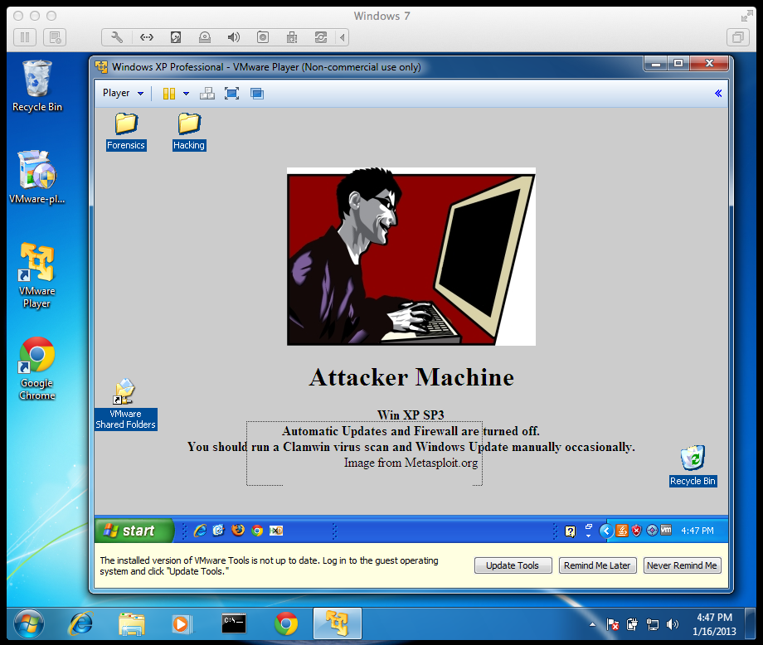
Changing Your Virtual Machine's Name
All the virtual machines now have the same name. This will cause warning messages to appear on the desktops, and it is confusing. So you should change your machine’s name to contain your name, with the following steps.
Click the Start button on your virtual machine’s desktop, right-click "My Computer", and click Properties.
Click the Computer Name tab.
Click the Change button.
Change the computer name to "XP-YOURNAME", replacing "YOURNAME" with your own name.
Click OK.
When a Computer Name Changes box appears saying: You must restart..., click OK.
In the System Properties box, click OK.
In the System Settings Change box, click Yes.
Wait while your virtual computer restarts. Log in as you did before.
Click the Start button on your virtual machine’s desktop, right-click "My Computer", and click Properties.
Click the "Computer Name" tab. The "Full computer name:" should contain your name, as shown below.
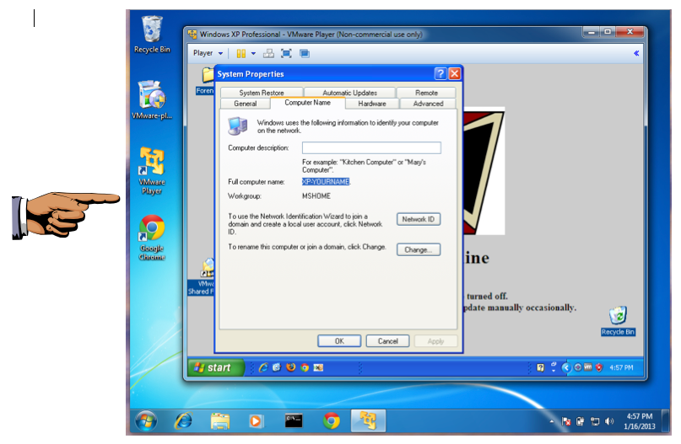
Saving a Screen Image
You have now completed Lab 1. The only thing that remains is to turn it in. To do that, you need to capture an image of the screen and email it to the instructor.
Note the hand symbol on the image above: that indicates screen images that you must capture and turn in.
Click the taskbar at the bottom of your host Windows 7 desktop, to make the host machine listen to the keyboard, instead of the virtual machine.
Press the PrintScrn key in the upper-right portion of the keyboard. That will copy the whole desktop to the clipboard.
YOU MUST SUBMIT A FULL-SCREEN IMAGE FOR FULL CREDIT!
On the host machine, not the virtual machine, click Start.
Type mspaint into the Search box and press the Enter key.
Click in the untitled - Paint window, and press Ctrl+V on the keyboard. The desktop appears in the Paint window.
In the upper left corner of the "untitled - Paint" window, click the little blue square icon (it looks like a floppy disk, something people used to use long ago--you might never have seen one).
Save the document with the filename "YOUR NAME Lab 1", replacing "YOUR NAME" with your real name.
Email the image to the instructor as an attachment to an e-mail message. Send it to: xxx@fe.edu.vn with a subject line of "Lab 1 From YOUR NAME", replacing "YOUR NAME" with your real name.
Send a Cc to yourself.
Shutting Down your Virtual Machine
In the VMware Player window, in the upper right corner, click the X. A box pops up, offering three choices, as shown below.
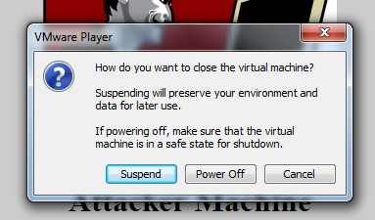
Suspend freezes your VM in its current state. This is usually the best choice.
Power Off is only for emergencies, when the guest operating system has crashed. It's the equivalent of pulling out the power plug on a real computer.
Click Suspend.

