Edrine K.

Report

My report for the CSY2028 Jobs website assignment.

Requested Features

| **Feature** | **Done?** | **Relevant Files** | **Relevant Pages** | **Notes** |
| --- | --- | --- | --- | --- |
| Change copyright notice to current year | Yes | * templates/footer.html.php | * *All pages* | I made the copyright date dynamic, so it will always be up to date. |
| Add "FAQs" page with placeholder text and link in menu | Yes | * controllers/Faqs.php | * /faqs |  |
| Fix issue with new categories not appearing on jobs page or navigation bar | Yes | * templates/topsection.html.php | * *All pages* | All pages will have the top section. They are all affected. |
| Add ability to archive jobs for reposting later | Yes | * controllers/Jobs.php * pages/admin/jobs.php | * /admin/jobs | Jobs can also be unarchived. Jobs can only be archived by staff members or the client account that created the jobs |
| Add category name as column in job list table, and allow filtering by category in admin page | Yes | * controllers/Jobs.php * pages/admin/jobs.php | * /admin/jobs | Both client and admin accounts can access this page. If a client is logged in. Jobs not created by them will not be shown. |
| Add ability for customers to filter jobs by location | Yes | * controllers/Jobs.php * pages/jobs.php | * / * /jobs *(through menu at the top)* | Customers can filter by category ID or location. The location does not have to be absolute or case sensitive. ‘north’ matches ‘Northampton’. |
| Implement user account management for staff access to admin area | Yes | * controllers/Admin.php * controllers/Accounts.php * pages/admin/accounts.php * pages/admin/accountmodify.php | * /admin * /admin/accounts * /admin/accounts/modify * /admin/accounts/modify?id=*X* | Only admin/staff members can create accounts.  *X* stands for an account ID to be modified. If the ‘id’ parameter is not present. This would mean modifying accounts in the systeme to add a new one and nothing will be autofilled. |
| Allow clients to add jobs and view applicant details in restricted admin area | Yes | * controllers/Admin.php * controllers/Jobs.php * pages/admin/jobs.php * pages/admin/jobmodify.php * pages/admin/jobapplicants.php | * /admin/jobs * /admin/jobs/modify * /admin/jobs/modify?id=*X* * /admin/jobs/applicants?id=*X* | Only clients that created the jobs or admin members will be able to view applicants and edit the job. |
| Display 10 jobs with closing dates soon on homepage | Yes | * controllers/Home.php * pages/index.php | * / | Jobs that have a closing date that is in the past or jobs that are archived by the client who created them or admin members will not be shown. |
| Add form to contact page for customer enquiries and store them on the website. Allow staff members to manage the enquiries. |  | * controllers/Contact.php * controllers/Enquiries.php * pages/contact.php * pages/admin/enquiries.php | * /contact * /admin/enquiries * /admin/enquiries?id=*X* | Any member can send an enquiries on the contact page. Only admin accounts (not clients) can view and mark or unmark them as complete. |

Testing

Code was tested using PHPUnit for form validation and functionality, including forms to add or edit a job/account and login.

I encountered a problem when attempting to run PHPUnit through Docker using the command docker-compose run -w /websites/jobs phpunit --coverage-html=./report. The issue was that it was not reading my PHPUnit configuration file, which included coverage and other settings. To resolve this, I installed my own PHPUnit binary through Composer by running the command composer require --dev phpunit/phpunit. I then ran the command XDEBUG_MODE=coverage ./vendor/bin/phpunit websites/jobs/ --coverage-html=./report which successfully executed the tests and generated a coverage report. It should be noted that when running PHPUnit through Docker compose, it properly identifies test files (as they are prefixed with "Test.php") and runs the tests successfully, however it does not read the config file for coverage.

My coverage reports are included in the ZIP file under the “report” folder.

PHPUnit test output screenshot

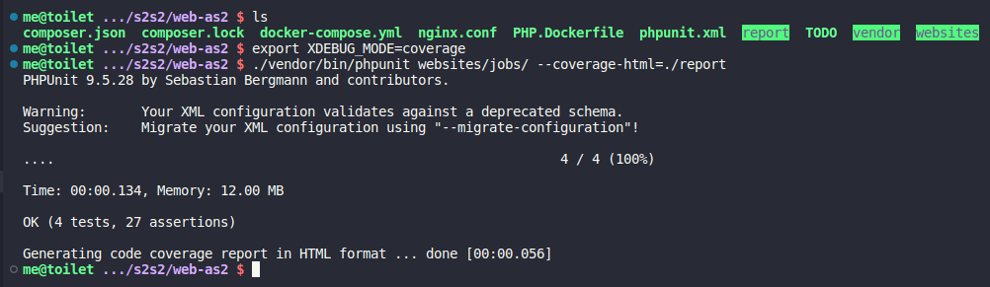

PHPUnit coverage browser screenshot

