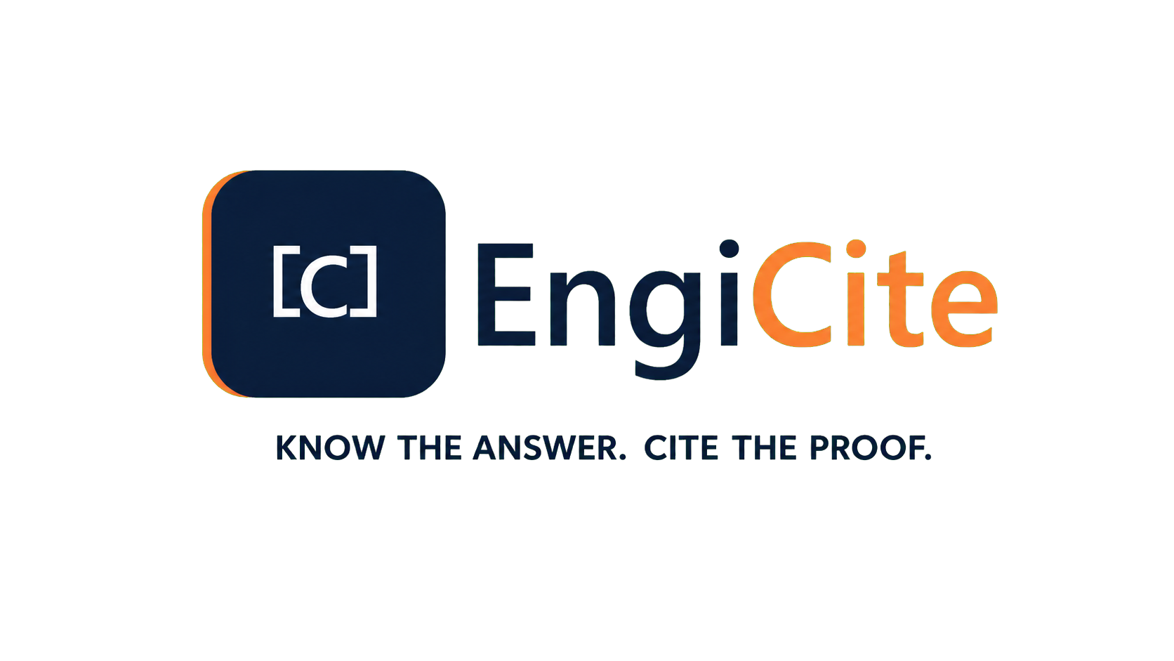

  - Complete End Product Blueprint
A plain-language definition of the product, its users, daily operation and intended business value.
PRODUCT VISION | AUGUST 2026

1. Product definition
EngiCite will be a secure engineering information workspace for organisations that manage large volumes of technical documents. It will bring document control, project collaboration, engineering search and evidence-backed artificial intelligence into one controlled environment.
Important product boundary: This document defines the intended end product. Some functions already exist; others will be delivered through later approved milestones.

2. Who will use EngiCite
- Organisation administrator: Controls the company workspace, users, subscriptions and organisation-wide settings.
- Project administrator: Creates projects, manages project membership and monitors project activity.
- Document controller: Creates document records, maintains metadata, uploads revisions and manages the master register.
- Engineer: Searches documents, reviews revisions, compares changes and asks evidence-backed questions.
- Viewer: Reads approved information without changing controlled records.
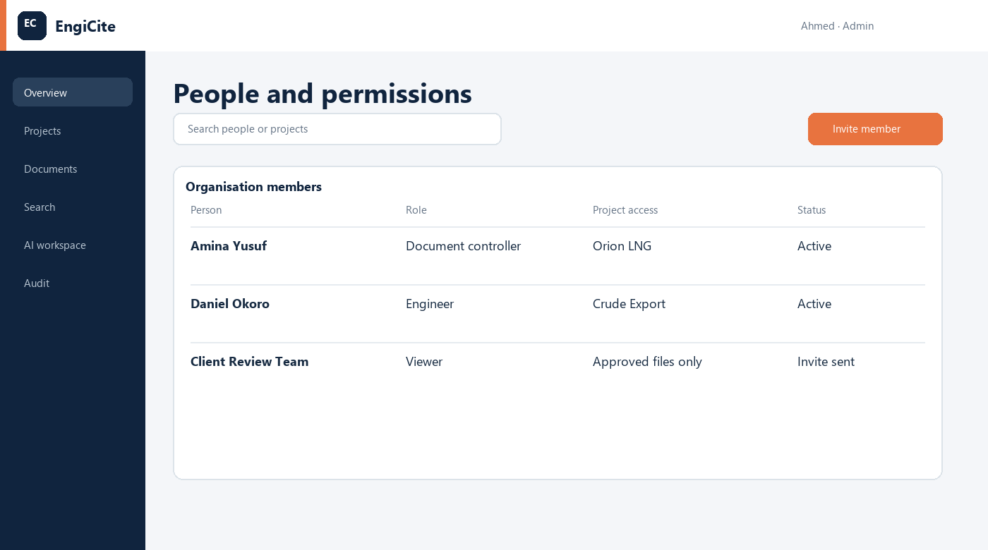
Illustrative interface - people, roles and project-specific access

3. How EngiCite will be used
- An administrator creates the organisation and its projects.
- Authorised people are invited and assigned a clear role.
- A document controller creates the document record and uploads a revision.
- EngiCite checks the file, keeps it private and updates the master register.
- Engineers search, review, compare revisions or ask questions over authorised documents.
- Every AI answer identifies the document number, revision and page used as evidence.
- Reviewers approve, return or comment on documents through a controlled workflow.
- Important actions remain available in the audit history and management reports.
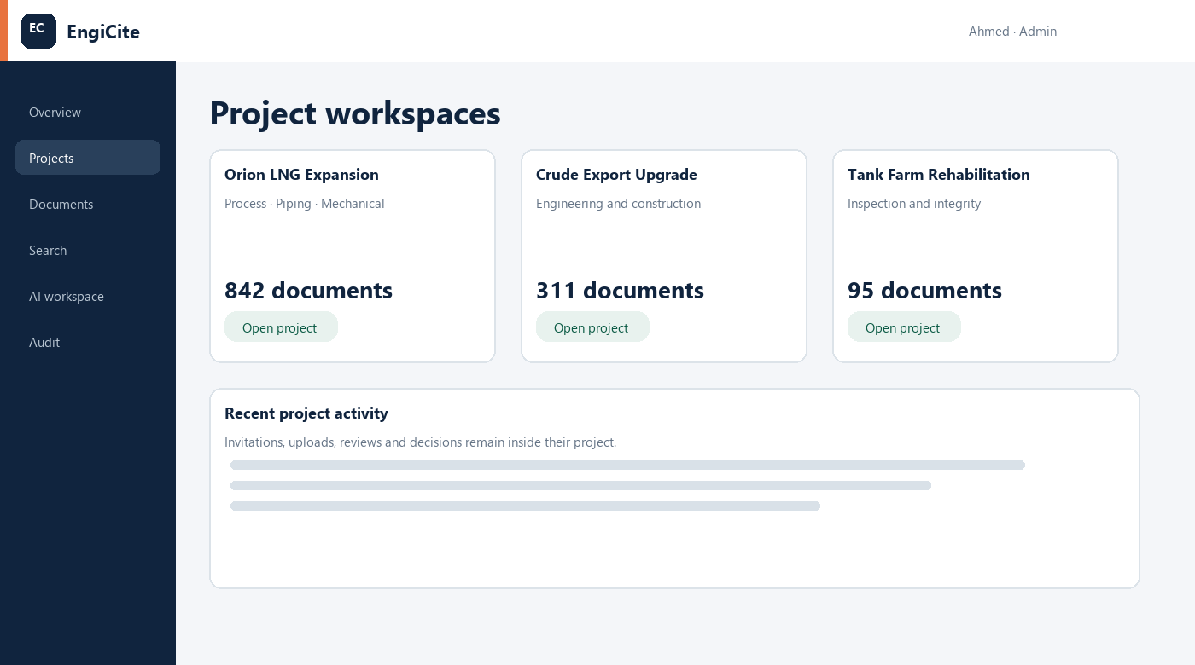
Illustrative interface - separate project workspaces and recent activity

4. Management overview
A professional dashboard will show what is happening across the organisation without requiring managers to open every project.
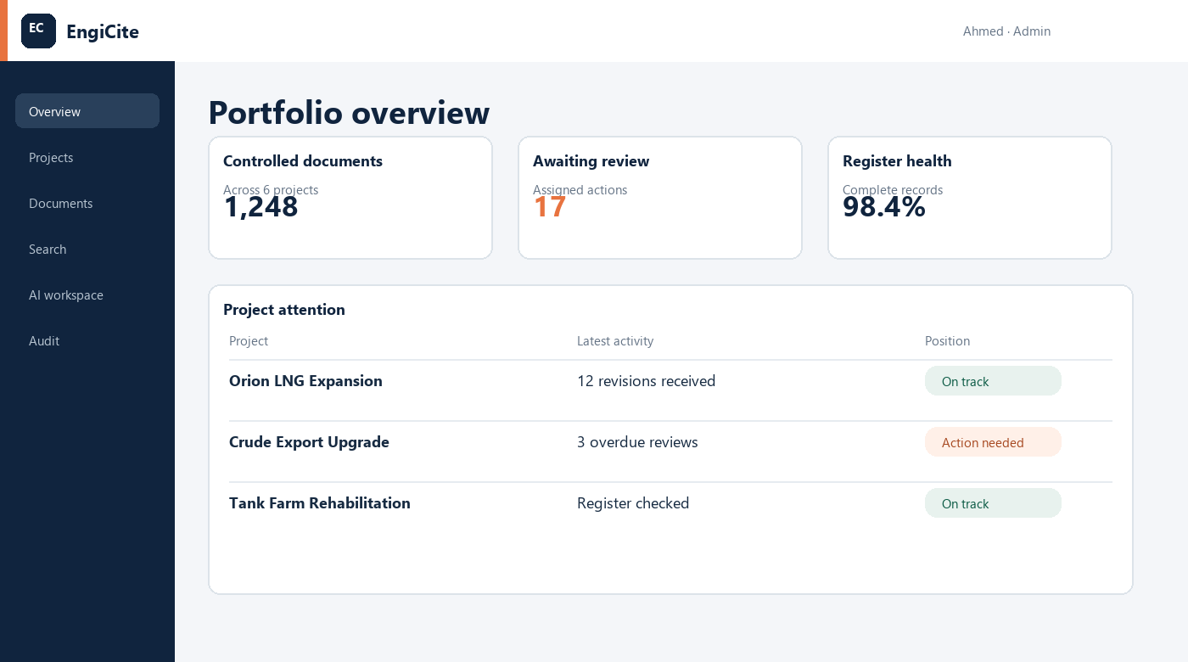
Illustrative EngiCite interface - 4. Management overview
Who uses it: Organisation administrators, project administrators and management.
How it is used: Open the dashboard to see document volumes, pending reviews, overdue work and project health.
Expected result: Faster decisions and fewer project surprises.

5. Organisations, people and permissions
Every customer will have a private organisation workspace. Administrators will decide which projects and actions each person may access.

Illustrative EngiCite interface - 5. Organisations, people and permissions
Who uses it: Organisation and project administrators.
How it is used: Invite a person, select a role and assign only the required projects.
Expected result: Strict separation between customers and controlled access inside each project.

6. Project workspaces
Each project will keep its own people, documents, register, questions and activity. Information from one project will not be mixed with another.

Illustrative EngiCite interface - 6. Project workspaces
Who uses it: Project teams, clients and administrators.
How it is used: Open a project to work only with its authorised documents and participants.
Expected result: Clear project boundaries and simpler collaboration.

7. Secure engineering document upload
Authorised users will upload PDF, DOCX, XLSX and DWG files together with the document number, title, discipline, revision, status and issue date.
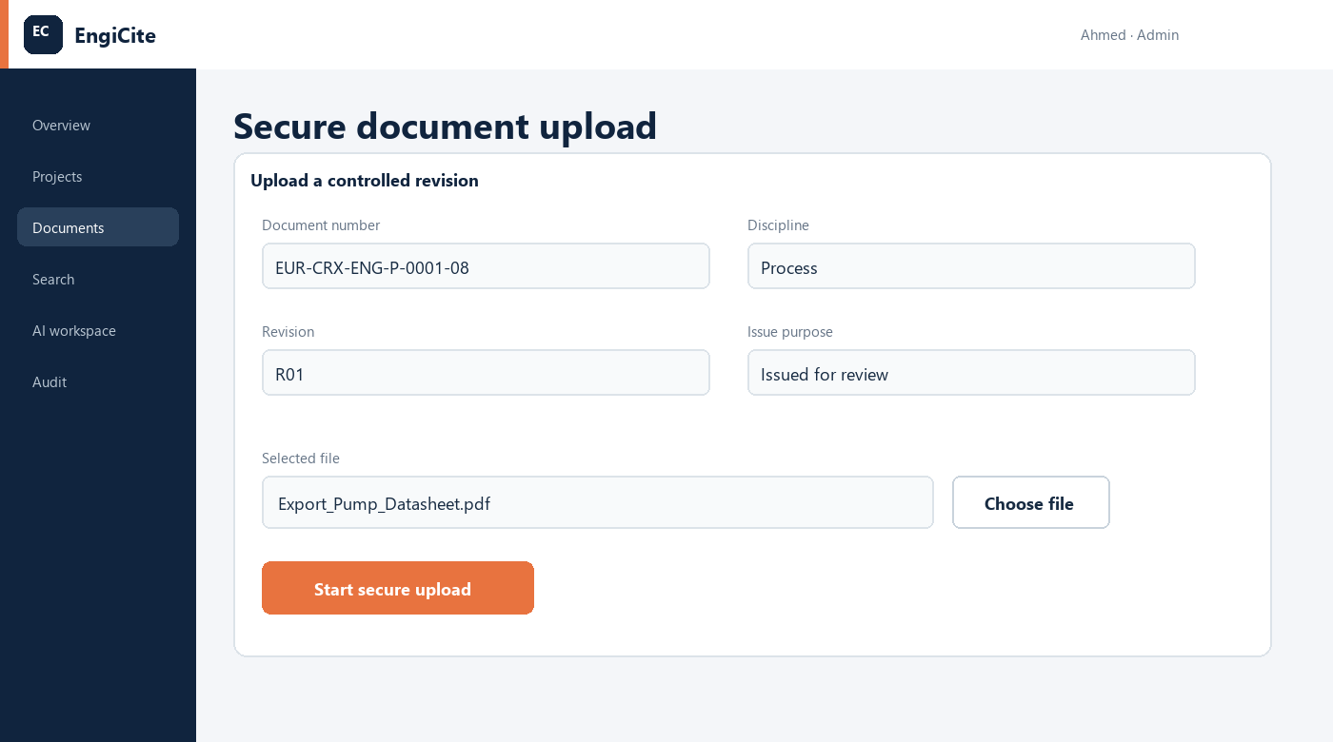
Illustrative EngiCite interface - 7. Secure engineering document upload
Who uses it: Document controllers and authorised engineers.
How it is used: Create or open the document record, choose the correct file and submit the revision into private storage.
Expected result: Every file enters the right project with a traceable identity and owner.

8. Master document register
The master document register will be a living list of every controlled document and its current position. It will replace disconnected spreadsheets used by different teams.
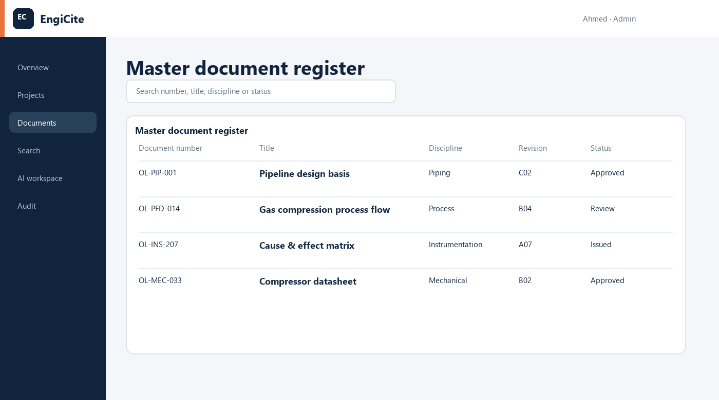
Illustrative EngiCite interface - 8. Master document register
Who uses it: Document controllers, engineers, managers and clients.
How it is used: Search, filter, sort and export the register by document number, title, discipline, revision or status.
Expected result: One agreed source of truth for project documents.

9. Revision history
Every document will retain its complete revision history, including issue purpose, date, uploader and processing position. Earlier revisions will remain traceable after a new revision becomes current.

Illustrative EngiCite interface - 9. Revision history
Who uses it: All authorised project users.
How it is used: Open a document to review its revision timeline and identify the current approved version.
Expected result: No uncertainty about which revision should be used.

10. Engineering search
Users will find documents through exact wording, document metadata or engineering meaning. Search results will remain limited to documents the user is authorised to access.
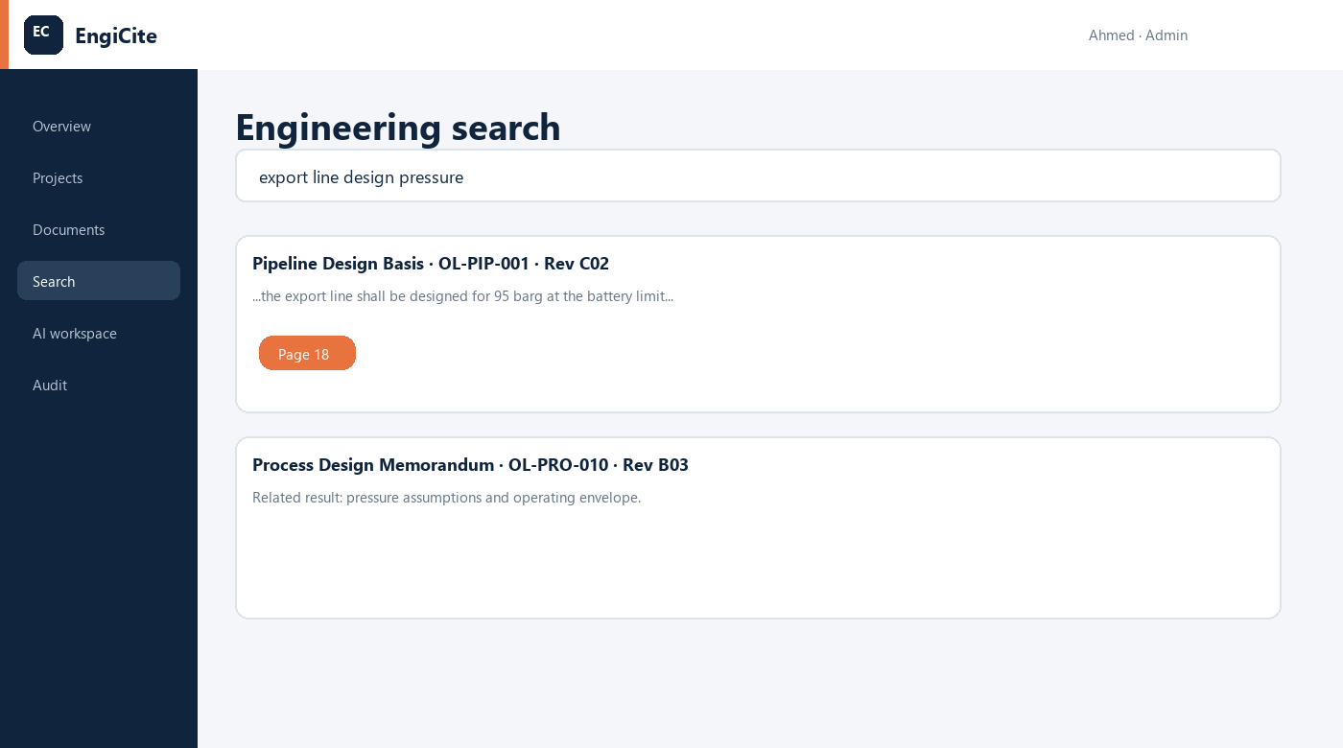
Illustrative EngiCite interface - 10. Engineering search
Who uses it: Engineers, reviewers and project managers.
How it is used: Search a phrase, document number, status, discipline or engineering concept, then open the relevant result.
Expected result: Less time spent searching and more time spent making engineering decisions.

11. AI questions with mandatory evidence
Users will ask questions over selected project documents. EngiCite will answer only from available authorised content and will identify the document number, revision and page supporting the answer.
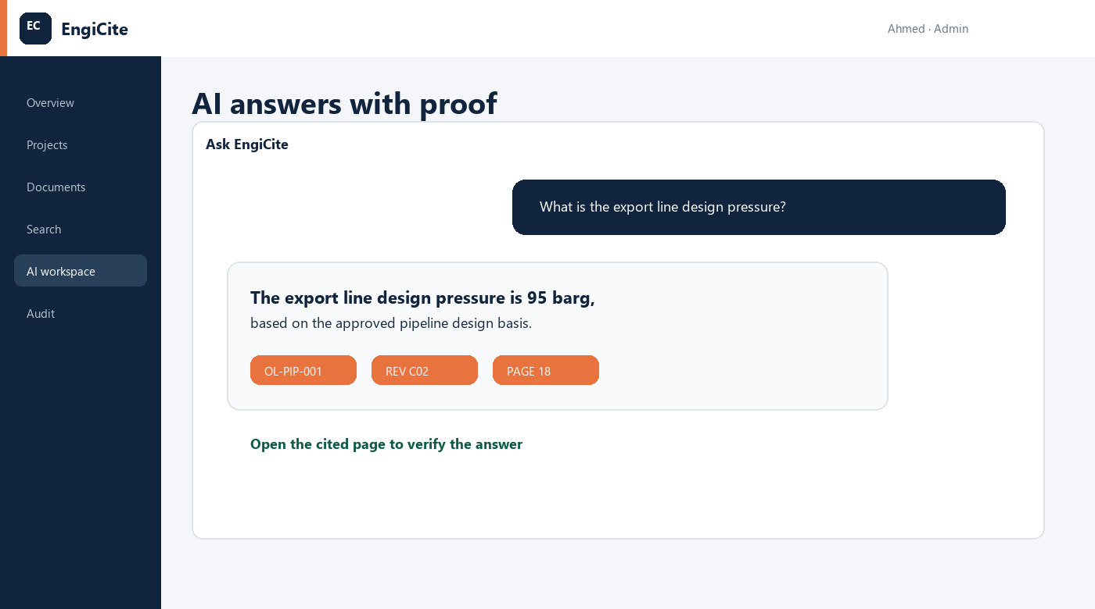
Illustrative EngiCite interface - 11. AI questions with mandatory evidence
Who uses it: Engineers and authorised project users.
How it is used: Select project documents, ask a question, review the answer and open each citation to verify it.
Expected result: Fast document understanding without losing engineering accountability.

12. Side-by-side revision comparison
Users will compare two revisions and see changed wording, values, pages and spreadsheet content side by side.
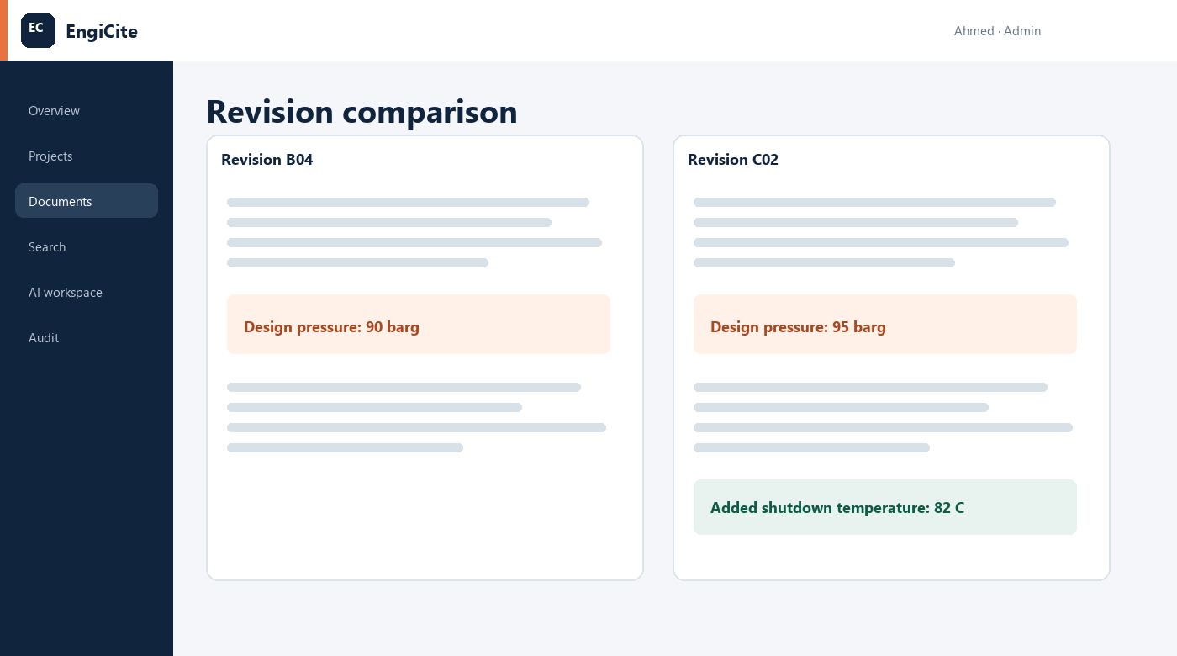
Illustrative EngiCite interface - 12. Side-by-side revision comparison
Who uses it: Engineers, checkers, approvers and document controllers.
How it is used: Choose an earlier and later revision, review highlighted differences and open the affected pages.
Expected result: Important design changes are less likely to be overlooked.

13. Reviews, comments and approvals
Documents will move through assigned review and approval stages. Reviewers can comment, approve or return a document while responsibilities and due dates remain visible.

Illustrative EngiCite interface - 13. Reviews, comments and approvals
Who uses it: Document control, technical reviewers and approvers.
How it is used: Assign reviewers, record decisions and issue the accepted revision when approval is complete.
Expected result: Clear accountability and fewer approval delays.

14. Notifications and action tracking
EngiCite will notify people when they are invited, assigned a review, sent a new revision or approaching an overdue action.

Illustrative EngiCite interface - 14. Notifications and action tracking
Who uses it: All users according to their responsibilities.
How it is used: Open the notification to go directly to the relevant project, document or review task.
Expected result: Less manual chasing and faster movement of work.

15. Audit history and reports
Important activity will be recorded, including uploads, downloads, edits, invitations, approvals, previews and AI questions. Administrators can review and export relevant reports.
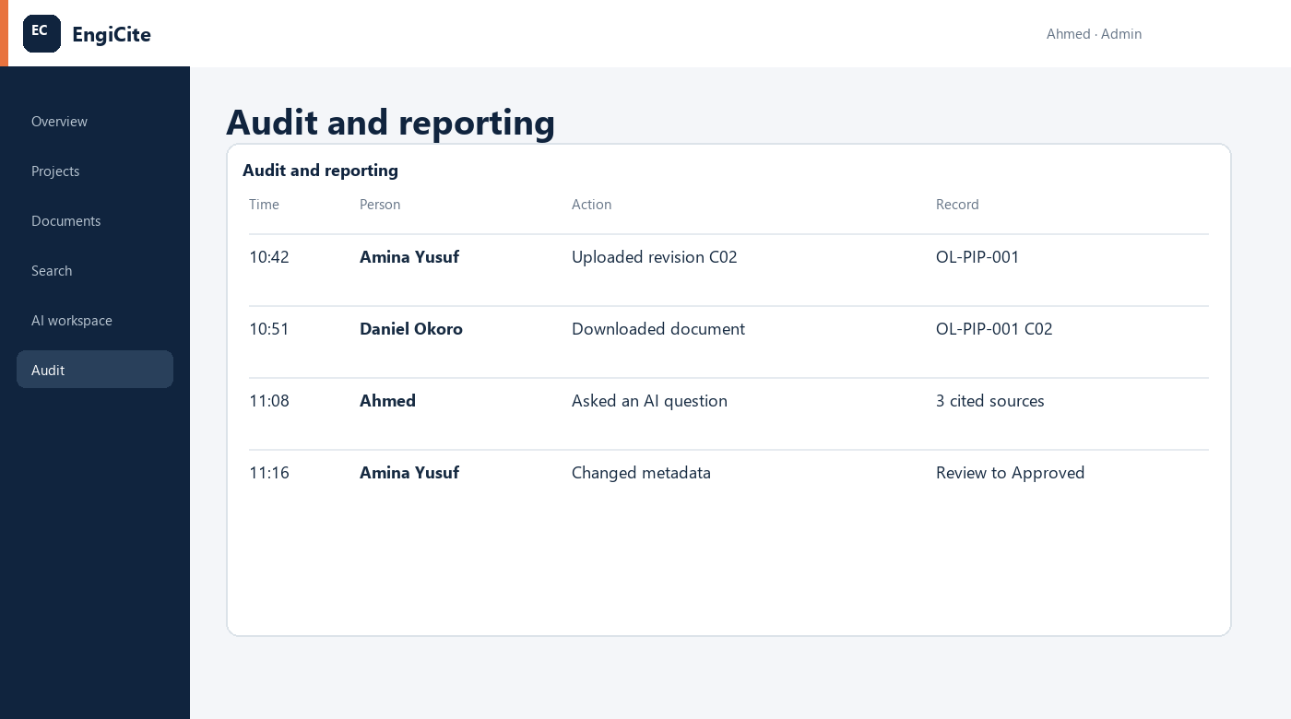
Illustrative EngiCite interface - 15. Audit history and reports
Who uses it: Administrators, auditors and project leadership.
How it is used: Filter activity by person, project, document, action or date and export a report when required.
Expected result: A defensible record for governance, assurance and dispute resolution.

16. Subscription and account administration
Organisation owners will manage authorised users, storage usage, billing contacts, invoices and future plan changes from one account area.

Illustrative EngiCite interface - 16. Subscription and account administration
Who uses it: Organisation owners and billing administrators.
How it is used: Review usage, add or remove seats and manage the organisation subscription.
Expected result: A commercial structure that can grow from a single project to an enterprise account.

17. Responsive office and field use
The same secure workspace will work across desktop, tablet and mobile. Full administration is suited to desktop, while search, preview, review and citation checks remain available on site.
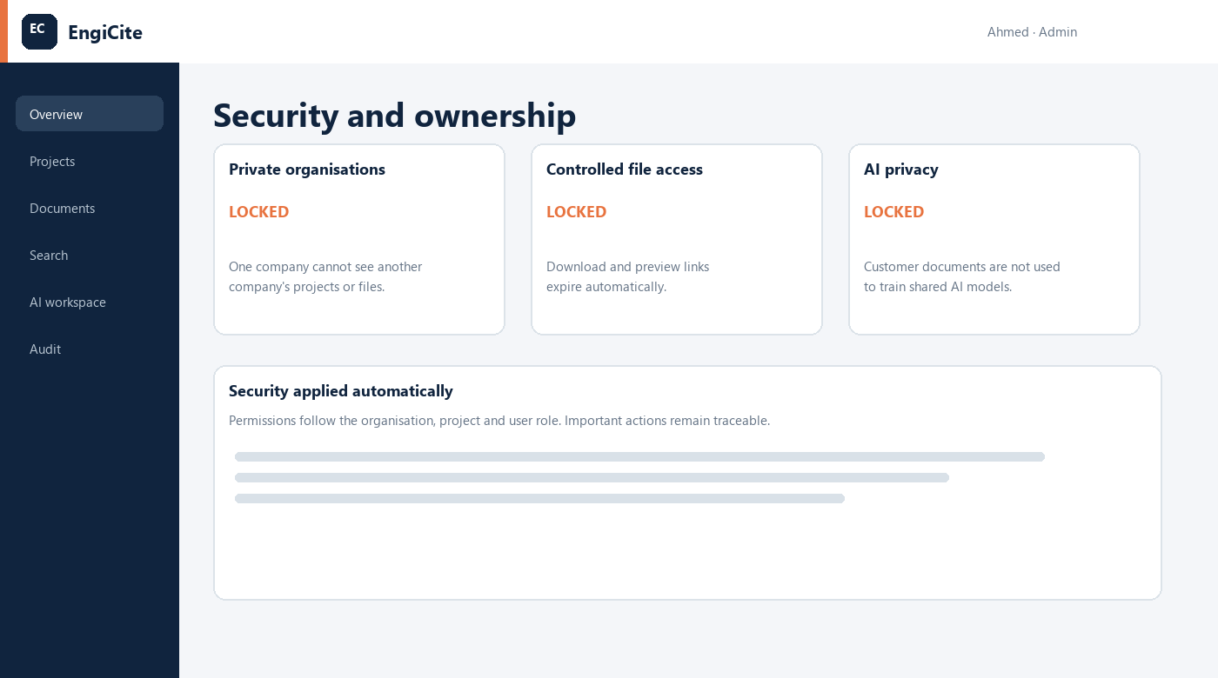
Illustrative EngiCite interface - 17. Responsive office and field use
Who uses it: Field engineers, travelling managers, reviewers and clients.
How it is used: Sign in from an authorised device and use the interface appropriate to its screen size.
Expected result: Project evidence remains available at the point of decision.

18. Security, privacy and customer ownership
Organisation and project boundaries will be enforced automatically. File links will expire, application secrets will remain on the server, and customer documents will not be used to train shared AI models.
Who uses it: Every customer and authorised user.
How it is used: Security follows the user role, organisation and project without requiring users to manage technical controls.
Expected result: Confidential engineering information remains under customer control.

19. Definition of a successful end product
- A user can identify the current controlled revision without consulting a separate spreadsheet.
- A user can locate engineering evidence quickly and open the exact cited page.
- An administrator can prove who uploaded, changed, downloaded, reviewed or questioned a document.
- No user can access another customer or an unauthorised project.
- Project teams can complete the document lifecycle from intake through review and issue in one workspace.
- The interface remains clear enough for occasional viewers while supporting professional document control.

Illustrative interface - customer isolation, controlled links and AI privacy

