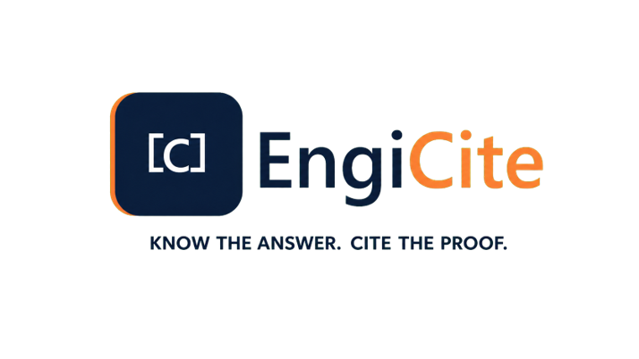

TEAM PRODUCT & DELIVERY BLUEPRINT
  - The operating guide for designing, building, securing, launching and scaling EngiCite
VERSION 1.0 | AUGUST 2026 | INTERNAL WORKING DOCUMENT
PURPOSE: Give every EngiCite team member one shared definition of the product, its users, operating rules, delivery sequence, quality bar and commercial outcome.

How to use this blueprint
This is the team’s working reference. Product decisions, interface design, database rules, security controls, test plans and launch readiness should all trace back to it. It is deliberately written in clear business language, while retaining enough operational detail for designers, engineers, document-control specialists, testers and commercial leaders.
Reader | Use this blueprint to
Founder / product lead | Protect the product vision, approve scope and resolve priority conflicts.
Engineering team | Translate capabilities, rules and acceptance criteria into working software.
Design team | Create consistent, role-appropriate journeys and accessible interfaces.
Document-control adviser | Validate metadata, revision, issue and approval behaviour.
Security / compliance | Verify tenant separation, evidence, retention and incident controls.
Sales / customer success | Set accurate expectations and prepare onboarding and support.

Document map
- North star and product boundaries
- Users, roles and access model
- Core information model and document lifecycle
- Detailed product capabilities
- Artificial intelligence and evidence rules
- Security, privacy and audit model
- Technical operating architecture
- Team operating model and delivery roadmap
- Quality, launch, adoption and commercial readiness
- Risks, decisions and definition of done

1. Product north star
What EngiCite exists to change, and what it must never become.

1.1 The problem
Engineering projects often spread controlled information across email, shared drives, spreadsheets and individual desktops. Teams lose time locating the correct revision, proving who received or approved it, and checking whether an answer came from an authoritative source. The result is avoidable delay, rework and technical risk.

1.2 The product promise
PROMISE: EngiCite gives authorised project teams a single secure place to control engineering documents, find the correct evidence and ask questions whose answers can be verified at the exact source page.

1.3 Product principles
- Evidence before convenience: an answer without a verifiable source is incomplete.
- Current revision by default: users should immediately understand which revision governs the work.
- Private by construction: access follows organisation, project and role boundaries automatically.
- Document control is a workflow, not a storage folder.
- Simple for occasional viewers; powerful for professional document controllers.
- Every important action leaves an understandable audit record.

1.4 Explicit boundaries
EngiCite is | EngiCite is not
A controlled engineering information workspace | A replacement for engineering judgement or design responsibility
A project-scoped document and evidence platform | An unrestricted general-purpose chatbot
A source-citing assistant over authorised content | A training system that reuses customer documents for shared models
A subscription-ready multi-tenant service | A public file-sharing drive

2. Users, roles and permission model
Every action begins with who the person is, which organisation and project they belong to, and what role they hold.
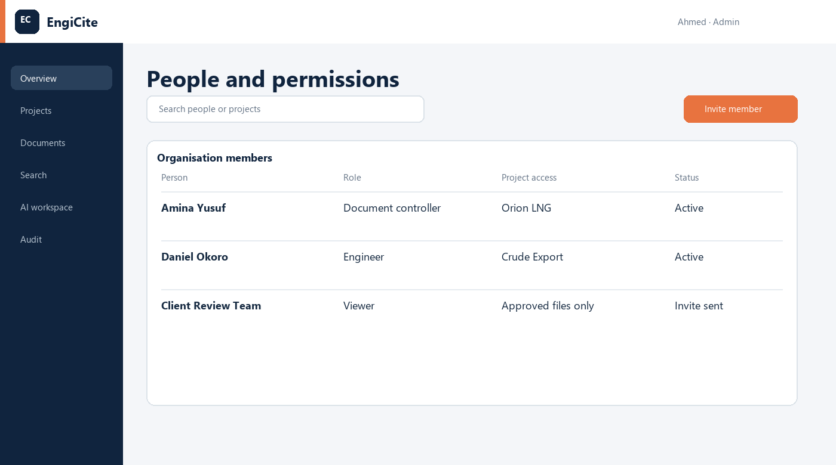
Interface concept: organisation members, project access, role and invitation state.
Role | Primary responsibility | Typical permissions
Organisation administrator | Own the customer workspace | Create projects, manage members, organisation settings, billing and reports.
Project administrator | Run a specific project workspace | Manage project members, project configuration, reviews and reporting.
Document controller | Maintain the controlled record | Create document records, edit metadata, upload revisions and manage the register.
Engineer | Use and review engineering information | Search, preview, compare, comment and ask evidence-backed questions.
Viewer | Consume approved information | Read, search and download only what has been authorised.

2.1 Permission rules
- Deny access unless a rule explicitly allows it.
- A person may belong to more than one project but sees each project separately.
- Project roles can be narrower than the organisation role.
- Only administrators can invite people; invitations expire and are auditable.
- Sensitive actions such as deletion, role change and issue approval require elevated permission.
- Downloads and signed links are limited, expiring and recorded.
ACCEPTANCE TEST: A user from Organisation A must never retrieve Organisation B data—even by changing a URL, guessing an identifier, calling an API directly or using search/AI.

2.2 Permission decision matrix
Action | Admin | Controller | Engineer | Viewer
Invite project member | Yes | No | No | No
Create document record | Yes | Yes | If granted | No
Upload new revision | Yes | Yes | If granted | No
Approve controlled issue | Configured | Configured | Reviewer only | No
Search / preview | Yes | Yes | Yes | Authorised only
Ask cited AI question | Yes | Yes | Yes | If enabled
Export audit report | Yes | No | No | No

3. Organisation and project operating model
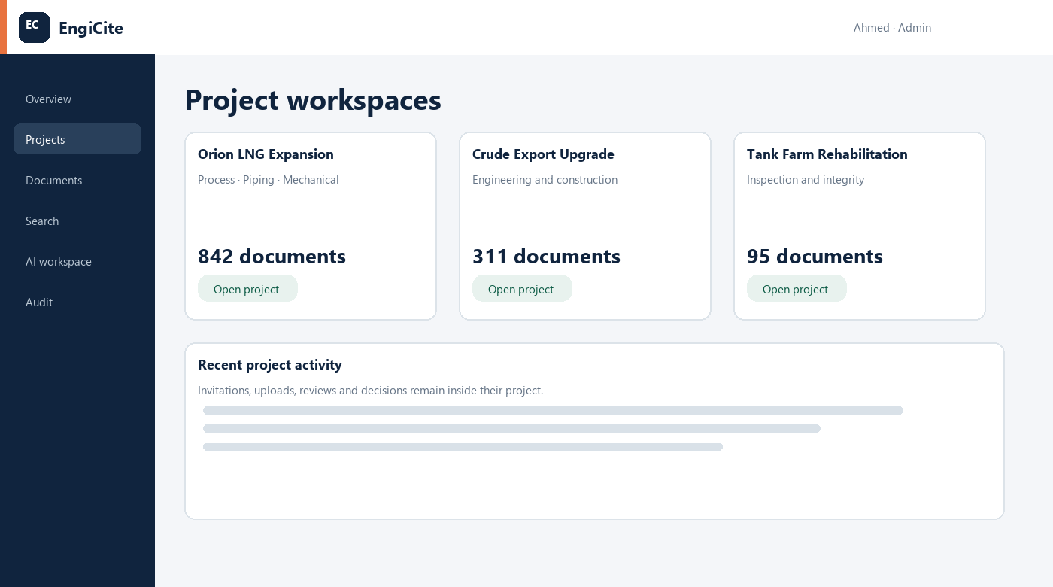
Interface concept: separate project workspaces with project-specific activity.

3.1 Organisation workspace
The organisation is the commercial and security boundary. It owns subscription status, users, projects, storage allocation, retention settings and organisation-wide audit reporting.

3.2 Project workspace
The project is the day-to-day collaboration boundary. It contains its own members, documents, master register, revisions, reviews, questions and activity. A project can be archived without deleting its controlled history.

3.3 Standard setup sequence
- Create the organisation and appoint at least one organisation administrator.
- Create a project with code, name, description, customer and lifecycle state.
- Invite project members and assign the least-privileged role.
- Configure disciplines, document types, issue purposes, numbering pattern and file limits.
- Import or create the opening master document register.
- Run an access check before admitting live customer information.

4. Controlled document information model
The document record is the permanent identity; each revision is a dated, traceable issue of that identity.
Object | Meaning | Minimum information
Document | Permanent controlled identity | Organisation, project, document number, title, discipline and type.
Revision | A particular issue of the document | Revision code, issue purpose/status, issue date, file, uploader and processing state.
File asset | Private stored binary | Storage path, original name, media type, size, checksum and scan result.
Extracted page/content | Searchable representation | Page/sheet reference, text, chunk order and extraction quality.
Citation | Evidence attached to an answer | Document number, revision, page/sheet and source excerpt location.
Audit event | Immutable activity fact | Actor, action, tenant, project, object, time and relevant context.

4.1 Metadata quality rules
- Document number is unique inside a project and normalised for reliable search.
- Revision codes are stored separately from filenames.
- Issue status and issue purpose use controlled lists, not arbitrary spelling.
- The current revision is calculated from approved business rules, not whichever file was uploaded last.
- Original filenames are retained, while storage paths use safe generated names.
- Changes to controlled metadata are audited with old and new values.

5. Secure upload and processing workflow
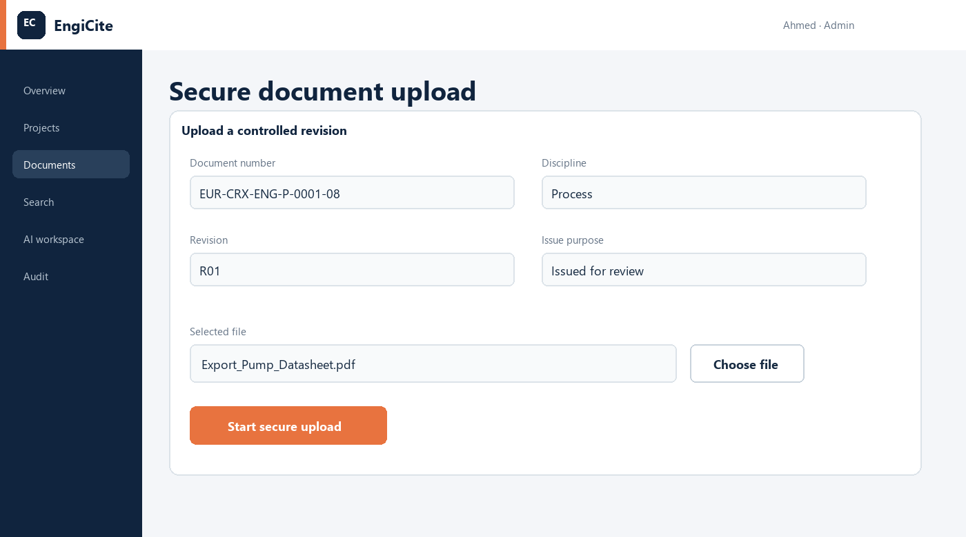
Interface concept: metadata-first upload with a clear file chooser and separate secure-submit action.

5.1 User journey
- Open or create the controlled document record.
- Enter revision code, issue purpose, issue date and required metadata.
- Choose one PDF, DOCX, XLSX or DWG file that matches the permitted limits.
- Review the selected filename and submit using the separate “Start secure upload” action.
- EngiCite validates the user, project, file type, extension, signature and size.
- The file is stored privately and the revision enters processing.
- The processing service scans, extracts, indexes and reports a visible result.
- The master register and audit history update only after the transaction succeeds.

5.2 Processing states
State | User meaning | System action
Awaiting upload | Record exists; no file received | Allow an authorised user to resume.
Uploading | File transfer is active | Show progress; prevent duplicate submission.
Processing | File is private and being analysed | Scan, extract text/pages, generate search data.
Ready | Revision can be searched and previewed | Expose authorised preview, search and AI use.
Needs attention | Processing could not complete | Show safe error, reference ID and retry path.
Quarantined | File failed a security check | Block access; notify an administrator.

6. Master document register and revision control
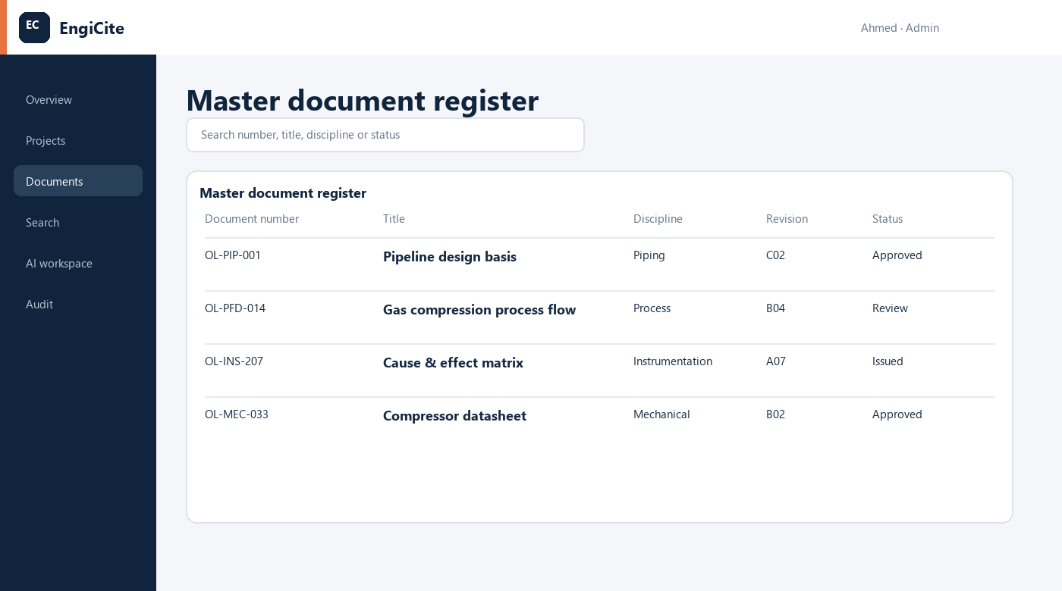
Interface concept: searchable master document register showing the current controlled position.

6.1 Register behaviour
- One row represents one controlled document, not one uploaded file.
- The displayed revision and status reflect the current controlled revision.
- Filters include discipline, type, status, issue purpose, date, assignee and missing metadata.
- Exports preserve applied filters and identify the export time and requesting user.
- Links open the document record and revision history rather than an uncontrolled storage path.
- Register health highlights missing metadata, failed processing and overdue reviews.

6.2 Revision control rules
- Earlier revisions remain available to authorised users and cannot be silently overwritten.
- A new revision never erases the audit history or citations of an earlier revision.
- Superseded revisions are clearly marked and excluded from “current only” searches by default.
- Side-by-side comparison requires two revisions of the same controlled document.
- Deletion is exceptional, permission-controlled and preferably replaced by archival or withdrawal.

7. Search, discovery and document preview
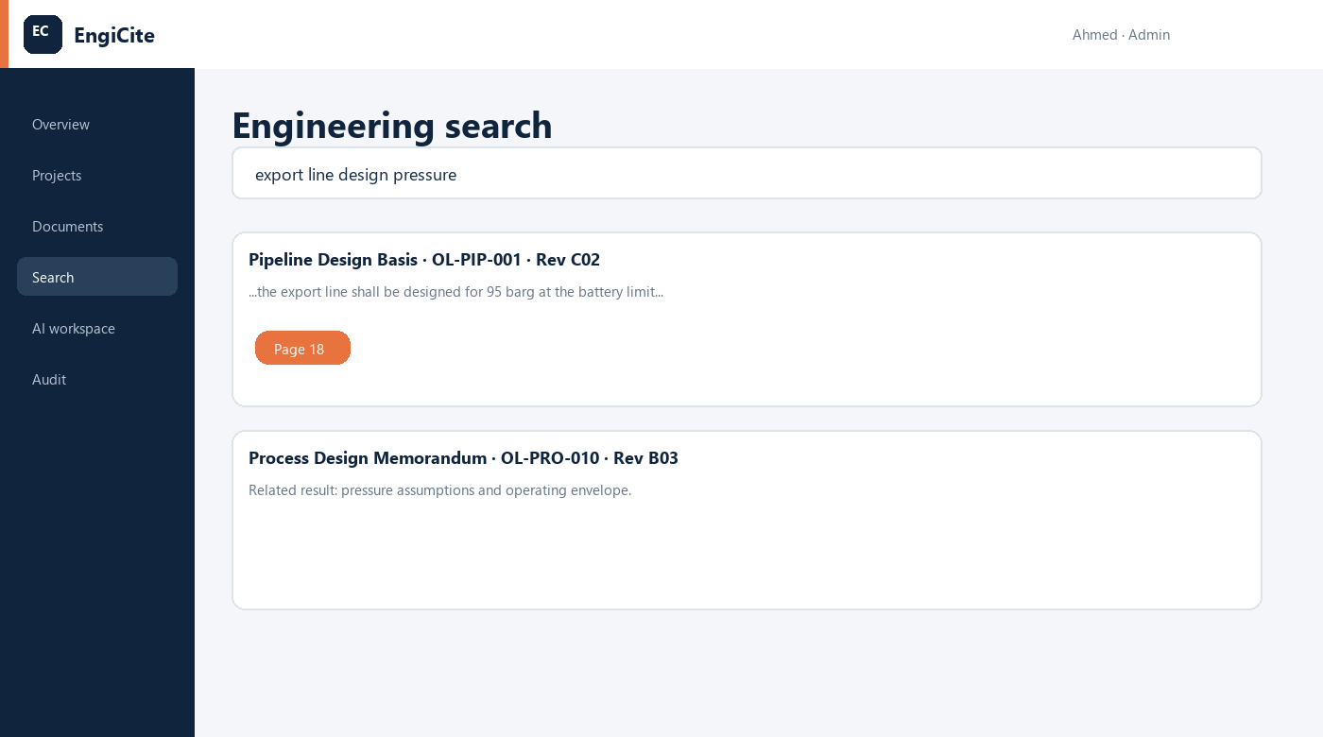
Interface concept: combined engineering phrase, metadata and semantic search.

7.1 Search modes
Mode | Best for | Expected behaviour
Exact / full text | Known wording, tags and document numbers | Rank exact matches strongly and highlight the matching passage.
Metadata | Discipline, type, revision, status and dates | Filter deterministically using controlled fields.
Semantic | Concepts expressed with different wording | Retrieve meaning-similar authorised content using vector search.
Current-only | Operational use | Prefer current controlled revisions unless the user asks for history.
Cross-document | Engineering investigation | Search multiple selected project documents without crossing project boundaries.

7.2 Preview expectations
- Open the relevant page or sheet directly from a result.
- Show document number, title, revision and status beside the preview.
- Clearly warn when the user is viewing a superseded or unapproved revision.
- Generate access links on demand; never expose permanent public file URLs.
- Record downloads and other material access events.

8. AI questions with cited proof
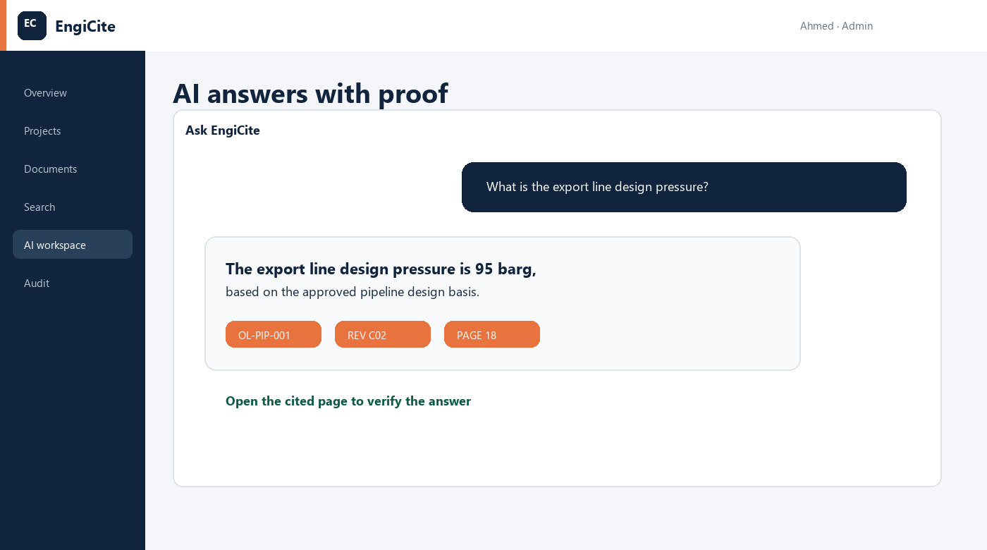
Interface concept: an answer accompanied by document number, revision and page-level proof.

8.1 Answer contract
NON-NEGOTIABLE: Every factual answer must identify the supporting document number, revision and page or sheet. If evidence is insufficient, EngiCite must say so rather than inventing an answer.

8.2 Question flow
- The user selects a project and optionally a controlled set of documents.
- EngiCite verifies the user can access every selected document.
- Search retrieves the most relevant authorised passages.
- The model receives only the minimum passages required to answer.
- The response is generated with structured citations.
- The server verifies every citation maps to a real authorised page/chunk.
- The user can open each cited page and inspect the source.
- The question, selected scope, response status and citations are audited.

8.3 Safety and quality behaviour
- Do not treat instructions inside uploaded documents as system instructions.
- Do not answer from model memory when the user requests project evidence.
- State uncertainty and conflicting evidence clearly.
- Keep prompts, provider credentials and service-role credentials on the server.
- Send only necessary content to the AI provider under approved data terms; customer documents are not used to train shared models.

9. Revision comparison, review and approval
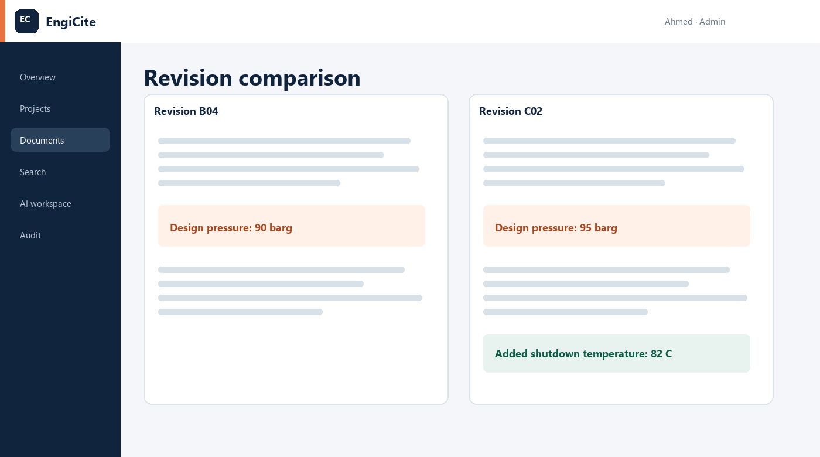
Interface concept: two revisions with significant engineering changes highlighted side by side.

9.1 Comparison
- Compare text, values and page/sheet structure where extraction supports it.
- Label both sides with document number, revision, status and issue date.
- Distinguish added, removed and changed content without implying automatic engineering approval.
- Allow the user to open the original source page for context.
- Record who requested or exported a comparison when required.

9.2 Review workflow
- Document controller submits a revision for review.
- Project administrator or configured workflow assigns reviewers and due dates.
- Reviewers add page-linked comments and record a decision.
- Returned revisions preserve comments and decision history.
- Approval changes the controlled position only when required reviewers complete their actions.
- Notifications and audit records are created at each material transition.

10. Audit, reporting and management control
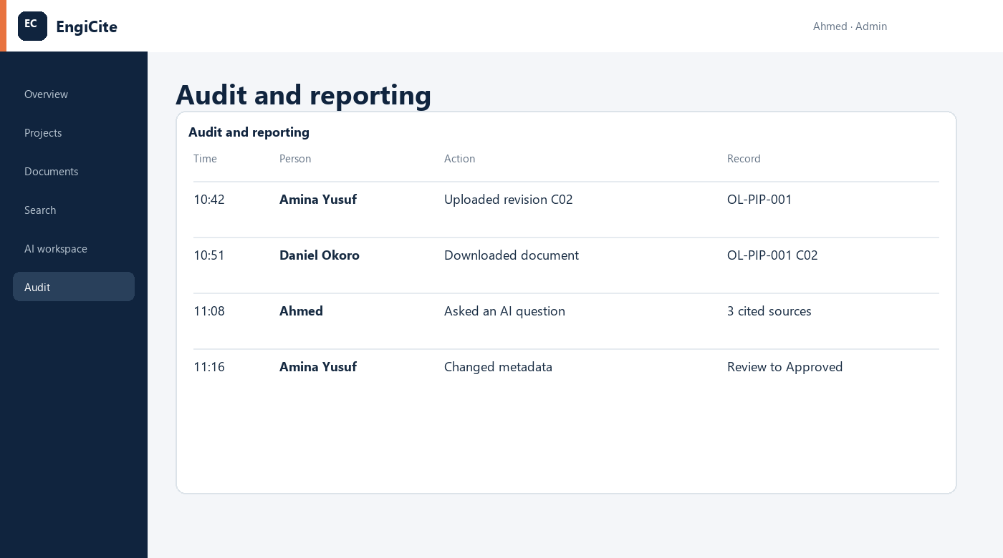
Interface concept: readable audit history of uploads, downloads, metadata changes and AI questions.

10.1 Events to record
- Registration, sign-in, sign-out, verification and security-sensitive account changes.
- Organisation/project creation, update, archive and membership changes.
- Invitation creation, acceptance, expiry, cancellation and role change.
- Document creation, metadata edit, upload, download, preview, revision and status transition.
- Search and AI questions at an appropriate privacy-preserving level.
- Review assignments, comments, approvals, returns and exports.
- Administrative access, failed permission checks and security-relevant errors.

10.2 Reporting outcomes
Report | Audience | Decision supported
Register health | Document control / project lead | Which records are incomplete, failed or overdue?
Revision and issue activity | Project administration | What changed and what is awaiting action?
Access and membership | Organisation administration | Who can access each project and why?
Audit export | Audit / assurance | Who performed a material action, when and on what?
Usage and storage | Commercial / billing | How is the subscription being consumed?
AI usage and evidence quality | Product / governance | Are answers cited, useful and within policy?

11. Security, privacy and resilience
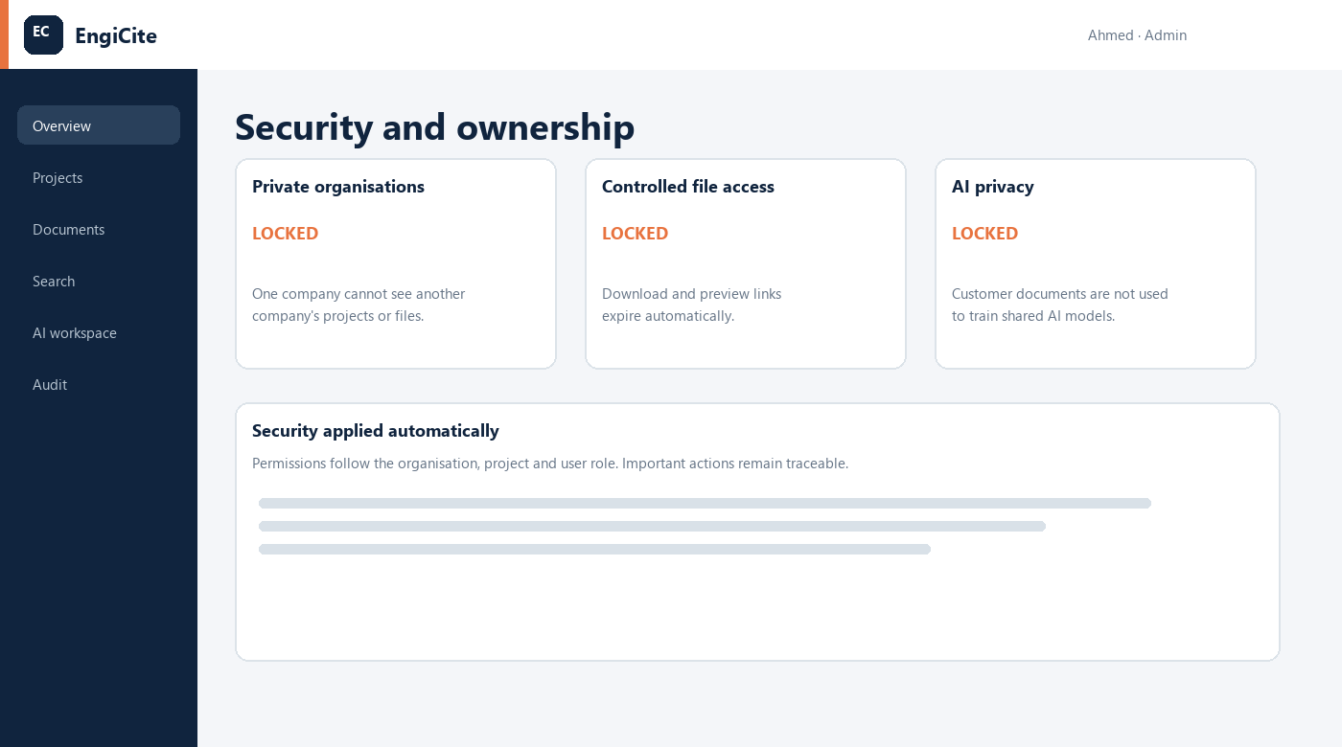
Interface concept: tenant isolation, controlled access links and customer-owned AI data.

11.1 Defence layers
Layer | Required control
Identity | Supabase authentication, verified email policy, secure session handling and optional MFA readiness.
Authorisation | Server checks plus PostgreSQL row-level security using organisation, project and role membership.
Database | Tenant identifiers on every tenant-owned row; migrations reviewed and tested; privileged keys server-only.
Object storage | Private bucket, generated paths, signed short-lived URLs and tenant-aware storage policies.
Upload | Allow-list, extension/MIME/signature/size validation, safe filenames, malware scanning and quarantine.
Application | Input validation, CSRF/session protection, secure headers, rate limits and safe error references.
AI | Authorised retrieval, prompt-injection controls, citation validation, minimal disclosure and usage limits.
Operations | Backups, restore tests, monitoring, incident response, secret rotation and dependency patching.

11.2 Resilience targets for launch
- Documented backup and restore procedure tested before production launch.
- Clear recovery point and recovery time objectives agreed for the subscription tier.
- Processing jobs are retryable and idempotent; duplicate retries do not create duplicate revisions and failures remain visible rather than becoming blank pages.

12. Technical operating architecture
A practical division of responsibility that keeps customer data private and the user experience responsive.
Component | Responsibility
Next.js web application | Responsive user interface, server actions/routes, session-aware navigation and business workflows.
Supabase Auth | Registration, login, verification, password recovery and secure user sessions.
PostgreSQL + RLS | Organisations, projects, membership, documents, revisions, invitations, audit and subscription-ready records.
Supabase Storage | Private original files and derived previews accessed through short-lived signed URLs.
FastAPI processing service | Scan/validate support, extraction, page mapping, chunking, embeddings and processing-state updates.
pgvector | Semantic representations used only inside authorised retrieval filters.
OpenAI API | Evidence-grounded answer synthesis; API key stays server-side.
Job/monitoring layer | Reliable background work, retry policy, error references, logs, metrics and alerts.

12.1 Trust boundaries
- Browser receives only publishable configuration and user-scoped data.
- Server routes validate session and permissions before privileged work.
- Processing service authenticates internal requests and never trusts user-provided tenant identifiers alone.
- Database and storage policies remain the final enforcement layer if application code is bypassed.
- AI calls occur after retrieval has applied tenant and project filters.

12.2 Environments and change control
- Separate local, test/staging and production configurations and credentials.
- Database changes are versioned migrations with rollback/recovery consideration.
- Production releases require passing automated tests, smoke tests and a named approver.
- Secrets are stored in environment/secret management, never source control or client bundles.
- Observability uses correlation/reference IDs without logging customer document contents unnecessarily.

13. EngiCite Team operating model
Workstream | Accountable outcome | Minimum recurring practice
Product | Clear priority and acceptance criteria | Weekly scope/decision review and maintained backlog.
Design | Usable, accessible and consistent journeys | Prototype review with role-based scenarios.
Web engineering | Secure customer-facing workflows | Code review, tests and error-state verification.
Data/security | Correct isolation and controlled data lifecycle | Migration/RLS review and tenant-isolation tests.
Document processing / AI | Reliable extraction, retrieval and citations | Evaluation set, processing metrics and failure review.
Quality assurance | Release evidence and regression protection | Risk-based plan plus end-to-end release checklist.
Customer success | Onboarding, education and support readiness | Pilot feedback, help content and issue escalation.
Commercial | Subscription and positioning readiness | Packaging, usage limits, legal/privacy commitments.

13.1 Definition of ready
- User problem and target role are named.
- Business rule and permission rule are explicit.
- Happy path, empty state, loading state and failure state are designed.
- Acceptance criteria are testable.
- Audit and notification effects are specified.
- Security/privacy impact and migration impact are reviewed.
- Interface wording is approved and no secret configuration is exposed.

13.2 Definition of done
- Implementation is reviewed and merged with relevant tests.
- Tenant isolation and permissions pass for positive and negative cases.
- Responsive interface and accessibility checks pass.
- Errors are visible, useful and correlated to server logs.
- Audit events and documentation are updated.
- Feature works end-to-end in the release environment.
- Product owner accepts the outcome against the original criteria.

14. Delivery roadmap and gates
Milestone | Outcome | Exit gate
1. Foundation | Repository, environments, design system, database baseline and security conventions. | Build/test pipeline works; secrets and migration flow are documented.
2. Identity and tenancy | Registration, login, organisations, projects, roles and invitations. | Automated tenant-isolation and permission tests pass.
3. Controlled upload | Document metadata, PDF/DOCX/XLSX/DWG upload, private storage and processing states. | Real files upload end-to-end; failures are visible and auditable.
4. Register and revisions | Master register, revision history, download/preview and controlled status. | Current revision rules and register exports are verified.
5. Search and AI | Full-text, semantic retrieval, project chat and source citations. | Evaluation demonstrates authorised, page-cited answers and safe refusal.
6. Compare and workflow | Revision comparison, comments, review, approval and notifications. | Workflow scenarios pass with complete decision history.
7. Operations and subscription | Audit reports, usage, billing readiness, monitoring, backup and support. | Launch checklist, restore test and pilot support plan approved.
8. Pilot and production | Controlled customer pilot followed by production launch. | Pilot outcomes meet agreed adoption, reliability and security thresholds.

SEQUENCE RULE: Do not accelerate AI features ahead of identity, tenant isolation, document integrity and reliable processing. EngiCite’s credibility depends on controlled evidence.

15. Quality and test strategy

15.1 Automated test portfolio
- Unit tests for business rules, validation and revision selection.
- Database tests for RLS, invitation acceptance, membership and tenant isolation.
- API/server tests for unauthenticated, unauthorised and malformed requests.
- Storage tests for path isolation, signed-link expiry and forbidden object access.
- Upload tests for allowed and disallowed extensions, signatures, sizes and duplicate submissions.
- End-to-end tests for registration, organisation, project, invitation, upload, register, revision and download.
- AI evaluation tests for citation completeness, permission boundaries, insufficient evidence and prompt injection.

15.2 Critical release scenarios
Scenario | Pass condition
Cross-tenant URL/API attempt | Returns no protected data and produces a security-relevant log.
Expired invitation | Cannot be accepted; user receives a clear recovery path.
Large or disguised upload | Rejected before processing with a safe explanation.
Processing failure | Revision shows “Needs attention”; retry is safe and no duplicate is created.
Superseded revision search | Current revision is preferred and historical status is unmistakable.
AI answer without evidence | System refuses or reports insufficient evidence; no invented citation.
Signed URL after expiry | Object cannot be accessed.
Mobile/slow connection | Loading/progress and retry states remain understandable.

16. Launch, onboarding and support readiness

16.1 Pilot design
- Select one organisation and one or two representative projects.
- Import a controlled sample containing realistic disciplines, revisions and file formats.
- Nominate a project administrator, document controller, engineers and viewers.
- Run scripted tasks and capture time-to-complete, failures, confusion and support questions.
- Hold weekly feedback reviews; separate defects from scope requests.
- Do not widen access until security, data quality and support blockers are closed.

16.2 Customer onboarding
- Confirm commercial owner, data owner and project administrator.
- Agree document numbering, metadata values, roles, retention and upload limits.
- Create organisation/project and verify access with test users.
- Load an opening register and controlled pilot documents.
- Train administrators and document controllers first, then engineers/viewers.
- Review audit, support, recovery and offboarding expectations.
- Complete acceptance and move to agreed production support.

16.3 Support model
Severity | Example | Initial response objective
Critical | Confirmed cross-tenant access or widespread production outage | Immediate incident process and leadership/security notification.
High | Uploads, login or controlled access unavailable for a customer | Rapid triage, workaround if safe, frequent updates.
Medium | Feature degraded with a viable workaround | Scheduled investigation with reference ID and owner.
Low | Question, usability issue or enhancement request | Guidance, backlog review or documentation update.

17. Commercial and subscription readiness
The account structure must support commercial packaging without compromising tenant isolation. Subscription state belongs to the organisation; usage is measured from authoritative records and never used to weaken access controls.
- Plan/entitlement model for users, projects, storage, processing and AI usage.
- Billing contact and organisation owner are distinct from ordinary project roles.
- Trial, active, past-due, suspended and cancelled states have explicit behaviour.
- Suspension prevents new paid activity while preserving controlled customer data according to contract.
- Invoices and payment integration remain outside document-control transactions.
- Export and offboarding provide customer-owned information in an agreed usable form.

17.1 Product metrics
Outcome | Suggested measure
Adoption | Active organisations/projects; invited-to-active conversion; weekly active roles.
Document control | Register completeness; upload success; processing success; overdue reviews.
Discovery | Search success, result-open rate and time to evidence.
AI trust | Citation completeness, citation-open rate, grounded-answer score and safe-refusal rate.
Reliability | Availability, error rate, processing duration and recovery performance.
Commercial | Paid conversion, seats/storage/AI consumption, retention and support load.

18. Risks, decisions and governance
Risk | Why it matters | Primary treatment
Tenant data leakage | Destroys trust and creates legal/security exposure. | RLS, server checks, negative tests, monitoring and incident readiness.
Wrong current revision | Can drive incorrect engineering work. | Explicit revision rules, status workflow, warnings and audit.
Uncited or invented AI answer | Creates false confidence. | Authorised retrieval, evidence contract, citation verification and refusal.
Poor extraction quality | Search and AI miss or misread evidence. | Quality metrics, file-specific handling, visible limitations and reprocessing.
Upload failure/silent state | Users cannot trust controlled intake. | Progress, transactional records, idempotent jobs and actionable errors.
Scope expansion | Delays reliable core document control. | Milestone gates, decision log and product-boundary discipline.
Operational immaturity | Small defects become customer-impacting incidents. | Monitoring, backups, runbooks, release gates and ownership.

18.1 Decision governance
- Record decisions that affect permissions, document truth, AI evidence, data retention, billing or customer commitments.
- Name the decision owner, date, options considered, selected outcome and consequence.
- Revisit a decision only when evidence or constraints materially change.
- Customer-specific exceptions must not silently become platform-wide rules.

19. Final acceptance: what “EngiCite is ready” means
END PRODUCT: EngiCite is ready when an authorised user can move from secure sign-in to a controlled, searchable, reviewable engineering record—and can verify every AI-supported answer at the cited document number, revision and page—without exposing another customer’s data.

19.1 Product acceptance checklist
- Organisation and project boundaries are enforced in application, database, storage, search and AI retrieval.
- All five roles behave according to approved permission rules.
- PDF, DOCX, XLSX and DWG intake is reliable, private, traceable and recoverable.
- The master document register identifies the current controlled revision.
- Revision history cannot be silently overwritten.
- Search opens the relevant authorised evidence.
- AI answers are cited, verifiable and safely refuse when evidence is insufficient.
- Comparison, review, approval and notification workflows retain accountability.
- Audit reports explain material actions without exposing secrets or unnecessary content.
- Backups, restore, monitoring, incident and support practices are tested.
- Subscription structure can scale organisations without weakening security.
- The interface is professional, responsive, accessible and never fails as a silent blank page.

19.2 Immediate team priorities
- Stabilise authentication, invitation acceptance and persistent session behaviour.
- Prove organisation/project membership and tenant-isolation tests against hosted Supabase.
- Make upload a complete, observable transaction from file selection to processed revision.
- Complete master register and revision history before expanding AI scope.
- Create a controlled AI evaluation set with page-level expected citations.
- Establish release, backup, monitoring and incident runbooks before pilot data.

