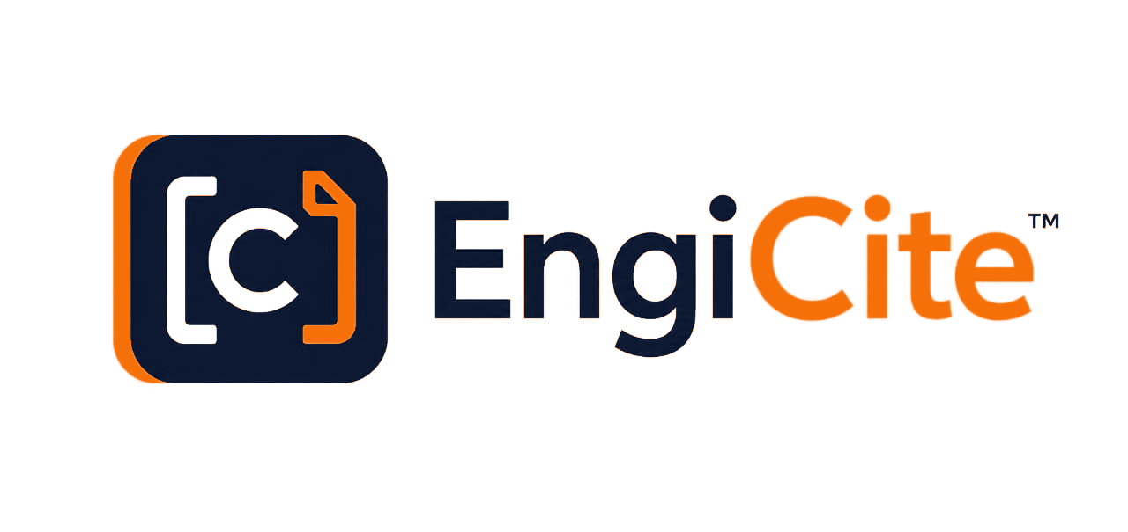
GOVERNANCE & OPERATING GUIDE

Levels of Control
  - Who controls organisations, projects, engineering documents, approvals and client transmission

CORE GOVERNANCE PRINCIPLE
EngiCite separates management, document control, engineering production and read-only access. No individual should create, submit, approve and transmit the same controlled document without independent oversight.

Document owner | EngiCite Product Team
Version | 1.0
Date | 12 August 2026
Audience | Administrators, project managers, DCC, engineers and viewers

1. Control architecture
The platform applies role separation at three practical levels: company governance, project execution and controlled document delivery.
OPERATING RULE
Access is granted only to the organisation, project, discipline and action required by the user's assigned role. Higher visibility does not automatically mean permission to perform DCC or engineering tasks.

Role and authority matrix
Role | Primary control | Permitted activities | Important restriction
EngiCite Super Administrator | The SaaS platform and its availability. | Manages subscriptions, platform health, technical support and controlled system administration. | Has no routine access to customer documents. Exceptional support access must be authorised and audited.
Organisation Administrator | The company workspace and portfolio. | Creates organisations and projects, appoints project leadership, allocates resources and monitors project health, progress and issues. | Does not normally create MDR entries, upload engineering revisions, approve submissions or issue transmittals.
Project Administrator / Project Manager | One project's objectives, team and delivery performance. | Maintains the project brief, objectives, team, disciplines, schedule, resources and overall progress. | Does not replace the Document Controller's formal document-control authority.
Document Controller (DCC) | The official MDR, revision acceptance and client issue record. | Creates or imports the MDR, assigns disciplines, invites engineers, sets dates, previews submissions, accepts or rejects revisions and issues controlled transmittals. | Does not upload revisions as the originating engineer and cannot bypass acceptance requirements.
Discipline Engineer | Production and submission of assigned engineering deliverables. | Views the project brief and assigned discipline, then uploads revisions against allocated MDR documents and deadlines. | Cannot create the MDR, upload into another discipline, approve their own work or issue client transmittals.
Viewer | Read-only access for authorised stakeholders. | Views permitted projects, documents, revisions, progress and approved records. | Cannot create, edit, upload, approve, invite, delete or transmit controlled information.

2. Controlled document workflow
The intended control chain is sequential. Each stage hands responsibility to a different authorised role.
- Organisation and project established
The Organisation Administrator creates the workspace and project, then appoints project leadership and resources.
- Project context and team defined
The Project Manager records the introduction, objectives, disciplines, schedule and responsible team.
- Master Document Register controlled
The DCC creates or imports planned deliverables, assigns disciplines and records agreed submission dates.
- Revision produced and submitted
The assigned Discipline Engineer uploads the correct revision only against an authorised document in their discipline.
- Submission independently checked
The DCC previews the file for conformance, then accepts it or rejects it with a reason and notification.
- Accepted records issued to the client
The DCC selects accepted, processing-ready revisions and freezes them into a numbered transmittal with acknowledgement evidence.
APPROVAL BOUNDARY
An engineer cannot approve their own submission. Only a DCC-accepted revision can be included in a controlled client transmittal.

3. Access and security boundaries
- Organisation isolation: Users in one organisation cannot see another organisation's information.
- Project isolation: Access to one project does not automatically grant access to other projects.
- Discipline isolation: An engineer can submit only to documents belonging to their assigned discipline.
- Revision control: Each file stays linked to its exact document number, revision and issue status.
- Approval control: Submission and acceptance are performed by separate authorised roles.
- Transmission control: Only accepted, ready revisions can enter a numbered client transmittal.
- File-access control: Downloads are provided through temporary signed links instead of public file locations.
- Audit control: Uploads, reviews, downloads, invitations, AI questions and transmissions are recorded.

4. Quick responsibility guide
Required action | Authorised role
Create an organisation or project | Organisation Administrator
Define project objectives, team and schedule | Project Manager
Create or import the MDR | Document Controller
Upload an engineering revision | Assigned Discipline Engineer
Preview, accept or reject a submission | Document Controller
Prepare and issue a client transmittal | Document Controller
View approved information without changing it | Viewer

5. Control outcome
When these controls are applied together, EngiCite provides a defensible chain of custody from project setup to client issue.
- Management receives portfolio visibility without taking over specialist document-control actions.
- Engineers receive clear assignments and upload rights limited to their disciplines.
- The DCC maintains an independent official record and controls what is formally issued.
- Clients receive traceable document packages linked to numbered transmittals and acknowledgement evidence.
IMPLEMENTATION NOTE
This guide describes the intended EngiCite operating model. Before production deployment, each role and boundary should be verified against the live permission tests, database policies and audit records.

