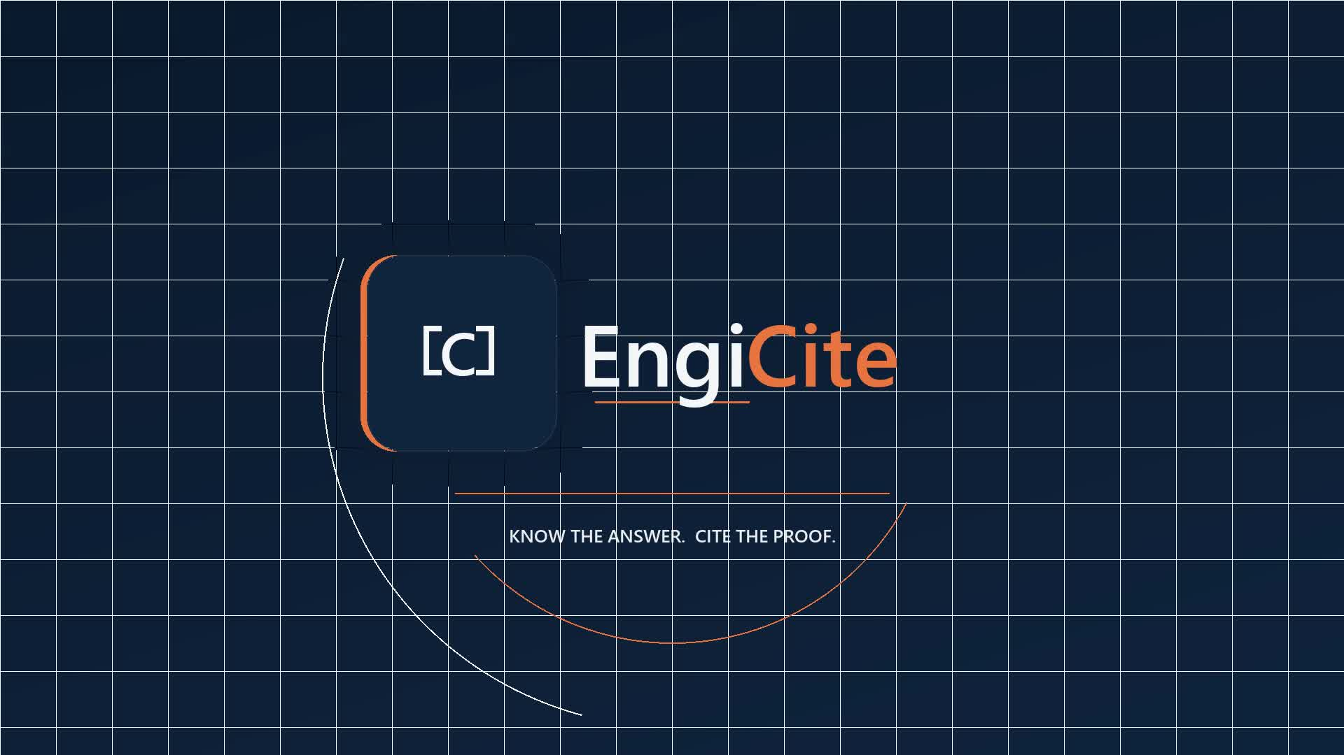
━━━━━━
ENGINEERING INTELLIGENCE,
EVIDENCED.
Controlled documents. Verifiable answers. Defensible decisions.
KNOW THE ANSWER. CITE THE PROOF.
www.engicite.com
hello@engicite.com
ENGICITE
Engineering knowledge, with the proof attached.
© 2026 EngiCite. All rights reserved.

