Howard University
College of Engineering and Architecture
Department of Electrical Engineering & Computer Science

Large Scale Programming
Fall 2024

Midterm Exam – Part I
October 17, 2024

Part I: 50 pts. (essay questions)

Instructions:
- Submit completed exam to your github repository under package org.howard.edu.lsp.midterm

Verify that the commit(s) completed successfully

- OPEN BOOK, OPEN NOTES. THERE IS NO COLLABORATION ON THIS EXAM
- Site any and ALL references for anything obtained off the internet.

Question 1. (10 pts.)

You are reviewing the following class in a Fitness Tracking System. The class is intended to manage various aspects of a user’s fitness activities.

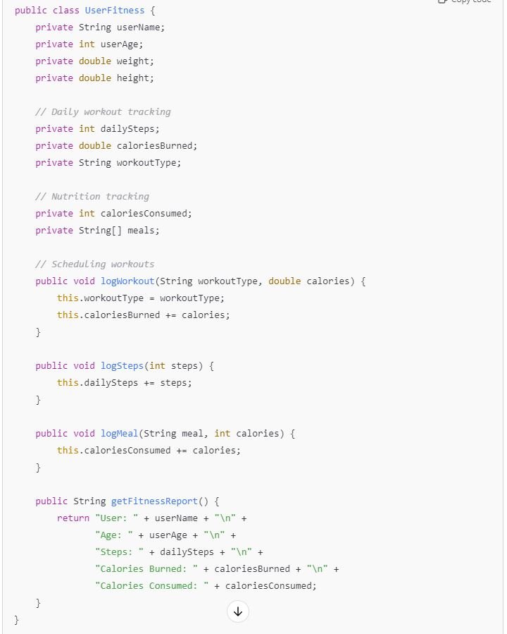

Tasks:
- Analyze the UserFitness class. Explain why this class has low cohesion. (5 pts.)
- The UserFitness class has low cohesion because it handles too many different tasks at once, like tracking both fitness activities and health data. This makes the class harder to understand and maintain since it's trying to do too many unrelated things​.

Reference: ooHeuristics and crcCards PowerPoints (Finding Objects in Requirements – CRC Cards and Object-Oriented Heuristics based on piazza )
- Describe, in general, how you would split the UserFitness class into more cohesive classes. Your answer should not be a complete design. (5 pts.)

- To make the class more cohesive, it should be divided into smaller classes, each with a specific focus. For example, one class could handle fitness activities, and another could track health metrics. This way, each class would have a clear, single responsibility​.

Reference: ooHeuristics and crcCards PowerPoints (Finding Objects in Requirements – CRC Cards and Object-Oriented Heuristics based on piazza)

Question 2. (5 pts.)
Given the following, answer the below questions.

A university manages its students using a program that has a class Student with subclasses FirstYear, SecondYear, and ThirdYear for year-specific state and behaviors. The program has a List that contains all Students.

Should Student be a class, an abstract class or an interface? Explain your answer
- Student should be an abstract class because it allows you to share common behaviors between all students while letting specific year groups, like FirstYear and ThirdYear, have their own unique behaviors. An interface wouldn’t allow for shared behavior across the student types.

Reference: ooHeuristics and TheJavaCollectionsFramework PowerPoints (The Java Collections Framework and Object-Oriented Heuristics based on piazza)

- At the end of each year, the third-year students graduate and must be removed. This is done by passing the list to the following method:

void removeThirdYears(List<Students> students) {
for (Student student : students) {
try {
ThirdYear = (ThirdYear) student;
students.remove(thirdyear);
}
}
}

Why is the above method flawed? Hint: Another Arthur Riel heuristic (5 pts.)

- The method has a problem because it tries to remove items from the list while going through it, which can cause errors. According to Arthur Riel’s guidelines, modifying a list while looping over it is not safe. It’s better to use an iterator to remove students safely or collect them in a separate list and remove them afterward​.

Reference: ooHeuristics and TheJavaCollectionsFramework PowerPoints (The Java Collections Framework and Object-Oriented Heuristics based on piazza )

Question 3. (5 pts.)
Given the following, answer the below questions.

public class BankAccount {
public String accountHolderName;
public String accountNumber;
public double balance;
public double interestRate;

public BankAccount(
String accountHolderName,
String accountNumber,
double initialDeposit,
double interestRate) {
this.accountHolderName = accountHolderName;
this.accountNumber = accountNumber;
this.balance = initialDeposit;
this.interestRate = interestRate;
}

// Exposed implementation for adding interest
public void addInterest() {
double interest = balance * (interestRate / 100);
balance += interest;
}

// Exposed implementation for deposits
public void deposit(double amount) {
balance += amount;
}

// Exposed implementation for withdrawals
public void withdraw(double amount) {
balance -= amount;
}
}

- Is BankAccount well-encapsulated? Why or why not? If so, describe what changes you would make to the class. Otherwise, state nothing. (5 pts.)

- No, the BankAccount class is not well-encapsulated. The class has public fields like accountHolderName, accountNumber, balance, and interestRate, which can be directly accessed and modified from outside the class. This violates the principle of encapsulation, where fields should be private to protect the internal state of the object. To fix this, the fields should be made private, and getter and setter methods should be provided to control access.

Reference: ooHeuristics and IntroductionToSoftwareEngineering PowerPoints (Software Engineering Concepts and Object-Oriented Heuristics based on piazza )

Question 4. (10 pts.)
Given the following, answer the below questions.

Given:
A car manufacturer uses Java software to track current vehicles being built. The UML diagram below shows an excerpt of the current software structure. You should assume the presence of other appropriate fields and methods

Car
getTrimLevel()
Engine
accelerate()
getFuelLevel()
Base
Sports
Luxury
Electric
Petrol

Each car can be built to one of three trim levels: Base, Luxury or Sport. They can also be configured with an electric or petrol engine. At various points in the manufacturing process the customer can choose to change the trim level.

Task:
- Explain in detail why the current structure does not support this. (5 pts.)
- The current structure likely uses inheritance to handle the different trim levels (Base, Luxury, Sport), which is a fixed setup. This means that once a car is created with a certain trim, you can’t easily change it. Since inheritance is static, it doesn't allow for switching trim levels during the production process​.

Reference: ooHeuristics and IntroductionToSoftwareEngineering PowerPoints (Software Engineering Concepts and Object-Oriented Heuristics based on piazza )

- Describe how to refactor the structure to allow trim-level change for a car to dynamically change. Hint: How would you modify Car to use composition to solve the problem? (5 pts.)

- To make the trim level adjustable, the structure should use composition instead of inheritance. The Car class should include a TrimLevel object, which can be swapped out when needed. This way, the trim level can be changed dynamically, allowing for flexibility during the car’s production without having to recreate the car object​

Reference: ooHeuristics and IntroductionToSoftwareEngineering PowerPoints (Software Engineering Concepts and Object-Oriented Heuristics based on piazza)

Question 5. (5 pts.)
Suppose you are about to code a particular class and find that you have written another class with nearly the functionality that you now are developing. This means that the two classes in large parts contain the same code, but in smaller parts have different code. Explain in detail why this may be a problem and how to solve it. Give your answer in terms of Arthur Riel’s design heuristics.

- When two classes have overlapping functionality, it can create maintenance challenges because duplicated code means changes have to be made in multiple places, raising the chance of errors. To fix this, Arthur Riel's design heuristics suggest consolidating the shared code into a common base class or utility class. This approach supports the idea that a class should focus on one main abstraction and use inheritance properly. Refactoring in this way results in a cleaner design, allowing each class to keep its distinct behavior while efficiently sharing functionality.

Reference: ​oo-terminology and ooHeuristics (Object-Oriented Heuristics and Object-Oriented Terminology – based on piazza)

Question 6. (5 pts.)
Suppose we need to store instances of the classes Car and BankAccount in a database. To obtain low coupling it may seem as if the functionality to save an instance should be in precisely those classes, since they have the information that shall be saved. Why is it unwise to place the database calls there?

- Placing database calls directly within classes like Car or BankAccount creates tight coupling between the classes and the database, making it difficult to change the database system without impacting the entire class. This violates the principle of low coupling. Instead, using a Data Access Object (DAO) or Repository pattern separates database functionality from the core class logic, allowing the classes to focus on their primary responsibilities while another component manages the database operations. This approach enhances flexibility and maintainability.
Reference: ooHeuristics Powerpoint (Object-Oriented Heuristics– based on piazza)

Question 7. (5 pts.)
Given a set of requirements, what conditions must be met to make it appropriate to create a new class hierarchy using inheritance? Neither superclass nor subclass exist before, the question is about designing a new class hierarchy.

- When designing a new class hierarchy with inheritance, certain conditions should be met to ensure it's appropriate. First, the relationship between classes must be an "is-a" relationship, meaning the subclass should be a specialized version of the superclass, following the Liskov Substitution Principle, where subclasses can replace the superclass without issues. Inheritance should be used to model a specialization hierarchy, where the subclass extends the superclass's behavior without overriding or nullifying its responsibilities. Additionally, inheritance should be avoided for "has-a" relationships, where composition is a better alternative to represent ownership or inclusion

Reference: ​oo-terminology and ooHeuristics (Object-Oriented Heuristics and Object-Oriented Terminology – based on piazza)

Question 8. (2.5 pts.)
Describe the difference between inheritance and composition why would you choose one over the other.

- Inheritance and composition are two ways to reuse code, but they work differently. Inheritance defines an "is-a" relationship where a subclass inherits properties and behavior from a parent class, making it a form of white-box reuse where the subclass can see the internal details of the parent. Composition, on the other hand, creates a "has-a" relationship by combining different objects, allowing for black-box reuse where the internal workings of the objects are hidden. Inheritance is best used when there’s a clear hierarchy, but it can lead to tight coupling, making changes in the parent class affect all subclasses. Composition offers more flexibility by allowing changes to individual components without impacting the whole system, though it often requires more code and may be slower. Overall, composition is more versatile, while inheritance is easier to implement when the relationship is straightforward.

Reference: ooHeuristics PowerPoint. (Object-Oriented Heuristics – based on piazza)

Question 9. (2.5 pts.)
Explain the meaning of cohesion and describe whether low or high cohesion is better.

- Cohesion describes how connected the tasks or functions within a module, class, or component are. It assesses how effectively the elements within that unit collaborate to achieve a common goal. High cohesion is better because it improves modularity, makes debugging easier, and boosts code clarity, whereas low cohesion can add complexity and make management more difficult.

Reference: https://www.geeksforgeeks.org/software-engineering-coupling-and-cohesion/

