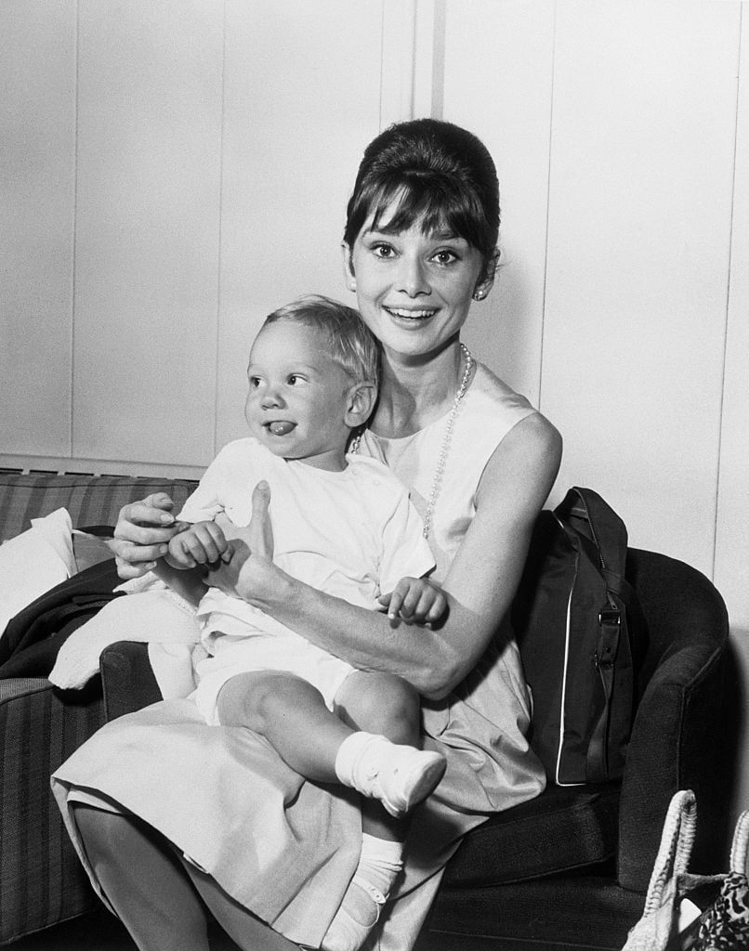

Sabrina ItineraryTraveler

Age: 32

Female

Family travel with a purpose

Wants her family’s travel to San Juan to be perfect for everyone.

As a family of four including two young adolescents, I want to know about family activities nearby.

As a family of four including two young adolescents, I want to be able to easily share details about the lodge with my family.

As a family of four including two young adolescents, I want to see pictures and dimensions of the lodge so I know there will be enough room.