Seth Glover

4/20/2025

Module 5.2 **Assignment: Value Stream Mapping (VSM)**

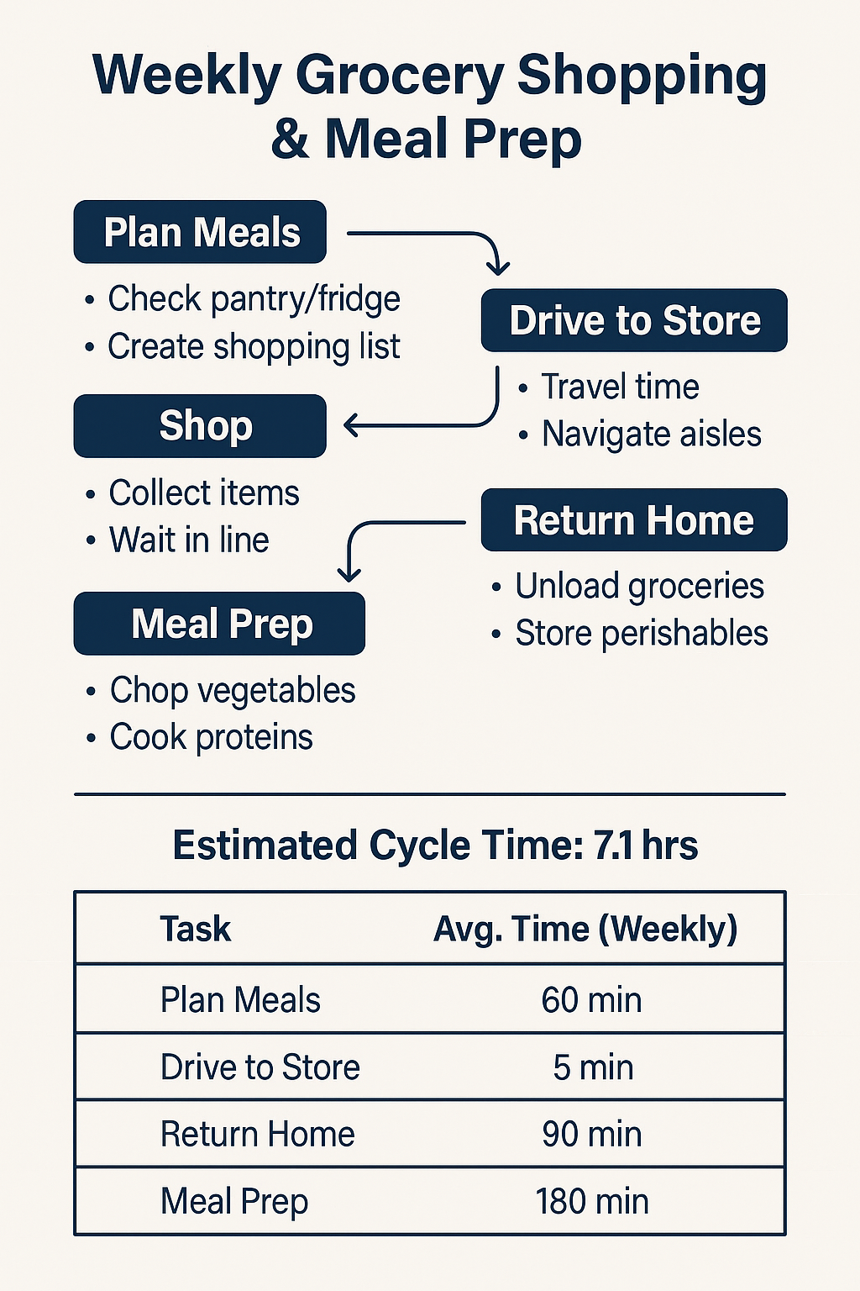CSD380-M320 DevOps

**Weekly Grocery Shopping and Meal Preparation**

| **Task** | **Avg. Time (Weekly)** | **Notes** |
| --- | --- | --- |
| Plan Meals | 60 mins | Often redundant; manual list making |
| Drive to Store | 5 mins | Minimal, but avoidable |
| Shop | 90 mins | Time-consuming; includes waiting in line |
| Return Home | 10 mins | Efficient unless items are forgotten |
| Meal Prep | 180 mins | Daily cooking adds to mental load |

**Total Time: 7.1 hours/week**

**Optimization Opportunities**

**1. Eliminate Waste**

* **Overprocessing**: Manual meal planning and repetitive list creation can be streamlined using digital tools.
* **Waiting**: Time spent in store lines is non-value-added… consider delivery or pickup.
* **Motion**: Navigating aisles aimlessly or backtracking wastes time and energy.

**Fixes:**

* Use a meal planning app (e.g., Paprika, Mealime).
* Organize shopping list by store sections.
* Stick to a weekly rotating meal plan for recurring meals.

**2. Batching & Standardization**

* **Batch Meal Planning**: Plan all meals on Sunday.
* **Batch Prep**: Pre-chop and portion for the week (e.g., store stir-fry mix in zip bags).
* **Standardize Routine**: Create a weekly meal + shopping template to minimize planning friction.

**3. Automation & Delegation**

* **Online Grocery Orders**: Use apps (e.g., Instacart, Walmart Pickup) to replace in-store shopping.
* **Delegate Tasks**: Involve family members in prep, unloading, or portioning meals.
* **Appliance Utilization**: Use slow cookers, rice cookers, and air fryers to reduce active cooking time.

**Future State Process (Optimized)**

**Modified Weekly Flow:**

| **Task** | **New Time Estimate** | **Optimization Technique** |
| --- | --- | --- |
| Plan + List | 15 mins | Meal planning app |
| Order Groceries Online | 10 mins | Store app / saved cart |
| Pickup or Delivery | 20 mins | Pickup window / scheduled delivery |
| Batch Meal Prep | 150 mins | Prep proteins, grains, and veggies |
| Daily Reheat/Assemble | ~5 mins/day (35m) | Microwave or light assembly |

**New Total Time: ~4.0 hours/week**  
**Time Savings: ~3.1 hours/week**

* **Reduced Cognitive Load** – Automating and standardizing reduces decision fatigue.
* **More Free Time** – Reclaim 3+ hours for family, hobbies, or rest.
* **Consistency & Less Waste** – Meal repetition ensures ingredients are used efficiently.
* **Improved Nutrition** – Planning in advance avoids defaulting to unhealthy takeout.