GTM965500P
Test Report
24V Model
GlobTek Engineering
Generated: April 16, 2026

Test Summary
Project: GTM965500P | 24V Model | Total Test Items: 22

Status | OK / Resolved | For Review | Regression Req'd | In Progress | Has Issue | Invalid/Incomplete Test | Unknown
Count | 2 | 10 | 0 | 1 | 0 | 0 | 9

24V
Test Item | Status | Link
Input
No Load Input Power | Marked for review | View →
Input Voltage | OK / Resolved | View →
Main Output
Turn-On Delay | Marked for review | View →
Load Regulation | Marked for review | View →
Voltage Ripple | OK / Resolved | View →
Transient Response | Marked for review | View →
Startup Overshoot | Marked for review | View →
Hold-Up Time | Marked for review | View →
Remote-Sense (SNS) | Marked for review | View →
Output Voltage Fine Adjustment | Marked for review | View →
Protections
Over-Power Protection (OPP) | Marked for review | View →
Short-Corcuit Protection (SCP) | Marked for review | View →

Changes Required

2 changes flagged across all tests.

Voltage | Test | Change Description
24V | Over-Power Protection (OPP) · Vision314 · 2026-04-01 | COMPONENT | OLD VALUE | NEW VALUE -- | -- | -- C26 | 6.8nF | 5.6nF C27 | 3.3nF | 2.2nF
24V | Output Voltage Fine Adjustment · Vision314 · 2026-04-02 | Req of Ra8, Ra9 and Ra11, Ra12 is 90.7kOhm Ra8, Ra11 = 88.7kOhm Ra9, Ra12 = 2kOhm Ra14 = 16kOhm Output range: 22.8V -> 25.2V

Tests Not Yet Run

10 tests have not yet been run.

24V
Test Item | Status | Link
Protections
Over-Voltage Protection (OVP) | In Progress | View →
Environmental / Reliability
Component Thermal Stress | Unknown | View →
Component Electrical Stress | Unknown | View →
Safety
Dielectric Withstand (Hi-Pot) | Unknown | View →
Output Touch Current | Unknown | View →
Earth Leakage Current | Unknown | View →
EMC
Conducted Emissions | Unknown | View →
Radiated Emissions | Unknown | View →
Electrostatic Discharge (ESD) | Unknown | View →
Electrical Fast Transient (EFT) | Unknown | View →

Detailed Test Results

24V
24V | No Load Input Power | OPEN | Marked for review

Specification / Procedure
Spec: < 500mW @ 240Vac (main-output disabled, i.e. remote-off low)

Solder RO pin to AUX GND to disable output without additional regulation board load

Use Yokogawa WT3000 with 20 second acquisition time (update rate)

Results
Vision314 · 2026-04-15 [LATEST]
570mW

Comments (1)
lauxtim · 2026-04-15 [LATEST]
See: https://github.com/GlobTek-Engineering/GTM965500P/issues/24#issuecomment-4255997812

24V | Turn-On Delay | OPEN | Marked for review

Specification / Procedure
Spec: < 2 seconds @ 115Vac

Measure AC input voltage with differential probe, passive probe on DC output. Check the time between AC turn-on and DC turn-on, at full load.

Results
Vision314 · 2026-04-06
239ms @ 22.9A

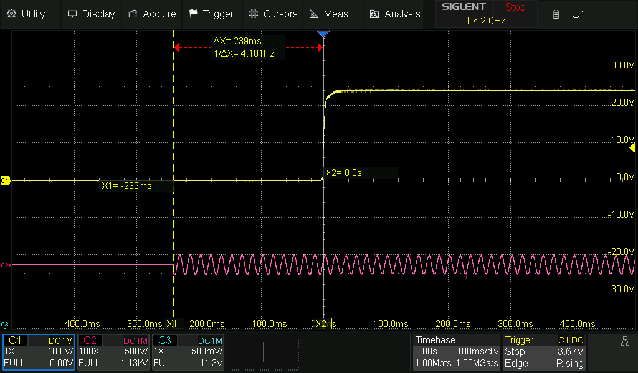

Vision314 · 2026-04-16 [LATEST]
GTSZ

Condition | Spec (mS) | Reading (mS) | Picture | Result
100Vac, 22.916A | 2000 | 1150 | 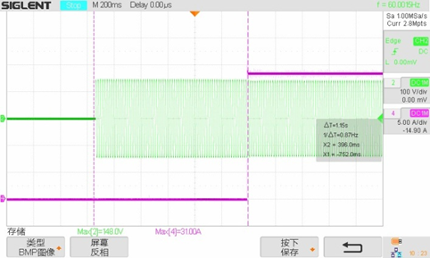 | PASS
240Vac, 22.916A | 2000 | 710 | 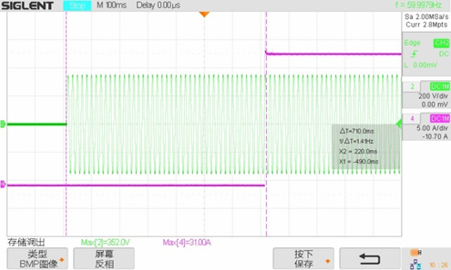 | PASS

24V | Load Regulation | OPEN | Marked for review

Specification / Procedure
Spec: ± 1.0% (measured at output connector)

Check the stabilized DC output voltage at no-load (0%). Check the stabilized DC output voltage at full load (100%).

% Load regulation = [ V(no_load) - V(full_load) / V(full_load) ] * 100%

Measure at 90Vac
Measure at 264Vac

Results
Vision314 · 2026-04-06

Input | V (no load) | V (full load) | Load Regulation (%)
90Vac | 24.036 | 24.033 | 0.01%
264Vac | 24.036 | 24.032 | 0.02%

Vision314 · 2026-04-16 [LATEST]
GTSZ

Input Voltage | 12V | Load (A) | Test Result
90 | 24.094 | 0 | PASS
 | 24.02 | 5.73 | PASS
 | 24.02 | 11.46 | PASS
 | 24.01 | 17.19 | PASS
 | 24.01 | 22.916 | PASS
115 | 24.094 | 0 | PASS
 | 24.02 | 5.73 | PASS
 | 24.02 | 11.46 | PASS
 | 24.01 | 17.19 | PASS
 | 24.01 | 22.916 | PASS
230 | 24.094 | 0 | PASS
 | 24.02 | 5.73 | PASS
 | 24.02 | 11.46 | PASS
 | 24.01 | 17.19 | PASS
 | 24.01 | 22.916 | PASS
264 | 24.094 | 0 | PASS
 | 24.02 | 5.73 | PASS
 | 24.02 | 11.46 | PASS
 | 24.01 | 17.19 | PASS
 | 24.01 | 22.916 | PASS

24V | Voltage Ripple | CLOSED | OK / Resolved

Specification / Procedure
Spec: < 1% pk-pk (measured with a 47µF low-ESR cap + 0.1µF ceramic cap, measured @ 20MHz BW)

Prior to recording data, check whether 90Vac or 264Vac yields worse results, if at all. Record data using the worst case input voltage.

Using the ripple probe fixture and matching 1x probe, connect close to the output connectors on the PCB, measure ripple with oscilloscope. Ripple is inclusive of HF (100KHz) and LF (120Hz) components. Timebase should capture 120Hz component (e.g. 2-5ms/div)

Three conditions, adjust potentiometer accordingly:
(95% * V_out)
(100% * V_out)
(105% * V_out)

Results
Vision314 · 2026-04-06 [LATEST]
ALL PASS
1% ripple = 240mV

Output Voltage | Picture | Measured Ripple
95% Vout | 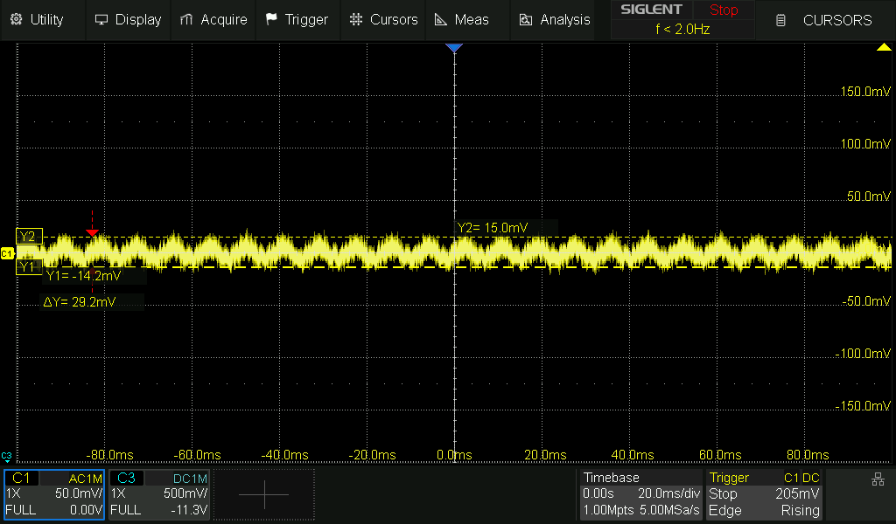 | 29.2mV
100% Vout | 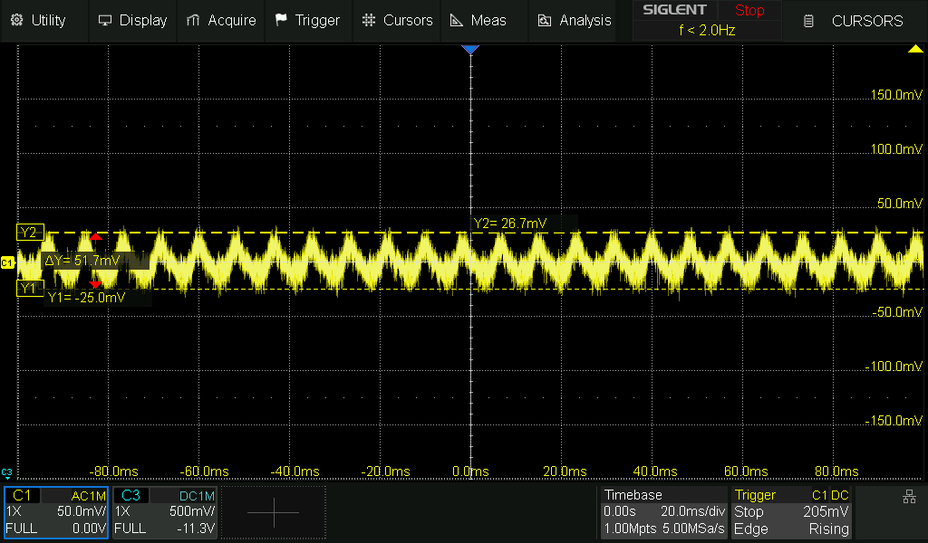 | 51.7mV
105% Vout | 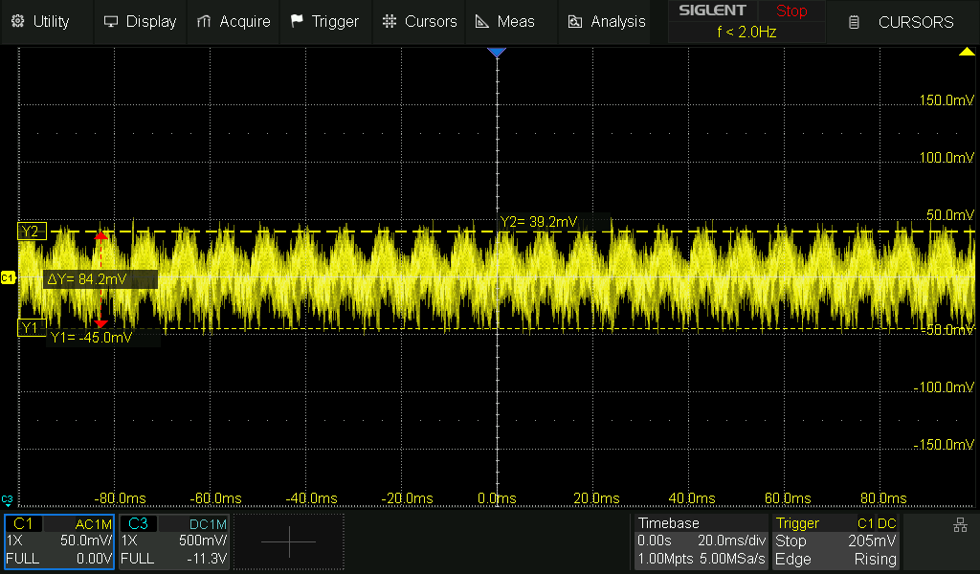 | 84.2mV

24V | Transient Response | OPEN | Marked for review

Specification / Procedure
Spec: ± 5% deviation max. (with 50% load step), recovery to within ±1% within 1ms

Taken at nominal input voltage (e.g. 115Vac)

Measure with ripple probe fixture PCB, Measure at power supply PCB. Measured with AC coupling.

Step load + load dump:
0 -> 25%
25% -> 50%
50 -> 75%
75 -> 100%

8 measurements total

Results
Vision314 · 2026-04-06 [LATEST]
Load Step

Transition | Deviation | Recovery Time
0A → 5.7A | 493mV | <1ms
5.7A → 11.5A | 248mV | <1ms
11.5A → 17.2A | 255mV | <1ms
17.2A → 22.9A | 303mV | <1ms

Load Dump

Transition | Deviation | Recovery Time
0A → 5.7A | 220mv | <1ms
5.7A → 11.5A | 182mV | <1ms
11.5A → 17.2A | 181.7mV | <1ms
17.2A → 22.9A | 207.5mV | <1ms

1% = 240mV

Load Step

Load Step | Picture | Deviation | Recovery Time
0A → 5.7A | 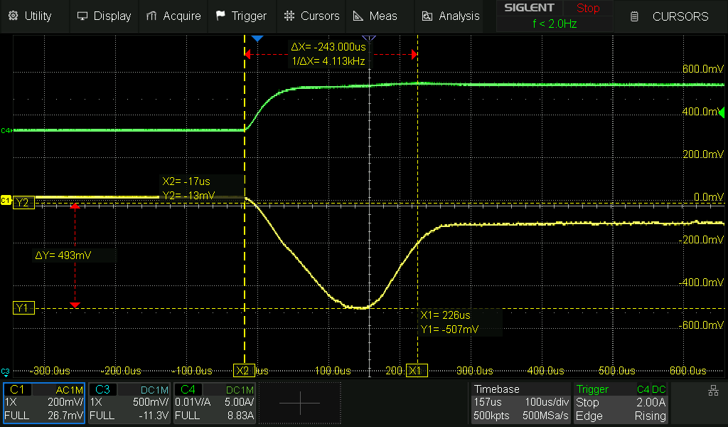 | 493mV | <1ms
5.7A → 11.5A | 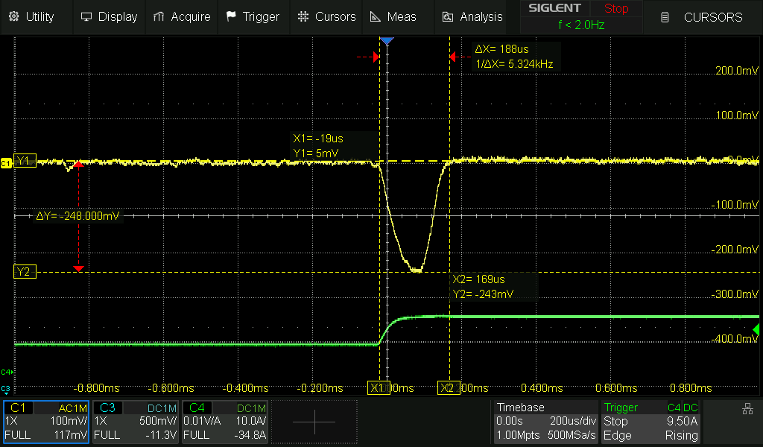 | 248mV | <1ms
11.5A → 17.2A | 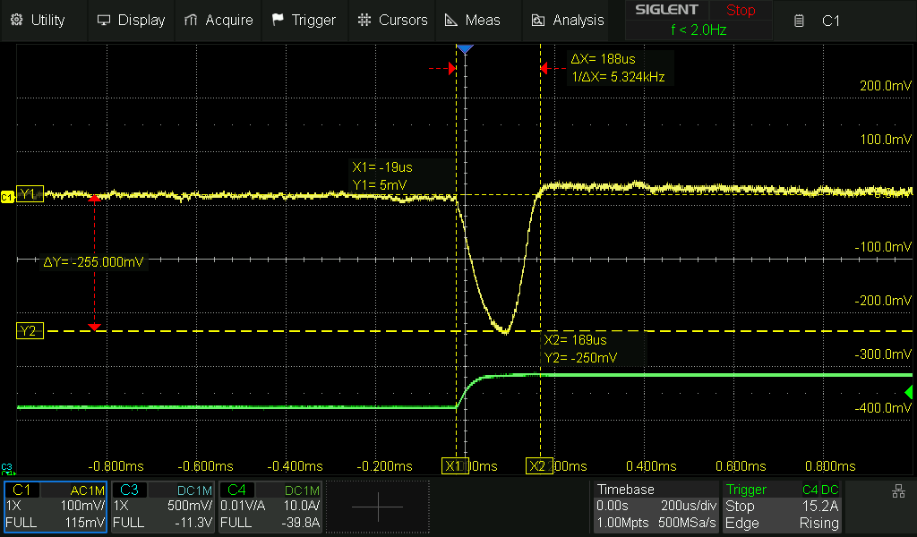 | 255mV | <1ms
17.2A → 22.9A | 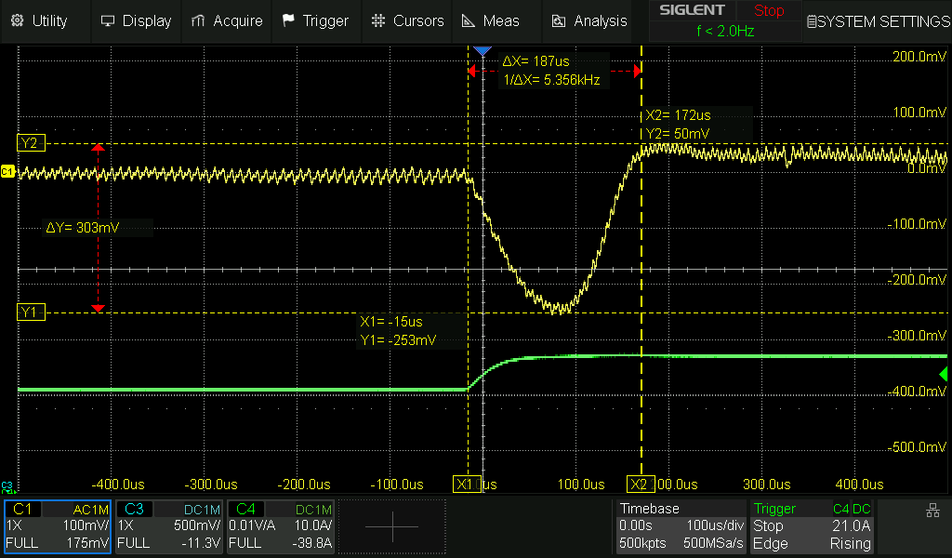 | 303mV | <1ms

Load Dump

Load Dump | Picture | Deviation | Recovery Time
0A → 5.7A | 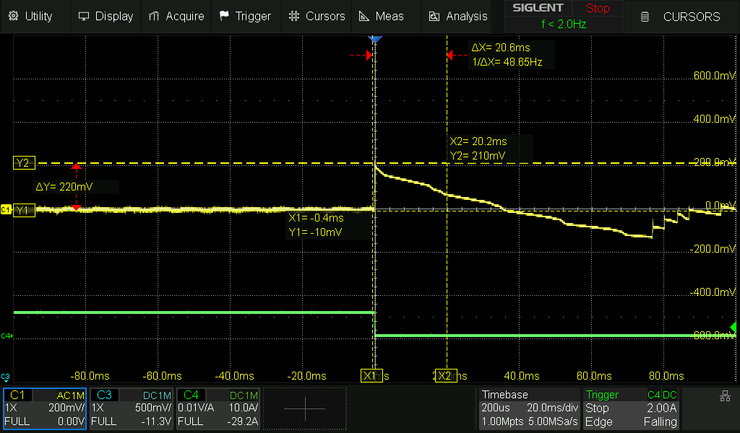 | 220mv | <1ms
5.7A → 11.5A | 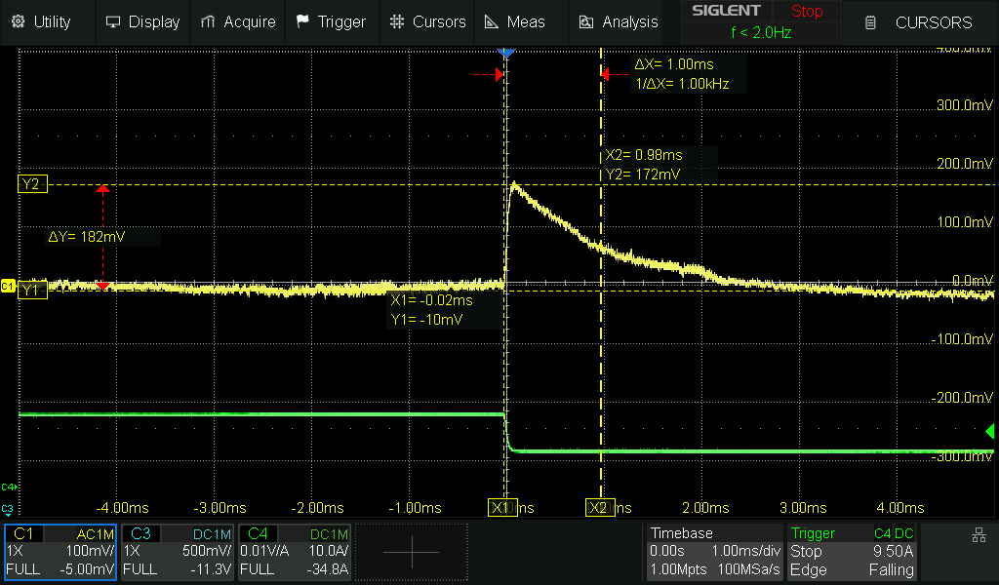 | 182mV | <1ms
11.5A → 17.2A | 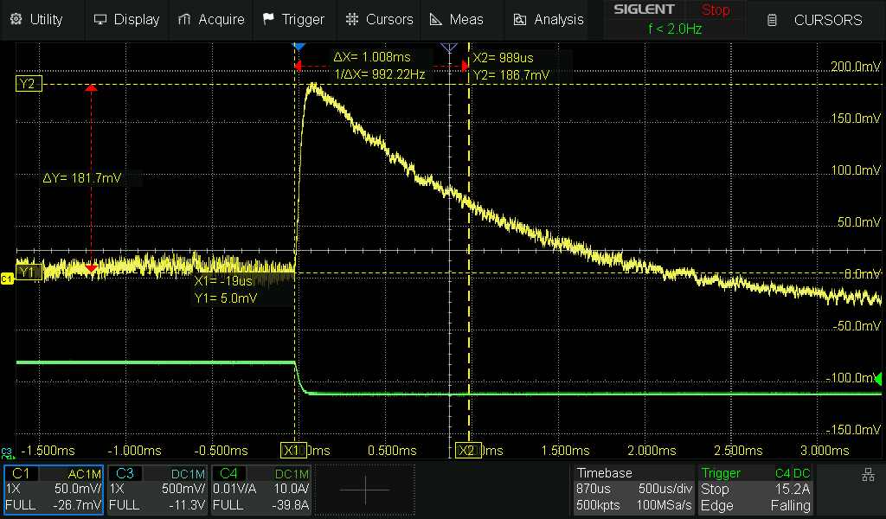 | 181.7mV | <1ms
17.2A → 22.9A | 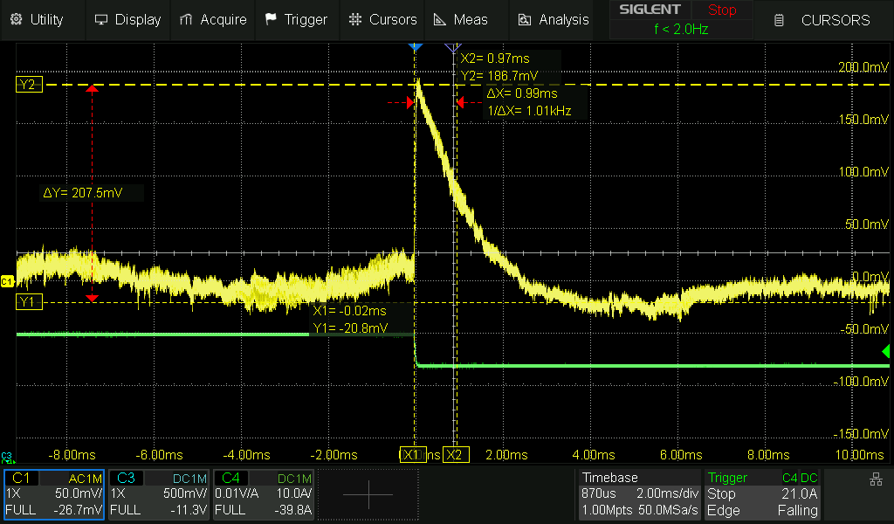 | 207.5mV | <1ms

Comments (1)
lauxtim · 2026-04-14 [LATEST]
In reviewing the transient response for 12, 24V, and 54V, many times the peak deviation does not ever exceed the 1% recovery threshold, so the recovery time should probably be marked as "N/A" or "Dev. < 1%" for those items. (Cannot quantify how long it takes to recovery if it never deviated outside of our bounds to start with.) Above, all of the load steps exceed 1% deviation (240mV), so then we need to assess whether the peak deviation has exceeded the 5% max or not. From inspection, seems like most are in the 200-300us range. Writing <1ms is OK as a pass/fail. For the future, you *could* record the actual recovery time.

No need to re-test, just update those which never deviated outside of 1% to "Dev. < 1%" or similar.

As a note:

I'd probably set the cursors as follows:

Y(1): At peak of measured waveform (measured max deviation)
Y(2): At the 1% recovery threshold
X(1): At t=0 (the moment the load step is applied)
X(2): At the moment the voltage recovers to less than Y(2), the recovery threshold (measured recovery time)

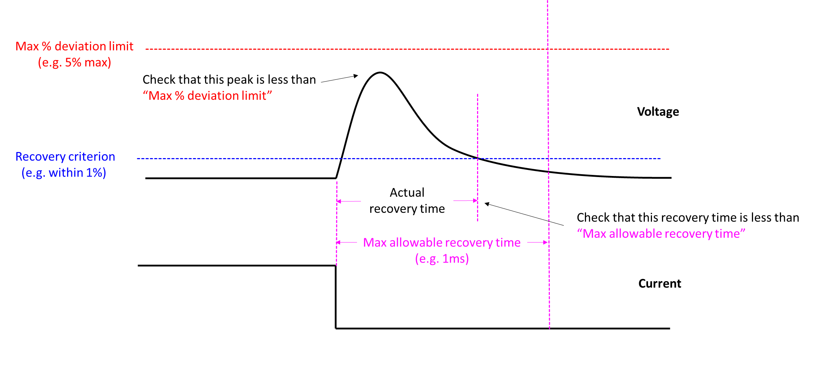

It may make sense (in general, all types of tests), to present data with the specified limits presented in line. This way, you can easily see (at a glance) whether the spec is met or not, no need to scroll up or remember what the spec is.

Load Dump Condition | Picture | Max Deviation | Max Deviation (Spec) | Recovery Time | Recovery Time (Spec)

24V | Startup Overshoot | OPEN | Marked for review

Specification / Procedure
Spec: <5%

Measure with oscilloscope in DC coupling.

Measure at 90Vac and 264Vac, at:
No load
Full load

4 measurements total

Results
Vision314 · 2026-04-06 [LATEST]
Output Voltage Overshoot

Condition | 90 Vac | 264 Vac
No Load | 0mV | 0mV
Full Load | 0mV | 0 mV

Output Voltage Overshoot

Condition | 90 Vac | 264 Vac
No Load | 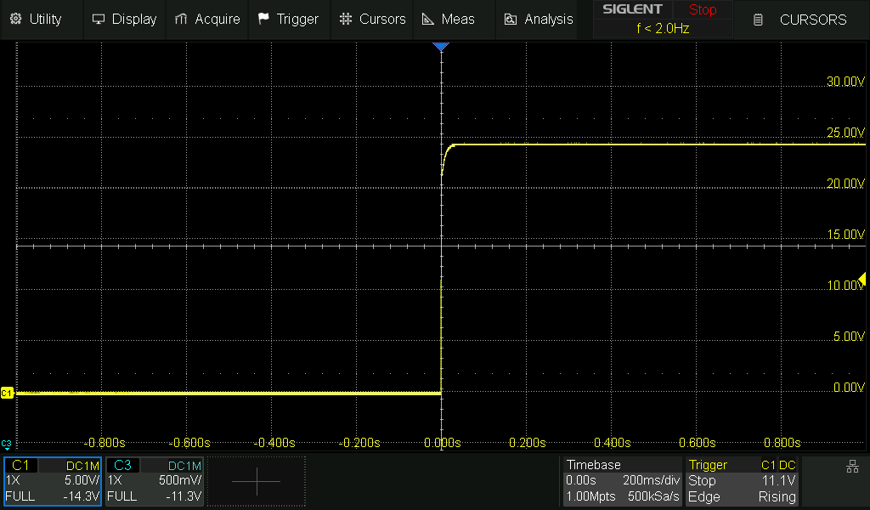 | 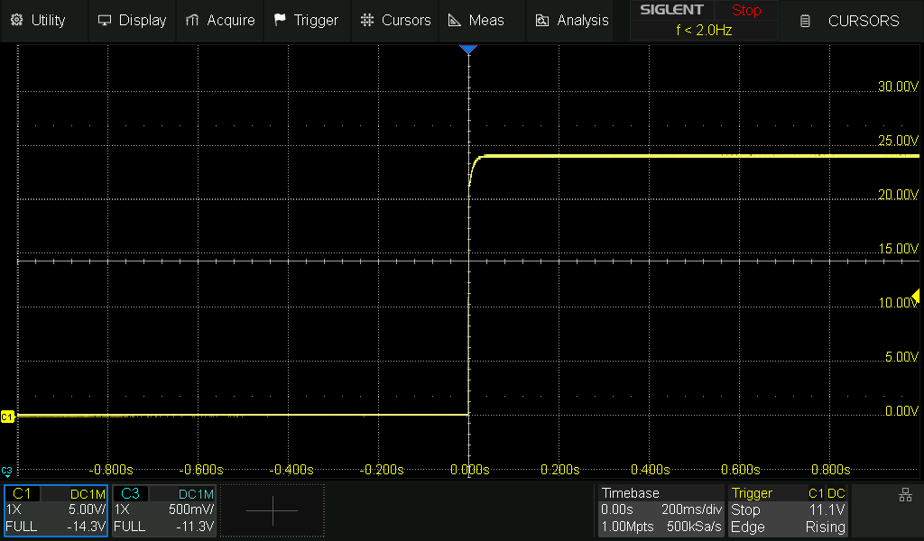
Full Load | 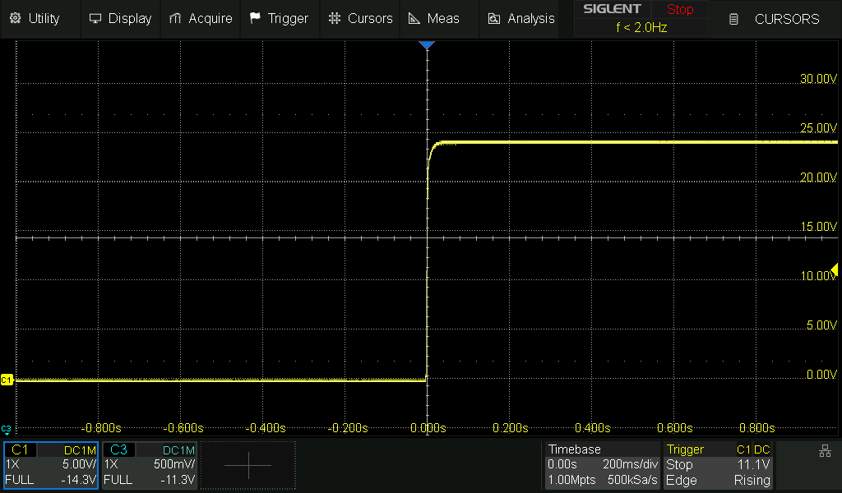 | 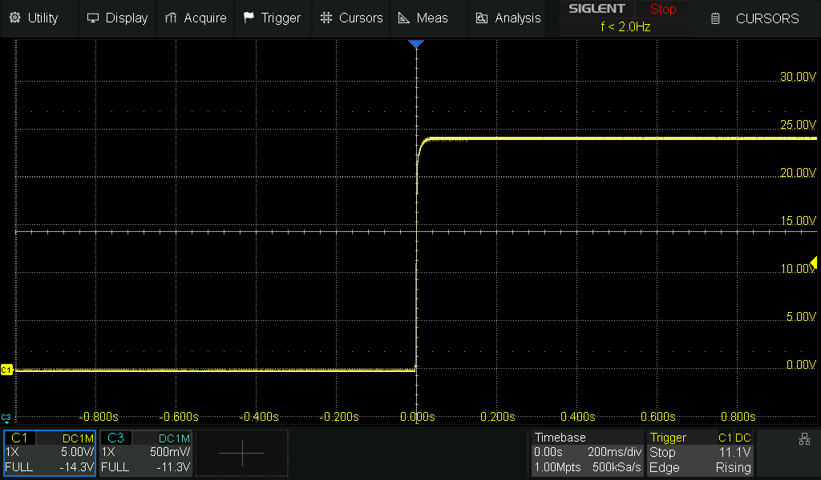

24V | Hold-Up Time | OPEN | Marked for review

Specification / Procedure
Spec: 20ms typ. (100% load), 20ms min. (95% load), 50ms typ. (50% load)

Attach differential probe to AC input. Attach passive probe to output. Set load according to the above. Measure the time between AC turn-off and DC output falling to approx. 95% * nominal V_out.

Results
Vision314 · 2026-04-02 [LATEST]

Input Voltage | Output Voltage | Hold Up Time (ms) 100% Load (22.9 A) | Hold Up Time (ms) 50% Load (11.5 A)
90Vac | 22.8 | 28.3 | 56.3
 | 24 | 27.5 | 52.3
 | 25.7 | 25.5 | 50.7
264Vac | 22.8 | 28.9 | 56.3
 | 24 | 27.3 | 52.3
 | 25.7 | 25.7 | 50.1

24V | Remote-Sense (SNS) | OPEN | Marked for review

Specification / Procedure
Spec: Up to 500mV total cable-drop compensation, reverse and short circuit protected. Connect SNS+/SNS- leads to point-of-load with twisted pair wire. (Note 1)

Attach sufficiently long wires between the output and the load, which causes a voltage drop exceeding 250mV per wire @ 85% load current. (Rationale for 85%: When remote sense is used, output voltage and output power goes up, when tested with a constant current load. We do not specify operation at P_out>100% rating.)

For instance, the DCR of 1.5m of 12AWG wire is 0.0075ohm. For the 12V model, this yields a drop of 292mV per wire, or 584mV total. Different cable lengths shall be used for other voltage models.

Part A:

- Run at nominal line voltage (e.g. 115Vac)
- Increase the set-point voltage to V_nom + 5% using the potentiometer.

1. Leave the sense leads disconnected from the load. Measure the voltage at the power supply PCB @ 85% load.

2. Connect the twisted-pair sense leads at the point-of-load (at the E-load terminals).

3. Measure the voltage at the power supply PCB again @ 85% load.

The voltage at the PCB should have increased by at least 500mV.

Part B:

1. Detach the SNS leads, reverse the leads (connect SNS+ to -load terminal and SNS- to +load terminal). Check that there is no damage during and after.

Part C:

1. Detach the SNS leads and connect them to each other (short SNS+ to SNS-, alone). Check that there is no damage during and after.

Results
Vision314 · 2026-04-13 [LATEST]
Previous issues were caused by broken/missing/incorrect TVS diodes for ZD6 and ZD7. Must be 54V zener ("RE" marking) for all voltage models.

85% load = 19.5A

Part A

Step # | Voltage @ Supply | Voltage @ Load
1 | 25.2 V | 24.25 V
3 | 25.8 V | 24.9 V

Part B - No damage

Voltage @ Supply | Voltage @ Load
26.45 V | 25.5 V

Part C - No damage

Voltage @ Supply | Voltage @ Load
26.3 V | 25.5 V

Comments (3)
Vision314 · 2026-04-07
Part A

12AWG | ~6ft | Rwire = 0.013 Ohm

85% load = 19.5A
1. 25.3 V
2. ..
3. 25.67 V

Part B

1. When I connected the SNS- to +load, there was a spark between those two terminals and the supply OVP'd. On startup the output voltage goes to ~40V and OVP's.

Part C
1. ...

Vision314 · 2026-04-08
The ZD7 TVS diode was removed previously for other rework troubleshooting

When the SNS+ connection touched the negative output terminal, this create some large voltage spike that damaged RJ2
RJ2 Failure Mode: open

Replacing RJ2 with another 2.2Ohm resistor fixed the supply

Solution: don't remove TVS diodes, we need them...

I will finish SNS testing shortly

lauxtim · 2026-04-15 [LATEST]
See: https://github.com/GlobTek-Engineering/GTM965500P/issues/55#issuecomment-4256097729

24V | Output Voltage Fine Adjustment | OPEN | Marked for review

Specification / Procedure
Spec: Via potentiometer, ±5% adjustment range (Note 1)

22.8V -> 25.2V

Run at nominal line voltage (e.g. 115Vac)

Sense leads (SNS) disconnected.

Adjust the potentiometer to minimum and maximum positions. Record the minimum and maximum output voltage, measured at the PCB.

Changes Required
Vision314 · 2026-04-02 [LATEST]
Req of Ra8, Ra9 and Ra11, Ra12 is 90.7kOhm

Ra8, Ra11 = 88.7kOhm
Ra9, Ra12 = 2kOhm
Ra14 = 16kOhm

Output range: 22.8V -> 25.2V

24V | Over-Power Protection (OPP) | CLOSED | Marked for review

Specification / Procedure
Spec: 105-150%, non-latching with auto-recovery

Spec update: Change from "Over-Current Protection" to "Over-Power Protection"

Run at 90Vac and 264Vac.

The specified range applies only for V_out = V_out(nom). (e.g. "12V" @ 12.00V, "24V" @ 24.00V, etc.), voltage measured at the PCB. The nominal design point should be 130 - 135%.

Reference OPP data should also be collected at V_out(-5%) and V_out(+5% + 500mV), for reference although not specified. At V_out(+5% + 500mV), at least 100% output power should be obtainable.

FRANKIE TESTING NOTES:
4/1/2026
Noting current values for regulation board. In order to test Vout max and min (22.8 V -> 25.7V) the following regulation board components were used and give a actual output voltage range of 21.4 V -> 26.5V

Ra8, Ra11 = 84.5kOhm
Ra9, Ra12 = 100Ohm
Ra10, Ra13 = 10kOhm

Ra14 = 7.5kOhm

Changes Required
Vision314 · 2026-04-01 [LATEST]

COMPONENT | OLD VALUE | NEW VALUE
C26 | 6.8nF | 5.6nF
C27 | 3.3nF | 2.2nF

Results
Vision314 · 2026-04-14 [LATEST]

Input Voltage | Output Voltage | OPP Point (A) | OPP Point (%) | PG Time (ms)
90Vac | 22.8 | 33 | 144% | 10
 | 24 | 32 | 140% | 10
 | 25.7 | 24 | 112% | 10
264Vac | 22.8 | 38 | 166% | 10
 | 24 | 32 | 140% | 10
 | 25.7 | 24 | 112% | 10

Comments (1)
Vision314 · 2026-04-01 [LATEST]
Trying the same values as the 12V:

COMPONENT | OLD VALUE | NEW VALUE
C26 | 6.8nF | 6.8nF
C27 | 3.3nF | 2.2nF

Input Voltage | Output Voltage | OPP Point (A) | OPP Point (%) | PG Time (ms)
90Vac | 22.8 | 34 | 148% | 0
 | 24 | 32 | 140% | 9.5
 | 25.7 | 27 | 126% | 9.5
264Vac | 22.8 | 43 | 188% | 9.5
 | 24 | 36 | 157% | 9.5
 | 25.7 | 27 | 126% | 9.5

FRANKIE TESTING NOTES:
4/1/26
Noting current values for regulation board. For testing between -5% to +(5% + 500mV) => 22.8 V -> 25.7V

21.4 V -> 26.5V

Ra8, Ra11 = 84.5kOhm
Ra9, Ra12 = 100Ohm
Ra10, Ra13 = 10kOhm

Ra14 = 7.5kOhm

24V | Short-Corcuit Protection (SCP) | OPEN | Marked for review

Results
Vision314 · 2026-04-15 [LATEST]
PASS

24V | Input Voltage | CLOSED | OK / Resolved

Specification / Procedure
Spec: 90 - 264Vac (Nameplate: 100 - 240Vac)

Confirm that full rated power can be drawn over the entire rated input voltage range. Test full load @ 90Vac, 115Vac, 240Vac, 264Vac

Results
Vision314 · 2026-04-16 [LATEST]
GTSZ

Input Voltage | Output Voltage | Load (A) | Test Result
90 | 24.094 | 0 | PASS
90 | 24.01 | 22.916 | PASS
120 | 24.094 | 0 | PASS
120 | 24.01 | 22.916 | PASS
240 | 24.094 | 0 | PASS
240 | 24.01 | 22.916 | PASS
264 | 24.094 | 0 | PASS
264 | 24.01 | 22.916 | PASS

Comments (1)
Vision314 · 2026-04-02 [LATEST]
https://github.com/GlobTek-Engineering/GTM965500P/issues/68#issuecomment-4172278539

Untested — Specifications

24V
24V | Over-Voltage Protection (OVP) | OPEN | In Progress

24V | Component Thermal Stress | OPEN | Unknown

24V | Dielectric Withstand (Hi-Pot) | OPEN | Unknown

24V | Output Touch Current | OPEN | Unknown

24V | Earth Leakage Current | OPEN | Unknown

24V | Conducted Emissions | OPEN | Unknown

24V | Radiated Emissions | OPEN | Unknown

24V | Electrostatic Discharge (ESD) | OPEN | Unknown

24V | Electrical Fast Transient (EFT) | OPEN | Unknown

24V | Component Electrical Stress | OPEN | Unknown

