GTM965500P
Test Report
Model Level Model
GlobTek Engineering
Generated: April 16, 2026

Test Summary
Project: GTM965500P | Model Level Model | Total Test Items: 11

Status | OK / Resolved | For Review | Regression Req'd | In Progress | Has Issue | Invalid/Incomplete Test | Unknown
Count | 1 | 3 | 0 | 0 | 1 | 0 | 6

Model Level
Test Item | Status | Link
Input
Input Current | Marked for review | View →
Inrush Current | Marked for review | View →
Power Factor | Marked for review | View →
Main Output
Power Good (PG) | OK / Resolved | View →

Tests Not Yet Run

7 tests have not yet been run.

Model Level
Test Item | Status | Link
Main Output
Remote-Off (RO) | Unknown | View →
Standby Output
Output Voltage Regulation | Unknown | View →
Fan Output
Output Voltage Regulation | Unknown | View →
Protections
Under-Voltage Protection (UVP) | Unknown | View →
Over-Temperature Protection (OTP) | Unknown | View →
EMC
Lightning Surge | Unknown | View →
PFC
PFC Voltage Drop at 90Vac - overload | Has Issue | View →

Detailed Test Results

Model Level
Model Level | Input Current | OPEN | Marked for review

Specification / Procedure
Spec: 6.5A max. @ 100Vac, 5.2A typ. @ 115Vac, 2.5A typ. @ 240Vac (full load)

Suggest using the 12V unit since it has the lowest efficiency and will have the highest input current.

Results
Vision314 · 2026-04-16 [LATEST]
GTSZ

12V

Spec (A) | Reading (A) | Result | Picture
6.5 | 6.128 | PASS | 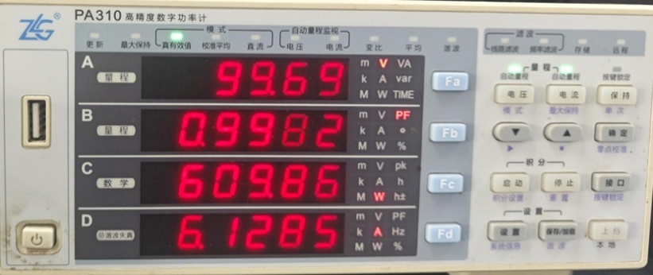

24V

Spec (A) | Reading (A) | Result | Picture
6.5 | 6.056 | PASS | 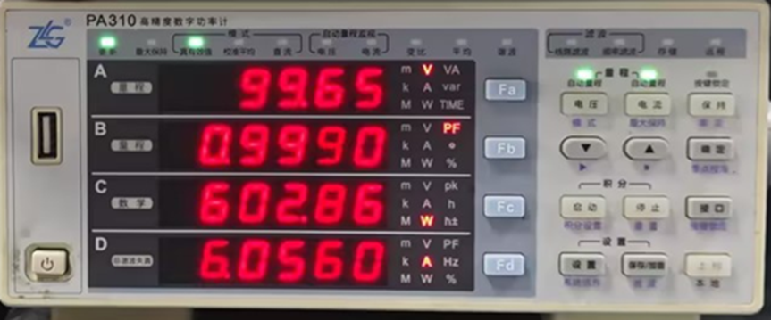

Model Level | Inrush Current | OPEN | Marked for review

Specification / Procedure
Spec: < 35A @ 115Vac , < 70A @ 240Vac (cold or warm start)

Use Chroma AC source, set start phase angle to 90°. Verify and record AC turn-on waveform, showing 90° turn-on with power supply detached. Connect power supply, Using oscilloscope current probe, measure and record peak value of inrush current.

Inrush current should not depend on output voltage so any voltage can be used.

Results
Vision314 · 2026-04-16 [LATEST]
[GTSZ]

12V

Voltage | Spec (A) | Reading (A) | Result | Picture
115Vac | 35 | 14.4A | PASS | 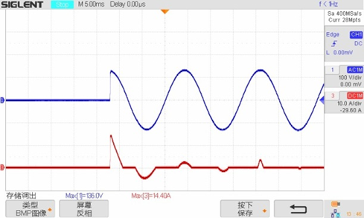
240Vac | 70 | 44A | PASS | 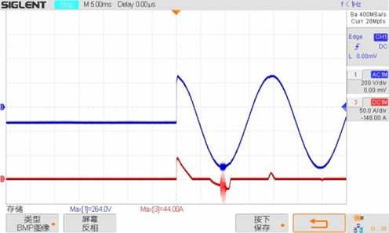

24V

Voltage | Spec (A) | Reading (A) | Result | Picture
115Vac | 35 | 18A | PASS | 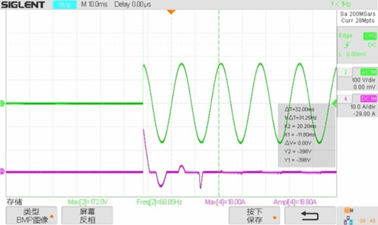
240Vac | 70 | 38.4A | PASS | 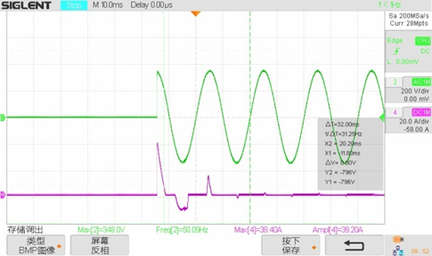

Model Level | Power Factor | OPEN | Marked for review

Specification / Procedure
Spec: > 0.98 @ 115Vac, > 0.97 @ 240Vac typ. (25 - 100% load)

Using Yokogawa WT3000, measure power factor at 25%, 50%, 75% and 100% load, at 115Vac and 240Vac.

Power factor does not depend on output voltage so any voltage can be used.

Results
Vision314 · 2026-04-16 [LATEST]
GTSZ

24V, 115Vac, Average Efficiency = 92.102%

Parameter | 100% | 75% | 50% | 25%
Percent of Rated Load | 100% | 75% | 50% | 25%
True Power Factor (Watts/VA) | 0.9992 | 0.9990 | 0.9987 | 0.9975
Efficiency | 91.763% | 92.566% | 92.886% | 91.193%

24V, 230Vac, Average Efficiency = 94.247%

Parameter | 100% | 75% | 50% | 25%
Percent of Rated Load | 100% | 75% | 50% | 25%
True Power Factor (Watts/VA) | 0.9987 | 0.9967 | 0.9920 | 0.9819
Efficiency | 94.652% | 94.625% | 94.415% | 93.295%

12V, 115Vac, Average Efficiency = 91.907%

Parameter | 100% | 75% | 50% | 25%
Percent of Rated Load | 100% | 75% | 50% | 25%
True Power Factor (Watts/VA) | 0.9985 | 0.9989 | 0.9988 | 0.9974
Efficiency | 90.751% | 91.875% | 92.853% | 92.151%

12V, 230Vac, Average Efficiency = 93.553%

Parameter | 100% | 75% | 50% | 25%
Percent of Rated Load | 100% | 75% | 50% | 25%
True Power Factor (Watts/VA) | 0.9985 | 0.9960 | 0.9907 | 0.9760
Efficiency | 93.438% | 93.786% | 94.010% | 92.976%

Model Level | Power Good (PG) | CLOSED | OK / Resolved

Specification / Procedure
Spec: Signal typically goes low ~10ms ahead of AC power failure or entering of protection state
5V logic level, VH = 4.90V typ. @ IPG= 100µA

Select any model output voltage. PG behavior should not depend output voltage.

Select a nominal input voltage (e.g. 115Vac)

At OPP: Step the load above the OPP threshold. Measure the time between PG asserting low and the output voltage going low.

At AC power failure: At 75% load, switch off AC input power. Measure the time between PG asserting low and the output voltage going low.

Results
Vision314 · 2026-04-14 [LATEST]
YELLOW - PG Signal
PINK - Output Voltage

12V

Failure Mode | PICTURE | PG Time
OPP | 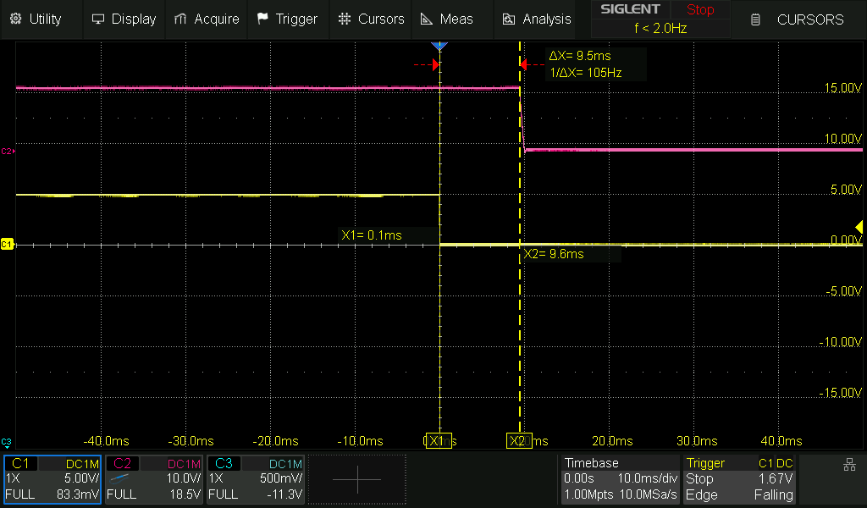 | 9.5ms
AC Power Failure | 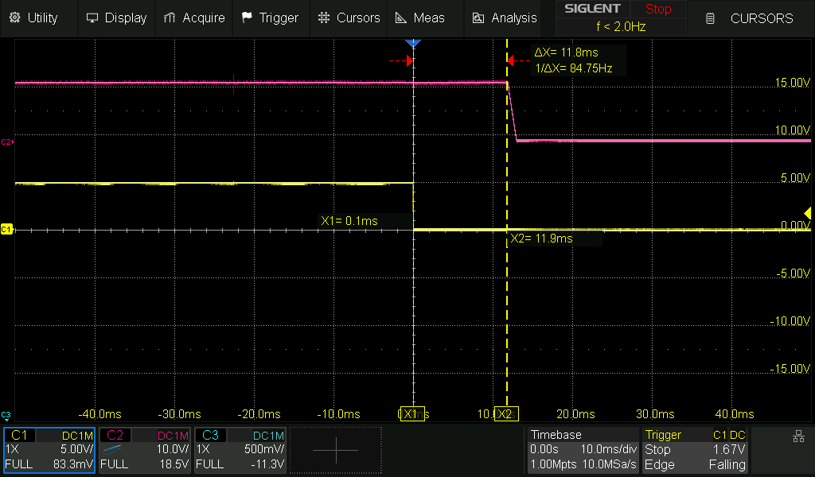 | 11.8ms

OPP Load = 66A (144%)
75% load = 34.4 A

24V

Failure Mode | PICTURE | PG Time
OPP | 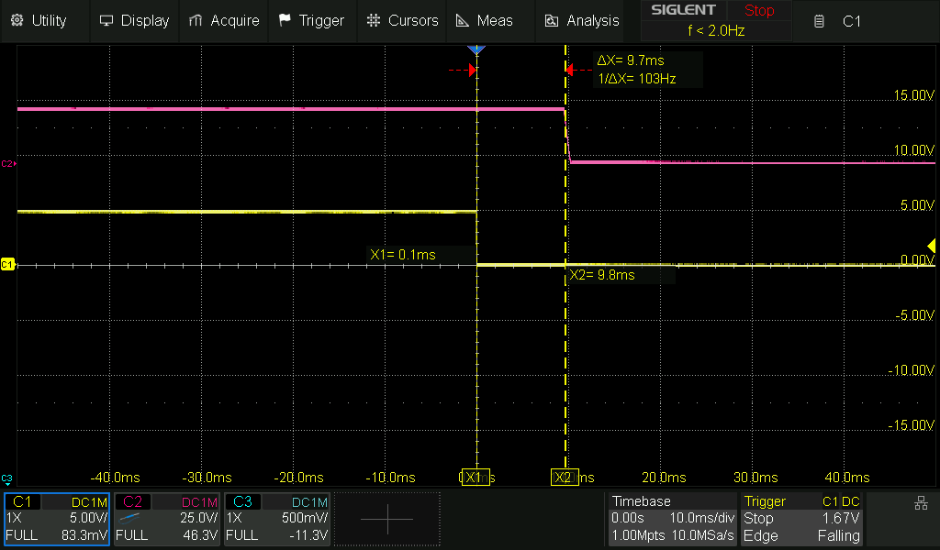 | 9.7ms
AC Power Failure | 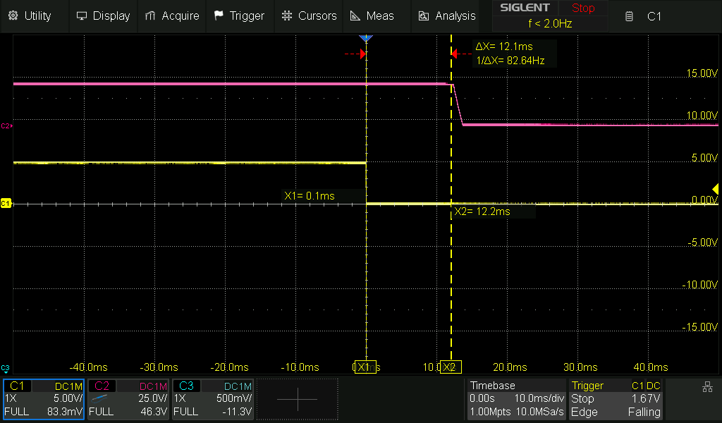 | 12.2ms

OPP Load = 32A (139%)
75% load = 17.2 A

54V

Failure Mode | PICTURE | PG Time
OPP | 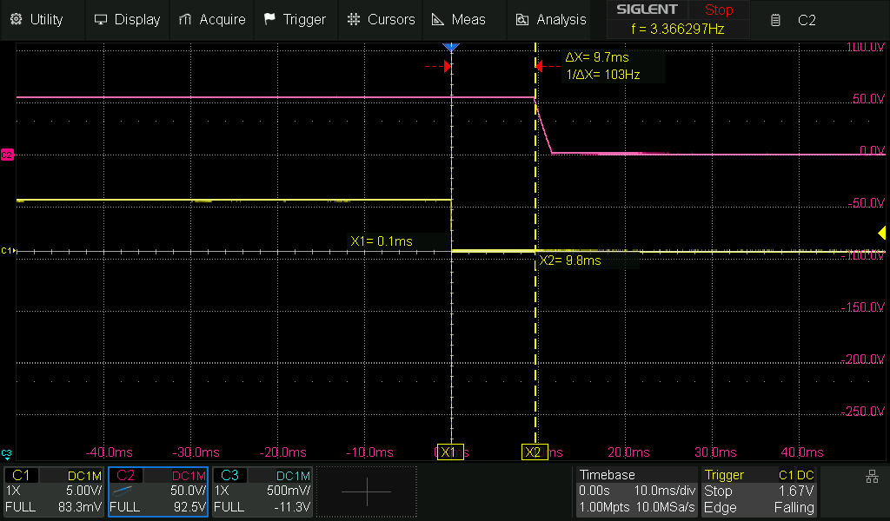 | 9.7ms
AC Power Failure | 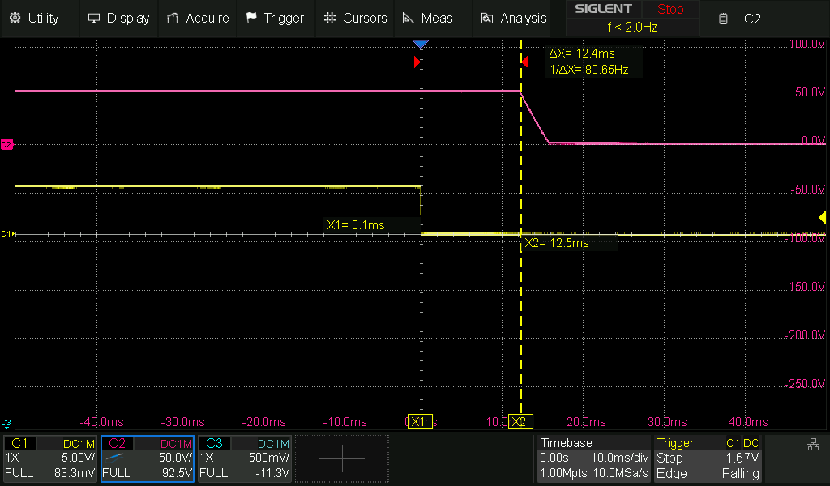 | 12.4ms

OPP Load = 13A (128%)
75% load = 7.6 A

Untested — Specifications

Model Level
Model Level | Remote-Off (RO) | OPEN | Unknown

Specification / Procedure
Spec: Pull 'Remote Off' to COM to disable main output; leave floating or connect to +5VSB otherwise, IRO = 2mA typ. during disabled/off state

Select a nominal input voltage (e.g. 115Vac).

Connect signal breakout board with RO switch. Capture RO signal going low at switch off. Capture V_out going low in response.

Model Level | Output Voltage Regulation | OPEN | Unknown

Specification / Procedure
Spec: ± 5.0% (set point tolerance + load/line/cross regulation)

At nominal line voltage (e.g. 115Vac), set main-output load to 50% load, measure the standby output voltage:

1. Fan output = 0% / Standby output: 0%
2. Fan output = 0% / Standby output: 100%
1. Fan output = 100% / Standby output: 0%
2. Fan output = 100% / Standby output: 100%

Then, disable main output via Remote Off (RO) switch, change input voltage to 90Vac, and record the standby output voltage:

1. Fan output = 0% / Standby output: 0%
2. Fan output = 0% / Standby output: 100%
1. Fan output = 100% / Standby output: 0%
2. Fan output = 100% / Standby output: 100%

With Remote Off (RO) still enabled (main output off), change input voltage to 264Vac, and record the standby output voltage:

1. Fan output = 0% / Standby output: 0%
2. Fan output = 0% / Standby output: 100%
1. Fan output = 100% / Standby output: 0%
2. Fan output = 100% / Standby output: 100%

Model Level | Output Voltage Regulation | OPEN | Unknown

Specification / Procedure
At nominal line voltage (e.g. 115Vac), set main-output load to 50% load, measure the fan output voltage:

Fan output = 0% / Standby output: 0%
Fan output = 0% / Standby output: 100%
Fan output = 100% / Standby output: 0%
Fan output = 100% / Standby output: 100%

Then, disable main output via Remote Off (RO) switch, change input voltage to 90Vac, and record the fan output voltage:

Fan output = 0% / Standby output: 0%
Fan output = 0% / Standby output: 100%
Fan output = 100% / Standby output: 0%
Fan output = 100% / Standby output: 100%

With Remote Off (RO) still enabled (main output off), change input voltage to 264Vac, and record the fan output voltage:

Fan output = 0% / Standby output: 0%
Fan output = 0% / Standby output: 100%
Fan output = 100% / Standby output: 0%
Fan output = 100% / Standby output: 100%

Model Level | Under-Voltage Protection (UVP) | OPEN | Unknown

Specification / Procedure
Spec: Off @ 70Vac typ., Restore @ 80Vac typ.

Select any voltage model.

At light load (e.g. 10%), slowly reduce the input voltage until the unit shuts off. Record the voltage at which it turns off. Raise the input voltage slow and record the voltage at which it turns back on.

At full load, slowly reduce the input voltage until the unit shuts off. Record the voltage at which it turns off. Raise the input voltage slow and record the voltage at which it turns back on.

Check that there is no chatter and that the transitions are clean.

Model Level | Over-Temperature Protection (OTP) | OPEN | Unknown

Model Level | Lightning Surge | OPEN | Unknown

Model Level | PFC Voltage Drop at 90Vac - overload | OPEN | Has Issue

Specification / Procedure
Issue: At 90Vac, the PFC fails to maintain 395Vdc output at/near full load and above. Currently, it is understood that the SNSMAINS signal is faulty/noisy, causing TEA2376DT to erroneously reduce voltage loop gain, causing the PFC output voltage to fall out of regulation. There are protections indicated. The PFC "does not think anything is wrong", but the ship is sinking.

Mentioned here: https://github.com/GlobTek-Engineering/GTM965500P/issues/66#issuecomment-4164434018

Below: Output voltage (yellow), PG signal (blue), PFC voltage (magenta). Conditions: Approaching 145% load @ 90Vac input

[image: https://github.com/user-attachments/assets/74615967-e722-4f3c-8a99-d9e7e29c6439]

Improvement was gained by adding an RC filter to SNSMAINS which allowed operation at 100% load / 90Vac, but the issue was still not totally eradicated because the phenomenon again arises at overloads exceeding roughly 145%. Perhaps this is sufficiently beyond the specified range to safely ignore, but on the other hand, it's persistence still suggests a sensitivity issue that may rear its head in other ways later.

