

Optimization of solid waste collections in Blantyre, Malawi

Author: Nicolas Seemann-Ricard

Supervisor: Elizabeth Tilley

Tutor: Florian Dörfler

29 March 2023

Contents

1 Introduction 4

1.1 Municipal Solid Waste Management 4

1.2 MSWM in Malawi 4

1.3 Justification and Research Questions 4

1.4 Operation research methods 5

2 Data analysis 6

2.1 Data 6

2.1.1 Skips filling data 7

2.2 Methods 9

2.2.1 Distances and travel times 9

2.2.2 Filling rates 9

2.2.3 Dump arrivals logs 11

2.3 Results 11

2.3.1 Filling rates 11

2.3.2 Dump logs 14

2.3.3 Extrapolating filling rates 16

2.4 Discussion 19

3 Optimization model 20

3.1 Methods 21

3.1.1 Pre-processing, scenario creation and selection 22

3.1.2 Problem formulation 23

3.1.3 Solver 25

3.2 Results 25

3.2.1 Current estimated operation 30

3.2.2 Estimated potential of organic waste separation 30

4 Discussion 31

4.1 Capital expenditure 31

4.2 Operation 31

5 Outlook 31

5.1 Implementation 31

5.1.1 Data collection 32

5.1.2 Information flow/monitoring 32

6 Conclusion 32

7 References 33

# Introduction

## Municipal Solid Waste Management

Municipal solid waste management (MSWM) is crucial for public and environmental health, to ensure the quality of the urban environment (Schübeler, 1996). Municipal waste is composed of various waste types with widely varying characteristics. The sources include household waste, commercial waste (e.g. markets), institutional waste (e.g. hospitals), street sweepings, hazardous waste, construction debris etc. (Coffey & Coad, 2010; Okot-Okumu, 2012). Some characteristics of waste include generation rate, density and composition (plastic, organic), which vary depending on the region (Diaz et al., 2005). In addition, MSWM involves a large range of stakeholders, existing in the public sector, but in some cases involving the private formal and informal sectors. This forms complex systems with political, legal, managerial, economic, technological and social implications (Mpanang’ombe et al., 2021).

## MSWM in Malawi

Broadly speaking, MSWM in Sub-Saharan Africa is a challenge because of quickly rising urbanisation, lack of waste management infrastructure, lack of resources, insufficient technical expertise, and lack of planning. Malawi has an annual urban growth rate of more than 5%/annum, resulting in 80% of the housing demand met through informal housing (UN-Habitat, 2020). In Blantyre, this combination of growth and informality results in, amongst others, an unacceptable level of service for MSWM. It is estimated that 70% of the solid waste generated in the city is not collected. Therefore, methods of disposal include rubbish pits, road-side dumping, and dumping in empty spaces (CEPA, 2019; Zeleza-Manda, 2009). The Blantyre City Council (BCC) is responsible for solid waste management in the city and does so in the less wealthy parts through 53 community skips, each 7m3, that are serviced by 2 trucks that carry those skips to Mzedi dump.

## Justification and Research Questions

In many low to middle-income countries, the large majority of MSMW costs are in collection. This is especially true in a system where the dumping site is not strongly regulated (Coffey & Coad, 2010; Kalina & Tilley, 2020) and where there is no evidence of effective planning and scheduling. As discussed in this work, the current operation of the service in Blantyre is irregular and results in frequent overflows of trash. In addition to the direct effects of uncollected trash, there are instances of trash burning which, although polluting, does help to avoid pests and to save space (Coffey & Coad, 2010; Zeleza-Manda, 2009). Irregularity of service has also been linked to a loss of trust in the authorities, which makes it more difficult to introduce other initiatives such as waste sorting at the skips or at the household levels. While regularity is less important in community skip collections than in curbside and door-to-door collections, consistent schedules and itineraries may also improve the internal organization of the service and help budget and plan in the longer-term (Coffey & Coad, 2010).

The quantitative data surrounding waste collection in Blantyre is quite scarce. Efforts have been made to characterize the dynamics of waste at several skips and the current operation of the collection service, from which some estimations of the required level of service can be extracted.

Assessments have already been done to improve the sanitary conditions in Blantyre (Kalina & Tilley, 2020; Kasinja & Tilley, 2018; Mpanang’ombe et al., 2021; Ndau & Tilley, 2018; Zeleza-Manda, 2009). However, the benefits and costs of specific interventions have yet to be quantified, while identifying the optimal changes to the operation of the MSWM service are also challenging to determine.

This project therefore seeks to minimize the costs of collection of the municipal solid waste management service in Blantyre Malawi, while eliminating overflowing and assigning regular collection schedules.

The approach is to develop an operational model at the daily level, encompassing costs, schedules, and constraints on the system. On the short term, it seeks to provide an optimal weekly schedule. In the longer-term, it gives insights into potential interventions, such as investment in equipment capital, as well as the sensitivity of the system to changes, such as an increase in usage.

More concisely:

1. How can the Blantyre MSWM service be modelled with limited data?
2. How many trucks are needed to service all the skips?
3. What would be the distance travelled and costs of servicing all skips without overflow?
4. What would be the optimal routing schedule?
5. What would be the impact of introducing more skips and vehicles?

## Operation research methods

This work therefore takes an operation research approach. Raucq et al.(2019) present a problem formulation for a roll-on-roll-off waste collection system. Baptista et al. (2002) and Coene et al. (2010) give periodic routing problems, both assigning *patterns* or *scenarios* to customers.

# Data analysis

## Data

In order to formulate feasible and pertinent recommendations, parameters reflecting the situation need to be calculated.

The data analysis is based on three datasets. The first is a timeseries of specific skips’ levels over a fixed period. However, the scope of it is quite narrow, with only 12 useful filling rates extracted, for only a small area of Blantyre. A second dataset gives the arrivals of skips at Mzedi dump, the main inorganic waste landfill in Blantyre. Though it covers all the skips in Blantyre, the information about the arrivals at the dump do not reflect the speed at which the skips fill up. Indeed, the individual filling data show that some skips go a long time without being emptied, thus overflowing, and presenting a public health risk.

The third dataset is the geographical locations of the 53 skips (Yesaya et al., 2022). They are assumed to be mixed waste (organic and inorganic) except for the ones explicitly said to be organic. The skips, the municipal dump (Mzedi dump), the truck storage facility and the compost facility are mapped in Figure 1.

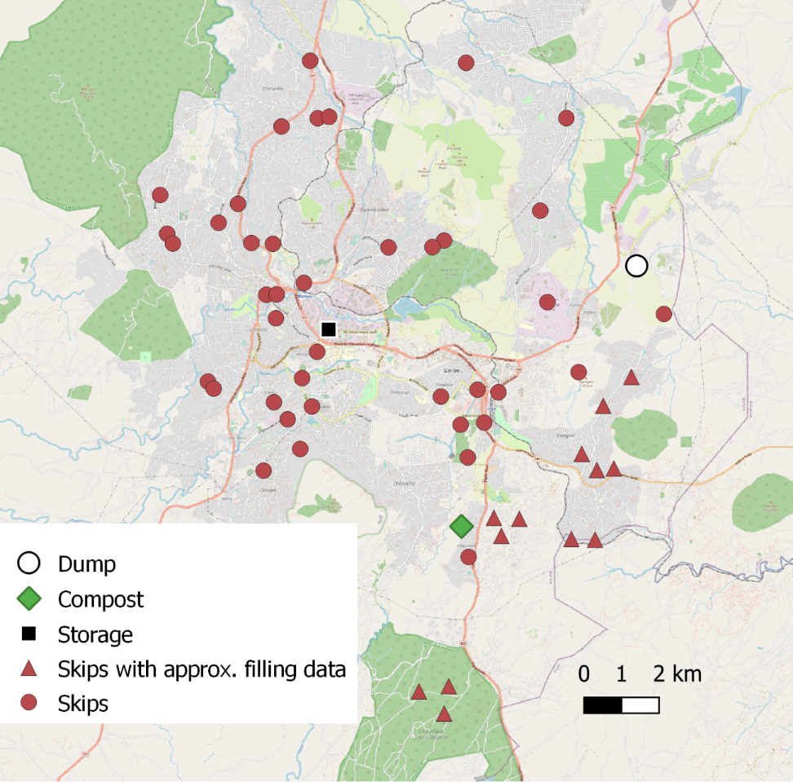

Figure Locations of skips, dump, compost facility and truck storage in Blantyre

### Skips filling data

Filling data for several skips is provided. Which skips from Figure 1 they exactly refer to is ambiguous (as there are several skips in each area and were not always uniquely identified), but the skips within the area which could match are annotated as “Skips with approximate filling data”. The areas are *Bangwe*, *BCA*, *Chigumula* and *Naizi*.

Over a certain period (depending on the skip), a measurement on a scale from 0-5 was taken visually (generally) every day at those skips. A score between 0 and 4 indicate the estimated fullness of the skip (the score represents the number of quarters of space that the trash occupies in the skip, i.e. 1= ¼, etc.), while a 5 means the skip was overflowing. Three of the 14 provided sets are shown inFigure 2**-**4.

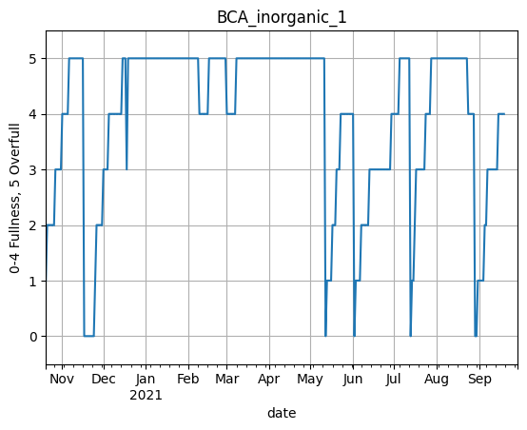

Figure Skip filling data for “BCA inorganic 1”

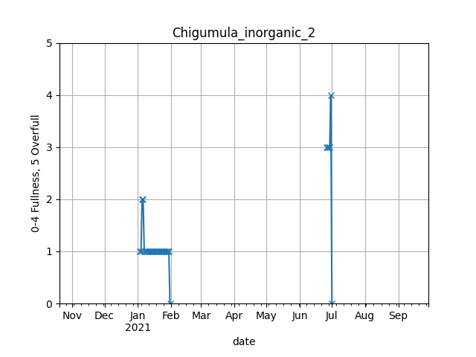

Figure Skip filling data for “Chigumula_inorganic_2”

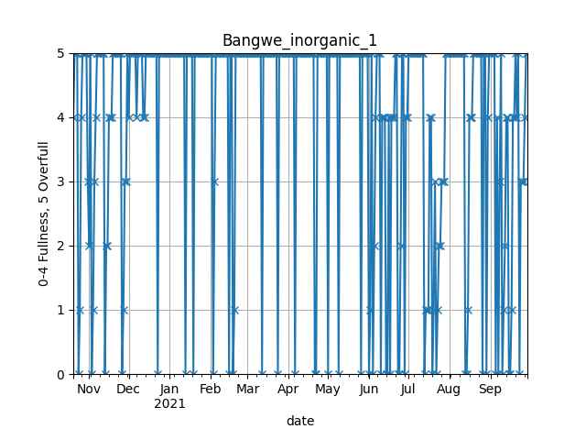

Figure Skip filling data for “Bangwe_inorganic_1”

*“BCA Inorganic 1”* gives a good example of a profile from which rising trends (ramps) are discernible and allow for a filling rate to be calculated easily. This visual method is useful in estimating the frequency at which the skip needs to be serviced. *“Chigumula Inorganic 2”*, however, simply does not have enough data points and must be dismissed. Finally, the data from *“Bangwe inorganic 1”* indicates that it fills up extremely fast, sometimes within a day.

## Methods

### Distances and travel times

A distance matrix is used to estimate the travel distances between any two skips, the dump, and the depot. OpenRoutingService, an optimal routing plugin for QGIS based on OpenStreetMap, is used to generate the optimal route distances between the points of interest. *Local expert opinion and tracking of the trucks* would be useful in getting an accurate overview of travel times. Computer-aided optimal routing is an interesting area of research but cannot match the situational awareness and context of a complex city such as Blantyre (Coffey & Coad, 2010).

### Filling rates

Filling rates are extracted from the skip-level data. The goal is to identify a rising trend over several days, and to compute the filling rate as the slope of this ramp. The filling rate is determined by performing the following steps:

1. Removing spikes

Spikes occur in the dataset frequently. These are points where the level quickly drops or increases before going back to its original level. Those are assumed to be measurement errors. Figure 5 shows the action of the filter for “*Chigumula_inorganic_1*”. The limitation of this method is that quick filling might be dismissed as a spike, effectively putting a lower bound of 0.5 skip/day filling rate.

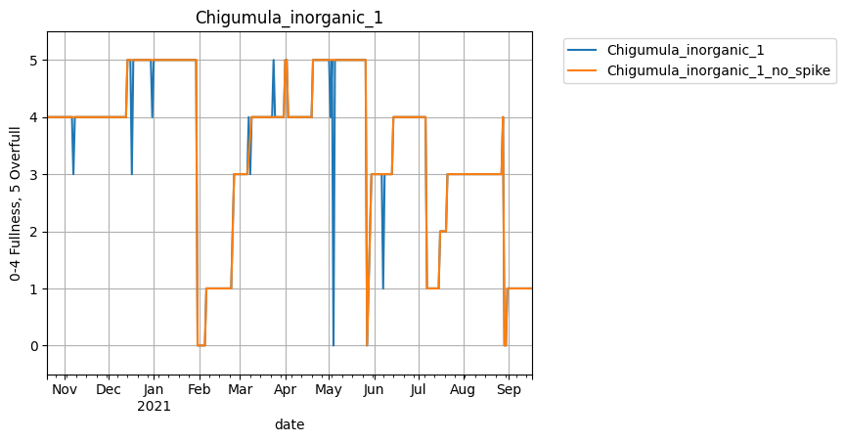

Figure Action of filtering spikes

1. Detecting the top of ramps

The top of the ramp is the end point of a rising ramp fitted to the time series. These may occur at any level. They are determined by a forward and a backward pass through the series. The forward pass identifies top “ends”, when the next value of fullness is smaller than the current one (which characterises the skip being emptied). A top end is also identified when the current value is 4 and the next is a 5 (or overfull). The reasoning behind this is the preference for ramps to finish with a 4. This level is defined as full, which is more precise than the “overfull” denomination. Still, in the absence of an intermediate 4 (e.g. a direct transition between 3 and 5), the top value will be the 5.

A backward pass detects the first date at which the top value appears. This point is considered to represent the time where the skip is emptied, or when it reaches full capacity. Finding this date is particularly important when the skip stays overfull for long periods of time. Using the top ends to calculate the filling rate would bias it to a lower rate.

1. Eliminating downgrading

Downgrading is clear in

Figure 6 (a zoomed in version of Figure 2), on two occasions between February and April. These events might occur for several reasons, such as:

* Trash being burned to eliminate the overflowing waste.
* Waste being cleared by another party.
* An error in data collection or the ambiguity in the measurement scale.

In the backward pass described in 2), the top values at the end of downgrading periods are removed by adding a condition that deletes the current top end if the level rises.

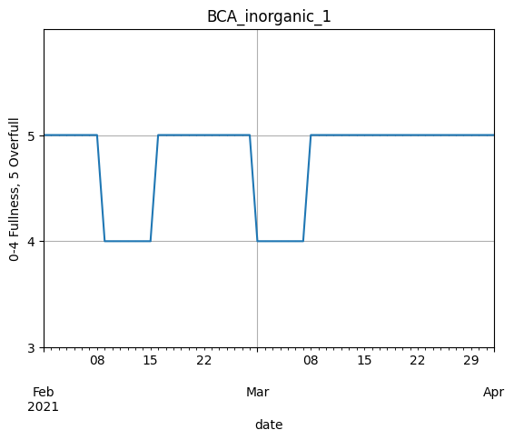

Figure Zoomed in "BCA_inorganic_1" filling data

1. Detecting the bottom of ramps

Finally, the bottom values and dates are extracted iterating backward from each top beginning, until the previous value is larger than the current one, at which point it is assumed the skip has just been emptied.

### Dump arrivals logs

This is a log lists arrivals at the Mzedi dump, along with the origin of the skip carried by each truck. The origins match exactly the geographical locations in Figure 1. The period of this series is 2020-12-05 to 2021-12-31.

## Results

### Filling rates

The result is shown in Figure 7 for BCA inorganic 1 and in Figure 8 for Bangwe inorganic 1. Clearly, the fit in the second case is less ideal. In this case, it is more accurate to not to remove spikes, leading to the ramps shown in Figure 9.

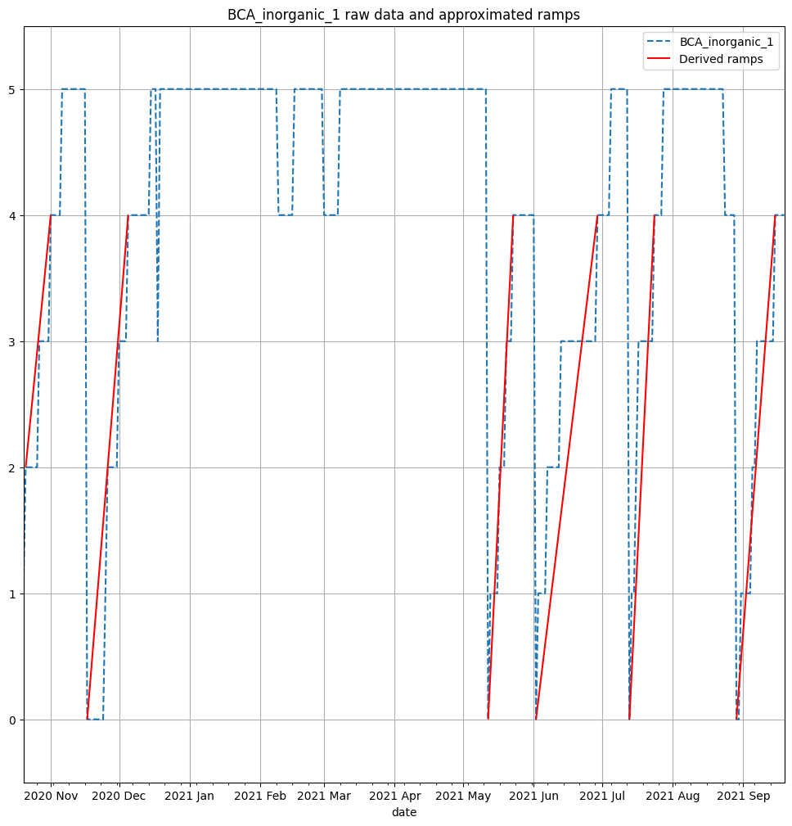

Figure Results of ramps for “BCA inorganic 1”

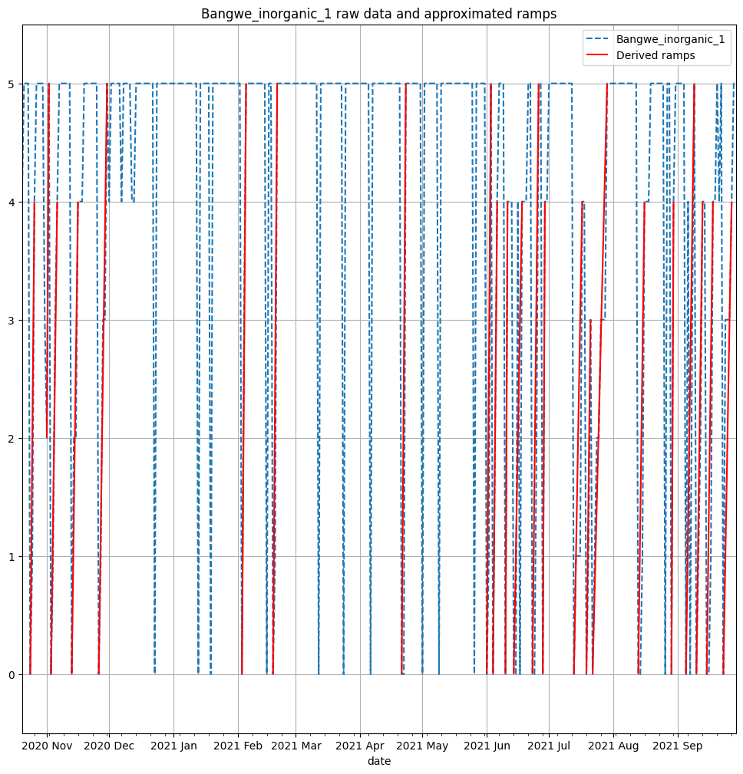

Figure Results of ramps for “Bangwe_inorganic_1” **with** spikes removed

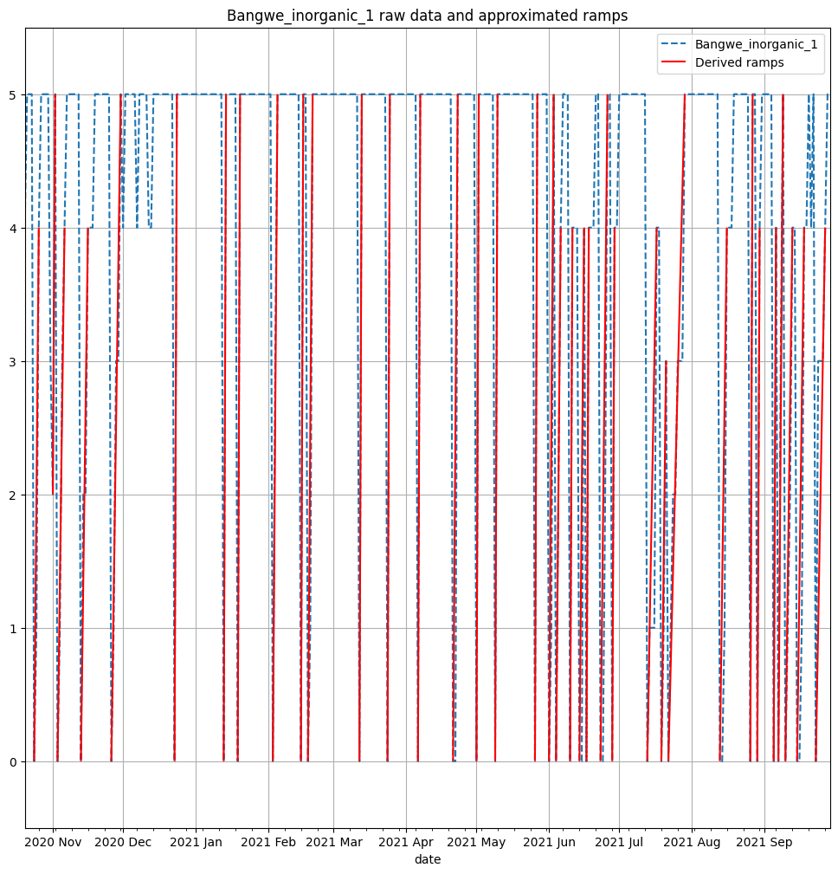

Figure Results of ramps for “Bangwe_inorganic_1” **without** spikes removed

The average slopes of the ramps are calculated for each skip in the dataset for the case where spikes are removed and where they are not. This method produces estimates of the lower and upper average filling rates, which are reported in Table 1. For skips such as “*Bangwe_inorganic_1”*, there is a large difference, as quick filling rates are counted as spikes. “*Chigumula_inorganic_1”* also has a large difference between the lower and upper filling rates. However, in this case and as shown in Figure 9, removing the spikes produces accurate ramps. The process is repeated for each skip based on the visual fit. In Table 1, the filling rates determined to be more accurate are highlighted.

Table Aggregate data from ramps analysis. Highlighted filling rates are selected to be the most accurate based on visual fit of the ramps. # indicates the number of ramps fitted. Prop. overfull is the proportion of days where the level is 5. The period is the period over which levels were measured

|  |  |  |  |  |  |  |
| --- | --- | --- | --- | --- | --- | --- |
| Skip | Avg filling rate min | Avg filling rate max | # min | # max | Prop. overfull | Period (days) |
| Bangwe_Organic_1 | **0.215** | 0.215 | **24** | 26 | 0.258 | 341 |
| Bangwe_Organic_2 | - | - | - | - | - | - |
| Bangwe_inorganic_1 | 0.49 | **0.766** | 23 | **36** | 0.725 | 345 |
| Bangwe_inorganic_2 | 0.4 | **0.541** | 16 | **20** | 0.737 | 265 |
| BCA_Organic_1 | **0.091** | 0.105 | **11** | 13 | 0.386 | 324 |
| BCA_Organic_2 | **0.077** | 0.077 | **2** | 2 | 0 | 54 |
| BCA_inorganic_1 | **0.063** | 0.126 | **6** | 7 | 0.536 | 335 |
| BCA_inorganic_2 | **0.038** | 0.047 | **1** | 2 | 0.627 | 178 |
| Naizi_Organic_1 | **0.046** | 0.046 | **8** | 8 | 0.21 | 324 |
| Naizi_Organic_2 | - | - | - | - | - | - |
| Naizi_inorganic_1 | **0.144** | 0.161 | **15** | 17 | 0.293 | 342 |
| Naizi_inorganic_2 | - | - | - | - | - | - |
| Chigumula_Organic_1 | **0.158** | 0.212 | **21** | 24 | 0.183 | 327 |
| Chigumula_Organic_2 | **0.127** | 0.142 | **13** | 19 | 0.106 | 223 |
| Chigumula_inorganic_1 | **0.056** | 0.308 | **4** | 9 | 0.256 | 333 |
| Chigumula_inorganic_2 | - | - | - | - | - | - |

### Dump logs

The sum of arrivals in each week is shown in Figure 10**.** A sizeable gap is noticeable between January 20th and February 26th . This is reflected in the skips filling data, where many skips were overflowing and not emptied during this period. The reason for this gap is unknown but assumed here to be the service simply not operating. Intra-weekly, the arrivals are relatively homogeneous, except for Sunday, as illustrated in Figure 11. This pattern does not change significantly before and after the service gap.

Of particular interest is the number of days between arrivals at the dump for each skip. The analysis of these gaps is shown in Figure 12. A noticeable characteristic is the variability of the time gaps, as illustrated by the size of the boxes and whiskers. For areas that are serviced often, such as Blantyre Flea Market, Limbe, Ndirande and Chirimba (where the median gap is at most 3), the outliers are frequent, indicating gaps where the skips are likely overflowing.

Importantly, the arrivals at the dump provide useful insights into the current operation of the municipal solid waste management system in Blantyre. It does not, however, allow by itself to infer the filling rate of bins. As seen in Table 1, at least some skips spend a considerable amount of time overfull. As such, the time between collections is dependent on other factors as well.

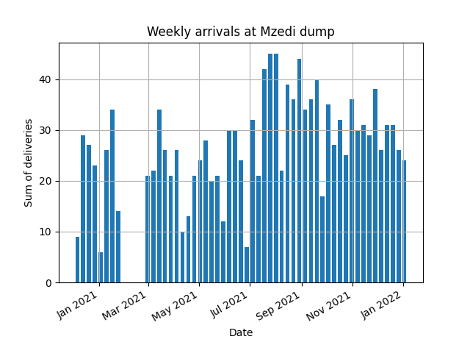

Figure Weekly sum of deliveries (arrivals) at Mzedi dump over the entire period of measurements

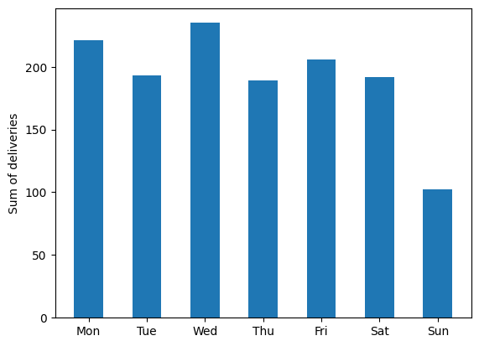

Figure Sum of deliveries to Mzedi dump per weekday over the entire period of measurements

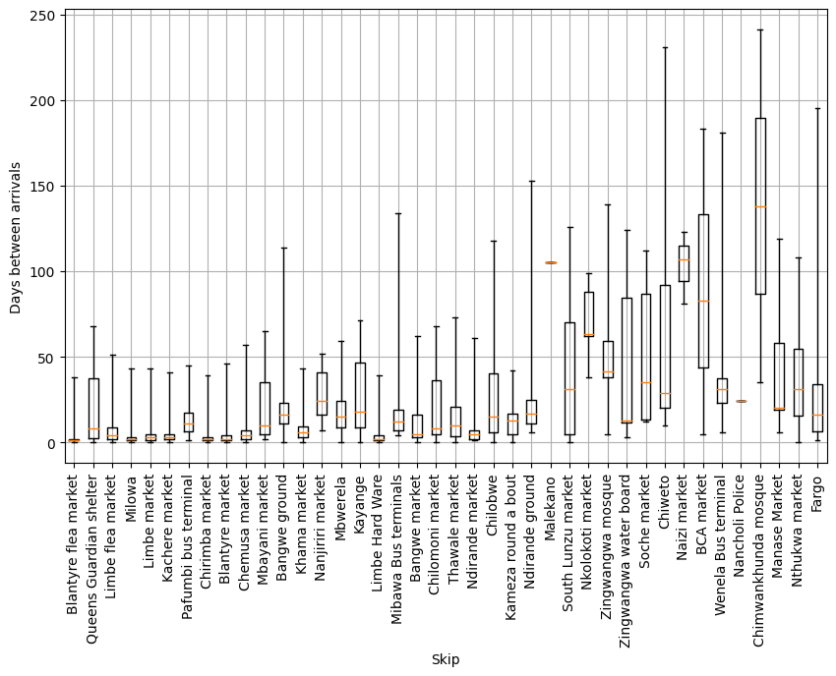

Figure Box plots of number of days between arrivals for each skip. The boxes represent the range between the quartiles Q1 (0.25) and Q3 (0.75). The whiskers extend to the minimum and maximum gaps.

### Extrapolating filling rates

As previously mentioned, the first dataset, though useful in estimating the filling rates, is limited to twelve skips. Those skips are also concentrated in one area of Blantyre, as seen in Figure 1. This makes it difficult to extrapolate to other areas in the city. I therefore attempted to use characteristics from the two datasets to obtain filling rates estimates for each skip. Since the skips in the filling dataset and the areas from the dump logs do not match, they are aggregated as shown in Table 2. Chigumula, though in the original list of skips, does not appear in the dump arrival logs even though the skip filling data indicates the inorganic skip was emptied 4 times in the period. The organic skips are not considered since they were processed at the composting facility.

Table Aggregation of skips and skip areas and number of data points

|  |  |  |  |  |
| --- | --- | --- | --- | --- |
| Aggregate area | Skips from filling data | # ramps | Area from dump logs | # arrivals |
| Bangwe | Bangwe_inorganic_1  Bangwe_inorganic_2 | 23  16 | Bangwe ground  Bangwe market | 14  31 |
| BCA | BCA_inorganic_1  BCA_inorganic_2 | 6  1 | BCA market | 4 |
| Naizi | Naizi_inorganic_1 | 15 | Naizi market | 4 |
| Chigumula | Chigumula_inorganic_1 | 4 | none |  |

Since it is known that not all Bangwe ground and Bangwe market skips are included in the skips filling data, the emptying events (which are the “bottom” dates described in 2.2.1) should all fit within the arrival events described in the Mzedi dump logs. Figure 13 contradicts this notion for Bangwe, however. It shows that many skip emptying events do not match with arrivals at the dump. Furthermore, there are noticeable clusters of emptying events and dump arrivals that do not match one another. In Figure 16, the proportion of emptying events matching arrival events is plotted, with a “padding”. An emptying event is said to match if it is within a period of time defined as the padding. For example, if a ramp event occurs on November 13th, and the padding is set to 2, the emptying event and arrival will match if there is an arrival on November 13th, November 12th or November 11th. The padding is only defined as a number of days before the emptying event, to cover the case where the skip levels are reported late. As padding is increased, more events match, but with a median time between arrivals of just a few days, events get confounded. Furthermore, for Naizi and BCA, the maximum matching for reasonable padding is 14% and 0% respectively.

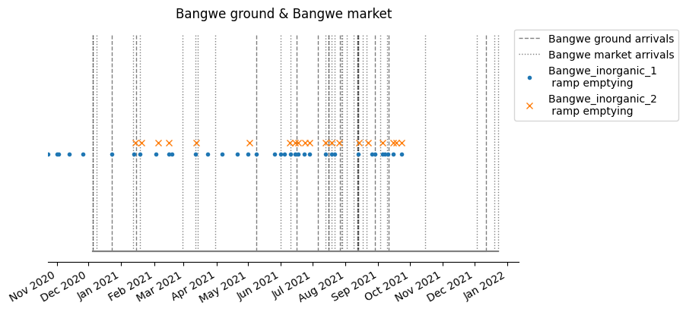

Figure Timeline of Bangwe arrivals at Mzedi dump and emptying events of select skips

`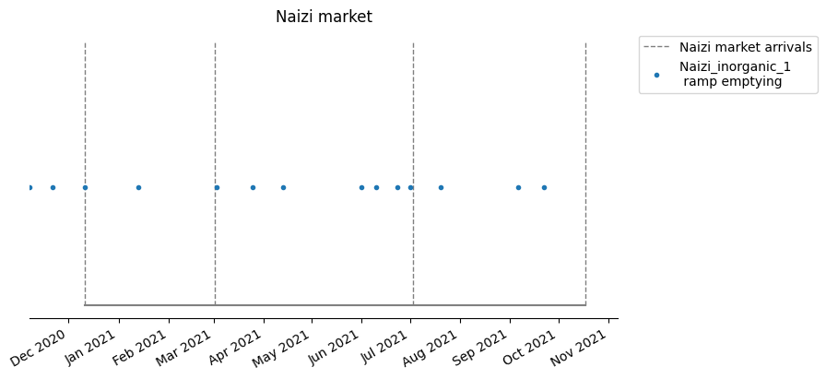

Figure Timeline of Naizi market arrivals at Mzedi dump and emptying events of select skips

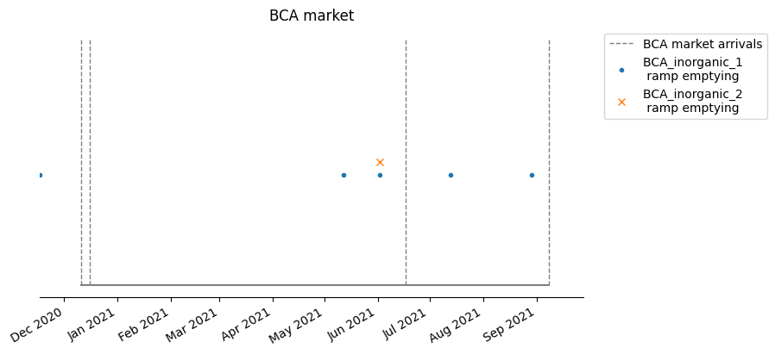

Figure Timeline of BCA market arrivals at Mzedi dump and emptying events of select skips

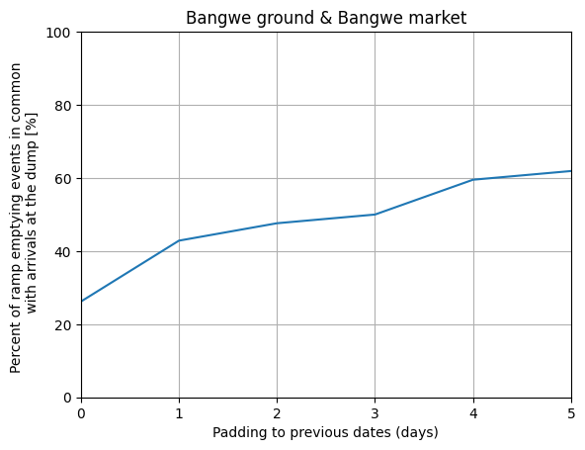

Figure Percentage of skip emptying events matching arrivals at the dump for Bangwe area, with padding to allow for error

Possible reasons for this mismatch are:

* Inaccuracies in the ramps fitting method
* Measurement errors in the skip filling data
* Issues with data logging at Mzedi dump, such as not all arrivals being logged

## Discussion

Several findings are drawn to build the optimization model. The service operates at reduced capacity on Sunday. It is therefore assumed that no skip emptying can be scheduled on Sunday. Additionally, there is high variability in collection periods for both skips that are serviced on a low and high frequency. This variability may point to unreliable service from the municipality and/or to varying filling rates, either in the long or short-term. The filling data is currently insufficient to model these variations in waste production.

The six extracted filling rates for inorganic skips can be used to estimate the filling rates in Bangwe, BCA, Naizi and Chigumula, based on the location in which each monitored skip is placed. For skips not covered in these four areas, the filling rates are estimated using:

|  |  |  |
| --- | --- | --- |
|  |  | () |

Where is the estimated filling rate for the skips in area i. is the first quartile (0.25) of the time gaps between arrivals at Mzedi dump for area i. is the number of skips in area i. For skips that are not covered in the two groups, an estimated filling rate is set as a parameter of the model.

# Optimization model

The goal of the model is to assign a regular schedule to each skip, so that they are reliably emptied before they overflow. Such a schedule would benefit the general population, which will not be exposed to solid waste or smoke from it burning. Additionally, this benefits its users, which will see this service as an added value and may increase general usage which would reduce the use of other more detrimental waste disposal methods.

An optimization is therefore done over a one week time span, also taking into account skips that fill so slowly that they are emptied less than once a week. Each day is split into two *periods*, set to be morning and afternoon, of specified time length. In each period, there can be a number of *shifts*. A *shift* is a truck going out for a collection round for one *period*. Therefore, there can be 0 or more shifts for each period, depending on the number of trucks dispatched during this period.

The collections are structured as roll-on-roll-off with an empty skip at the beginning. This means that each skip is only visited once when it is emptied. The truck arrives with an empty skip at a location, swaps it with the full one, goes to the dump to empty it, then moves on to the next skip location with the freshly emptied skip. Therefore, the order in which skips are visited does not matter, since the truck always travels between a skip and the dump. The exception is the first skip to be visited in a shift, since the truck has to travel between the depot and the skip. At the end of the shift, the truck does the trip from the dump to the depot. When there are multiple trucks operating in the same period, the number of first skips to be visited as well as the number of return trips from the dump to the depot are equal to the number of shifts in this period. An example collection pattern for a single period with two trucks (and therefore two shifts) and five skips to be serviced is shown in Figure 17. The reason for this pattern is twofold. First, if the trucks did not have an additional empty skip at the beginning of the round, it would have to travel to a location, pick up the skip, go to the dump, return to the same location and then travel to another location. This less efficient method would result in a number of trips = 3N+1, where N is the number of skips to be serviced in a shift. In the structure used here, the number of trips is 2N+1. Importantly, this means that there needs to be a number of empty skips available at the depot at the beginning of each period equal to the number of trucks operating in that period. *Alternatively, if in some locations several skips are located together, one of them could be “borrowed” for the day, as long as the others can be guaranteed not to overfill.* In the current analysis however, it is assumed that for each vehicle operating, and additional empty skip must be available.

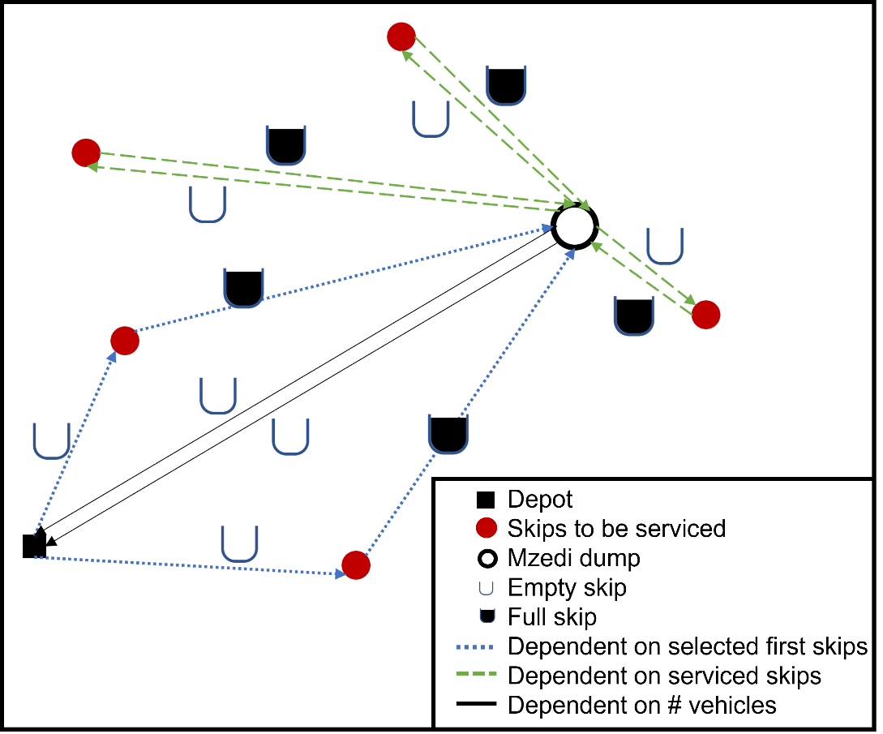

Figure Example collection pattern for a single period. There are two trucks operating, five skips to be serviced. The dashed arrows are only dependent on the serviced skips in this period, and are not assigned to a specific vehicle. The single black arrows represent the vehicles returning from the dump to the depot. There are exactly as many returns to the depot as there are vehicles operating on that period. The dotted routes are dependent on the selected first skips to be serviced in that period.

## Methods

The optimization problem is an integer program with most variables constrained to binary. The problem relies on several parameters which are used at different stages.

The *pre-processing parameters* are not used directly in the problem fed to the solver, but are set to prepare decision variables, to reduce the complexity of the problem, and as variables to test the sensitivity of the model. Importantly, changing some of these parameters changes the structure of the optimization problem, as discussed in 3.1.1.

The *optimization problem parameters* are used directly in the optimization problem. They are directly related to the objective function (costs) and to constraints (maximum number of added skips and maximum travel time).

Finally, the *optimizer parameter* is the bound gap. This gap is the difference between the objective function value (total cost) of the current feasible solution and the objective function value of the problem with relaxed constraints. The problem with relaxed constraints is a lower bound on the objective function value, i.e. the final solution cannot be lower than this bound. For each feasible (but not necessarily optimal) solution the solver outputs in the iterative process, it also generates a lower bound on the objective function. As the solutions get closer to the optimal, the objective function and its lower bound converge. The bound gap parameter defines the percentage difference between the objective and the lower bound where the solver stops and considers the problem solved.

The parameters are shown in Table 3, with the values that are used as default and their units.

Table Problem parameters

|  |  |  |  |
| --- | --- | --- | --- |
| Stage | Parameters | Default value | Unit |
| Pre-processing parameters | Average speed | 30[1] | km/h |
| Days in optimization horizon | 7 | days |
| Periods per day | 2 | periods/day |
| Under-usage threshold (see 3.1.1) | 0.6 | - |
| Possible additional skips for each existing location | 2 | skips/skip |
| Number of weekly collections above which additional skips are considered | 3 | collections/week |
| Default skip filling rate where missing | 0.2 | skip/day |
| Wage structure (1 if constant wage per day, 0 if dependent on number of vehicles out per period) | 1 | - |
| Optimization problem parameters | Labour cost of operating a truck for one period (or daily labour costs if the wage structure is 1) | 5400[2] | MWK |
| Cost of travel | 384[3] | MWK/km |
| Maximum number of additional skip | 0 | skips |
| Maximum number of vehicles | 2[4] | trucks |
| Maximum travel time per period | 4[5] | hours/period |
| Optimizer parameter | Bound gap (trade-off between computation time and proximity to optimal solution) | 1 | % |

### Pre-processing, scenario creation and selection

Several computations are done before the optimization, which reduces the number of constraints and variables, which in turn reduces the computation time.

Because of possible variations of filling rates during the week, the filling rates have a vector length of 14, which is the number of periods. For now, they are set as constant throughout these periods.

Several possible skips schedules are generated. These are referred to as scenarios. For each period of the week, the scenario vector is assigned either a 1 or a 0. A 1 indicates the skip is serviced in that period. *Intra-weekly (once a week up to 6 times a week)* and *extra-weekly (once every two, three and four weeks)* scenarios are generated, with a combination of morning and afternoon collections. *The difference between the smallest and longest gap between collections may not be larger than 1 day (or 2 periods), which constrains the collection scenarios to be regular* (e.g. for a purely illustrative 4 period scenario -weekly scenarios normally have 14 periods-, [1 0 1 0 1] is possible while [1 1 1 0 0] is considered too irregular). No scenario can have a collection on the two periods corresponding to Sunday. The *extra-weekly scenarios* are assigned a cost coefficient, which, in the objective function, is multiplied by the collection costs of the skip it is assigned to in order to give the *average cost of collection over several weeks*.

Next, each skip is assigned its *feasible scenarios*. The filling rate of each skip is combined with each scenario, and if a scenario does not result in overflowing, it is added to the possible scenarios for this particular skip. Additionally, *scenarios which result in the skips being underutilized* (i.e. consistently emptied when it is below the under-usage threshold), are not considered, to reduce the number of possible scenarios and therefore the size of the problem. The parameter controlling this is the “under-usage threshold”. An under-usage threshold of 0.6 means that if the maximum fullness of a skip plus its smallest filling rate is smaller than 0.6, the scenario is not considered. This is a strict condition meant to exclude scenarios only if they are deemed completely useless for a particular skip.

Depending on the waste characteristics, environmental parameters, *a lower bound on the collection frequency may have to be put in place to limit fly breeding, public comfort and decomposition*, which have a detrimental impact on public health (Coffey & Coad, 2010).

There are also scenarios where *additional skips* are added. These are considered for a particular skip if it has more than a certain number of collections in a week or if no other scenarios are feasible. Additional skips simply divide the filling rate of the existing skip and add a skip at the same location to the optimization problem. By default, the maximum number of skips that can be added to a location is 2, due to space concerns.

### Problem formulation

*Variables*

The top-level decision variables are the scenario selected for each skip, the number of vehicles operating on each period and the first skip to be serviced on each round. Consequent variables are the *number of added skips* (which results from the selected scenarios) and the number of crews[6].

*Objective* *function*

The objective function adds all the considered costs. It assumes optimal operation of the system (roll-on-roll-off with an empty skip following optimal routes at a constant speed). The costs are split into operation costs, which in this case is the distance travel cost (fuel costs), and labour costs (based on the number crews). The aggregated costs are minimized.

|  |  |
| --- | --- |
|  | () |

Where is the total costs in period . is a period in the set 𝒫= {1,2,…,14}. is the number of crews being paid in period , is the cost of labour for one crew, or operating vehicle in one period. is the set of all skips . is the set of skips to be serviced first in period . is the set of other skips serviced in period . , the cost of travelling a kilometre and is the distance between point a and b.

*Constraints*

The first constraint is the maximum time length of a period. In a period, this is the sum of the time to go to from the depot to the first skips, to the dump, then do the back and forth between subsequent skips and the dump, and finally ending from the dump to the depot. Notice . This constraint assumes the set of skips to be serviced can be partitioned amongst the vehicles to satisfy individual vehicle time constraints.

|  |  |  |
| --- | --- | --- |
|  |  | () |

Where is the total time needed to complete the servicing of all the skips in and . is the maximum time in a time period for a single truck. is the number of trucks operating in . is the time spent between point a and b. In the current version of the problem, it is based on a constant speed assumption based on the travel distances between points.

There is an upper limit on the number of vehicles, such that:

|  |  |  |
| --- | --- | --- |
|  |  | () |

Where is the parameter indicating the number of available vehicles in the system.

In the case of a constant wage, where staff are on a constant payroll:

|  |  |  |
| --- | --- | --- |
|  |  | () |

Where is the number of crews available in the system.

And when labour costs are dependent on active vehicles, meaning crews are paid depending on the number of periods they operate:

|  |  |
| --- | --- |
|  | () |

Finally, there is a constraint on the number of additional skips, such that:

|  |  |
| --- | --- |
|  | () |

Where is the number of additional skips, which is dependent on the selected scenarios.

### Solver

The problem is described in MATLAB and solved with the commercial solver Gurobi through the YALMIP interface. This is done to leverage both MATLAB’s matrix computation capabilities, useful in problems with as many decision variables as this one, and Gurobi’s versatility and speed with MILP problems.

## Results

With the default parameters given in Table 3, the model is infeasible. With 2 trucks and without adding any skips*, there is no combination of schedules that satisfy the constraints*. In fact, any number of additional skips is infeasible with 2 vehicles, including with the option to add 2 skips at each location. This is due to the period time constraint.

Additionally, setting the maximum number of vehicles to 3 with no additional skip is also impossible. This is simply because skips for which filling rates are higher than 2/3 skip/day require an extra skip so that they do not overflow over the Saturday-Monday gap. Therefore, *there needs to be at least 3 additional skips to account for the three that fill at a rate of 1 skip/day.* In this case, however, the model finds that at least 4 trucks are required, because of the time per period constraint. When 5 additional skips are allowed (or 4 when two can be added to a single skip location), only 3 trucks are needed. *Alternatively, there could be exceptional collections on Sunday just for skips that absolutely need it*, which would provide additional time and allow more flexibility in the selection of scenarios for the quickly filling skips. This scenario may result in higher labour costs, and depends on local organization and labour laws. In the current state of the system, 4 trucks are not considered beneficial. The cost of a new truck is estimated at MWK20 Mio. with a yearly maintenance cost of 8% = MWK1.6 Mio. (based on (Coffey & Coad, 2010)), and the cost of a new skip is estimated at MWK3 Mio. No savings in operational costs is found for the same number of skips and a higher number of trucks, and the case with 4 trucks and 3 additional skips is considerably more expensive than all the feasible cases with 3 trucks. *The number of trucks does not decrease operational efficiency, but determines the feasibility based on the time constraints.*

The maximum number of added skips to the system to be analysed is 15, considered to be well above the current budget of the service. Because of the operation described in Figure 17, each vehicle starts the period with an empty skip. Therefore, in the following analysis, a maximum of 12 skips can be added at existing skip locations.

As previously mentioned, when only 1 skip is allowed to be added to each location and assuming 3 trucks are operating, it takes 5 total additional skips for the problem to be feasible. When 2 additional skips are allowed at each location, it takes 4 additional skips. Figure 18 shows the total costs dependent on the maximum total additional skips for both 1 and 2 maximum additional skips at each location. The difference in cost is negligible when few skips are added, and increases to only MWK21000 per week (1.6% of total weekly costs) as more additional skips are made available. When a maximum of 1 skip can be added to each location, adding more than 10 skips does not result in marginal operational cost savings. The first additional skip saves MWK13600 per week (1% of costs). This additional skip, assuming a cost of MWK3 Mio., would be of net value after 221 weeks, or 4 years and 3 months.

Adding skips can decrease the total weekly costs through two mechanisms. First, splitting the filling rate in 2 halves (with 1 additional skip) or 3 thirds (with 2 additional skips) may result *in assigning a more efficient schedule, with less total servicing over the week*. For example, a skip filling at 0.5 skip/day will need minimum 5 collections per week, according to the feasible scenarios. Two skips filling at 0.25 skip/day only need 2 collections per week each, resulting in 4 every week. The second reason for cost saving is the *increase in flexibility, which allows for less shifts in a week*. In the model, there is an incentive to minimize the number of shifts because of the fuel costs of travelling between the dump and the depot at the end of each period. The two effects can be seen in Figure 19. The average costs per shift decrease until the schedule can be reshuffled and there is one less shift. Therefore, *additional skips are not always added where the filling rates are the highest, but where it is most strategic to eliminate overflowing, minimize spending by maximizing skip utilization, and decreasing the number of periods in which the service operates*.

With 3 vehicles and the option to add one skip to each location, the least capital extensive feasible option is 5 total additional skips. The resulting schedule and expenses are shown in Figure 20-Figure 22. The total costs for a week is MWK1.391mio.

Figure Costs for additional skips with a maximum of 1 and 2 additional skips at each existing skip location

Figure Weekly average cost per shift dependent on the total number of added skips



Figure Schedule for the existing and added skips. The skips above the horizontal line are added to the system. Special points (the *, x and +) represent extra-weekly collections. The week periodicity gives the number of weeks between each collection for a specific skip.

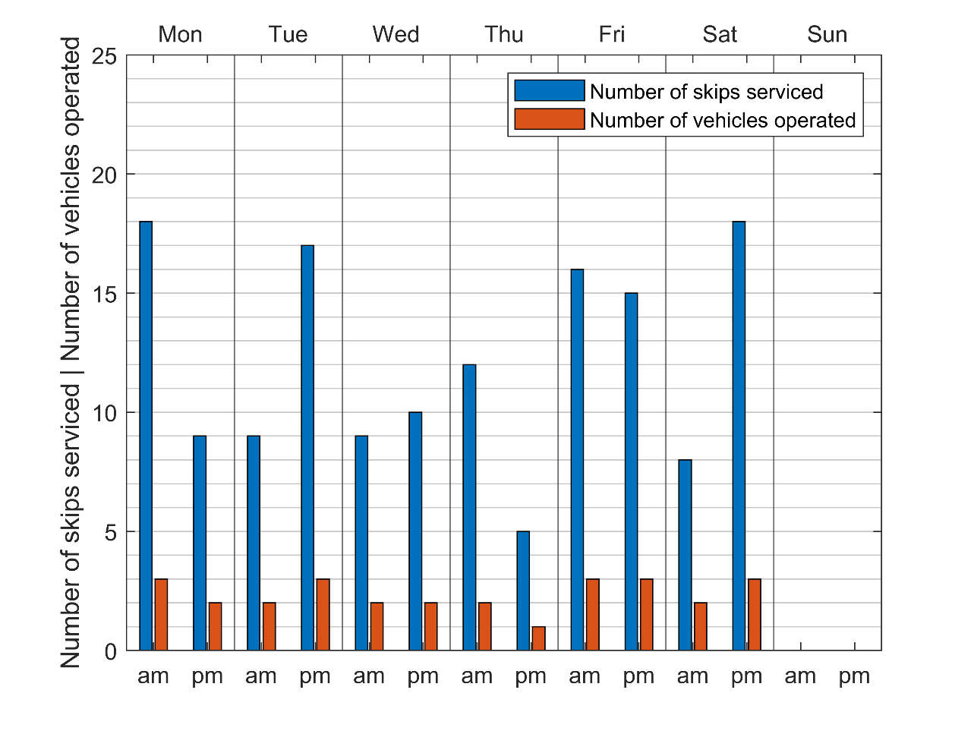

Figure Number of skips serviced and number of vehicles operated on each day.

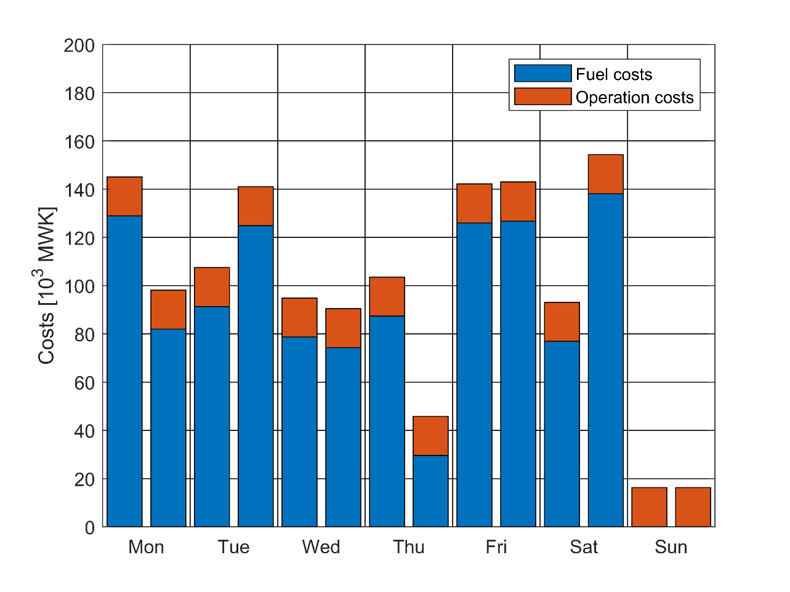

Figure Costs for each day. Note the constant labour costs.

### Current estimated operation

The dump logs are used to estimate the current costs of service. For each arrival event, the distance travelled between the corresponding skip and the dump (based on the distances from 2.2.1) is computed and the cost is based on the distance cost set in Table 3. When the name of a skip in the dump logs matches several in the list of skips, the average distance of the skips matching this name is used. Additionally, when the name is missing, the average of all other dump arrival event distances is used. This assumption biases the distance closer to the skips that are emptied more often. One crew is assumed to be employed for each of the 2 trucks operating. Finally, for each day, in which at least one skip arrives at the dump, the cost of travelling from the depot to the dump and from the dump to the depot multiplied by 2 (the number of vehicles) is added. Following this estimation, the average weekly cost of the service is MWK0.422514 Mio. including MWK0.0756 Mio. in labour costs. This average excludes the 4 weeks where the service is not operating at all. This operation also results in an average of 53% of days where the 6 inorganic skips in Table 1 are overflowing. This cost estimation is 70% lower than the MWK1.391Mio corresponding to the case with 3 vehicles, 5 additional skips and a maximum of 1 additional skip at each existing location.

### Estimated potential of organic waste separation

To evaluate the potential of separating organic waste for composting, some modifications are made to the problem in order to approximate the cost difference. No two skips in the dataset are at a distance of less than 240 meters. This excludes partitioning the current skips into organic and non-organic skips, since this would lead to a deterioration in the service to current users of the skips. The users would either not travel the further distance to throw the specific waste into the correct skip, according to Coffee and Coad (2010). Alternatively, people would throw inappropriate waste into the organic or inorganic skips.

Waste separation is therefore only possible with the considerable expansion of the system. A useful case is one in which one skip has been added to each current skip location. In this case, the waste collection has doubled, and though organic waste represents 60-80% of total waste, its higher density and imperfect sorting let us assume that the filling rates of the added skips is identical to the skips they complement. Finally, because the period time utilization is above 95% in all the studied cases (i.e. shifts are close to 4 hours and therefore quite time efficient), it is assumed that the organic and inorganic optimal collection schedules can be considered separately. The inorganic waste schedule corresponds to the case with 3 vehicles, 5 additional skips and a maximum of 1 additional skip at each existing location, at a cost of MWK1.391Mio/week.

The organic waste schedule is optimized with the distances and travel times to and from the dump replaced with the *distances related to composting facility*. In this case, 3 vehicles are needed to make the problem feasible, in addition to 4 additional skips. The weekly cost is MWK1.298Mio.

The sorted weekly costs is therefore the sum of the inorganic and organic costs = MWK2.689Mio.

The case where there is no sorting is simply the inorganic waste schedule doubled, resulting in weekly costs of MWK2.782Mio.

Sorting therefore results in a 3.84% decrease in costs, and 1 less skip needed to operate. It must be underlined that this assessment is constructed on several layers of assumptions, and that more accurate measures of distances, costs of travel, time of travel, organisational structure would be needed to plan accurately.

# Discussion

## Capital expenditure

From the preliminary analysis and optimization, it is clear that the solid waste management service needs additional capital to operated correctly. Additional costs would include at least 1 additional truck, and 7 skips (3 to be used by the 3 trucks and to be parked at the depot and 4 to be added at the current skip locations). While the skips may have a marginal impact on operation costs, the trucks only have an impact on the feasibility of operating the system without overflowing. Some changes in operation may decrease the need for additional skips, but their viability has yet to be explored. This includes “borrowing” some skips from locations with several skips to be used during collection rounds, and servicing some skips on Sunday. Introducing organic waste separation may lower the need for capital with the expansion of the system, but not in its immediate state.

## Operation

Current operation based on the arrivals at Mzedi dump indicate a similar number of deliveries on each day, except Sunday. The optimized operation, however, shows that in order to prevent overflowing, there needs to be more skip servicing on Monday and Saturday, to empty the skips that fill quickly over Sunday. The operation costs with no overflowing are shown to be considerably higher than the cost of current operation. Not to be underestimated is the fuel shortage, which adds an additional constraint on distance travelled every week.

# Outlook

## Implementation

Implementing a schedule optimization tool would demand a more in-depth analysis of stakeholders, costs, operation parameters, and other constraints (e.g. fuel due to shortage). This would allow one to set an optimized strategy to improve the level of service in the long-term, including the benefits of purchasing certain equipment.

Considering that the current equipment capital and operation costs would not allow for the skips to be serviced without some overflow, some trade-off has to be made in the short term to minimize this overflow. In the longer term, implementation will require a set information flow and intuitive decision making tools. These tools would ideally take the form of more or less systematic decision rules that can be implemented in spreadsheet.

Planning a sufficient and efficient service would require information about the system. This could be provided by a data collection campaign. Operating this service it will require a set information flow and monitoring strategy to adapt around uncertainties.

### Data collection

Useful data includes more complete skip-level time data. It would use a more robust scale, based on more objective measurements. Measurements would also be taken at least twice a day, to observe progressions of waste levels, and a more representative set of skips would be selected. It would also be useful to categorize skips, based on location context (i.e. market, road-side, hospital, etc.), type of waste, difficulty of access.

This more complete skip-level data could be used alongside the dump arrival data to estimate overfilling, underfilling and costs.

Adding GPS trackers to trucks would be useful in estimating current operation, as well as in informing the optimization model on travel times, actual distances, time delays at the dump and at each skip, etc. This methodology would be especially feasible with a small number of trucks.

Qualitative and quantitative surveys could be used to get the impressions of customers and workers on the operation of the service and ideas on how it could run better.

### Information flow/monitoring

Monitoring helps reduce the uncertainty in the operation of the service. It needs to be set within an information flow framework, which includes regular monitoring, reporting of full skips, records keeping and specific actions to be decided based on the information.

# Conclusion

This works presents a proposed optimization formulation for the scheduling of skip servicing in Blantyre, Malawi. This problem included elements of planning, such as adding certain equipment. Costs are estimated for several operational scenarios. Adding equipment results in some cost savings. However, in large parts, decisions should be made around the feasibility to operate the service without overflowing of the skips. Several possible strategies are proposed to reduce the amount of equipment to be added.

# References

Baptista, S., Oliveira, R. C., & Zúquete, E. (2002). A period vehicle routing case study. *European Journal of Operational Research*, *139*(2), 220–229. https://doi.org/10.1016/S0377-2217(01)00363-0

CEPA. (2019). *National Waste Management Strategy*. Malawi Government.

Coene, S., Arnout, A., & Spieksma, F. C. R. (2010). On a periodic vehicle routing problem. *Journal of the Operational Research Society*, *61*(12), 1719–1728. https://doi.org/10.1057/jors.2009.154

Coffey, M., & Coad, A. (2010). *Collection of municipal solid waste in developing countries*. UN-HABITAT.

Diaz, L., Savage, G., & Eggerth, L. (2005). *Solid Waste Management*. UNEP.

Kalina, M., & Tilley, E. (2020). ‘Bad’ Trash: Problematising Waste In Blantyre, Malawi. *Detritus*, *12*, 187–200. https://doi.org/10.31025/2611-4135/2020.13994

Kasinja, C., & Tilley, E. (2018). Formalization of Informal Waste Pickers’ Cooperatives in Blantyre, Malawi: A Feasibility Assessment. *Sustainability*, *10*(4), 1149. https://doi.org/10.3390/su10041149

Malawi 24. (2022, April 28). *Govt increases civil servants’ salaries*. Malawi 24. https://malawi24.com/2022/04/28/govt-increases-civil-servants-salaries/

MERA. (2022, September 14). Review Of Prices Of Petrol, Diesel, And Paraffin For The Month Of September 2022. *Malawi Energy Regulatory Authority*. https://mera.mw/2022/09/14/review-of-prices-of-petrol-diesel-and-paraffin-for-the-month-of-september-2022/

Mpanang’ombe, W., Mallory, A., & Tilley, E. (2021). Poverty, politics and plastic: Organic waste sorting in Blantyre’s public markets. *Journal of Urban Management*, *10*(3), 192–204. https://doi.org/10.1016/j.jum.2021.05.001

Ndau, H., & Tilley, E. (2018). Willingness to Pay for Improved Household Solid Waste Collection in Blantyre, Malawi. *Economies*, *6*(4), Article 4. https://doi.org/10.3390/economies6040054

Okot-Okumu, J. (2012). Solid Waste Management in African Cities – East Africa. In *Waste Management—An Integrated Vision*. IntechOpen. https://doi.org/10.5772/50241

Raucq, J., Sörensen, K., & Cattrysse, D. (2019). Solving a real-life roll-on–roll-off waste collection problem with column generation. *Journal on Vehicle Routing Algorithms*, *2*(1–4), 41–54. https://doi.org/10.1007/s41604-019-00013-6

Schübeler, P. (1996). Conceptual Framework for Municipal Solid Waste Management in Low-Income Countries. *Urban Management And Infrastructure*, 59.

UN-Habitat. (2020). *Urbanization in Malawi: Building inclusive & sustainable cities*. https://unhabitat.org/malawi

USAID, & Nathan Associates Inc. (2018). *Malawi Wage Bill Analysis, Leadership in Public Financial Management II* (p. 47). USAID.

Yesaya, M., Schöbitz, L., & Tilley, E. (2022). *Locations of 53 public waste skips in Malawi, Blantyre.* (0.0.1). Zenodo. https://doi.org/10.5281/ZENODO.6470364

Zeleza-Manda, M. A. (2009). *Water and sanitation in urban Malawi: Can the millennium development goals be met? : a study of informal settlements in three cities*. International Institute for Environment and Development.

1. Intentionally a low estimate to account for standing time at the skips and the dump.
2. Based on a 2-person crew (Coffey & Coad, 2010), the average public servant salaries for grades N to R based on (USAID & Nathan Associates Inc., 2018) and adjusted to recent increases (Malawi 24, 2022). This results in MWK1.965Mio./year.
3. Based on MWK1,920.00/L for diesel (MERA, 2022) and an estimated 20L/100km fuel consumption.
4. Current number of trucks operated by the BCC in Blantyre, Malawi.
5. Assuming an 8 hour work day split into two periods of 4 hours each.
6. When the wage structure is fixed salaries for all employed collection workers, the number of crews is a decision variable constant every day but constrained to be the maximum number of crews dispatched at the same time over the horizon. This is equivalent to a number of workers on constant payroll. If the workers are paid per collection period, the number of crews are individual to the period and corresponds to the number of vehicles out on that specific period.