Design and Development of a Low-Cost Hydrogen Sulfide Sensor System for Biogas Monitoring
Flurin Vital

Background
The global demand for renewable energy has grown substantially in recent decades, driven by the need to reduce dependence on fossil fuels and mitigate climate change. Biogas, produced through the anaerobic digestion of organic waste materials such as agricultural residues, municipal solid waste, and sewage sludge, has emerged as one of the most promising and versatile renewable energy carriers. It can be used directly for cooking and heating, converted to electricity, or upgraded to biomethane for injection into gas grids or use as vehicle fuel. The technology is applicable across a wide range of scales, from household digesters to large industrial plants, and has seen rapid growth in installed capacity across Europe, Asia, and increasingly Africa and Latin America (Navarro, 2025; Weiland, 2010).

While biogas technology is well established in Europe, its potential in the Global South is particularly significant. In Sub-Saharan Africa, South Asia, and Latin America, millions of households and smallholder farms generate large quantities of organic waste with limited access to modern energy services. Biogas represents a uniquely appropriate technology for these contexts because it simultaneously addresses energy poverty, waste management, and agricultural productivity through the nutrient-rich digestate it produces. However, persistent barriers to widespread adoption remain, including lack of technical capacity, limited access to spare parts, and the absence of affordable monitoring and quality control tools (Surendra et al., 2014). Projects in the Global South frequently underperform or fail not due to a lack of demand but due to inadequate operational support and monitoring infrastructure (Somorin et al., 2025). Africa's biogas sector has repeatedly attracted investment and optimism without delivering sustained impact at scale, partly because the operational realities of maintaining digesters in low-resource settings are systematically underestimated (Kalina et al., 2022). Long-term plant performance is rarely monitored, and gas quality in particular receives almost no systematic attention at the field level (Clemens et al., 2018).

A critical but frequently overlooked aspect of biogas quality is the presence of hydrogen sulfide (H₂S). H₂S is produced during anaerobic digestion whenever sulfur-containing organic compounds are broken down by sulfate-reducing bacteria. Its concentration in raw biogas varies considerably depending on feedstock composition, with typical ranges from below 100 ppm in some agricultural systems to several thousand ppm in biogas derived from sewage sludge or high-sulfur industrial waste (Ryckebosch et al., 2011). This variability makes continuous monitoring important, as concentrations can shift significantly with changes in feedstock or digester operation. Even at relatively low concentrations, H₂S is highly corrosive to metal components including engines, compressors, and piping, leading to accelerated wear and costly maintenance. At higher concentrations it also poses a serious acute health risk, with effects on the central nervous system and respiratory function documented at concentrations well below the levels commonly found in raw biogas (Lim et al., 2016). The WHO classifies H₂S as acutely toxic, with concentrations above 100 ppm posing an immediate danger to health (Chou & International Programme on Chemical Safety, 2003).

Despite the well-documented risks of H₂S in biogas systems, affordable and field-suitable monitoring solutions remain scarce. Commercially available portable H₂S meters are predominantly designed for occupational safety applications, where the relevant range is below 100 ppm, making them inadequate for biogas environments where concentrations routinely exceed this threshold. Laboratory-grade analyzers capable of covering higher concentration ranges are expensive, require calibration infrastructure, and are not suited to continuous deployment in remote or low-resource field settings. Electrochemical sensors represent the most promising platform for low-cost, portable H₂S detection, offering low power consumption, a compact form factor, and sufficient sensitivity for environmental and industrial monitoring applications (Pandey et al., 2012). The convergence of affordable electrochemical sensor technology, low-cost PCB fabrication services, and accessible microcontroller platforms creates a realistic opportunity to address the lack of affordable, field-deployable H₂S monitoring tools for biogas applications.

Problem statement and goals
Hydrogen sulfide is a toxic and corrosive gas present in raw biogas at concentrations that frequently exceed 100 ppm, which is the upper limit of most commercially available portable meters. This monitoring gap poses both a safety risk to operators and an operational challenge for biogas plant management, particularly in low-resource settings where laboratory-grade equipment is not accessible. The goal of this project is to design and build a low-cost H₂S sensor system capable of detecting concentrations up to 1500 ppm. The system will consist of a digital electrochemical sensor, a miniature gas pump with a 3D-printed flow chamber, and a custom PCB with a display and data logging capability, assembled into a single compact device. Success is defined by the system functioning as an integrated unit, delivering adequate gas flow to the sensor, maintaining a stable output in clean air, and being realized at a component cost significantly below that of commercially available instruments.

Research Questions
- How can the sensor, microcontroller, display, and data logging components be integrated into a single compact and functional monitoring device?

- What pump and flow chamber design is sufficient to deliver a gas sample to the sensor within a practically acceptable response time?

- What baseline stability and noise levels does the signal conditioning circuit achieve in clean air, and are they sufficient for H₂S detection?

- How does the component cost of the complete system compare to commercially available H₂S meters, and what cost reductions are achievable through design optimization or alternative component selection?

Methods
- A digital H₂S sensor will be selected based on datasheet specifications and availability, with the primary requirement being a direct digital concentration output covering the target measurement range. The sensor will be integrated with a microcontroller, a small display, and an SD card module on a custom PCB designed in KiCad. The PCB will be fabricated through JLCPCB and assembled into a single compact device, with the goal of producing a functional, self-contained monitoring unit.

- A 3D-printed gas flow chamber will be designed in CAD to route sampled gas past the sensor element using a small off-the-shelf pump. The chamber geometry and pump flow rate will be selected based on the sensor manufacturer's recommended operating conditions. The adequacy of the design will be verified by measuring the actual flow rate delivered by the pump and comparing it against the datasheet specifications.

- The assembled device will be powered continuously and the sensor output recorded in clean air over a period of time. Any noise and systematic drift in the digital output will be assessed over this period to establish whether the sensor provides a sufficiently stable baseline in the absence of H₂S.

- A complete bill of materials will be documented throughout the development process, covering all electronic components, PCB fabrication costs, and 3D printing materials. The total system cost will be compared against the retail price of commercially available H₂S meters with equivalent or lower measurement ranges, and the main cost drivers will be identified.

Planning

Gantt chart
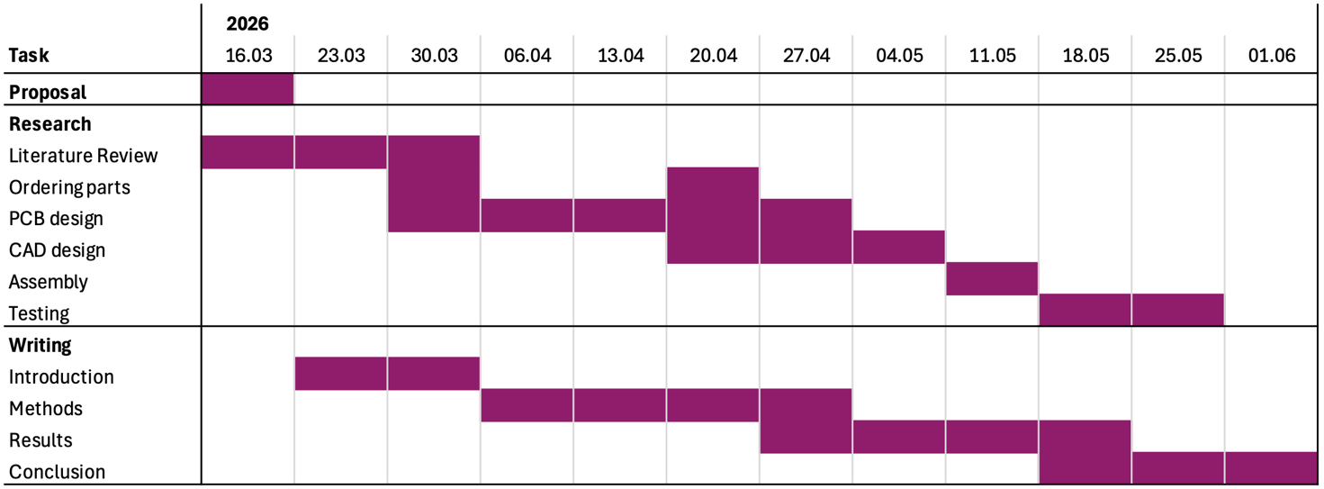
Figure 1. Gantt chart
The most important phases are the PCB design and the mechanical CAD design of the gas flow housing. These phases are the most critical as all subsequent testing and validation depends on functional hardware being available. The main potential bottleneck is component and PCB delivery time, as fabrication and shipping from services such as JLCPCB can take one to two weeks and any design errors requiring a second revision will cause significant delays. To mitigate this, to be purchased parts should be ordered as early as possible and PCB and housing designs should be finalized and orders placed no later than the midpoint of the project.

Data Management Plan (DMP)

Data collection

dataset | data type | data format | data documentation
PCB design | CAD data | KiCAD → Gerber (.gbr), Drill (.drl) | Version-controlled on GitHub
CAD design | 3D geometry | OnShape → STL file | Version-controlled on GitHub
Sensor measurements | Time-series data | CSV | Includes timestamp, concentration, raw signal
Change log | Text/ logs | Markdown/ text | GitHub commits and notes
(Secondary data) | Sensor datasheet

Data storage

All design files (KiCad, CAD) and experimental data will be stored in a version-controlled GitHub repository. Measurement data will be recorded in CSV format and analyzed using Python (NumPy, Pandas, Matplotlib). Backup copies will be maintained locally and on cloud storage.

Budget

No | expense | amount | unit price [CHF] | total price [CHF] | link
1 | Hydrogen Sulfide Sensor | 1 | 189.- | 189.- | PSD4  PS4
2 | Microcontroller (Arduino) | 1 | 30.- | 30.- | nano
3 | PCB | 1-2 | 30.- | 60.-
4 | Display | 1 | 15.- | 15.-
5 | SD card | 1
6 | Electro motor/ pump | 1 | ? | ? | pump
7 | Electronic Components | -
8 | 3D printing materials | -
 | Total |  |  | 294.-

References
Chou, C.-H. S. J. & International Programme on Chemical Safety (Hrsg.). (2003). Hydrogen sulfide: Human health aspects. World Health Organization.
Clemens, H., Bailis, R., Nyambane, A., & Ndung’u, V. (2018). Africa Biogas Partnership Program: A review of clean cooking implementation through market development in East Africa. Energy for Sustainable Development, Scaling Up Clean Fuel Cooking Programs, 46, 23–31. https://doi.org/10.1016/j.esd.2018.05.012
Kalina, M., Ogwang, J. Ò., & Tilley, E. (2022). From potential to practice: Rethinking Africa’s biogas revolution. Humanities and Social Sciences Communications, 9(1), 374. https://doi.org/10.1057/s41599-022-01396-x
Lim, E., Mbowe, O., Lee, A. S. W., & Davis, J. (2016). Effect of environmental exposure to hydrogen sulfide on central nervous system and respiratory function: A systematic review of human studies. International Journal of Occupational and Environmental Health, 22(1), 80–90. https://doi.org/10.1080/10773525.2016.1145881
Navarro, K. (2025, Oktober 16). World Biogas Association (WBA) | IEA Report Highlights Rapid Growth in the Global Biogas Industry. World Biogas Association (WBA). https://www.worldbiogasassociation.org/iea-report-highlights-rapid-growth-in-the-global-biogas-industry/
Pandey, S. K., Kim, K.-H., & Tang, K.-T. (2012). A review of sensor-based methods for monitoring hydrogen sulfide. TrAC Trends in Analytical Chemistry, 32, 87–99. https://doi.org/10.1016/j.trac.2011.08.008
Ryckebosch, E., Drouillon, M., & Vervaeren, H. (2011). Techniques for transformation of biogas to biomethane. Biomass and Bioenergy, 35(5), 1633–1645. https://doi.org/10.1016/j.biombioe.2011.02.033
Somorin, T., Bodach, S., & Tripathi, M. (2025). From waste to value: Key insights and lessons learned from biogas initiatives in the Global South. International Water Management Institute (IWMI). https://doi.org/10.5337/2025.202
Surendra, K. C., Takara, D., Hashimoto, A. G., & Khanal, S. K. (2014). Biogas as a sustainable energy source for developing countries: Opportunities and challenges. Renewable and Sustainable Energy Reviews, 31, 846–859. https://doi.org/10.1016/j.rser.2013.12.015
Weiland, P. (2010). Biogas production: Current state and perspectives. Applied Microbiology and Biotechnology, 85(4), 849–860. https://doi.org/10.1007/s00253-009-2246-7

