Power Supply Design
The power supply architecture of the "Dripito" IV flow rate monitor has been deliberately designed to be simple, robust, and appropriate for low-resource, humanitarian settings. This section details the power path from battery to regulated system voltage and highlights the rationale for each component and configuration.

Battery Selection and Holder Design
Dripito is powered by a single AA alkaline battery. This choice is driven by availability (ubiquity in nearly every healthcare setting), low cost, and its typical capacity of ~2000 mAh. The battery holder used is the BK-92 model, a low-cost through-hole component that provides reliable retention force and mechanical robustness.

Figure 1:BK-92 Battery Holder
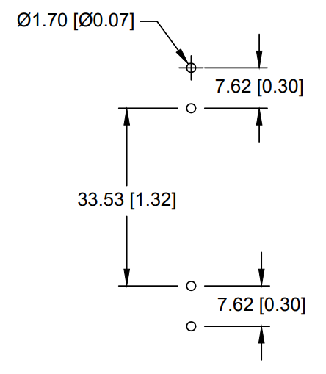
Figure 2:BK-92 PCB Mounting Holes (Datasheet)
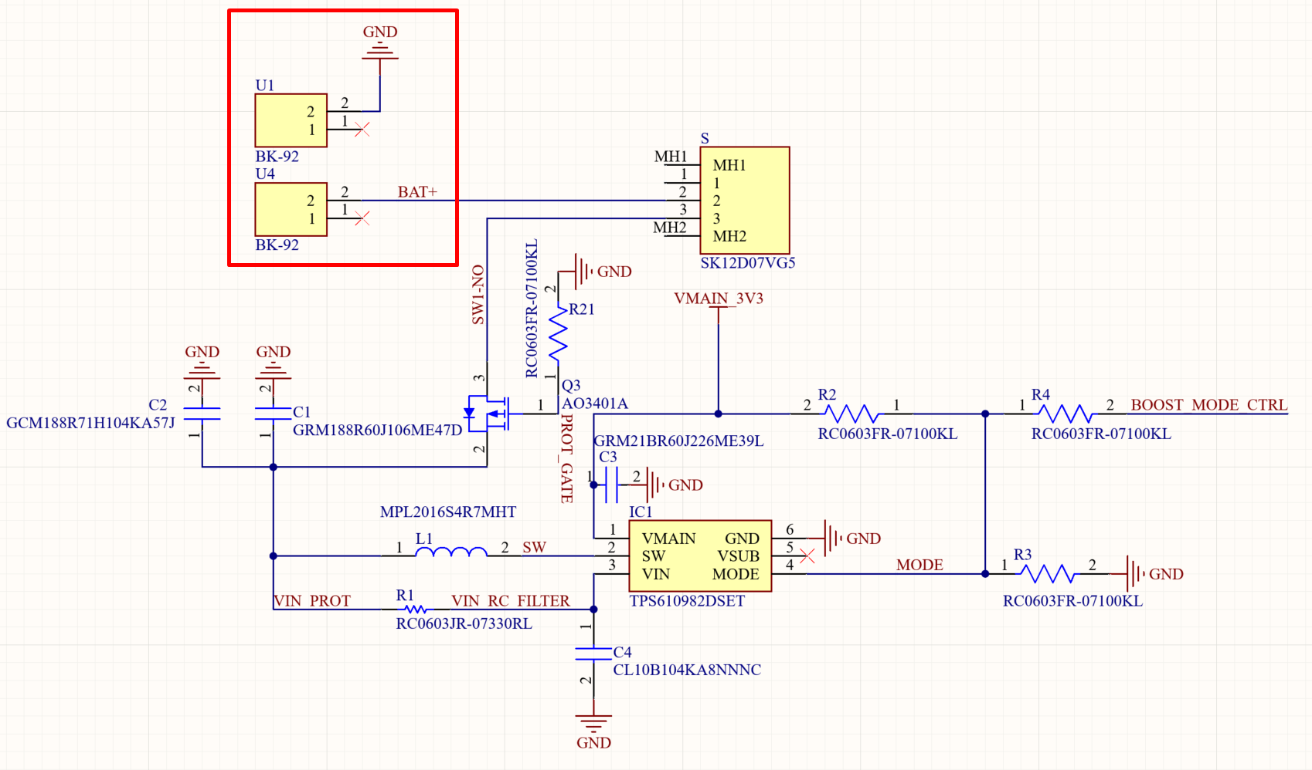
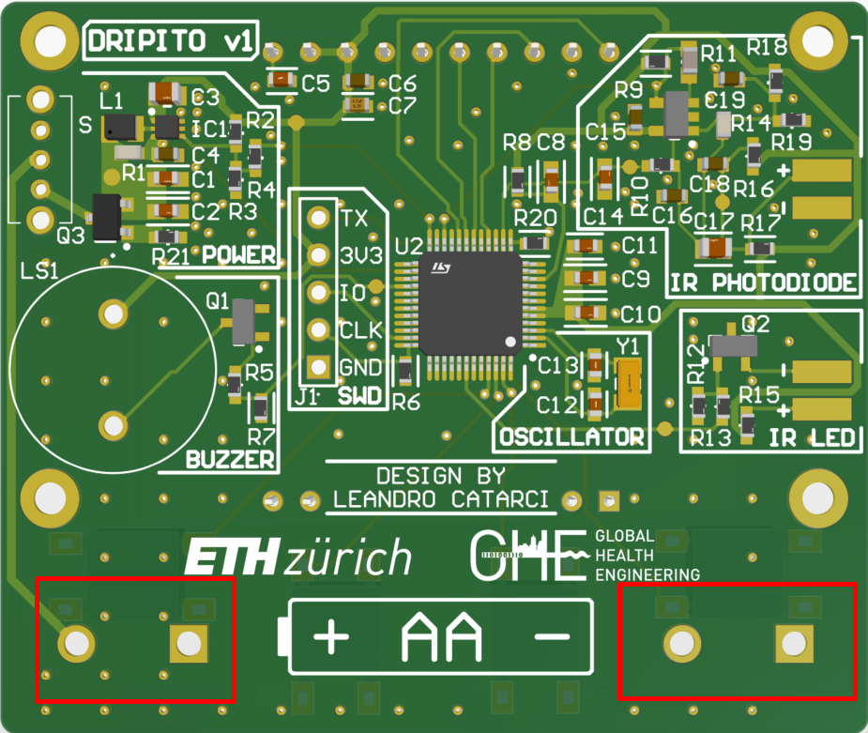
Figure 3: Battery Holders — Schematic Extract
Figure 4:BK-92 PCB Mounting Holes

Reverse Polarity Protection
To protect against incorrect battery insertion — a realistic risk in pediatric or emergency contexts — reverse polarity protection was implemented using a P-Channel MOSFET (AO3401A). Unlike a diode-based approach, this introduces nearly no forward voltage drop, preserving valuable millivolts in a low-voltage supply. The gate is pulled low via a 100k resistor, allowing current to flow only when the polarity is correct.
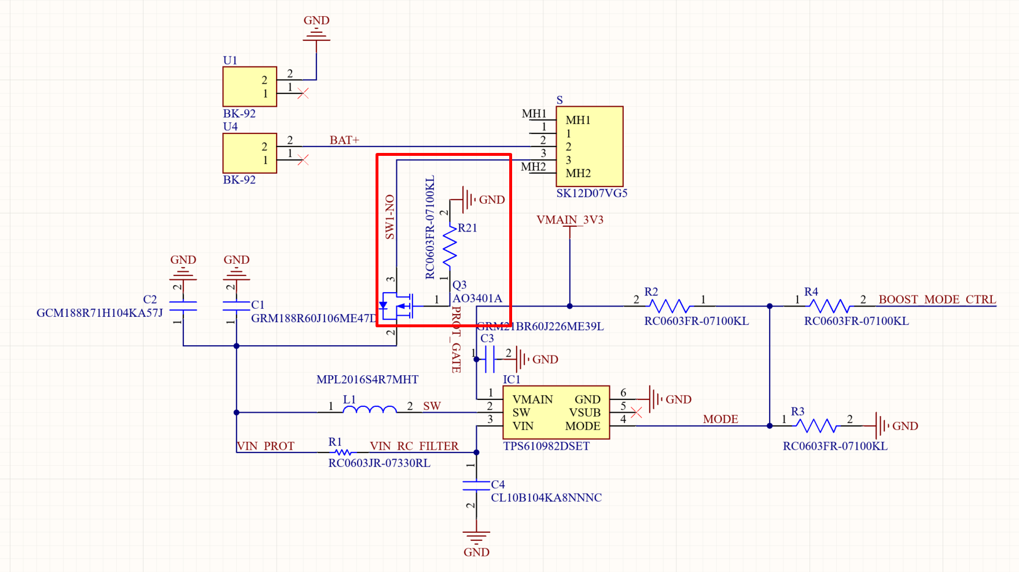
Figure 5:Reverse Polarity Protection Circuit — Schematic Extract
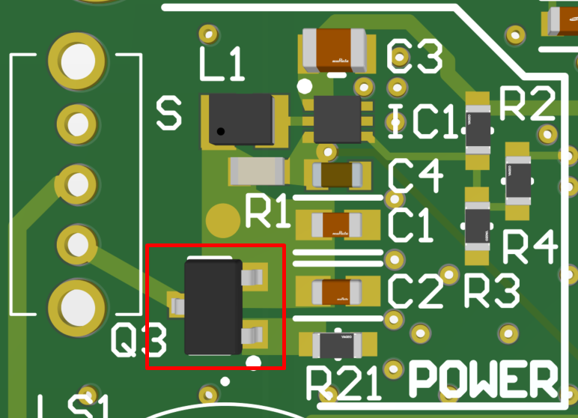
Figure 6: Reverse Polarity Protection Mosfet
A large positive battery symbol on the silkscreen further guides correct insertion, but the MOSFET ensures resilience against human error.

Boost Conversion with TPS610982
Given the wide voltage range of an AA battery (1.5 V fresh, ~0.7 V depleted), a DC-DC boost converter is necessary. The Texas Instruments TPS610981DSET was selected due to its high efficiency, compact footprint, and suitability for low startup voltages.
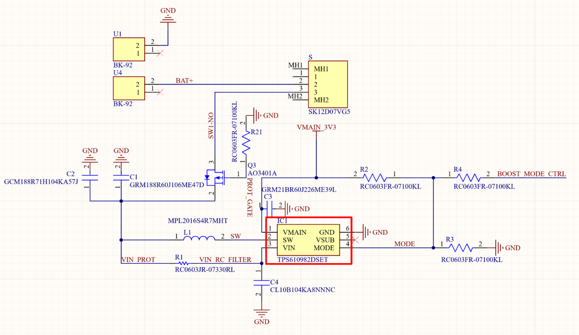
The device converts the battery voltage up to a regulated 3.3 V supply for the microcontroller and sensors. Its internal feedback loop ensures tight voltage regulation even as battery capacity diminishes.

Figure 7:Boost Converter— Schematic Extract
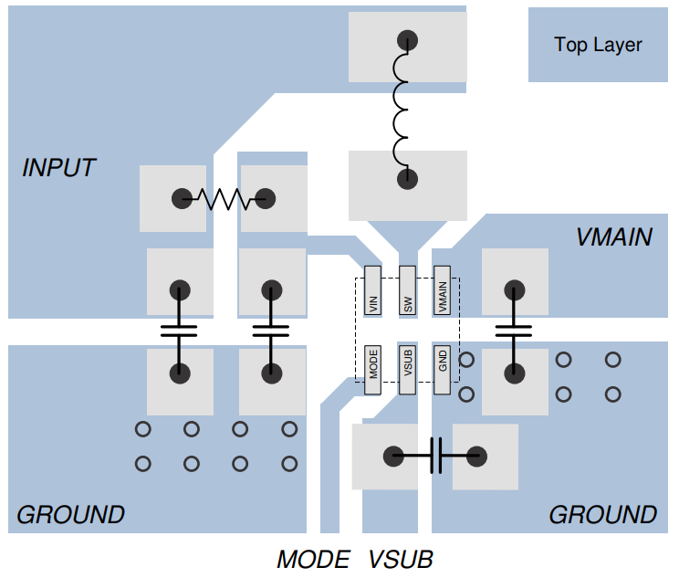
Figure 8:TPS610982 — Example Layout from Datasheet for Comparison

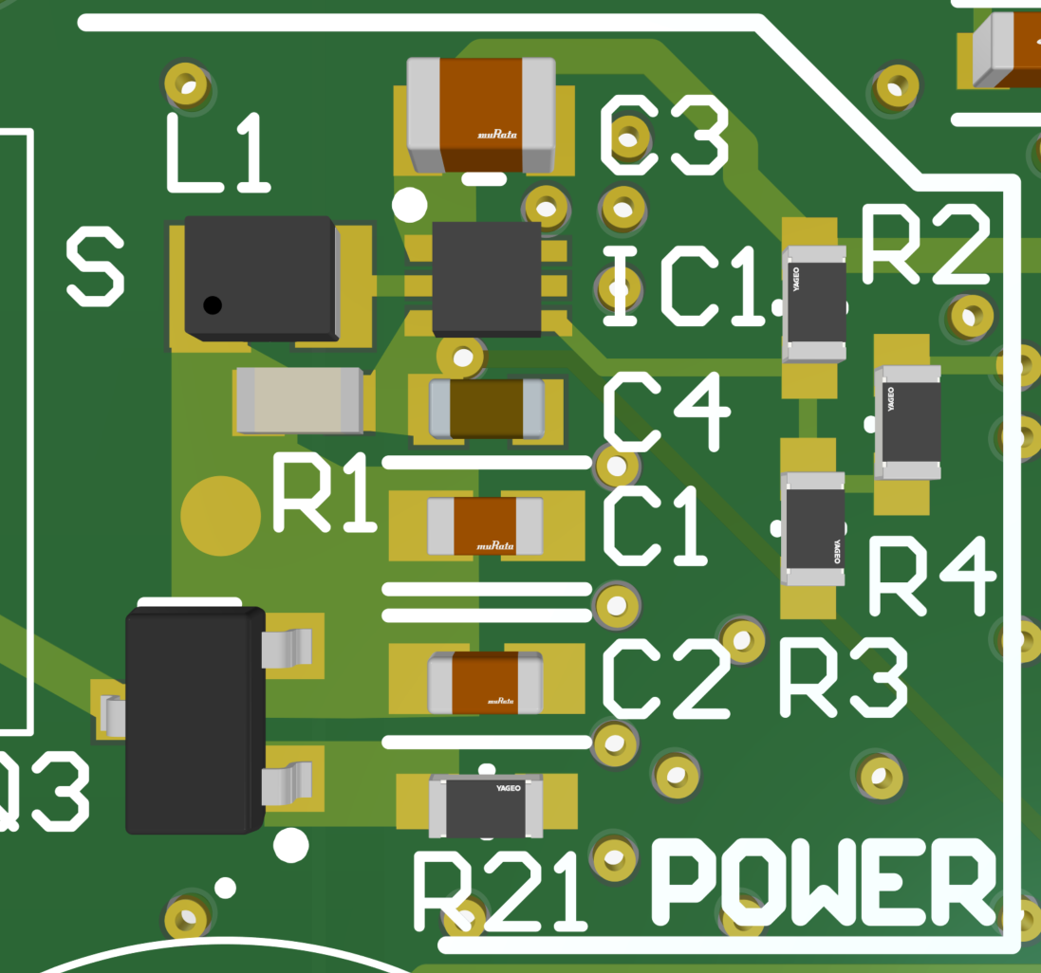
Figure 9:Boost Converter — PCB Layout

Battery Voltage Monitoring (Gauge)
The node labeled VIN_RC_FILTER is directly routed to an analog-capable pin on the STM32G030 microcontroller. This connection allows the firmware to sample the battery voltage (pre-boost) periodically. This setup enables simple estimation of battery fullness, which may be used to trigger low-battery warnings.

