Leandro Catarci

Development of Pediatric IV Flow Rate Monitor for Humanitarian Settings

Background
Critical care medicine is an essential component of healthcare, aimed at stabilizing patients with life-threatening conditions through intensive monitoring and frequently invasive interventions. (Adhikari et al., 2010) Access to critical care is inconsistent globally, especially in low-resource areas affected by disasters, conflicts, and disease outbreaks. Weak healthcare infrastructure, staff shortages, and limited resources make treatment difficult, increasing mortality rates. (Diaz et al., 2019) In humanitarian contexts, where preventable conditions such as dehydration, famine, and trauma-related shock are prevalent, ensuring access to basic life-saving medical support remains a major challenge (Lee et al., 2019).
Humanitarian organizations have demonstrated that critical care principles can be adapted for resource-limited environments. Even without fully equipped ICUs, basic treatments like IV fluid resuscitation can save lives. Meeting these challenges requires affordable, practical solutions that fit the unique demands of humanitarian care (Malkin, 2007; Shah et al., 2015).
In resource-limited humanitarian settings, gravity-assisted IV therapy is often the only feasible method for fluid administration due to the lack of advanced medical equipment and stable power sources, largely because infusion pumps are too expensive and difficult to maintain in these environments. However, precise control of infusion rates remains a major challenge, increasing the risk of fluid overload or insufficient delivery, particularly in critically ill patients, neonates, and those receiving vasopressors (Malkin, 2007).
Pediatric patients in humanitarian settings are especially vulnerable, as children are more susceptible to dehydration, malnutrition, and infectious diseases, which often require immediate IV fluid resuscitation (Turner et al., 2016). MSF reports that children under 15 make up over 60% of patients in MSF missions, often arriving in critical condition due to delayed treatment and inadequate pediatric healthcare infrastructure (Child Health | MSF Medical Activities, 2023). Pediatric patients need precise dosing due to their small body weight, making them highly sensitive to fluid imbalances, as well as under- or overdosing of medicine (Shah et al., 2015). A reliable IV flow meter designed for low-resource settings can help ensure safe and effective fluid administration when used alongside gravity-assisted IV drips, reducing mortality and easing the burden on overworked medical staff (Shah et al., 2015; Venkatesh et al., 2022).
To be effective in humanitarian settings, IV flow meters must be affordable, robust, portable flight safe, and easy to use with minimal training. They should function without reliance on the power grid, operating efficiently on batteries, withstand harsh conditions, and integrate seamlessly into existing gravity-fed IV systems. A cost-effective and reliable IV flow meter can significantly improve critical care delivery in austere environments, aligning with the fundamental goal of humanitarian medicine—to save lives efficiently under constrained conditions (World Health Organization, 2010).
Problem statement and goals
The goal is to develop a compact, precise, energy-efficient and cheap IV flow monitor with an intuitive UI and reliable alerts. It must achieve ±1% accuracy in drop detection. The device will use a drop detection system based on an IR light gate (emitter + receiver) approach, calibrated to support 10, 15, 20, 60, and ideally 100 gtt/mL drip sets. The device should be ≤100 × 50 × 25 mm and ≤100g, reducing bulk compared to existing solutions. It must operate for at least 360 hours. The UI will feature a display, color-coded LEDs, and an alarm system for critical alerts. The system will include audible and visual alarms to ensure effective monitoring in various environments.

Research Questions
To evaluate the feasibility and effectiveness of the proposed IV flow meter, this research will address the following key questions:
- How accurately does the IV flow meter measure flow rates between 1–100 mL/h under controlled laboratory conditions, and how does its error margin compare to the ±1% drop detection accuracy of the DripAssist (DripAssist - Shift Labs, Inc. - PDF Catalogs | Technical Documentation, n.d.)? Additionally, does this accuracy remain stable when extending the range to 200 mL/h for adult use?
- What cost-effective materials and production methods can be used to manufacture an IV flow meter for under $59.22 (=52.28 CHF), a figure to remain comparable to DripOMeter (Venkatesh et al., 2022), per unit while ensuring ±1% drop detection accuracy and a battery life of at least 360 hours?
- What UI design principles can improve ease of use for IV flow meters with minimal training, considering language barriers and limited technical expertise?

Methods
To evaluate the feasibility and effectiveness of the proposed IV flow meter, this research will employ a combination of experimental testing, cost analysis, and usability studies. Each research question will be addressed as outlined below.
The IV flow meter’s accuracy in measuring flow rates between 1–100 mL/h will be tested using standardized IV drip sets (10, 15, 20, 60, and 100 gtt/mL). The device will be calibrated against a high-precision digital flow meter, and its error margin will be compared to the ±1% drop detection accuracy of the DripAssist flow monitor. Additional tests will extend the range to 200 mL/h to determine accuracy for adult use.
To identify cost-effective materials and production methods, a comparative analysis of available electronic components and sensor technologies will be performed. The design will prioritize affordability without compromising performance, aiming to keep production costs as low as possible per unit. Prototyping will involve 3D printing for housing components and readily available electronic parts, with iterative testing to refine material selection. Manufacturing feasibility will be assessed through consultation with industry experts and suppliers to estimate bulk production costs and scalability potential.
The UI will be designed with minimal training requirements in mind, using a display, color-coded LEDs, and an alarm system for critical alerts. Feedback will be gathered from 2-3 medical professionals or field workers with experience in low-resource settings. These individuals will provide insights on ease of use, readability, and alarm responsiveness based on their interaction with the device. Their feedback will inform iterative design improvements to enhance accessibility, particularly in environments with language barriers and limited technical expertise.
These methodologies will ensure that the IV flow meter meets the accuracy, affordability, and usability requirements essential for effective deployment in humanitarian settings.

Planning

Gantt chart
The project begins with research and planning in March, gathering information from existing products and humanitarian settings, preparing the design process. From April onwards, the development and experimentation phase follow an agile approach, incorporating brainstorming, system architecture planning, and rapid prototyping to refine multiple (2-3) design iterations before converging on an optimized prototype. Writing and documentation are done throughout the process, to ensure that experimental findings and design insights are recorded right as they happen. This allows flexibility to adapt based on test results and ensures steady progress toward the final submission in August.
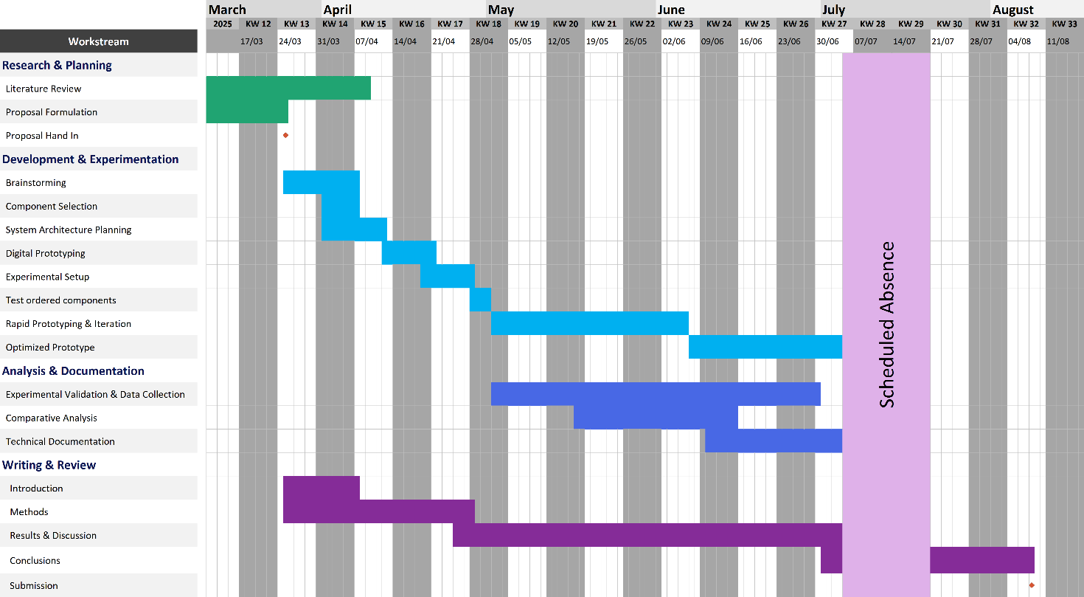
Figure 1: Project Timeline Gantt Chart
The timeline will be updated periodically to account for unforeseen delays, scope changes, feedback from supervisors requiring revisions or additional approvals, technical challenges, and experience gained from previous phases that suggest better approaches.

Mind Map
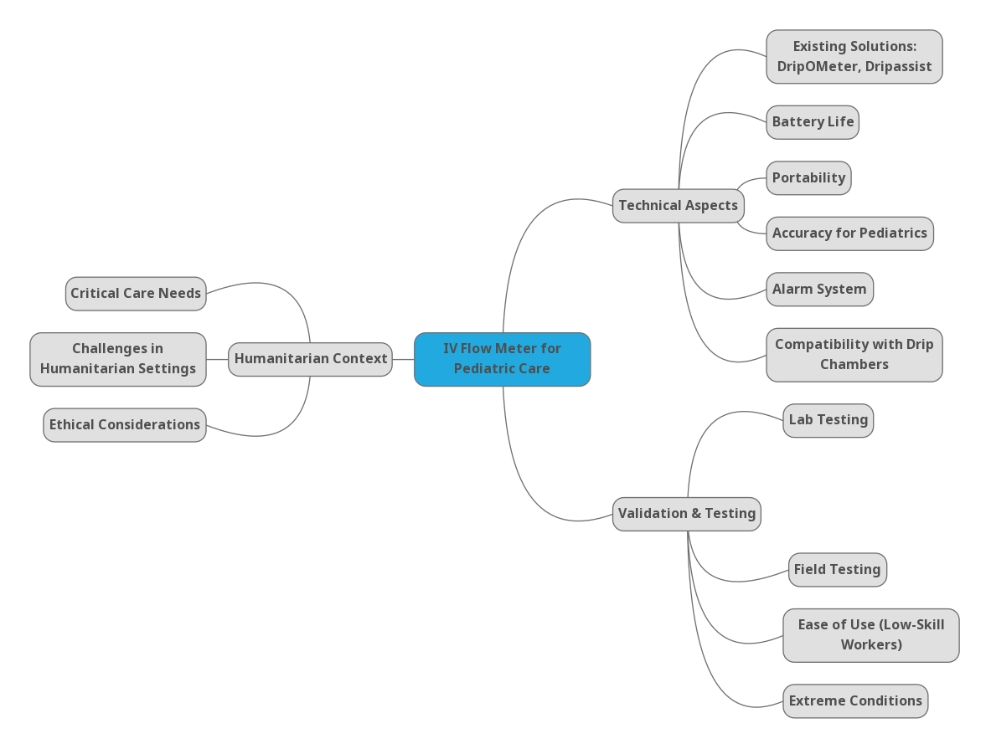
Figure 2. Project Mindmap
The mind map provides a structured overview of the key aspects of the project, ensuring focus on the most critical elements, including the Minimum Viable Product (MVP). It highlights both technical aspects and humanitarian challenges, helping to maintain a clear direction throughout development.

Data Management Plan (DMP)
This DMP outlines data collection, generation, and reuse strategies. It is expected to evolve throughout the project.

Data collection
dataset | data type | data format | data documentation
IV flow rate measurement (mouse sensor, IR breakbeam, optional ToF/acoustic) | Sensor data | CSV export from microcontroller | Variables include timestamp, drip rate (dp/min), flow rate (mL/h), total volume administered (mL), battery level (%). Sensors tested sequentially (optical sensors such as IR barrier and mouse sensors). Estimated dataset size: ~500 observations.
Power consumption during operation | Electrical measurement data | CSV export from microcontroller | Variables include timestamp, voltage (V), current (mA), and estimated power (mW). Logged during typical operating cycles for each prototype sensor (mouse, IR, ToF, etc.) to assess battery draw and optimize energy efficiency. Sampling interval: ~1 Hz.
Structured feedback from supervisor and medical professionals | Observational data | Notes → Google Sheets → CSV | Structured feedback documented after sessions, focusing on UI usability, accuracy perception, and practical improvements. Feedback from supervisor and up to 3 medical professionals, estimated total ~5 entries.

Data storage
Raw datasets collected from microcontroller-based systems and observational calibrations will be directly exported or digitized into CSV files and stored in the provided Google Drive folder under data/raw_data. Structured observational feedback will be digitized and stored separately in CSV format within data/raw_data. Secondary data (PDF standards documents) will be stored in data/raw_data if applicable, or clearly referenced in documentation if publicly accessible.
Data analysis will be performed using primarily Excel. The raw datasets will remain unaltered to ensure data integrity. Processed data and analyses will be systematically version-controlled and stored within the provided Google Drive folder, following the recommended directory structure from Global Health Engineering.

Budget
Expense | Amount | Unit Price [CHF] | Total Price [CHF]
Core Electronics & Processing
Arduino Pro Mini (3.3V) | 3 | 2.13 | 6.39
FTDI USB-to-Serial Adapter | 2 | 1.23 | 2.46
3.3V USB Power Supply for Arduino | 1 | 1.48 | 1.48
DC/DC 1.5V -> 3.3V Converter | 2 | 0.95 | 1.9
Sensors & Input Components
Infrared LED Diodes (940nm) (Receiver + Emitter) | 1 | 1.57 | 1.57
TSOP38238 IR Receiver | 1 | 1.84 | 1.84
MOSFET (for IR LED switching) | 1 | 1.99 | 1.99
Current/Power/Voltage Sensor | 1 | 1.23 | 1.23
Power & Battery Components
AA Batteries | 12 | 1.66 | 19.92
AA Battery Holder | 1 | 1.71 | 1.71
Circuitry & Prototyping
Resistor Kit | 1 | 10.59 | 10.59
Capacitor Kit | 1 | 2.94 | 2.94
Jumper Cables | 1 | 4.97 | 4.97
Prototyping PCB Boards | 1 | 3.13 | 3.13
Breadboard MB-102 | 1 | 2.79 | 2.79
LED Kit | 1 | 1.14 | 1.14
Button Kit | 1 | 2.25 | 2.25
Display & Feedback Components
Piezo Buzzer (Alarm) | 1 | 1.69 | 1.69
HD44780 16x2 LCD + I2C Modul | 1 | 2.43 | 2.43
Data Logging & Storage
Micro SD Card (32GB) | 1 | 3.39 | 3.39
Micro SD Card Module (Arduino) | 1 | 1.44 | 1.44
Micro SD Card Adapter (USB) | 1 | 1.49 | 1.49
Real-Time Clock (RTC) & Timekeeping
RTC Module DS3231 | 1 | 0.89 | 0.89
Manufacturing & Miscellaneous
PLA Filament (1kg) | 1 | 26.5 | 26.5
Delivery Cost | 1 | 13.59 | 13.59
IV Infusion Set | 1 | 50 | 50
Buffer
Contingency Budget (ca. 15%) |  |  | 30
Total |  |  | 199.72

References
Adhikari, N. K. J., Fowler, R. A., Bhagwanjee, S., & Rubenfeld, G. D. (2010). Critical care and the global burden of critical illness in adults. Lancet (London, England), 376(9749), 1339–1346. https://doi.org/10.1016/S0140-6736(10)60446-1
Child health | MSF medical activities. (2023). https://www.msf.org/child-health
Diaz, J. V., Riviello, E. D., Papali, A., Adhikari, N. K. J., & Ferreira, J. C. (2019). Global Critical Care: Moving Forward in Resource-Limited Settings. Annals of Global Health, 85(1), 3. https://doi.org/10.5334/aogh.2413
DripAssist—Shift Labs, Inc. - PDF Catalogs | Technical Documentation. (n.d.). Retrieved March 20, 2025, from https://pdf.medicalexpo.com/pdf/shift-labs-inc/dripassist/107787-182657.html
Lee, J. S., Roberts, S. W. P., Götsch, K., Moeller, U., & Hawryluck, L. (2019). Caring for Critically Ill Patients in Humanitarian Settings. American Journal of Respiratory and Critical Care Medicine, 199(5), 572–580. https://doi.org/10.1164/rccm.201806-1059CP
Malkin, R. A. (2007). Design of Health Care Technologies for the Developing World. Annual Review of Biomedical Engineering, 9(Volume 9, 2007), 567–587. https://doi.org/10.1146/annurev.bioeng.9.060906.151913
Shah, K., Skerrett, E., Nojoomi, M., Walker, T., Maynard, K., Pan, M., Flynn, B., Yuan, M., Horton, P., Vaughn, T., Miros, R., Molyneux, E., Saterbak, A., Oden, Z. M., & Richards-Kortum, R. (2015). Maji: A New Tool to Prevent Overhydration of Children Receiving Intravenous Fluid Therapy in Low-Resource Settings. The American Journal of Tropical Medicine and Hygiene, 92(5), 1053–1058. https://doi.org/10.4269/ajtmh.14-0495
Turner, E. L., Nielsen, K. R., Jamal, S. M., von Saint André-von Arnim, A., & Musa, N. L. (2016). A Review of Pediatric Critical Care in Resource-Limited Settings: A Look at Past, Present, and Future Directions. Frontiers in Pediatrics, 4, 5. https://doi.org/10.3389/fped.2016.00005
Venkatesh, K., Alagundagi, S. S., Garg, V., Pasala, K., Karia, D., & Arora, M. (2022). DripOMeter: An open-source opto-electronic system for intravenous (IV) infusion monitoring. HardwareX, 12, e00345. https://doi.org/10.1016/j.ohx.2022.e00345
World Health Organization. (2010). Medical devices: Managing the mismatch: an outcome of the priority medical devices project. Dispositivos Médicos: La Gestión de La Discordancia: Un Resultado Del Proyecto Sobre Dispositivos Médicos Prioritarios. https://iris.who.int/handle/10665/44407

Currency conversions in this document use rates as of March 2025.

